AP Physics B Free-Response Index

 |  | B1 | B2 | B3 | B4 | B5 | B6 | B7 | B8
2008 | Rubric | Collisions | Springs & Energy | Current balance | Fluids & projectiles | Thermo cycle | Mirror – ray diagrams | deBroglie wavelength; photoelectric effect
2008b | Rubric | Momentum conservation | Mechanics; springs | LAB: magnetic field measurement | fluids | Lens – ray diagrams | Thermo cycle | Nuclear radiation
2007 | Rubric | Dynamics; inclined plane | Mass spectrometer | Circuits; RC circuit | Torricelli’s theorem | Thermo; isobaric process | LAB: determine the focal length of a lens | Positron-electron pair annihilation
2007b | Rubric | dynamics | q moving thru a B field | RC circuit | Torricelli’s theorem | Thermo; isometric process | LAB: determine the index of refraction of a slab of glass | Pair production
2006 | Rubric | Dynamics; modified Atwood’s w/ spring | LAB: World class runner – 100 m dash | Electrostatics; field and potential | Snell’s Law; graphical derivation of n;  Thin film interference | Thermo; PV diagram | Energy of photon; wave properties of an electron
2006b | Rubric | LAB: graphical derivation of g | Energy, momentum conservation; friction dynamics | Electrostatics | Reflection/refraction;  Double slit interf. | Thermo; PV diagram | deBroglie wavelength;  Electron/positron annilihation
2005 | Rubric | Kinematic, dynamics & graphs | pendulum | Electrostatics – point charges | LAB: double slit interference | buoyancy | PV=nRT graph | Energy levels;  Photoelectric effect
2005b | Rubric | Kinematics, dynamics, graphs | pendulum | Electrostatics – point charges | LAB: two source interference | Fluid flow: Torricelli’s theorem | PV=nRT graph | Photons and Photoelectric effect
2004 | Rubric | Energy conservation, rollercoaster, circles | Pressure and depth;  Newton’s laws | Faraday’s Law | Two source interference | PV-diagram, thermo | LAB: Photoelectric effect
2004b | Rubric | Energy conservation, rollercoaster, circles | Pressure and depth;  Newton’s laws | LAB: Standing waves in tube | Faraday’s Law | PV-diagram, thermo | Compton scattering
2003 | Rubric | F = ma, accel, FN, | R and C in circuit | Rail Gun: FB, work-energy | LAB: concave mirror image | PV diagram, energy | Fluids: pressure-depth, gauge pressure, Archimedes’s Princ. | atomic energy diag., HeNe laser
2003b | Rubric | F = ma, kinematics | LAB: circuit to power motor | single & double lens | E in capacitor, vector motion of electron, | 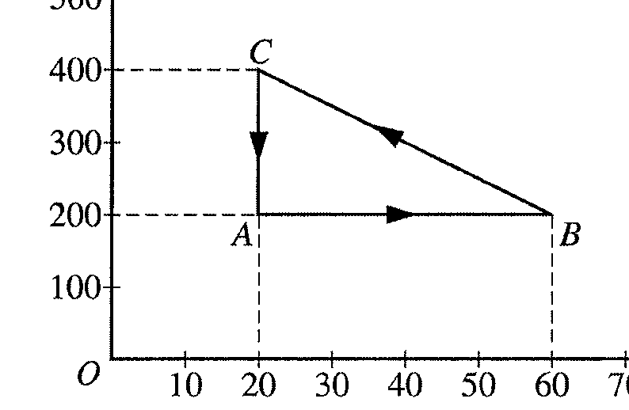  PV diagram, energy | Bernoulli’s princ., power, fluid flow | Atomic energy diagram, range of visible light
2002 | Rubric | F=ma, impulse, kinematics | U vs. x, energy, proj.motion, | Two light bulbs, rated in Watts, in series and parallel | converging lens with virtual image then with real image | B and E fields on proton | LAB: spring and Archimedes’ Principle | photon-electron collision
2002b | Rubric | collision with impulse  kinematics and energy | conical pendulum, projectile motion | light bulbs in series and parallel | submarine window as mirror, lens | capacitor E, V, C, electron released: find F, energy | Canister of gas:  ncΔt, mcΔt, PV=nRT, ht. of fusion | LAB: deBroglie wavelengths, atomic energy diagrams
2001 | Rubric | 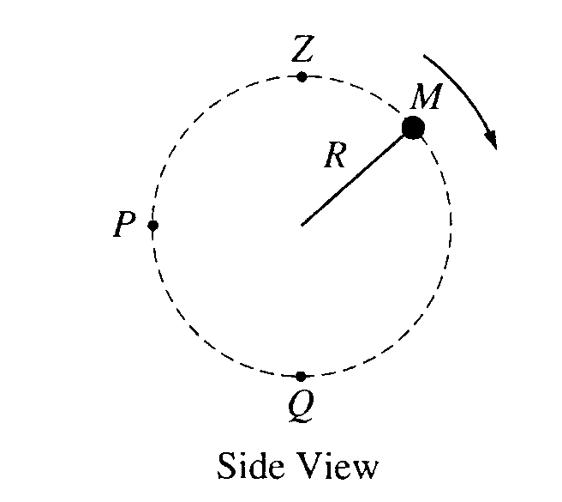  2001 - circular motion, projectile | 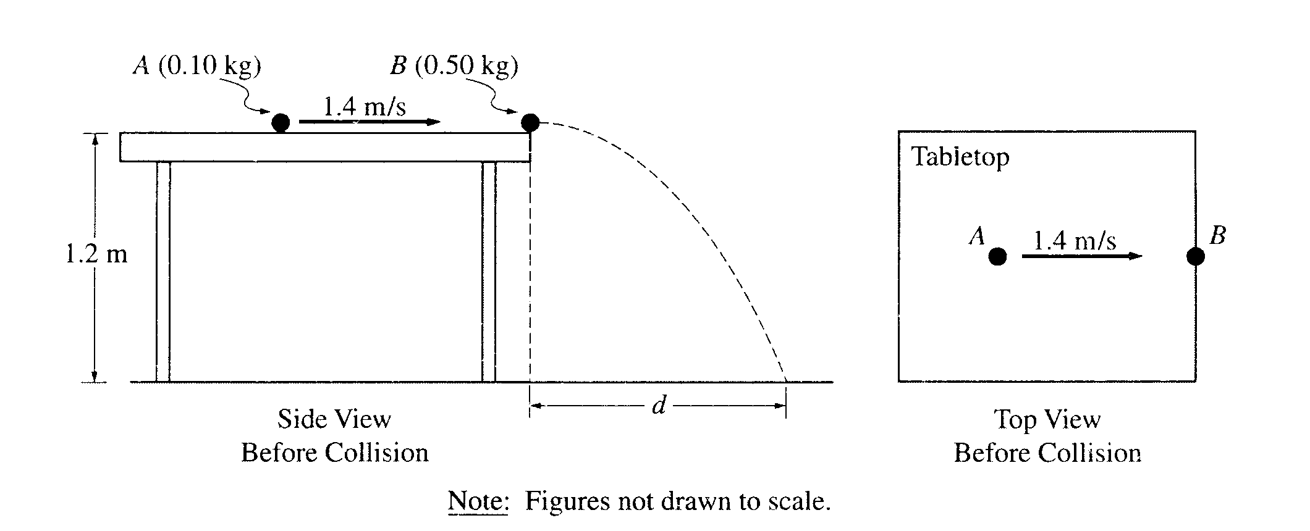  momentum, projectile | 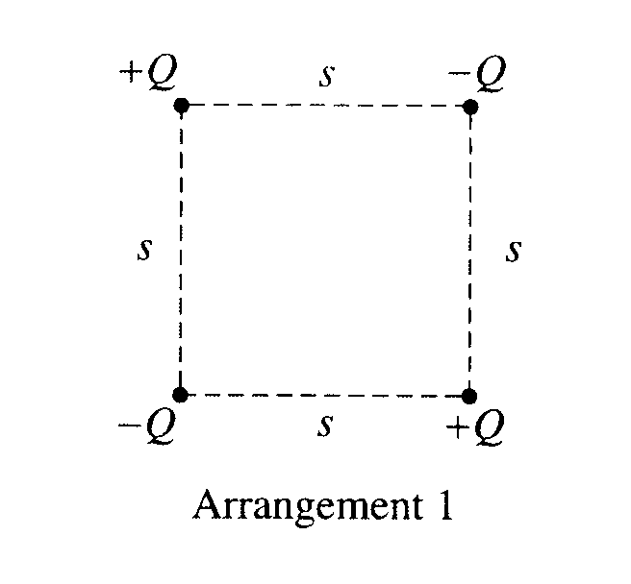  electrical forces, fields, potential | 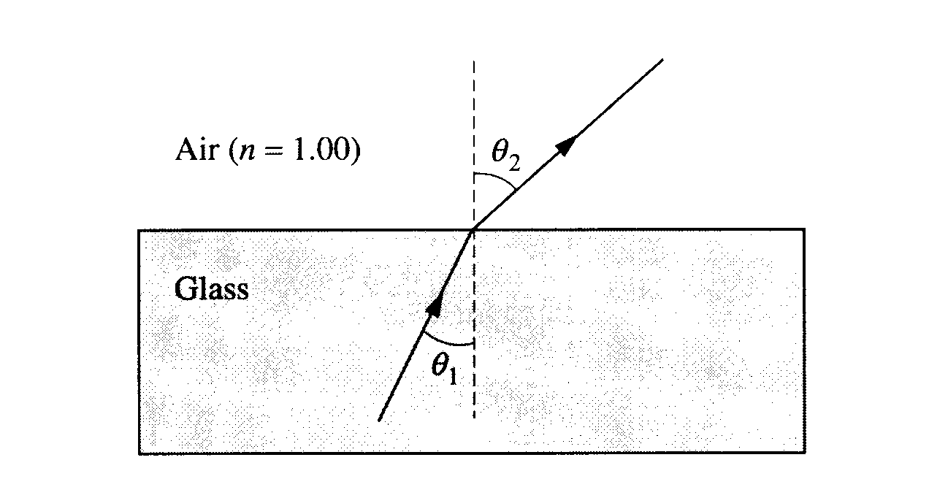  wavelength dependent refraction | 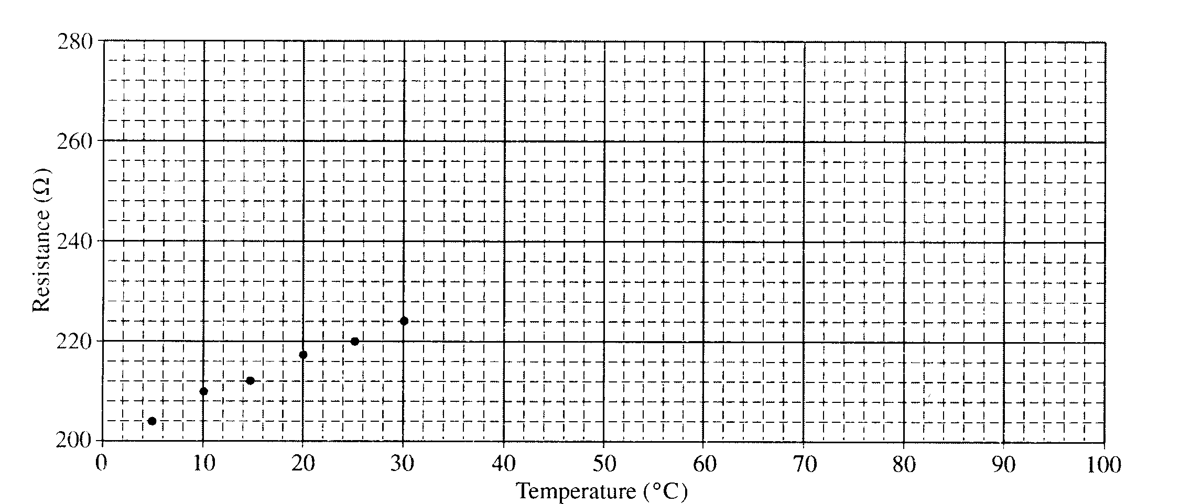  LAB - temp dependent resistor used as thermometer | 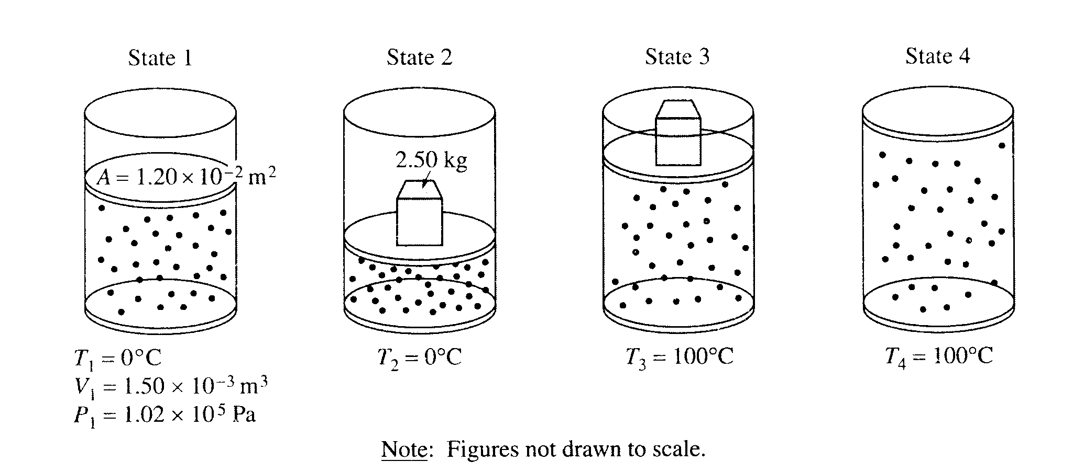  gas thermo - types of processes. | nuclear reaction, mass defect.
2000 | Rubric | 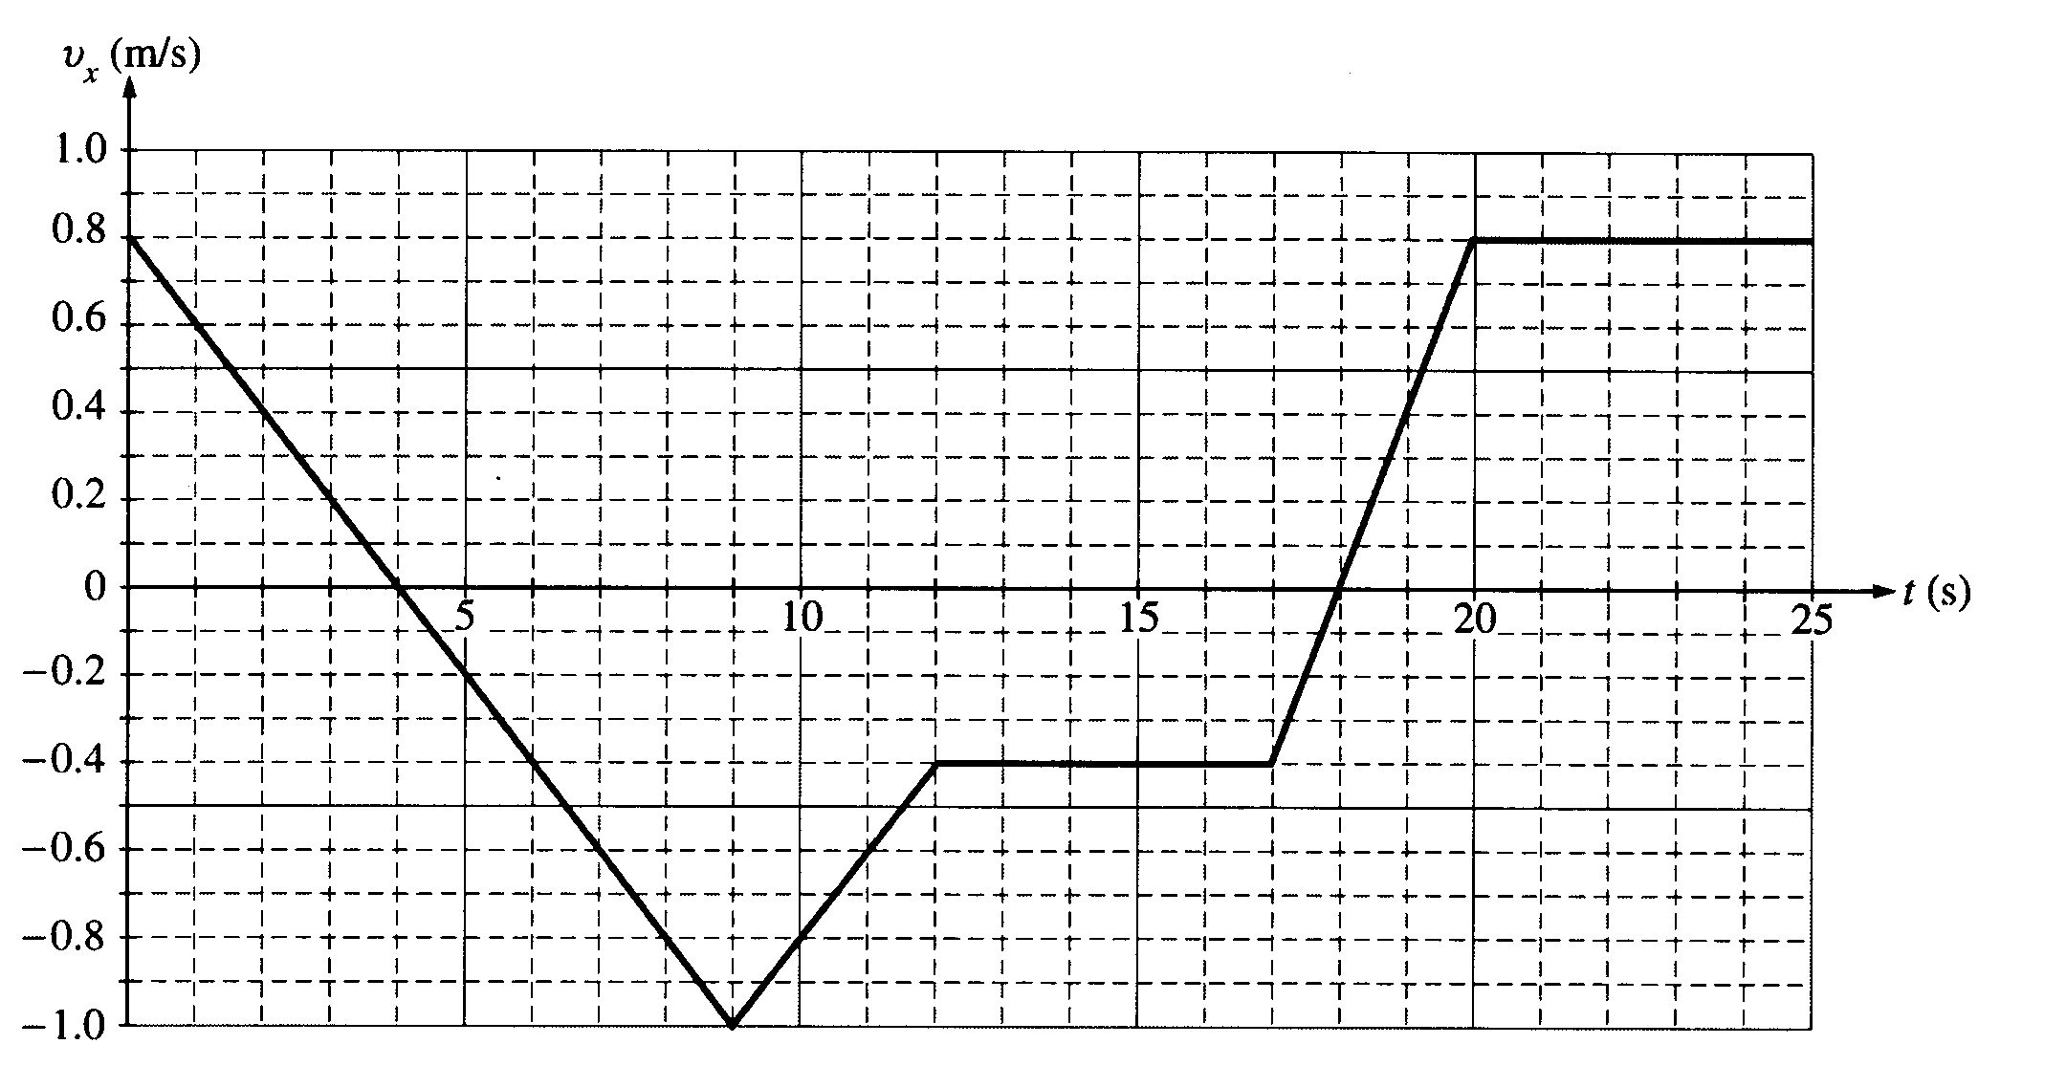  (2000) kinematics graph, projectile | Incline, forces, friction. | RC circuit. dielectric | refraction, thin film. | Photoelectric effect | LAB: determine specific heat of liquid. | Elec, Mag field on particle. Mass spectrometer.
1999 | Rubric | 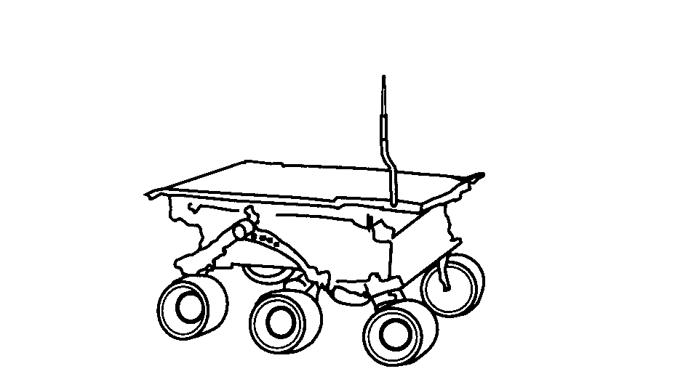  1999 – kinematics, work, en, friction | 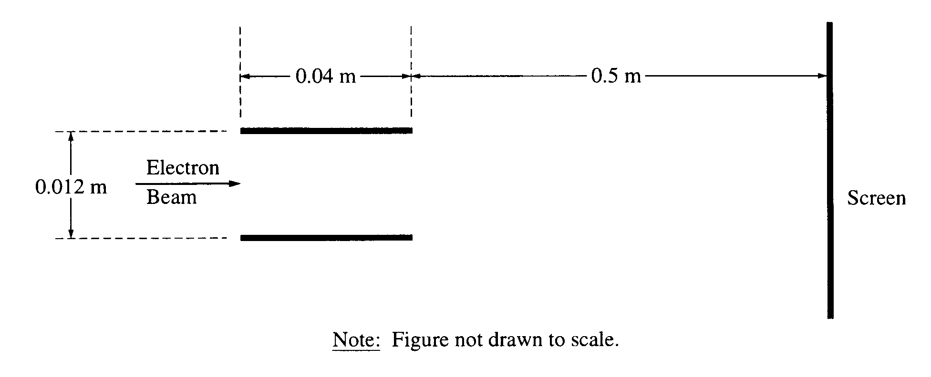  CRT, electron projectile in E field. B field | 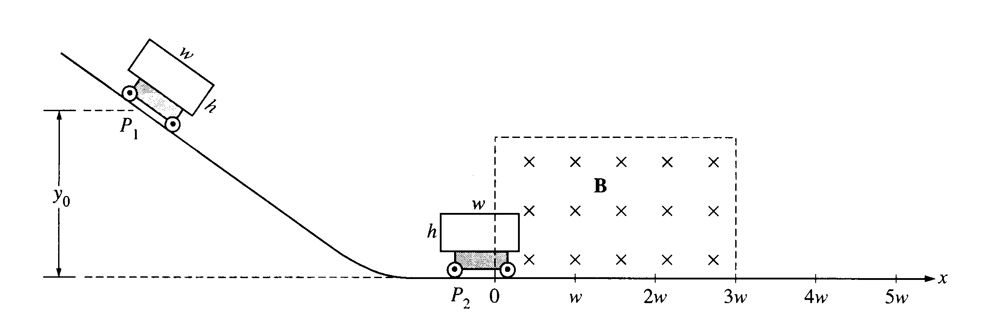  Energy on hill, induction | 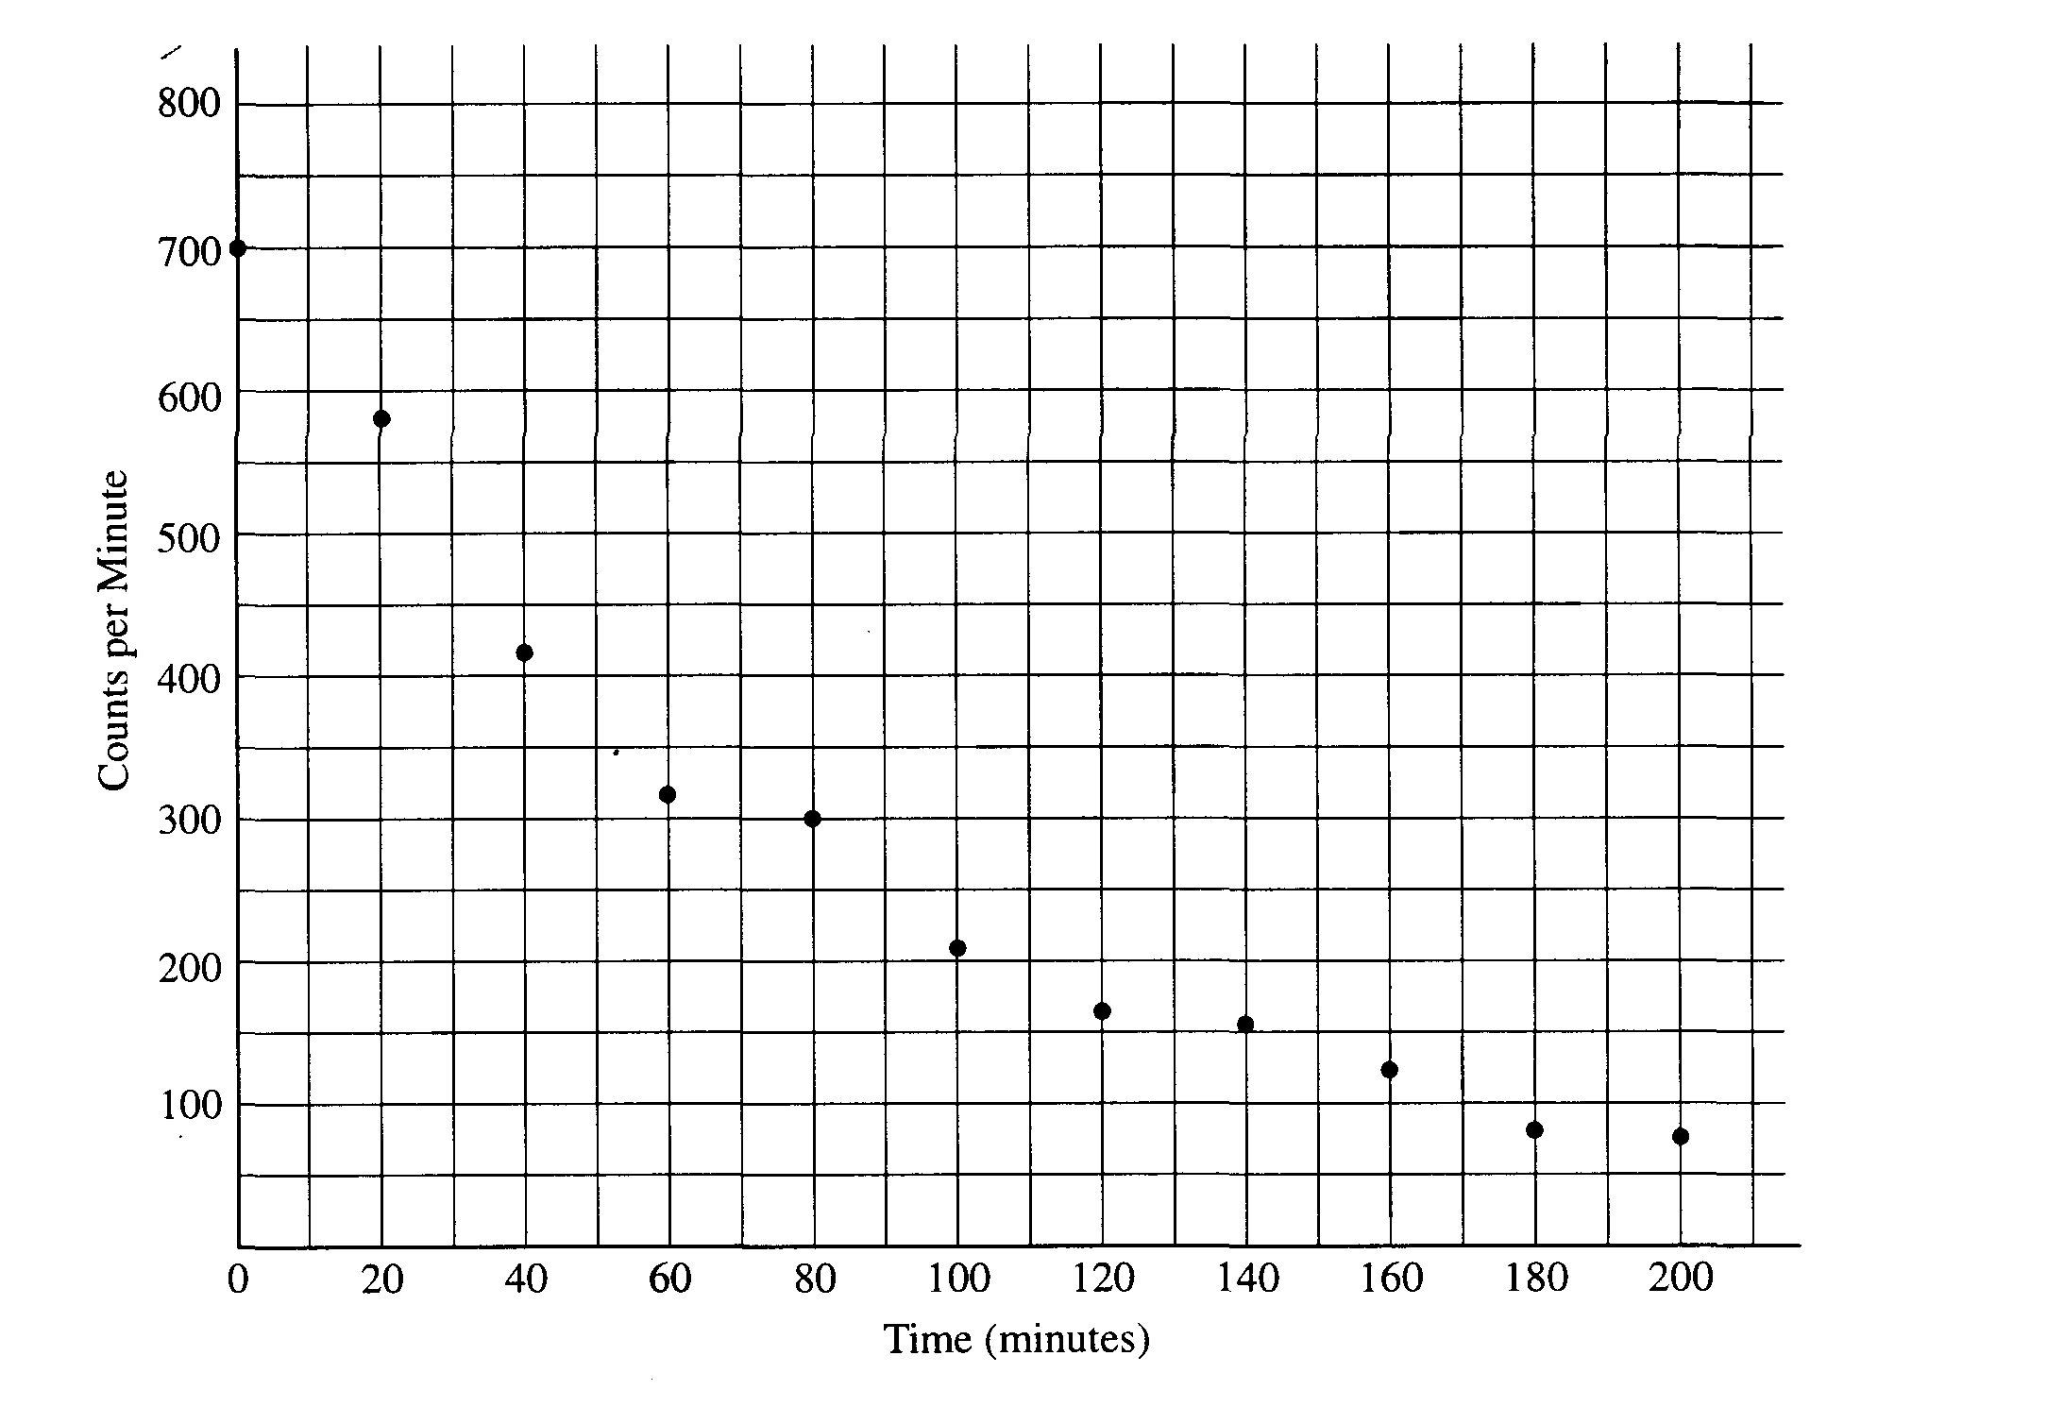  radioactive decay, half life | 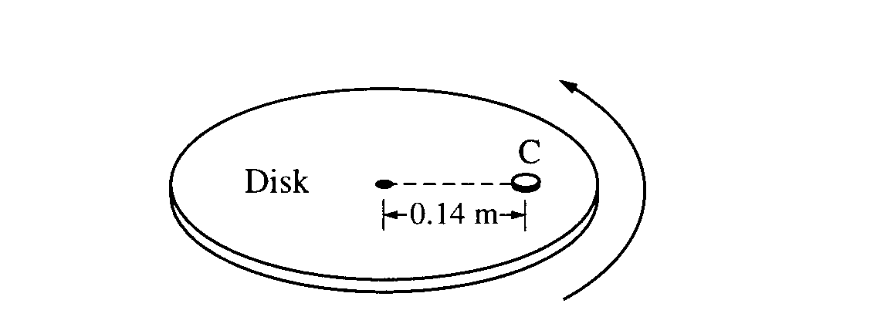  centripetal force on a turntable | Refraction and diffraction Lab experiments – design | 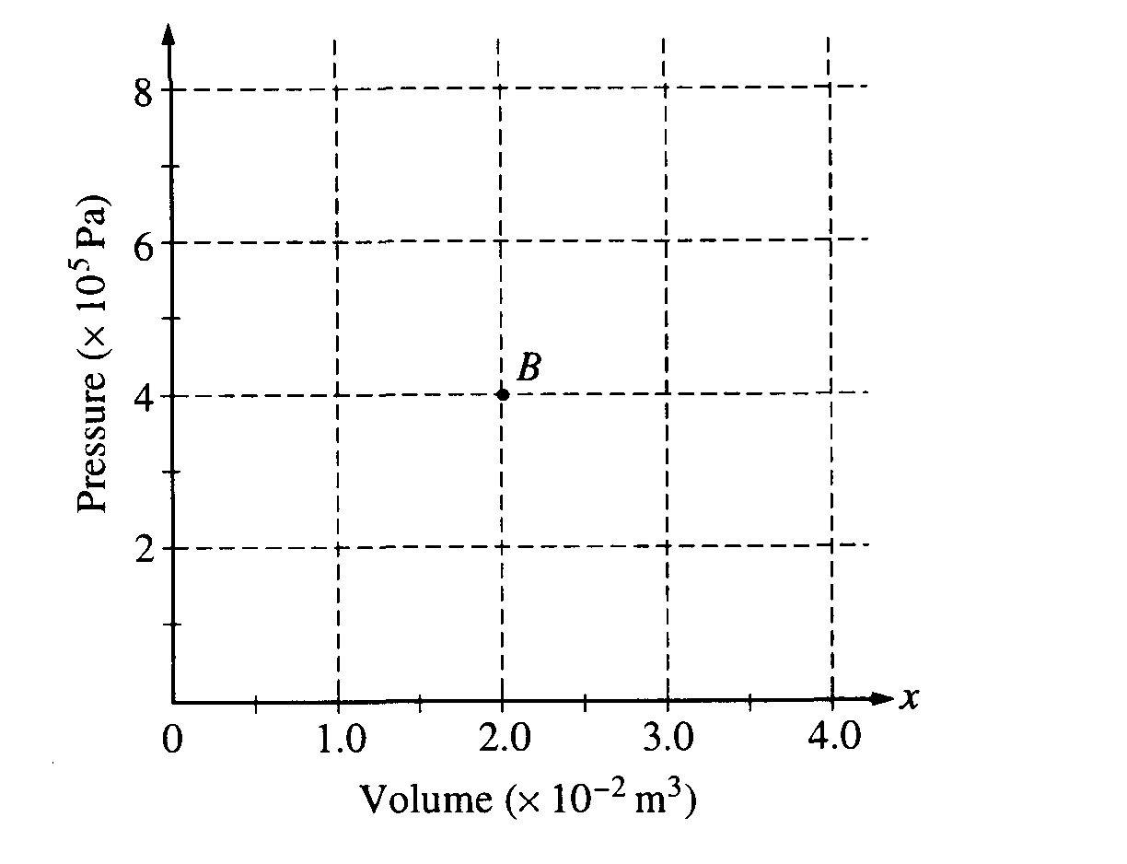  Gas cycle, heat engine
1998 | Rubric | 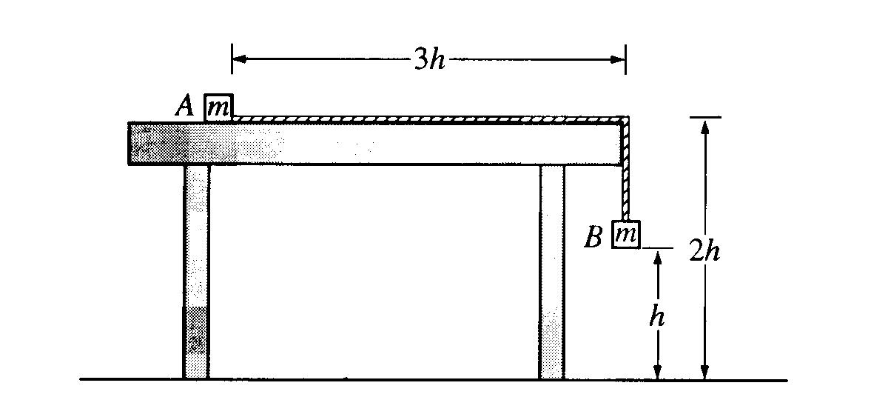  1998 – acceleration on table, projectiles | 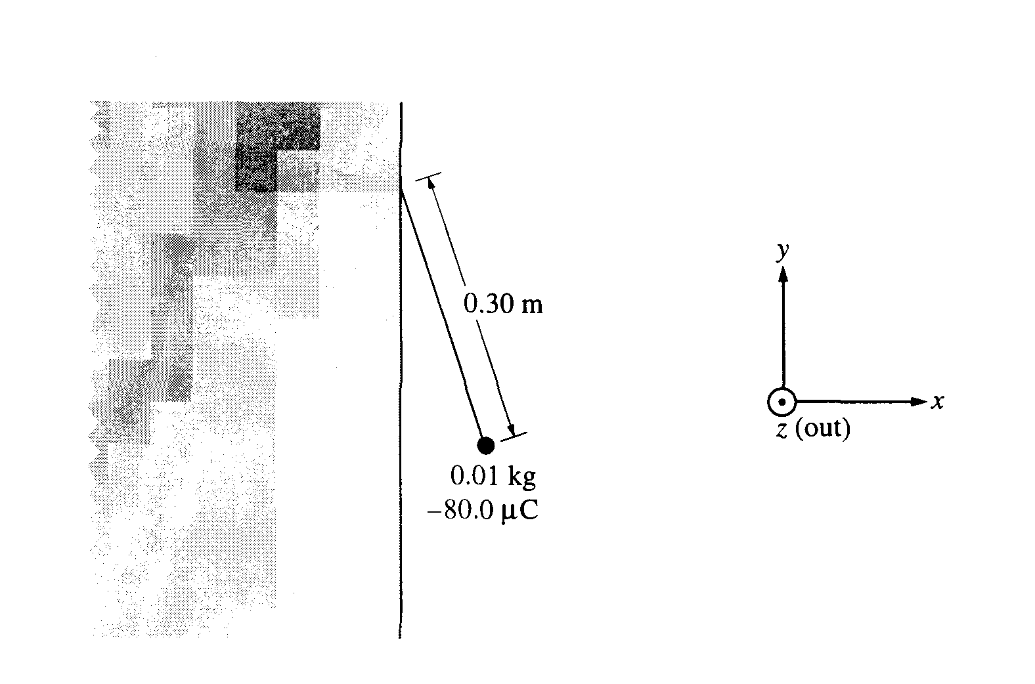  force on charged particle in E field. | 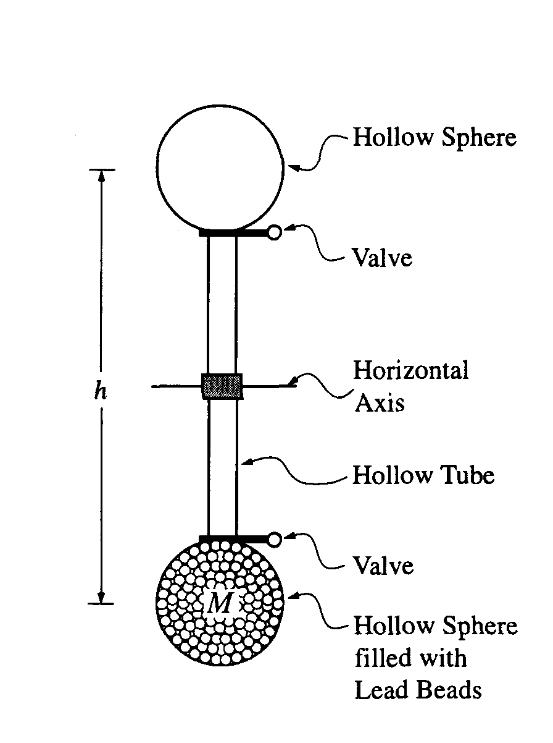  LAB: Energy transfer by GPE. Specific heat | 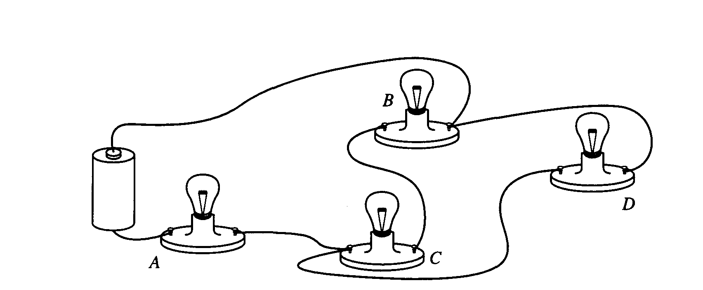  142 – bulbs in circuit. Drawing, Ohms law. | 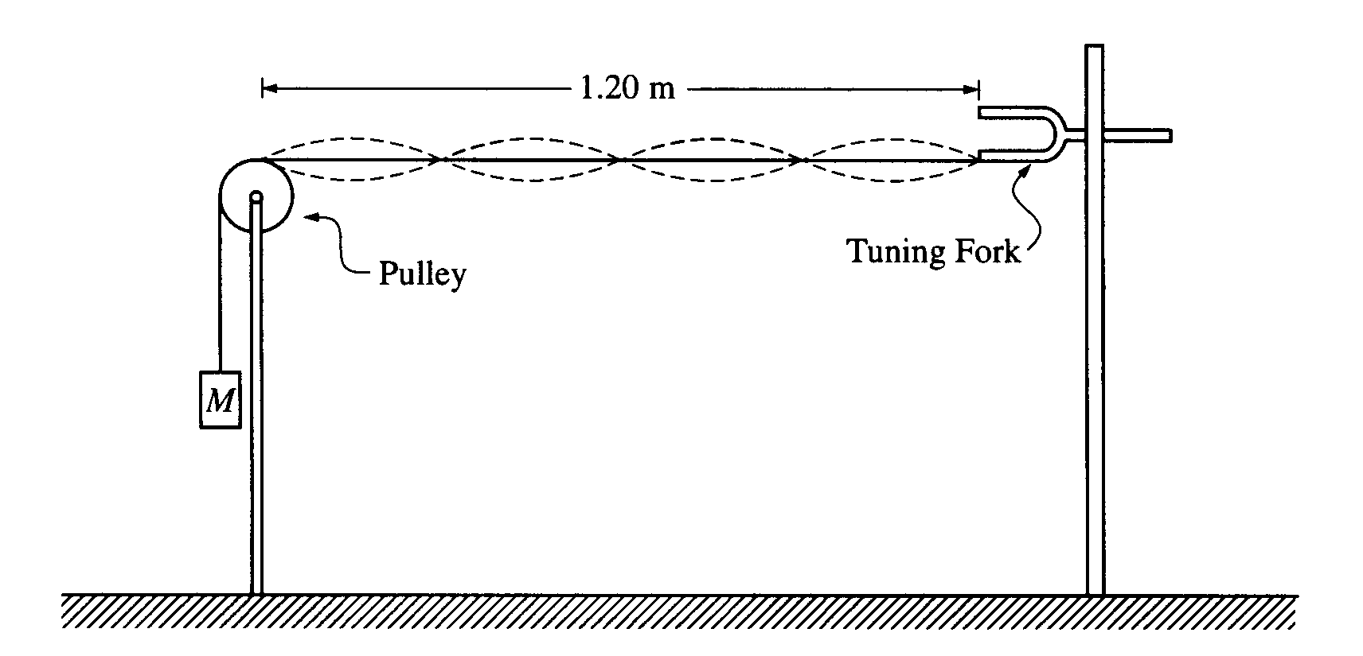  Standing waves on a string. | 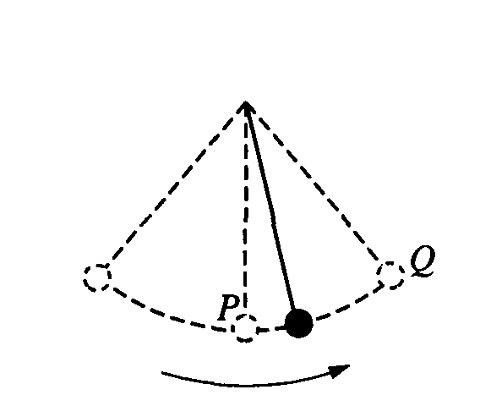  ball swinging directions of V and a | 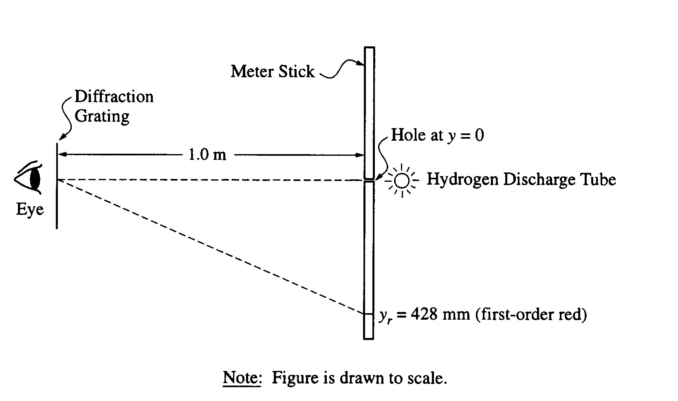  diff grating interference, Bohr level. | 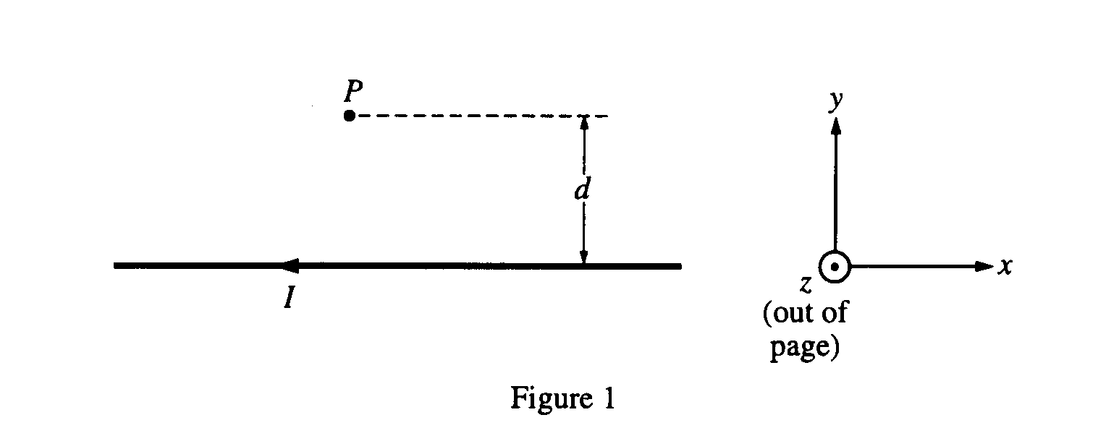  146 B forces on wire and particle.
1997 | Rubric | 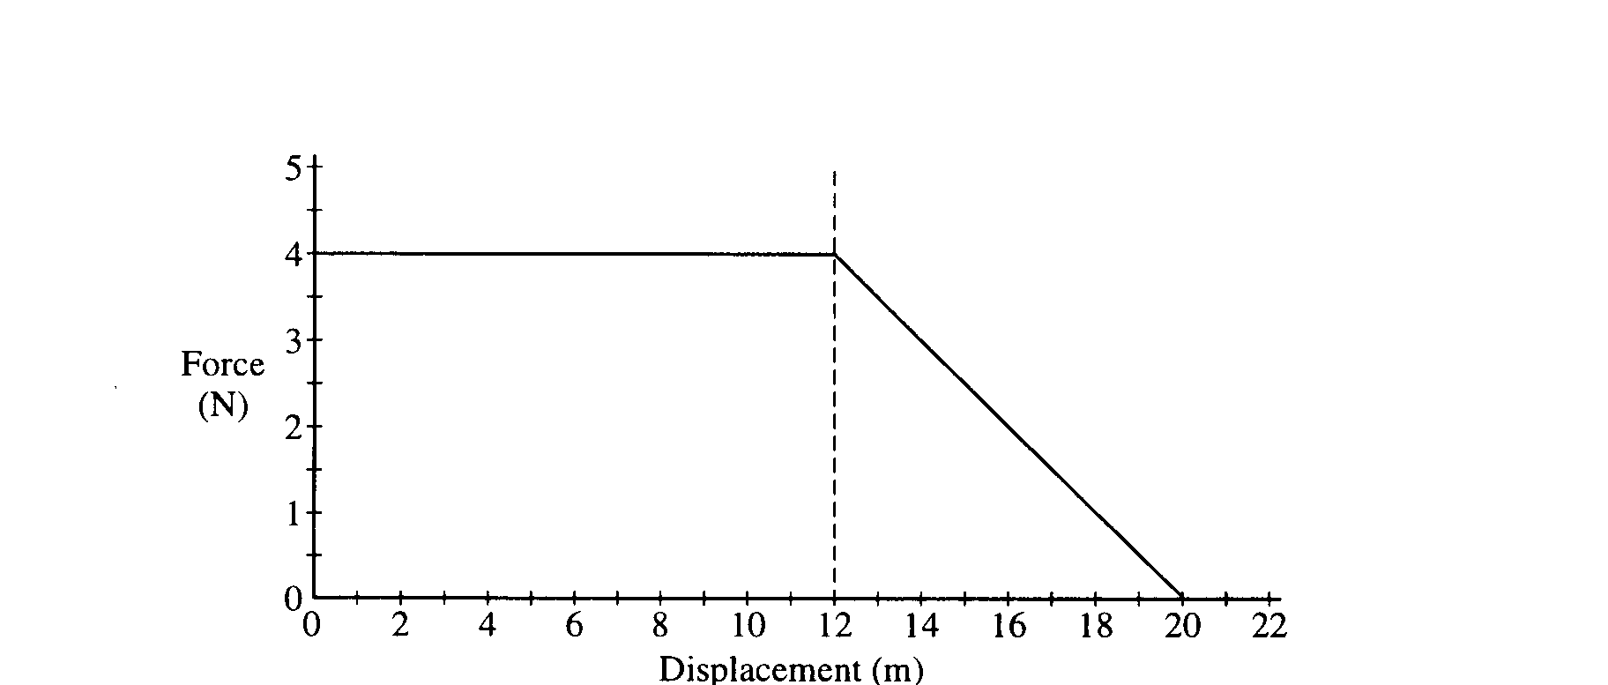  1997 – F vs D – find work, etc. | 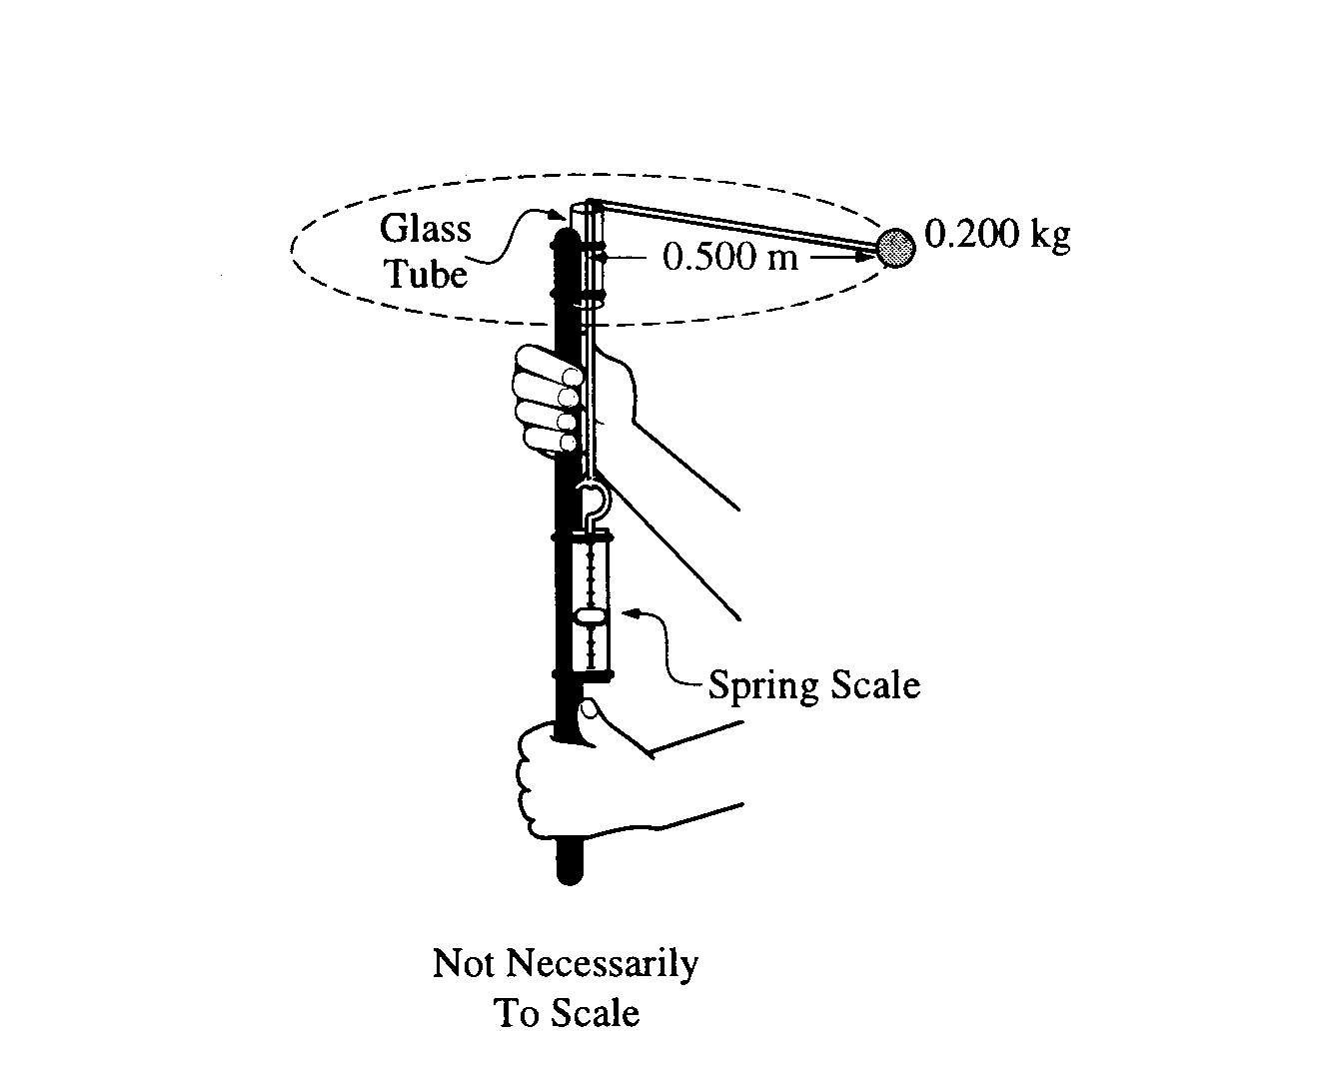  LAB: Centripetal force | 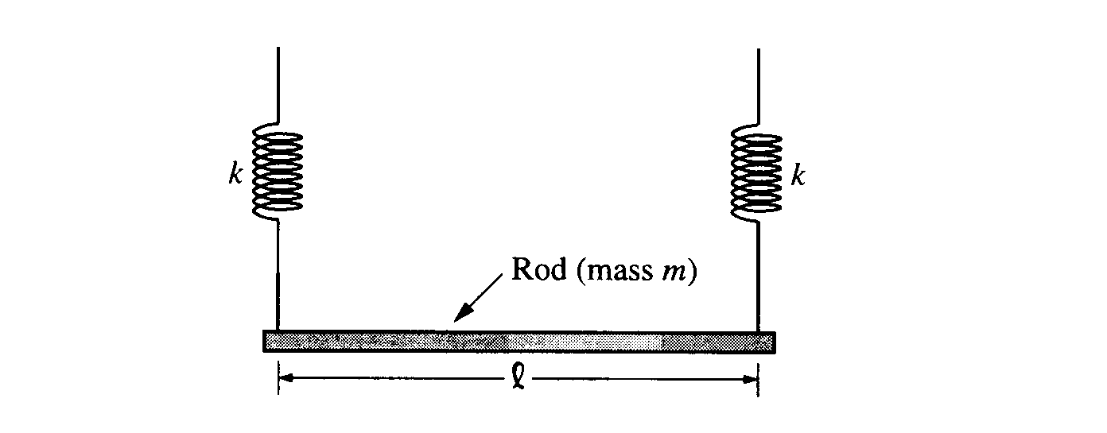  Spring, force on current in B field. | use resistors to heat water – draw circuit, do calculations | 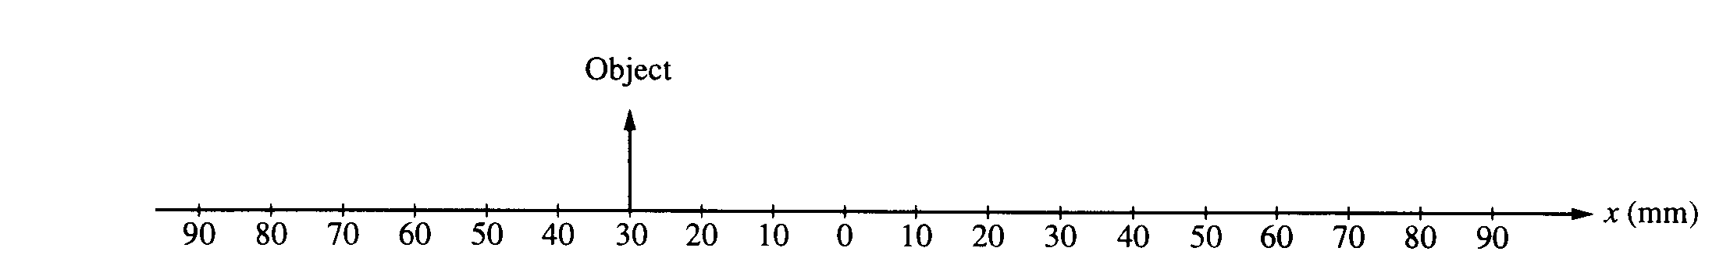  convex lens, concave mirror, draw and calculate | A – discuss experiment, pick from 3. | 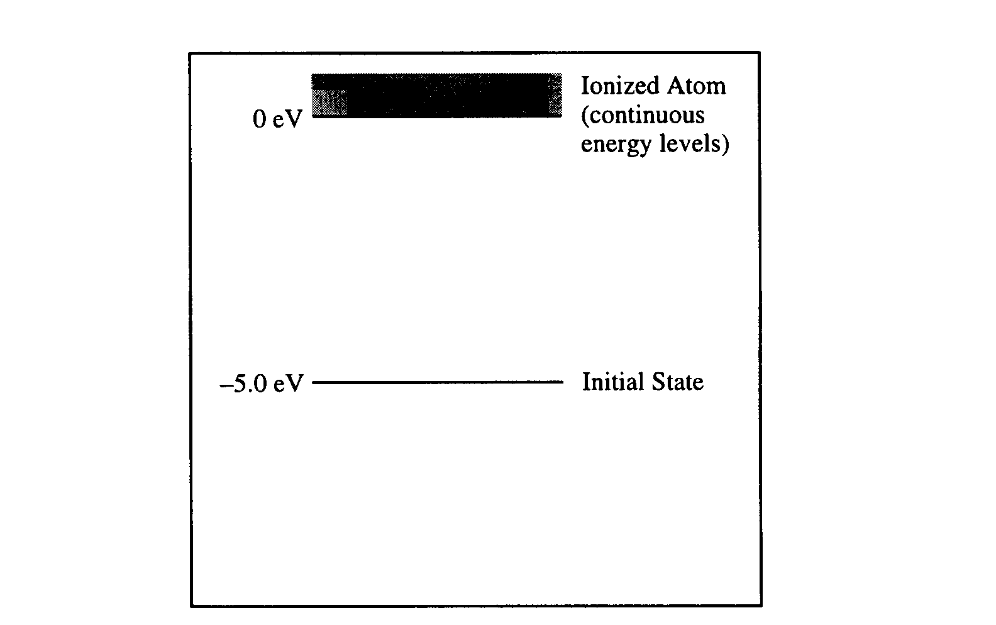  energy levels
1996 | Rubric | 1996 - elastic and inelastic collision on air track | LAB: Hooke’s law | Double slit interference | Hook up specific circuit. Ohm’s law | alpha decay, energies, momentum | Millikan experiment | gas in a can, moles
1995 | Rubric | 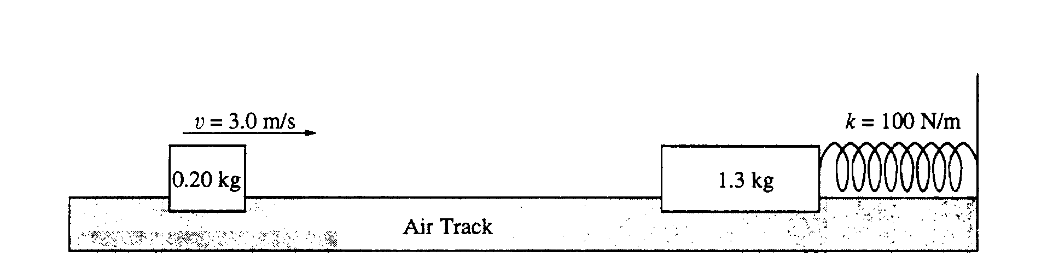  1995 – air track, inelastic collision, energy in spring | 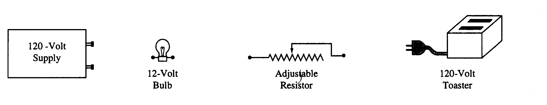  toaster circuit, hooking up. | 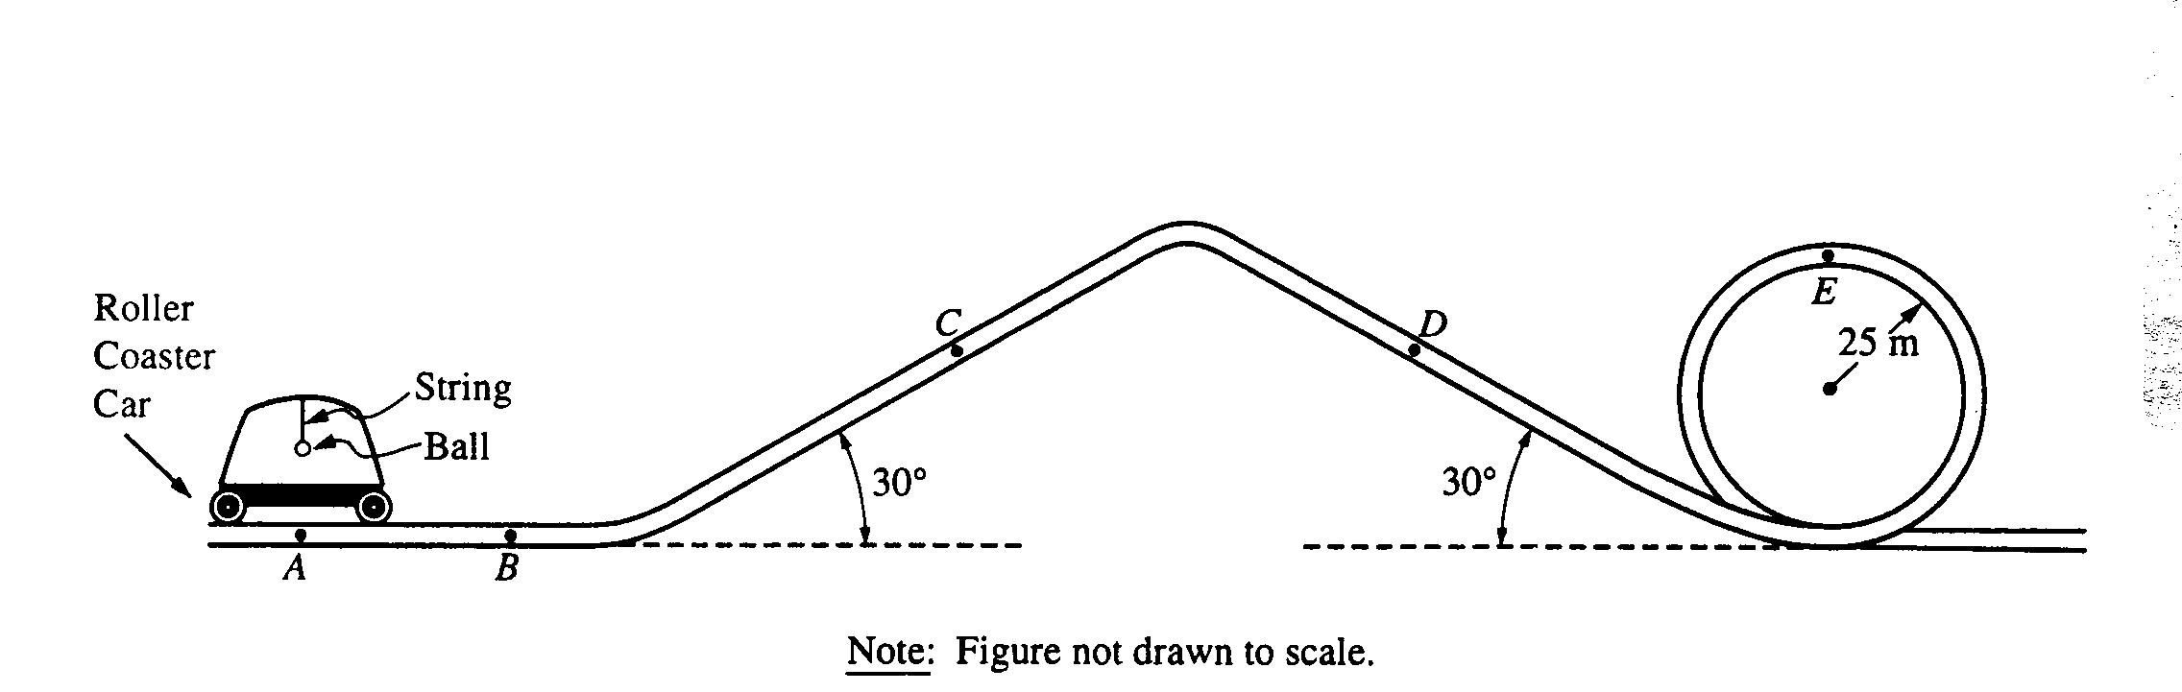  Acceleration on a roller coaster. | 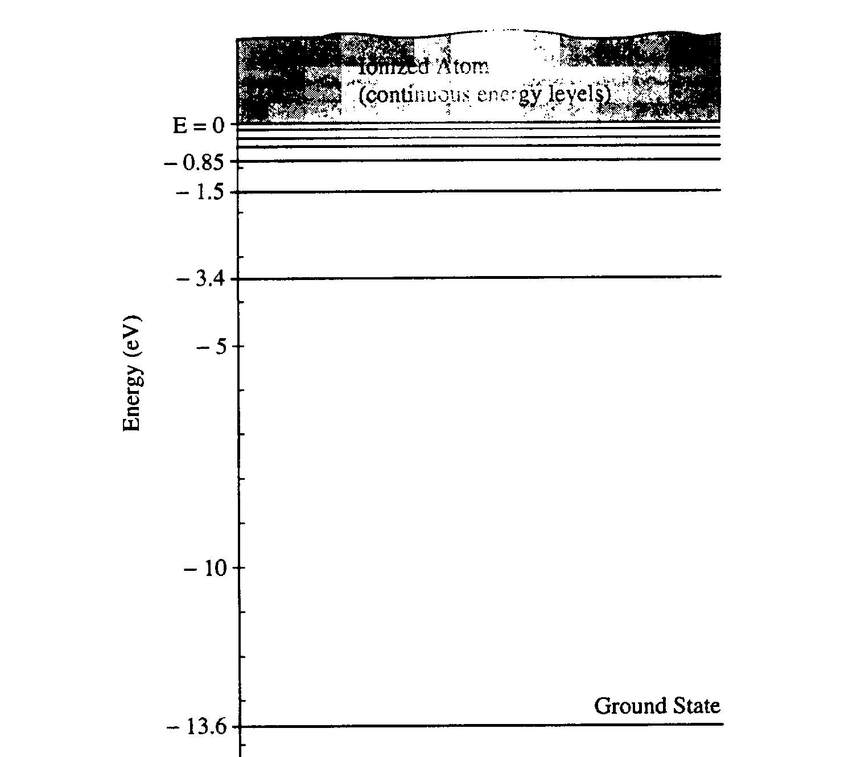  Energy level diagram, de Broglie | Heat engine, Carnot efficiency, power | 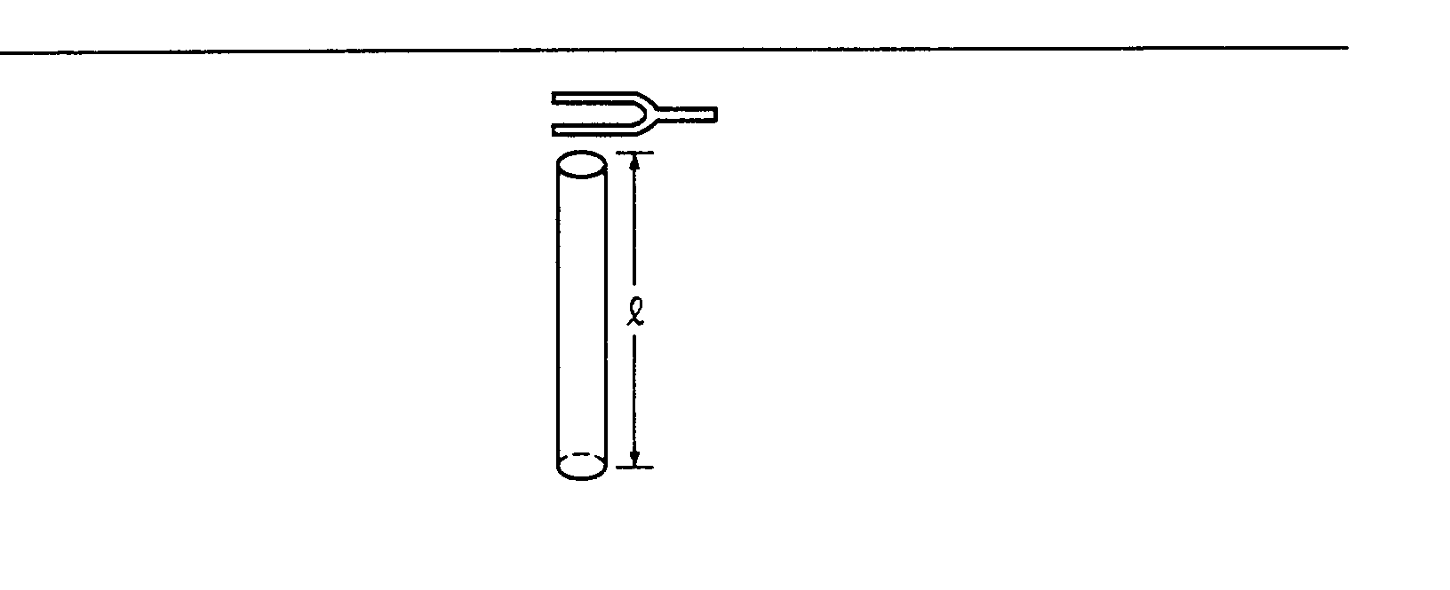  resonance in a tube. | 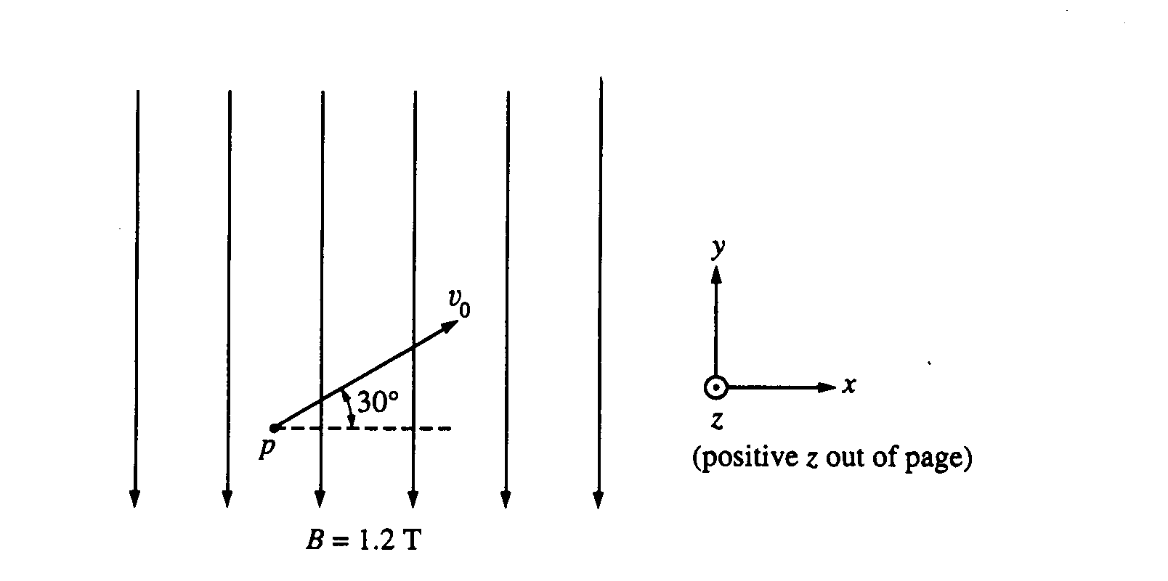  B force on electron.
1994 | Rubric | 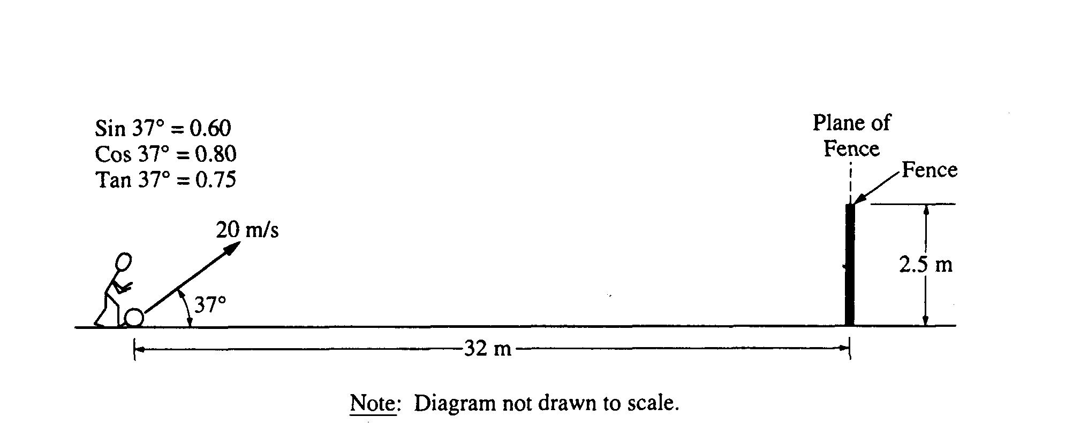  1994 - kick soccer ball over fence – proj. | 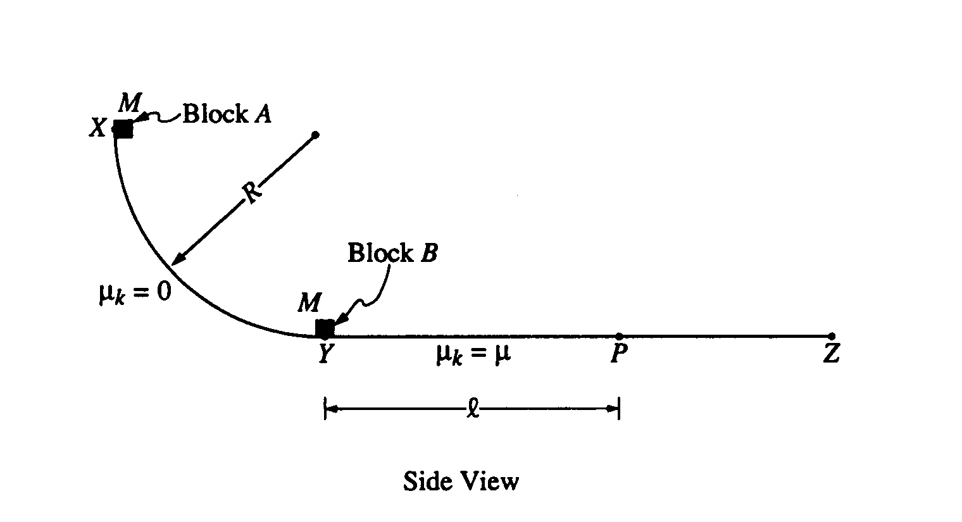  arc track, energy ideas, friction work | A: photoelectric effect graph;  B: relativistic motion. | 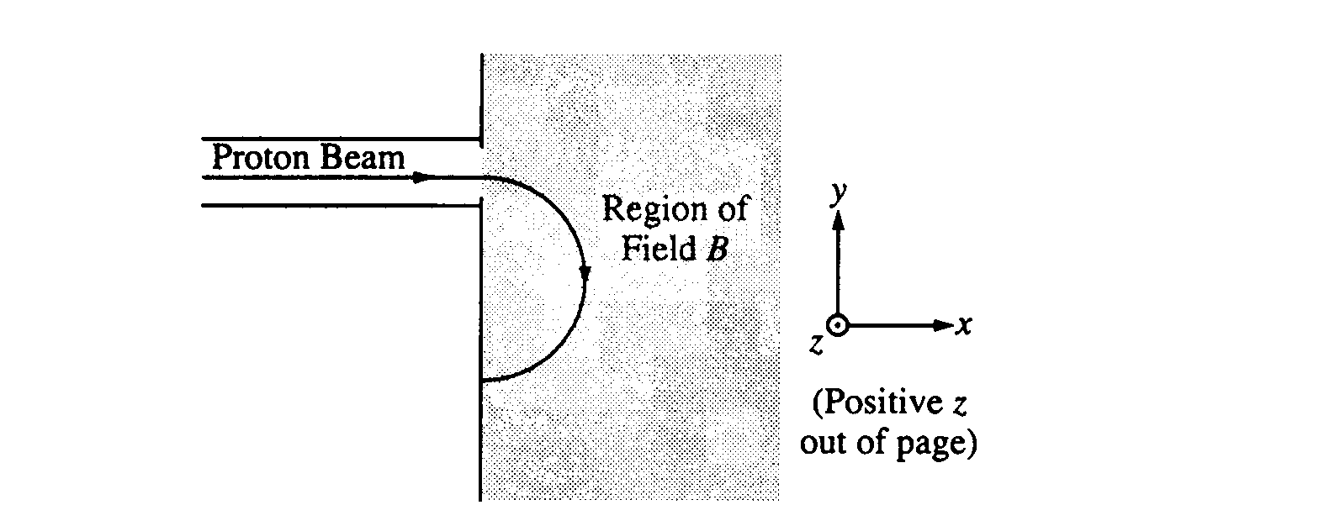  work to acc electrons, control by B field | 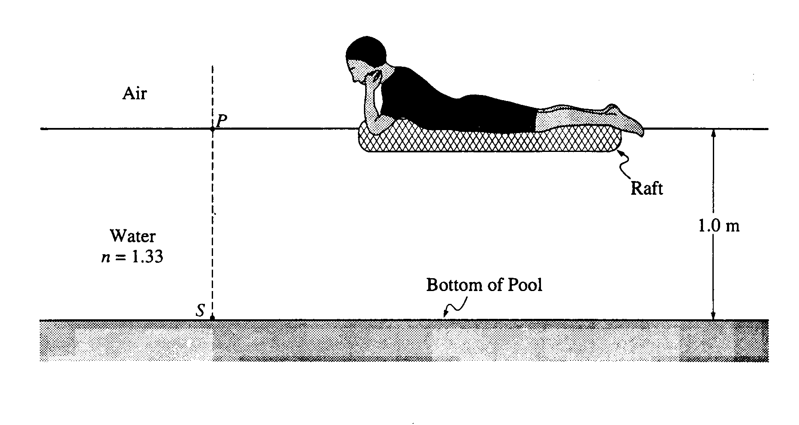  path of light in water, TIR, lens under water. | 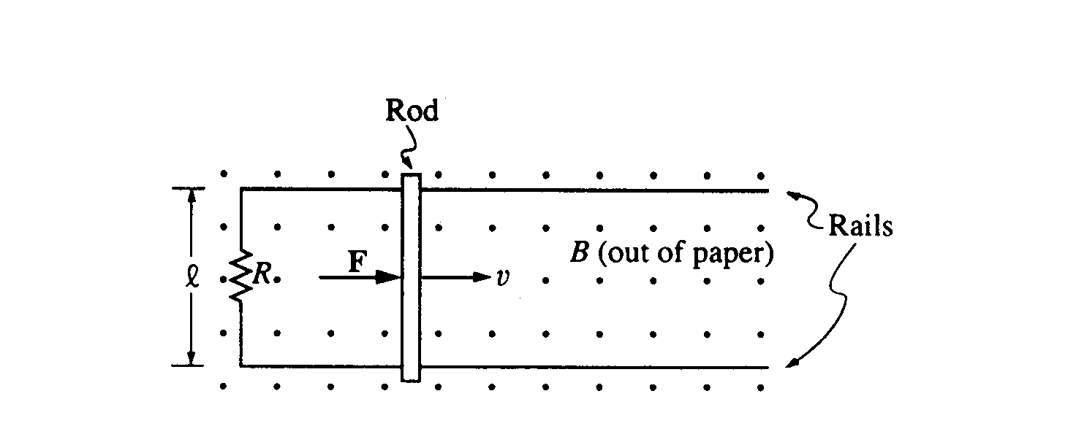  motional emf, induced E, Lenz’s Law
1993 | Rubric | 1993 – elevator, constructing d, v, a graphs for motion | 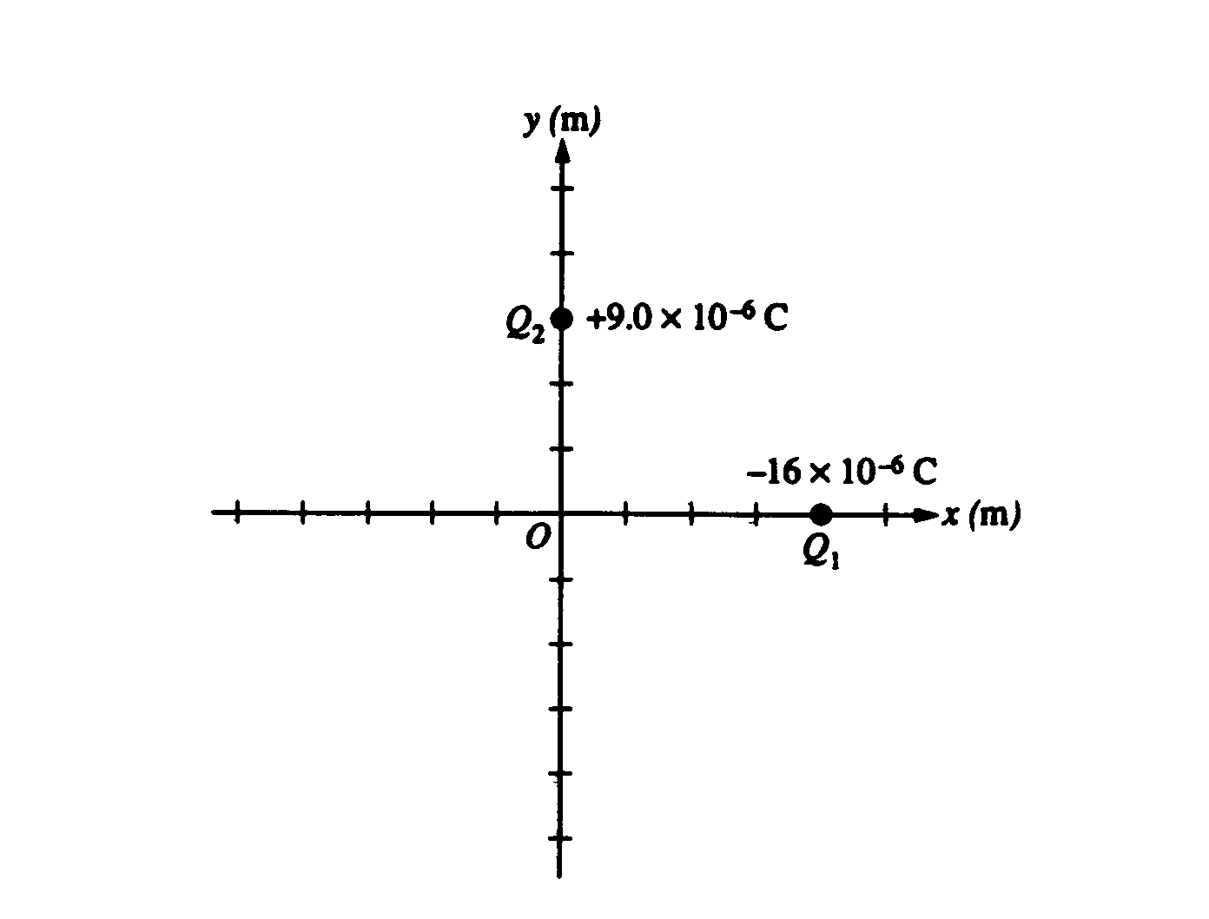  E fields & Potential of point charge | 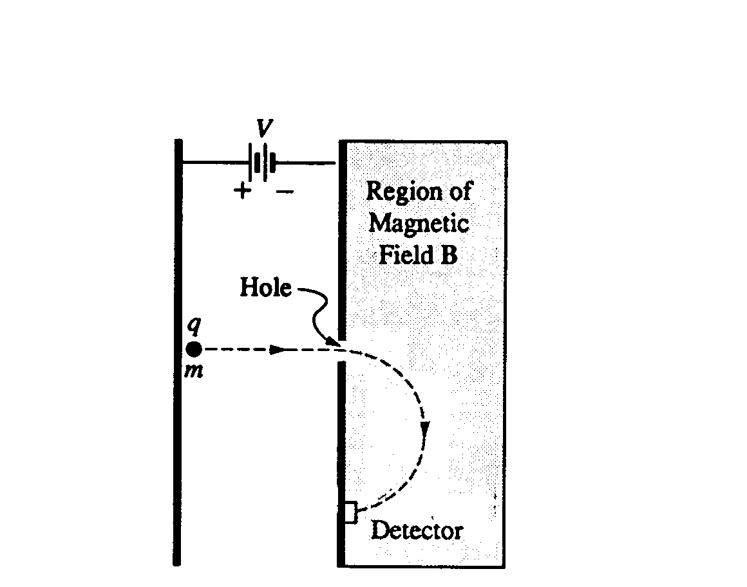  control chgd particle with B & E fields | 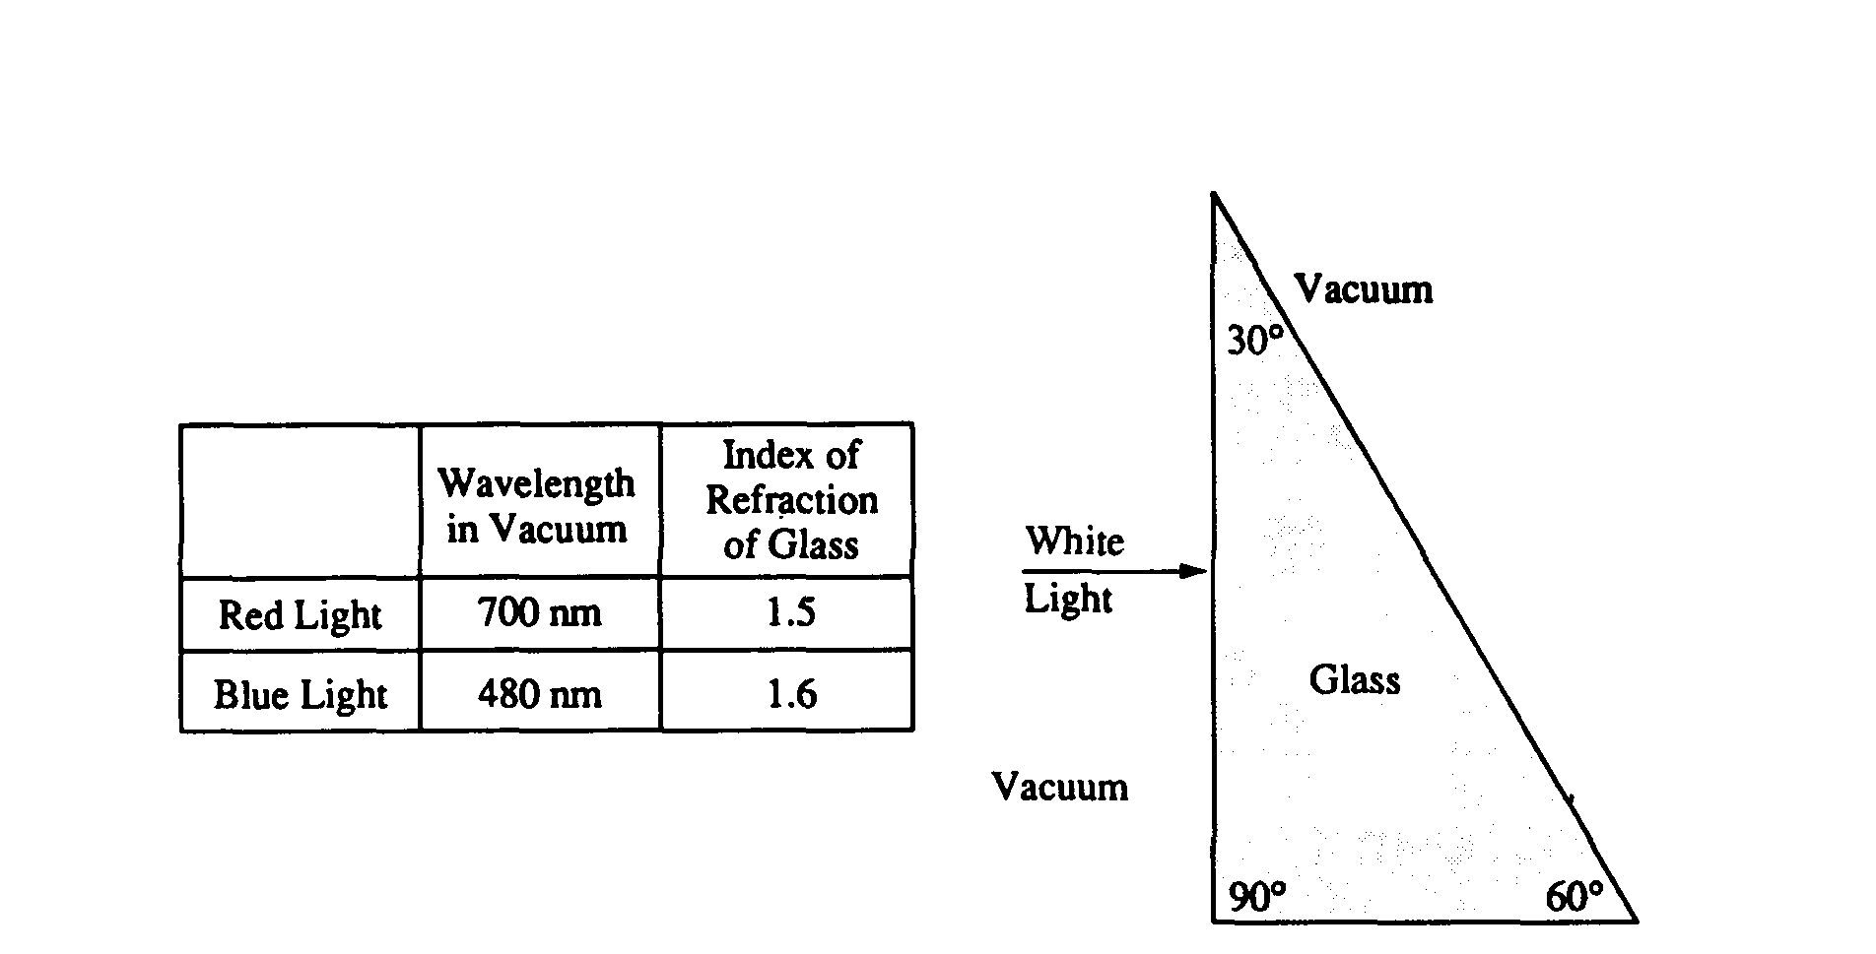  refraction in glass and λ dependence | 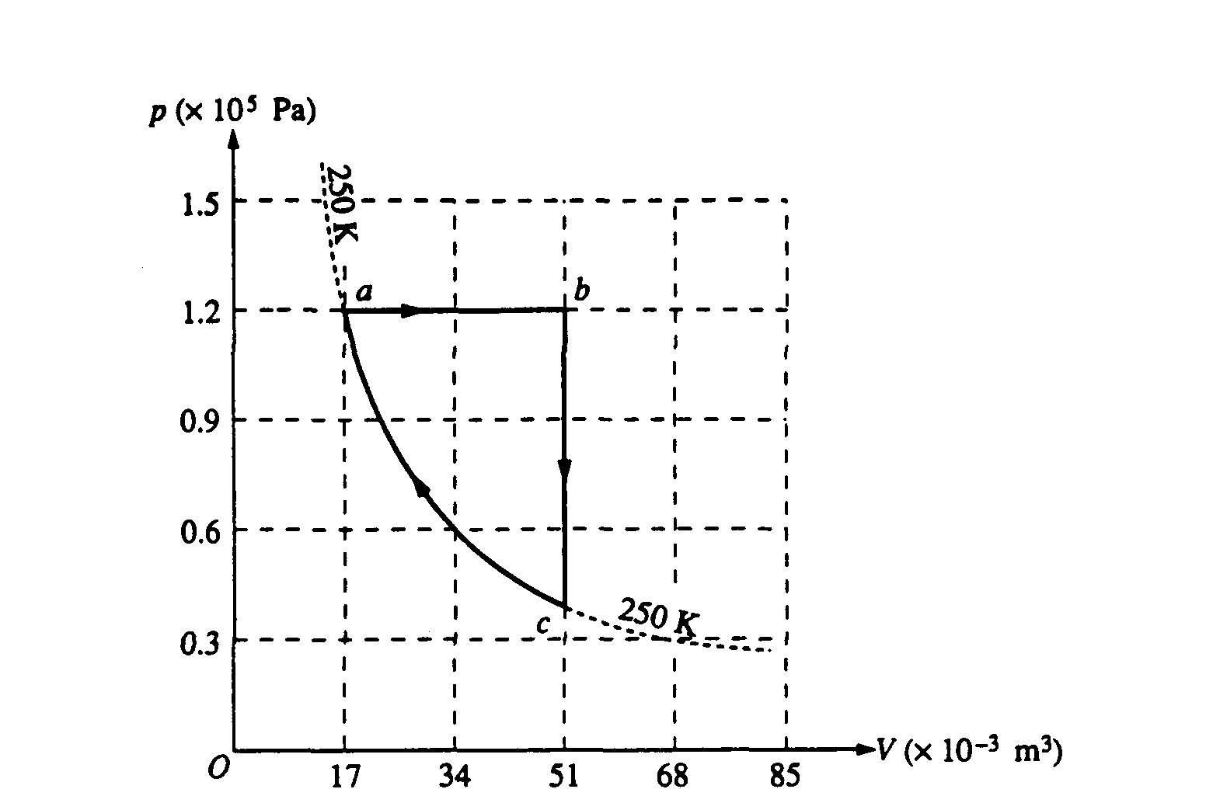  gas process, work and heat in cycle (mistake) | 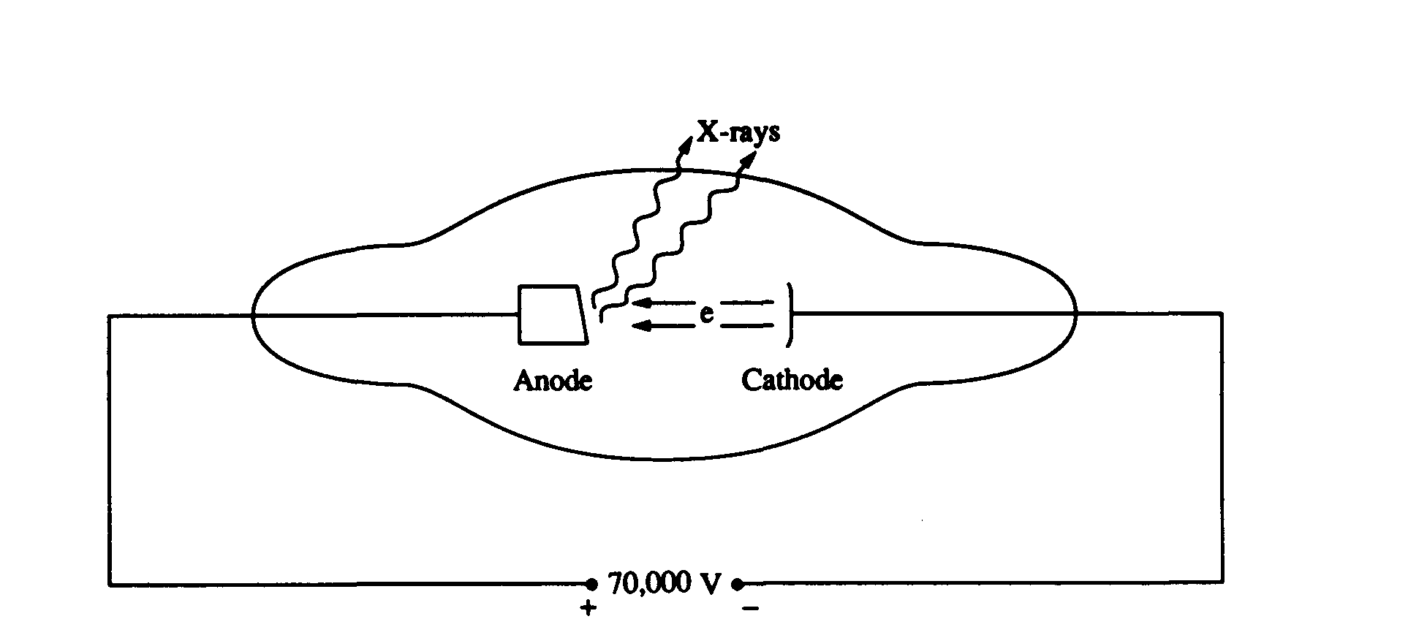  X ray tube, Compton scattering
1992 | Rubric | 1992 – vertical circle, tension, centripetal motion | conservation of momentum, energy, during collision and separation. | elec power, fusion, heat flow | Energy level diagram, transitions | CRT, E, B, field on electron | convex lens, concave mirror, diagram & calc’s
1991 | Rubric | 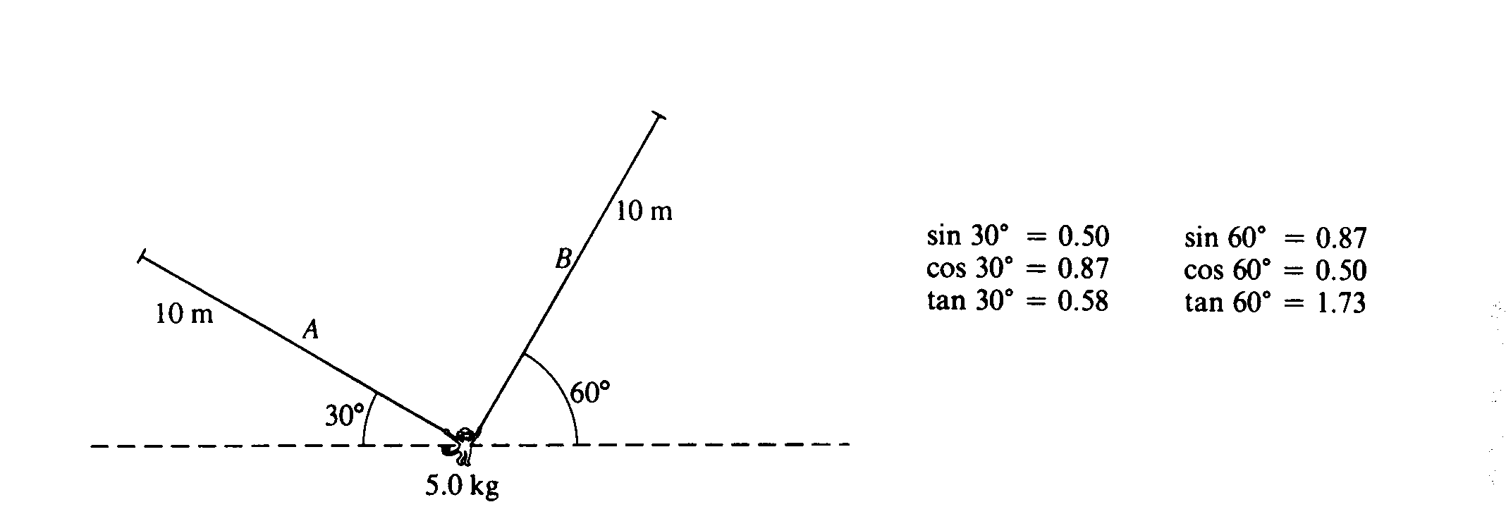  1991 – monkey static equilibrium, centripetal accel | 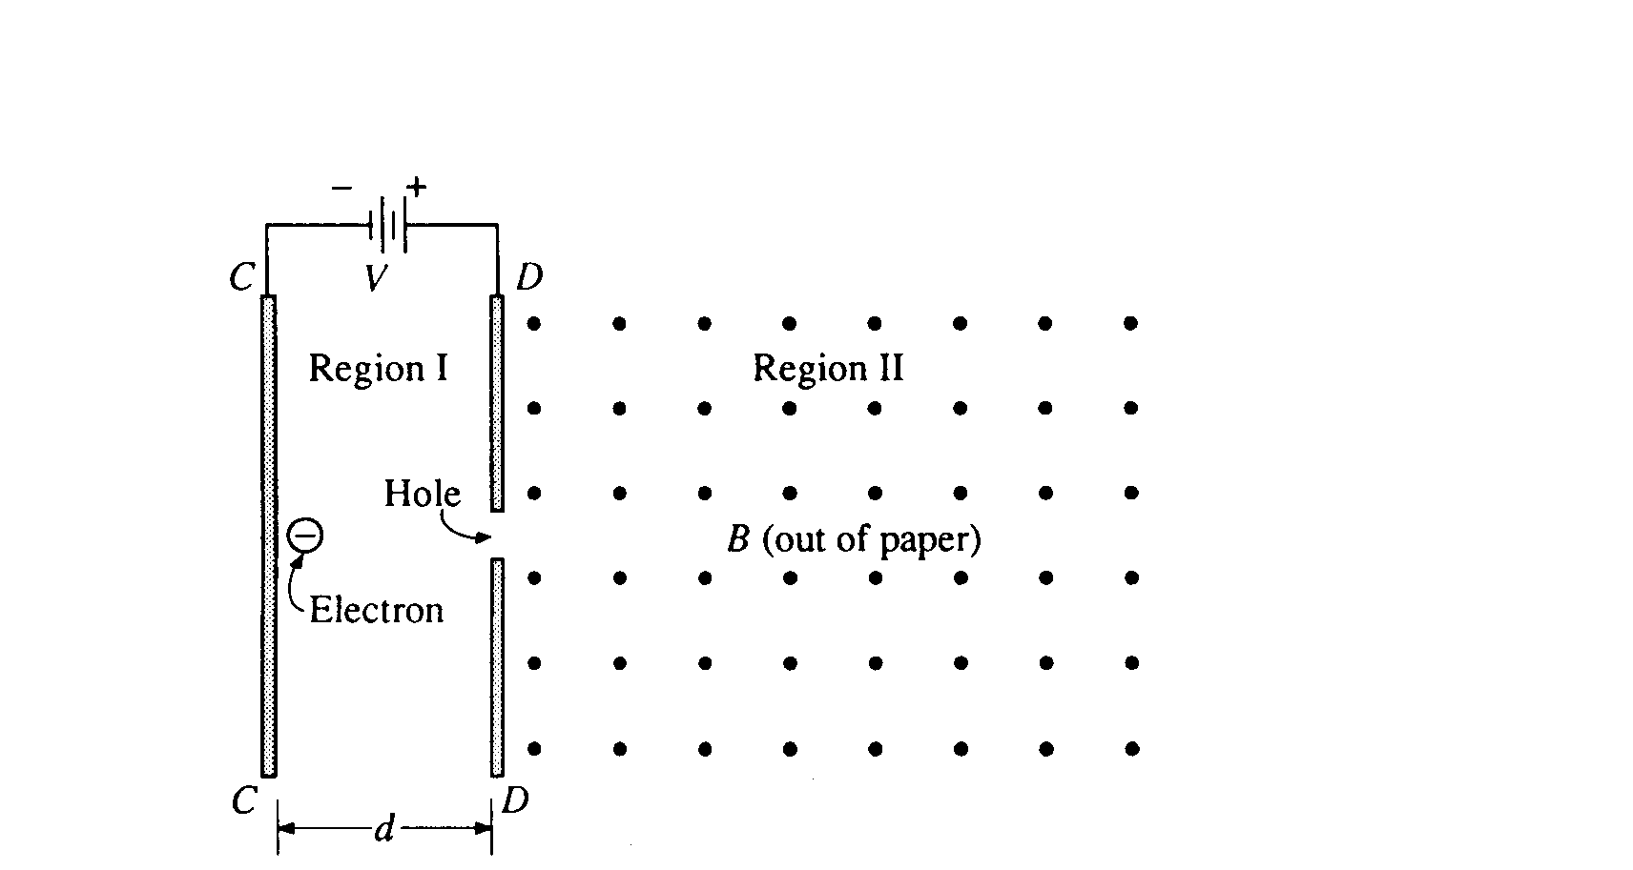  control of charge with E & B fields. | Heat engine, eff, heat absorption by water. | 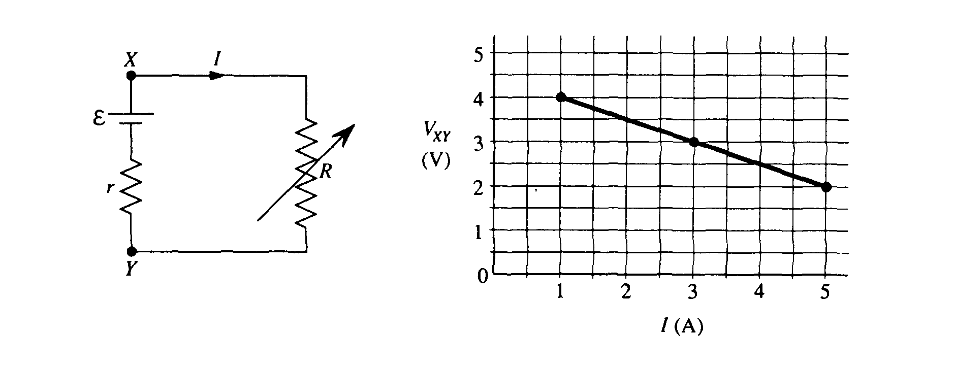  battery, get intern resistance, ohm’s law, draw circuit | Nuclear alpha decay, equation, de Broglie λ, energy, Rutherford scattering | 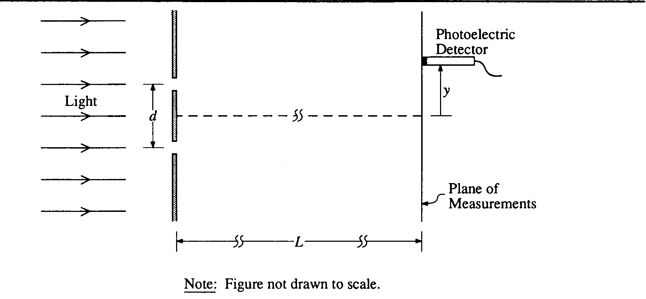  2 slit interference, photoelectric work function
1990 | Rubric | 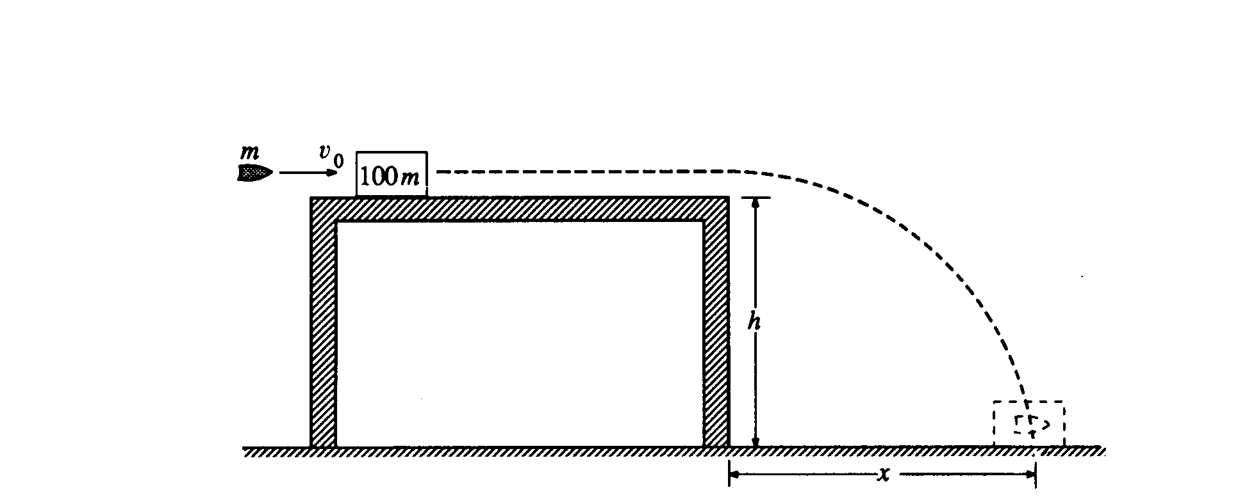  1990 - inelastic collision projectile | 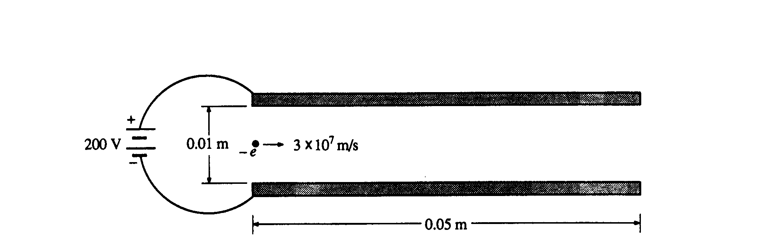  chg particle doing projectile path betw charged plates | 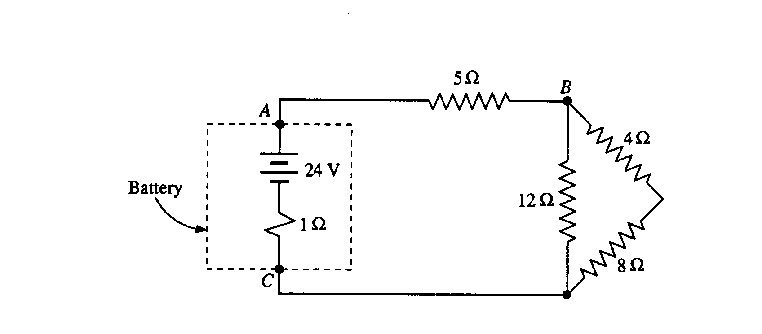  ohm’s law, power | 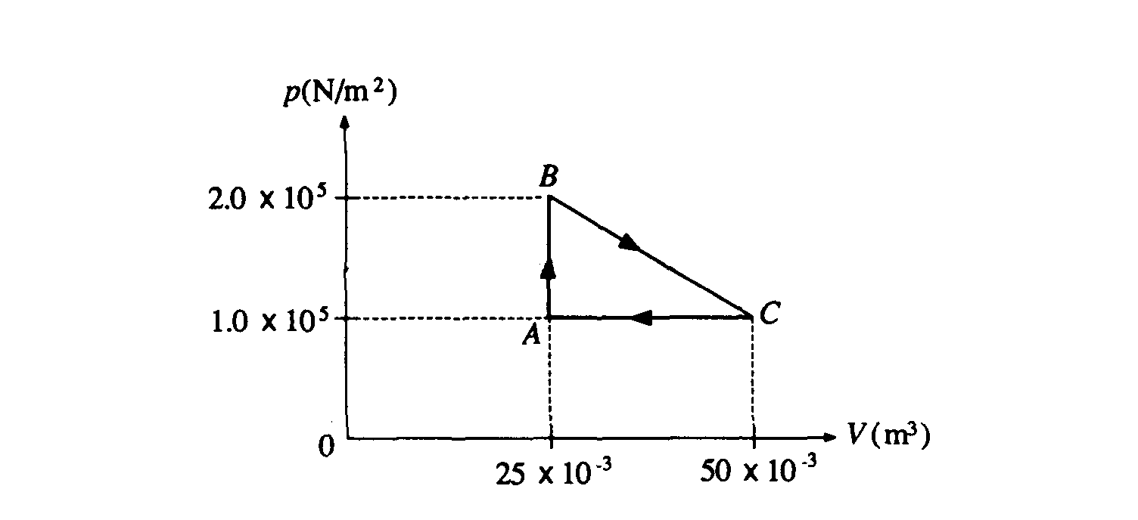  gas cycle, work done, efficiency | accelerated elect. Resulting e-m waves, energy | 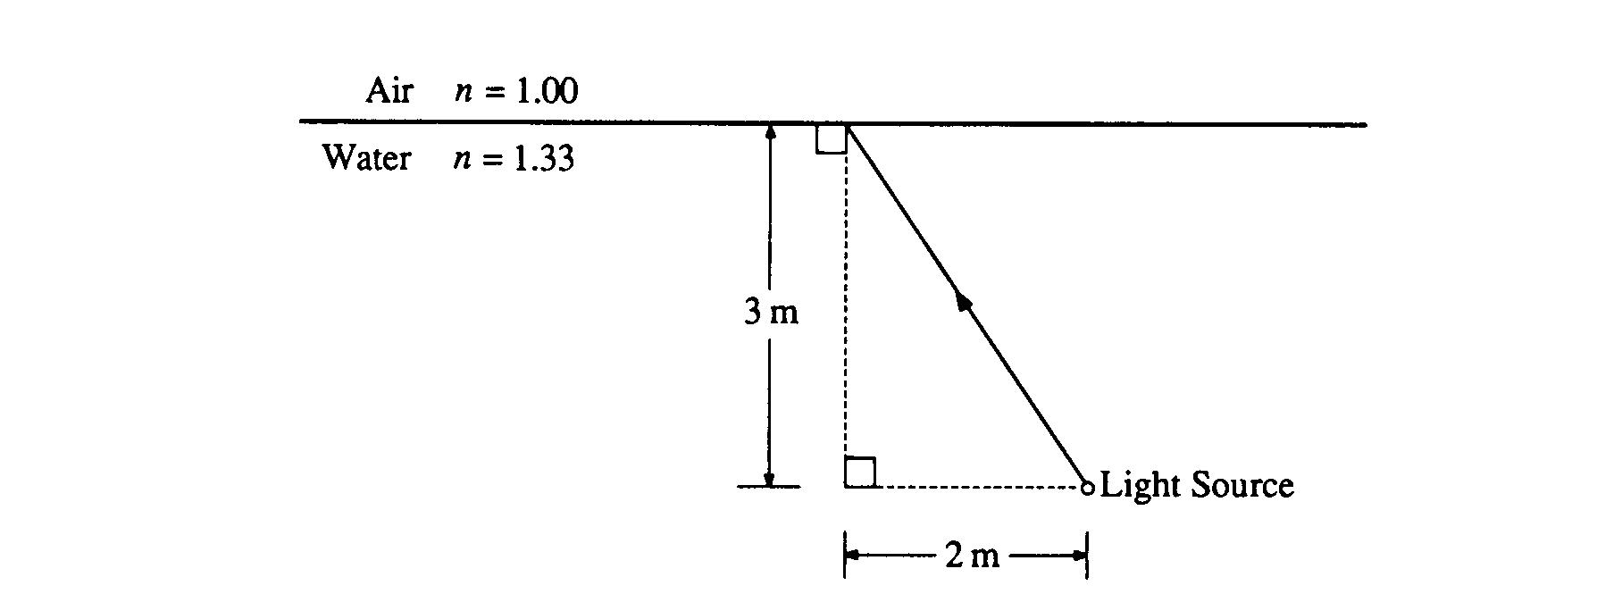  reflection, refraction, thin film interference.
1989 | Rubric | 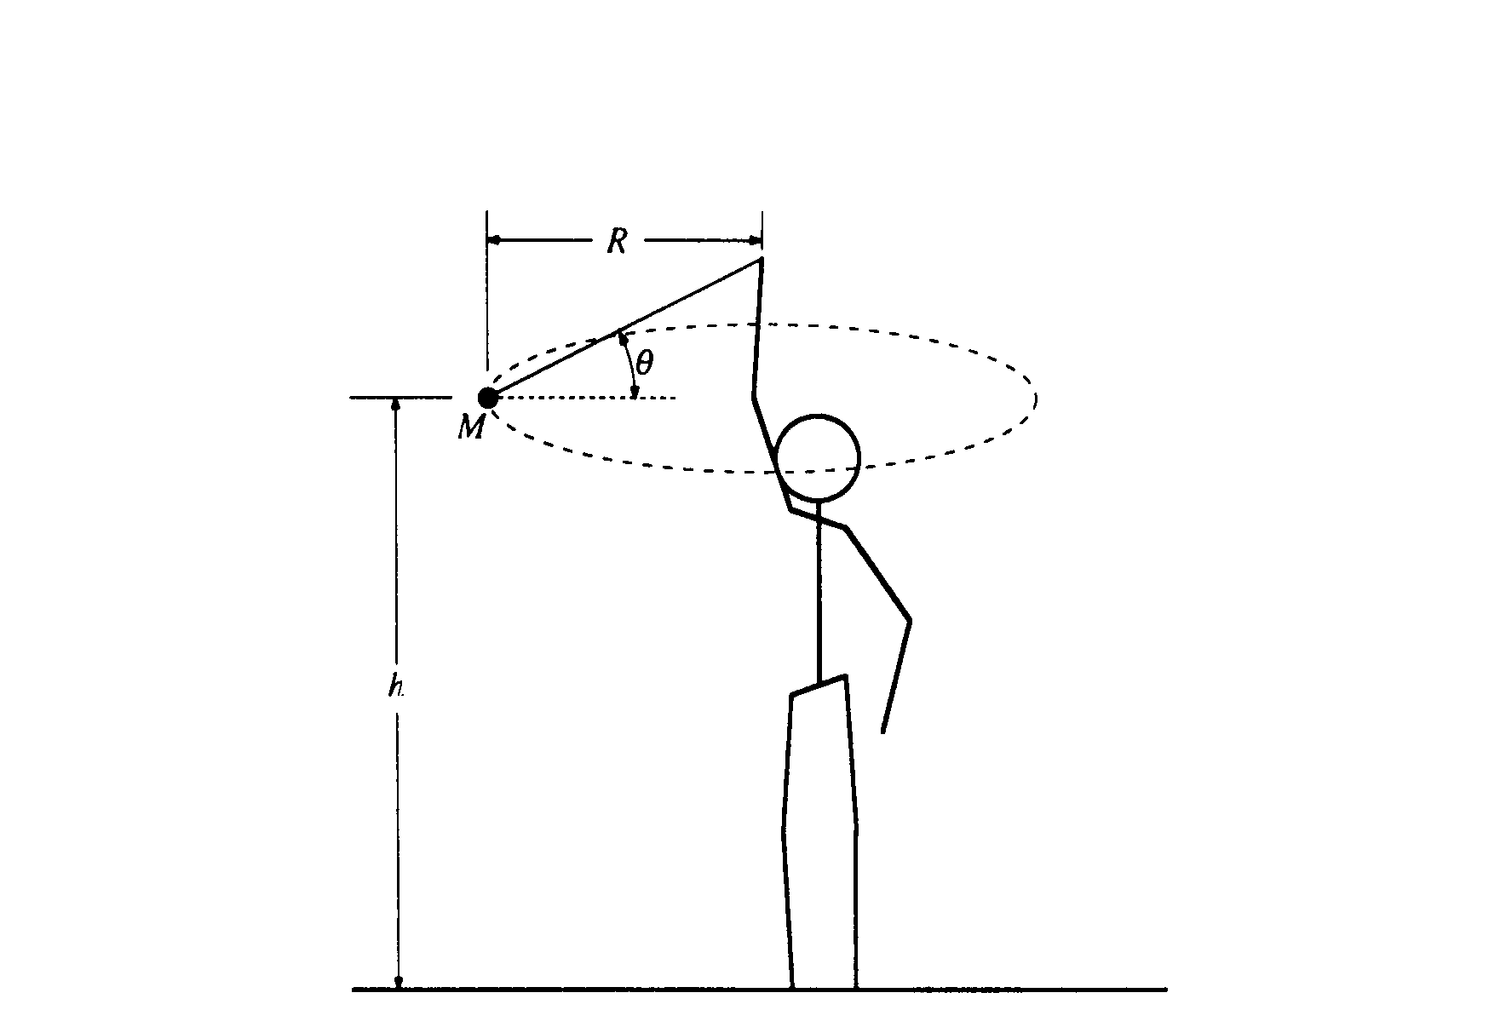  1989 -Centripetal motion, projectile. | 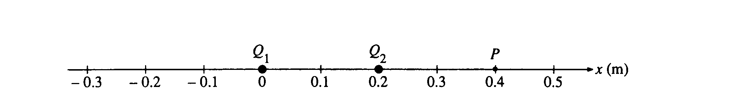  electric force, potential, work | 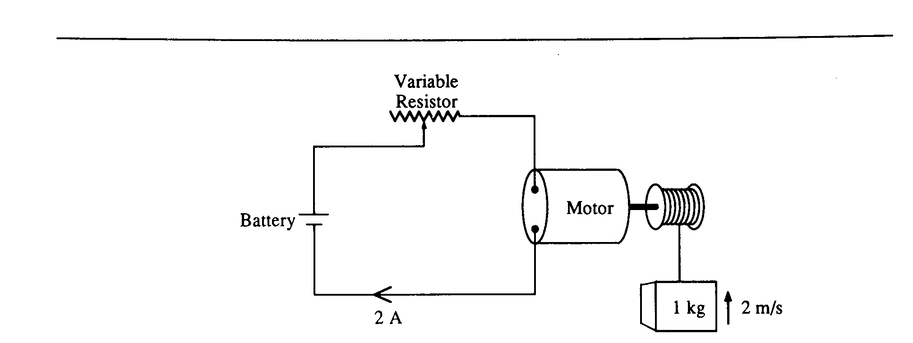  electrical – mechanical energy equivalence, Ohm | Thermo – PV diagram, work done in various processes | Nuclear decay, energy, rest mass. | 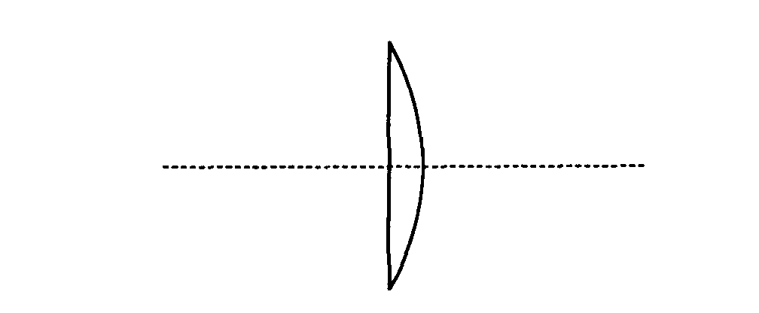  convex lens, image formation, graph di vs do
1988 | Rubric | 1988 - helicopter vertical acceleration, tension, kinematics | ball bounce, energy lost, specific heat. | 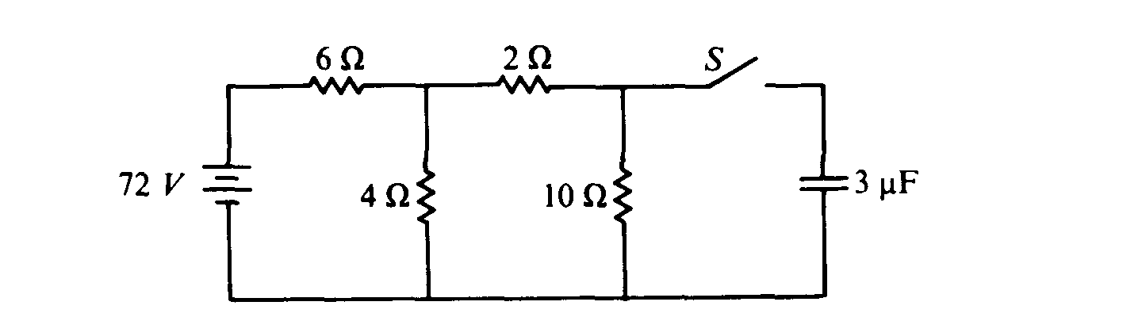  RC circuit, beginning & end | 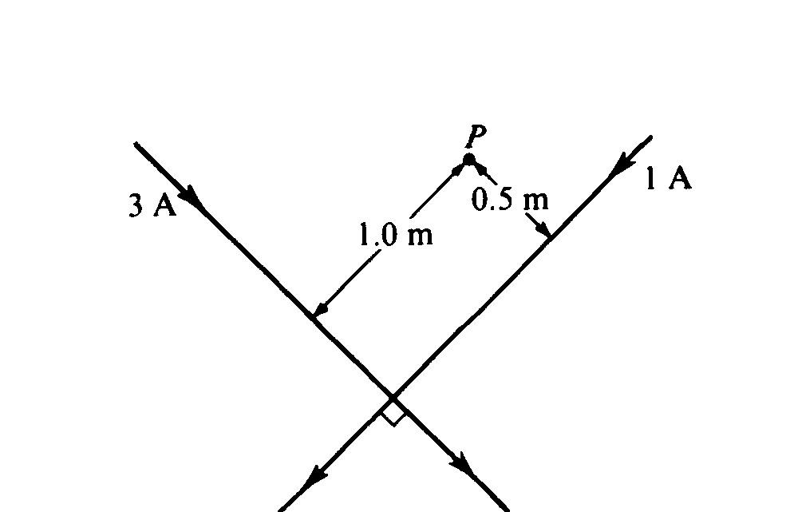  B field of wire, force on moving charged particle | 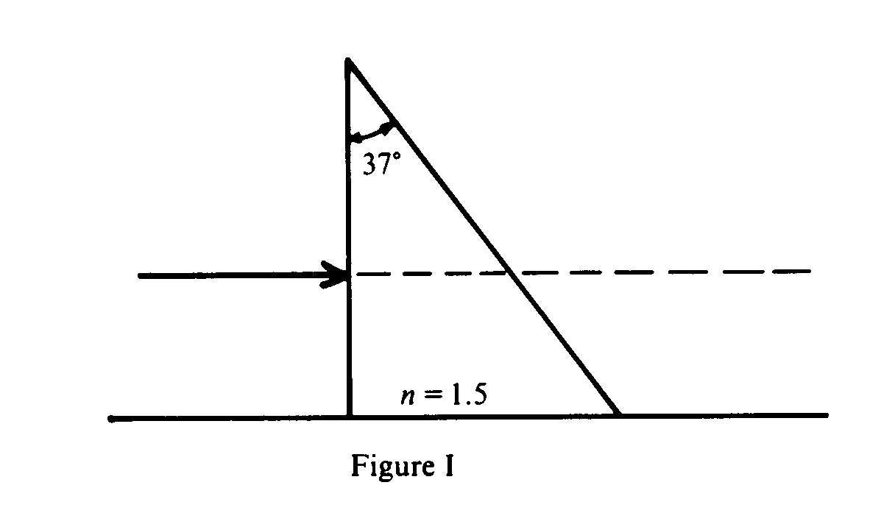  refraction, crit angle, new medium | 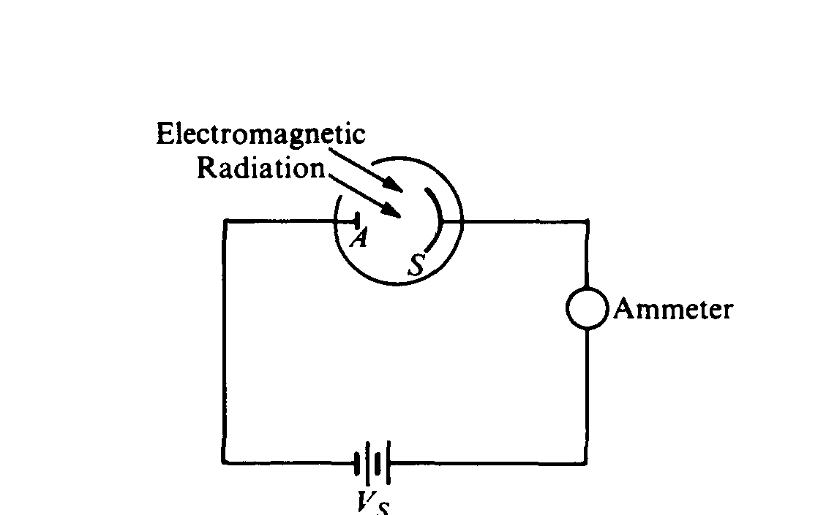  Photoelectric effect, calculations
1987 | Rubric | 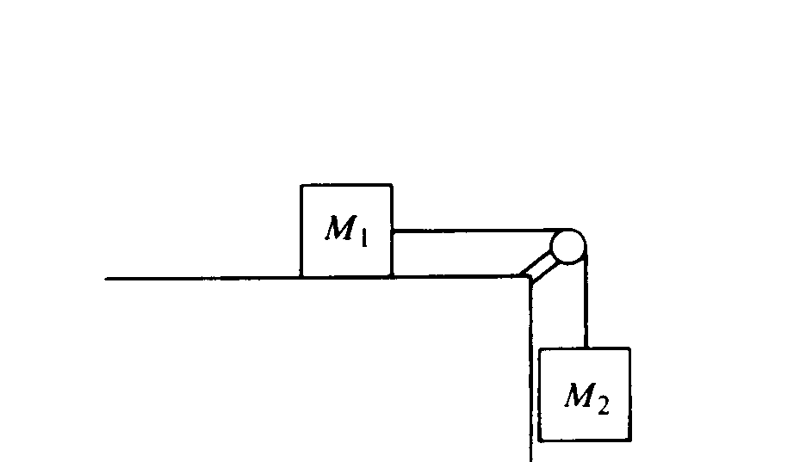  Modified Atwood’s machine | 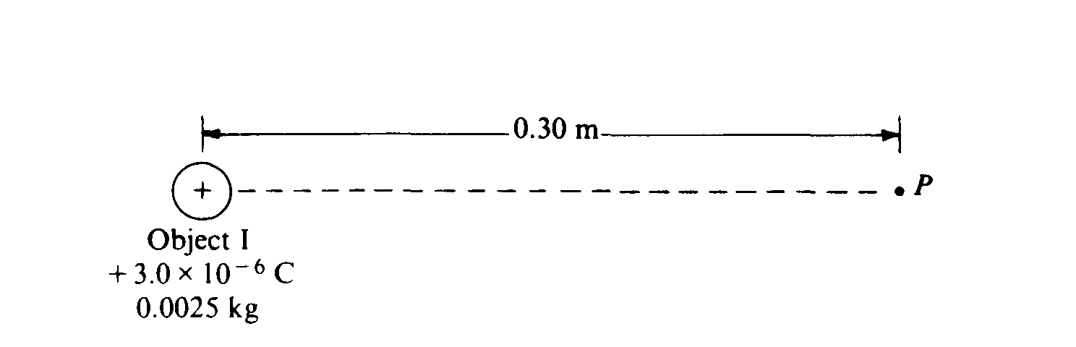  forces, field, potential of point charges. | Heat movement, specific heat | 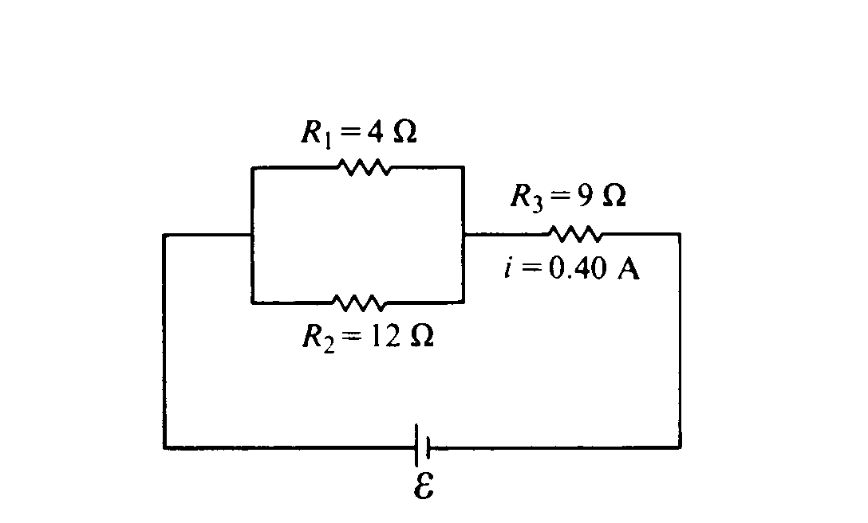  Ohm’s law, Q=It | 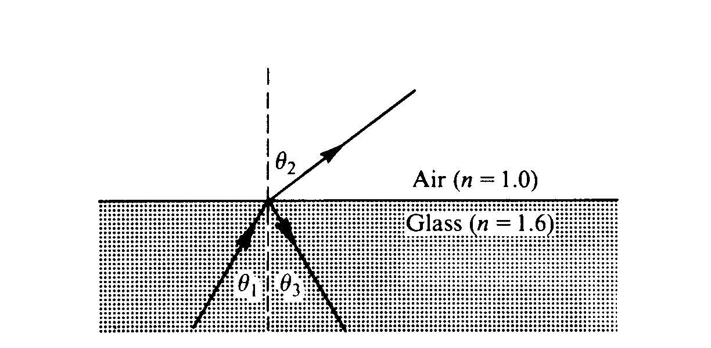  refraction, speed, critical angle | 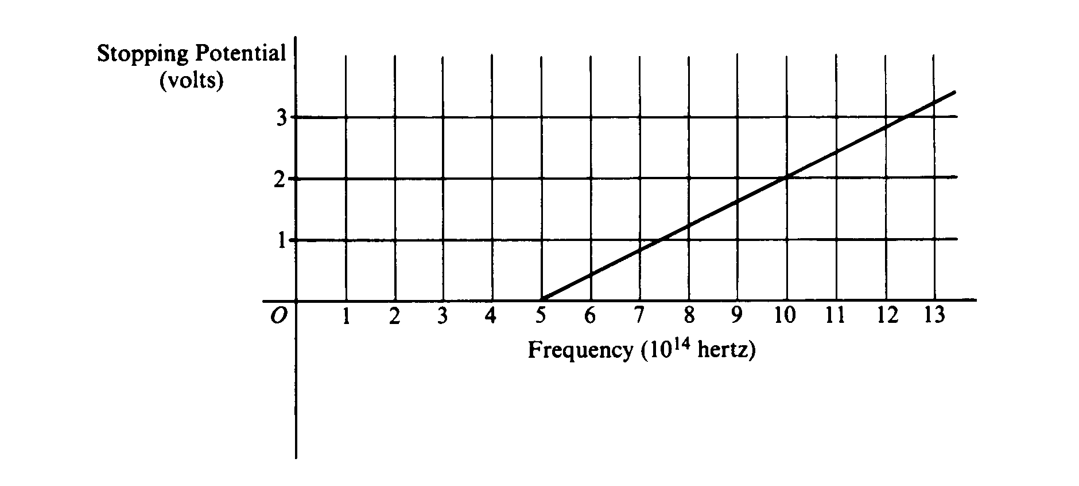  Photoelectric effect, graphical calc
1986 | Rubric | 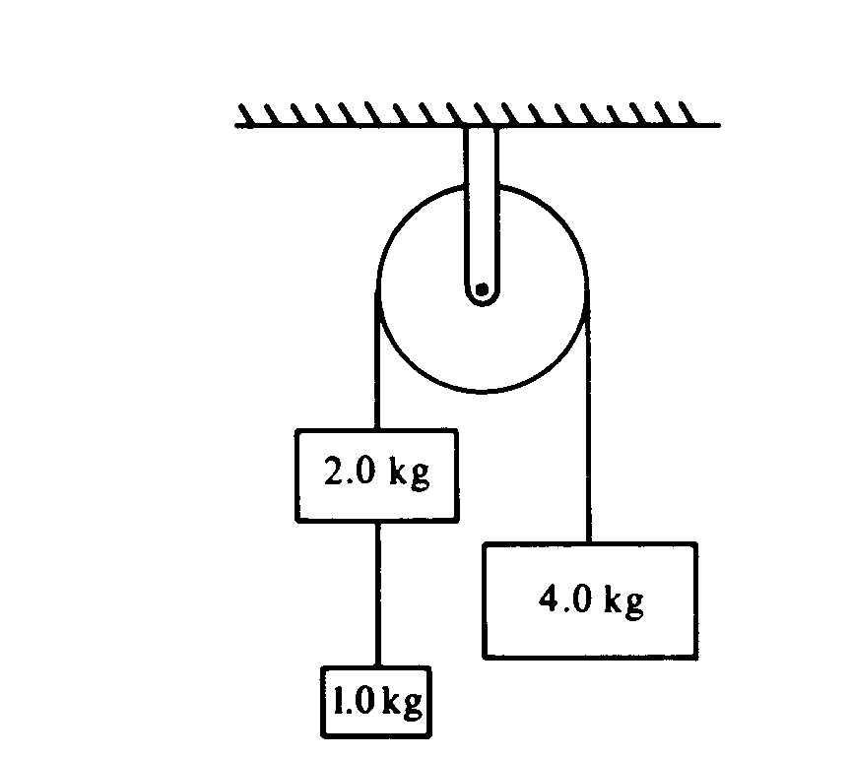  1986 - Atwood’s mach, tension, acceleration | 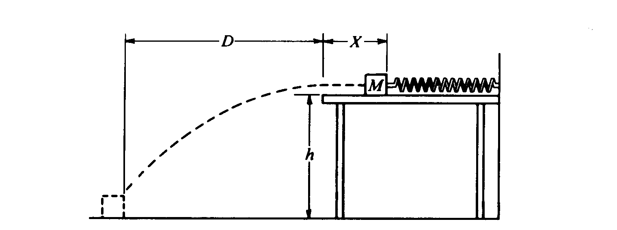  Energy in spring, projectiles | 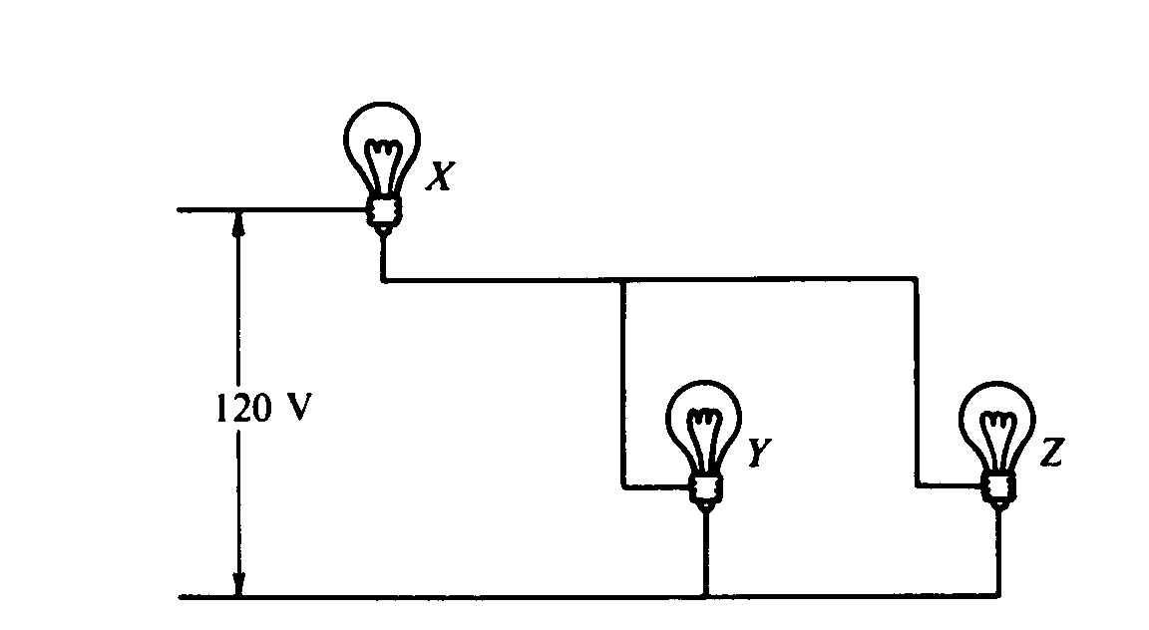  Circuits, ohm’s law | 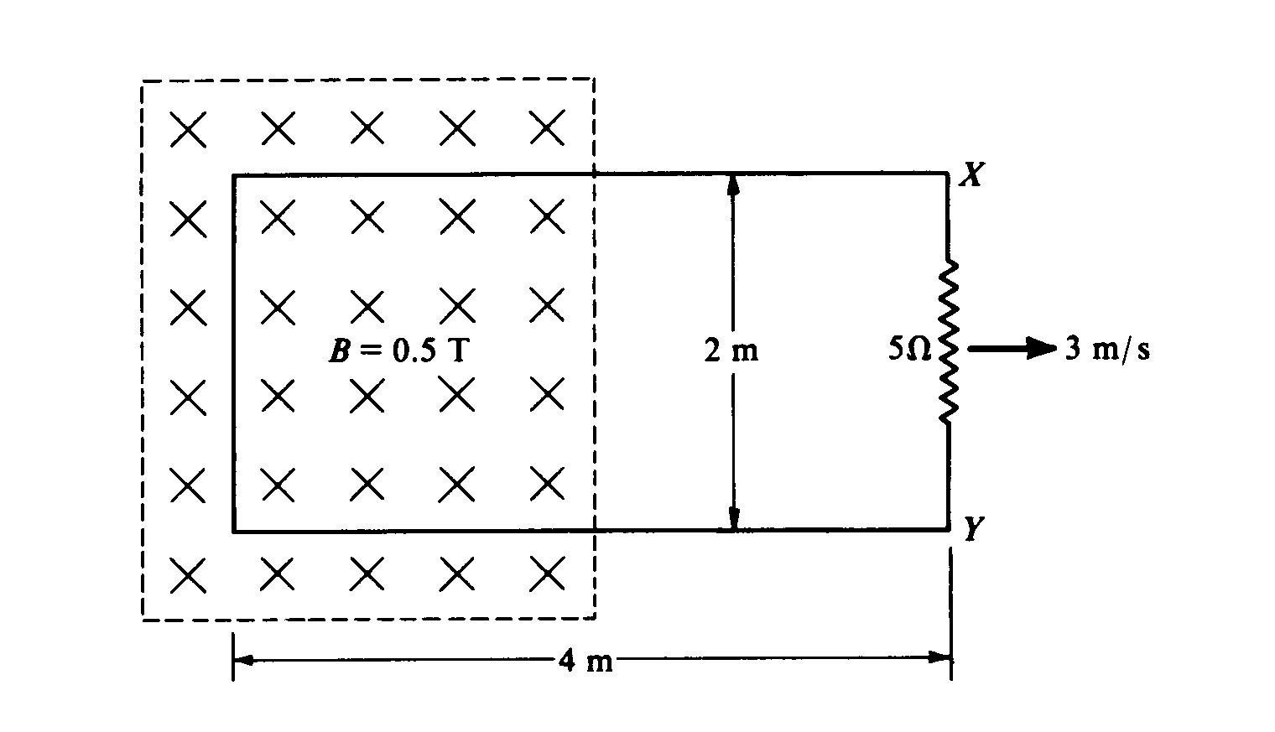  Induction, forces on wire in B field | 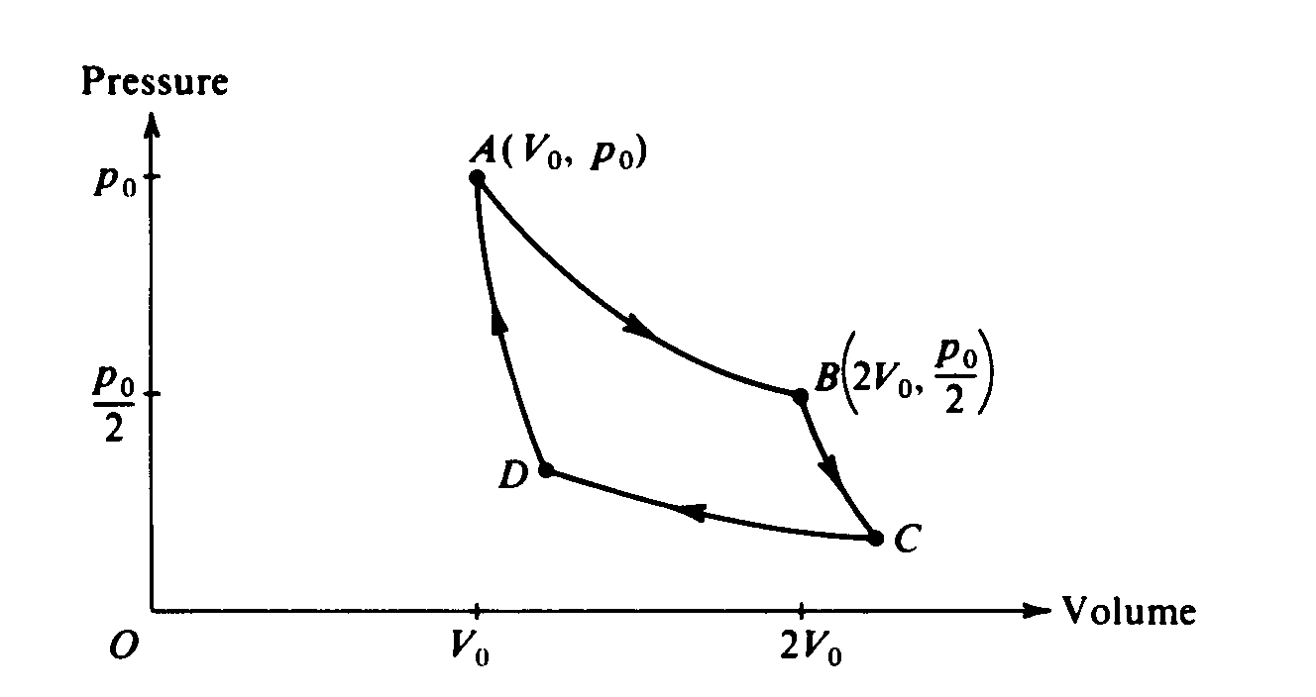  Carnot cycle, PV diagram | Concave and convex lenses – diagrams and calculations.
1985 | Rubric | 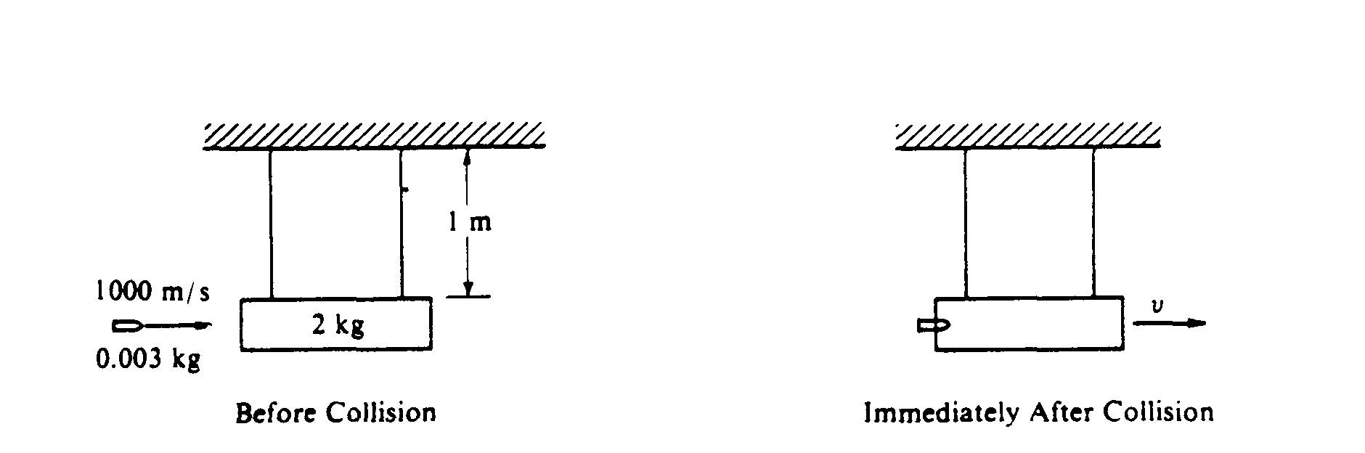  1985 – ballistic pendulum | 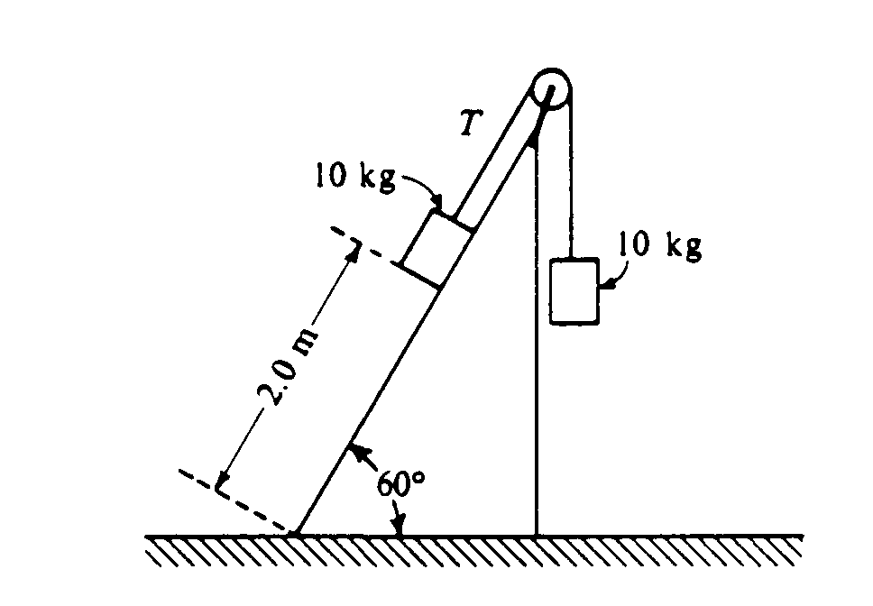  static equilibrium, acceleration on incline, energy conv | 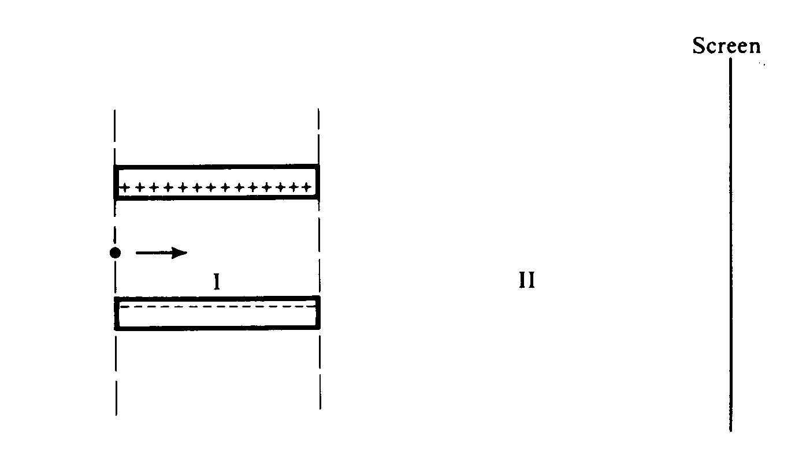  e field, work, energy, forces | 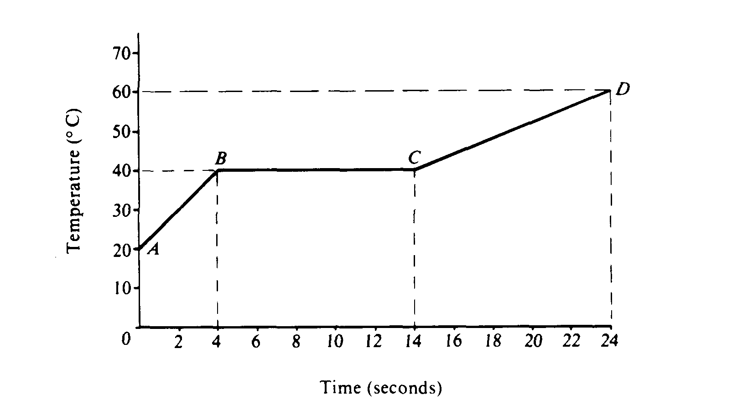  Specific heat, flow, phase change. | double slit interference in air and water. | 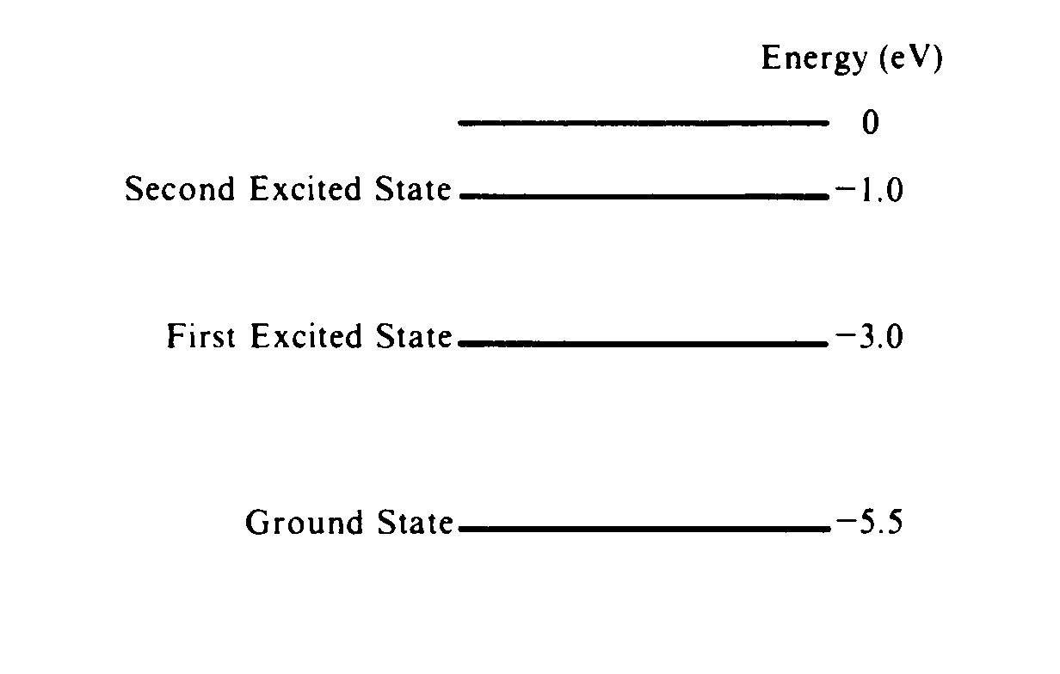  energy level transitions, photons
1984 | Rubric | 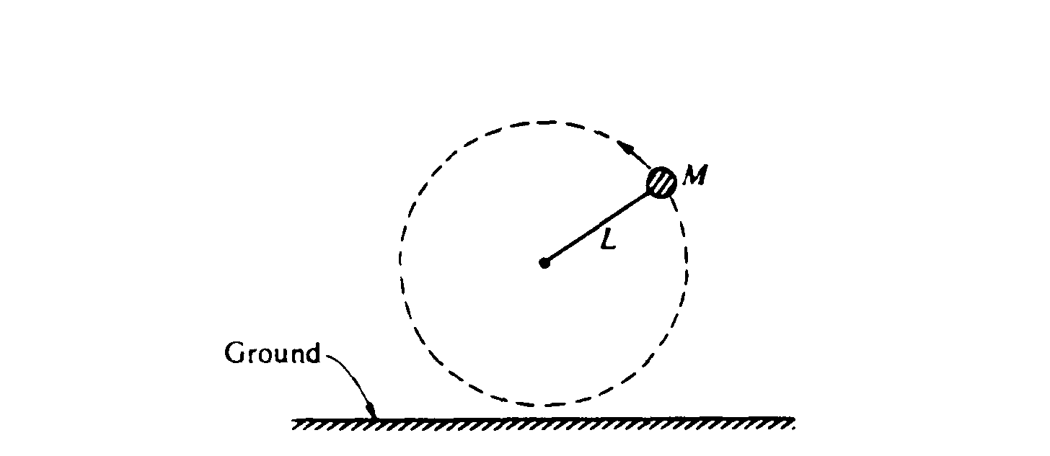  1984 - vertical circle, projectile | 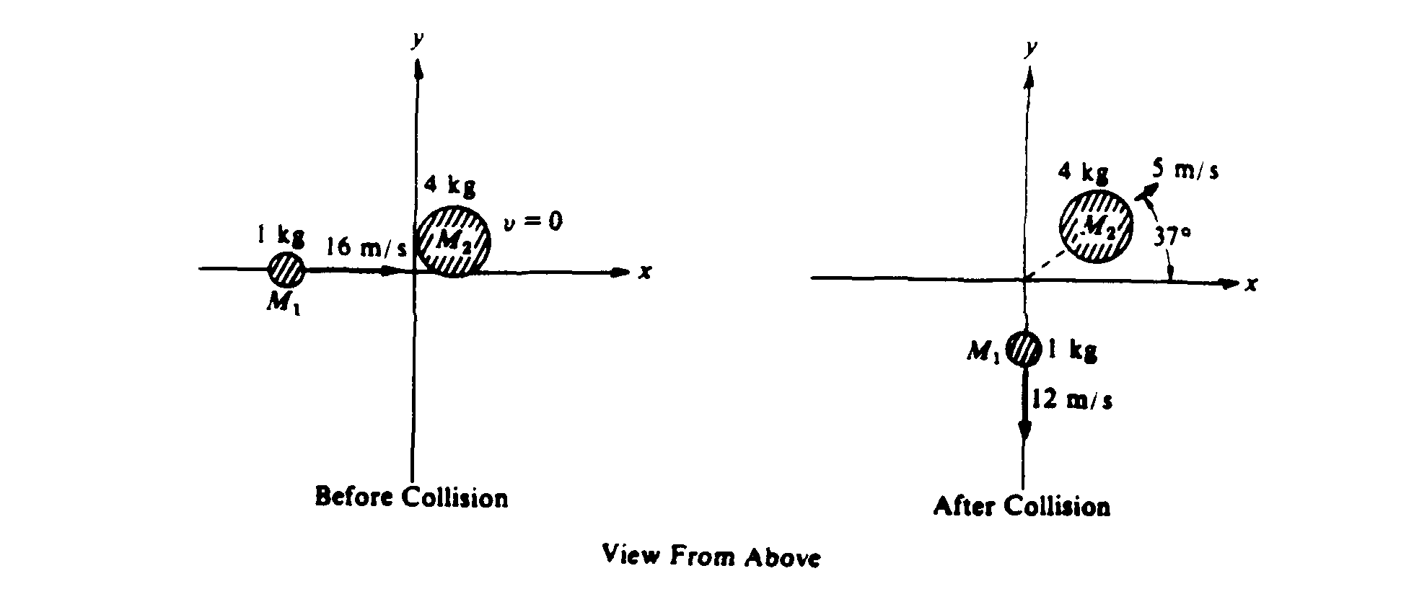  momentum cons, elastic coll. angles | heating water, change of state, time, ohm’s law, power. | 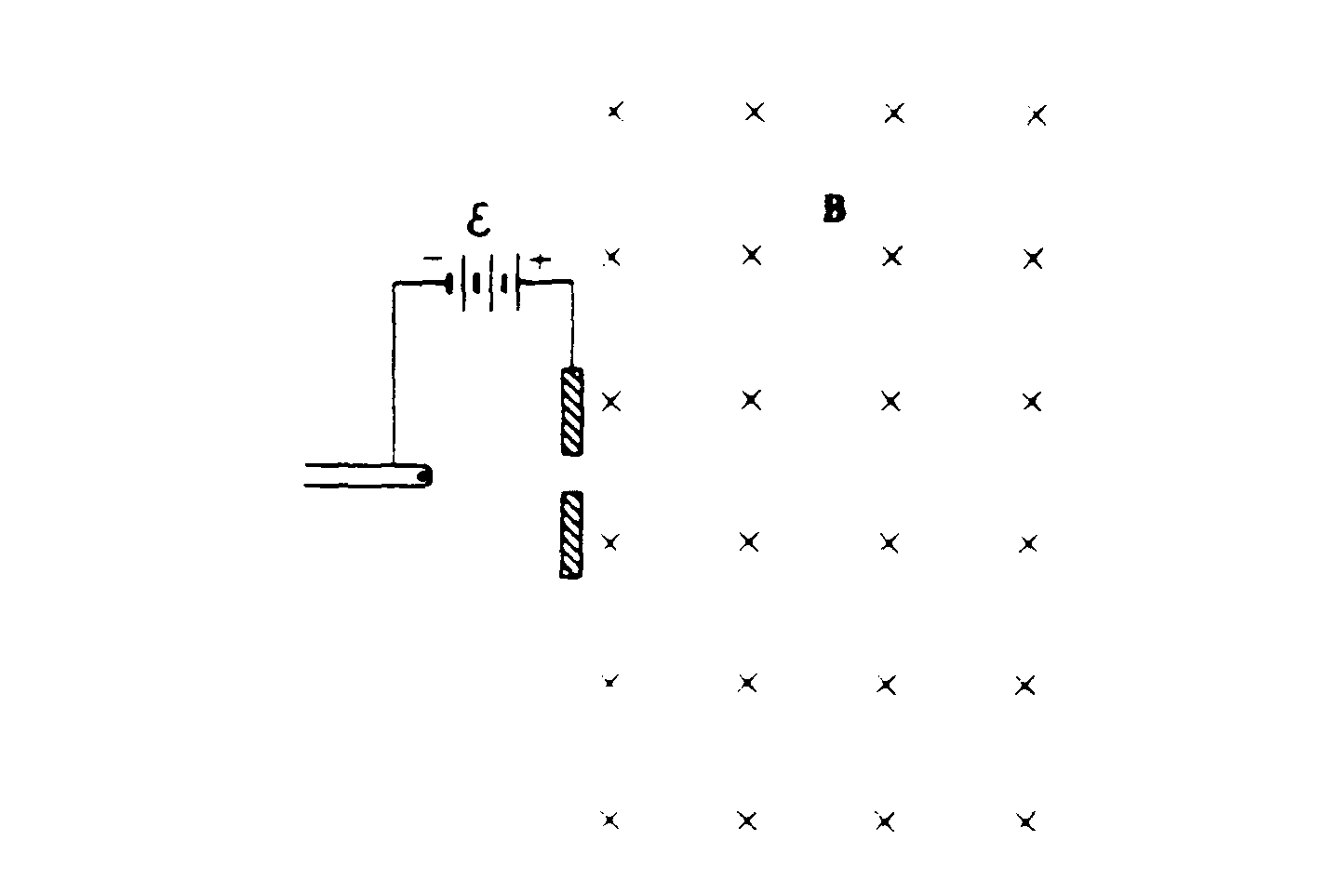  e – m forces on chg part. | 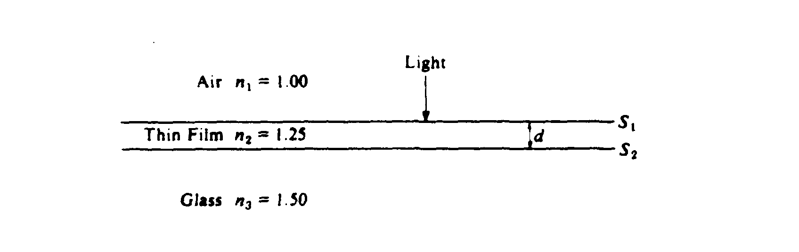  refraction, thin film interference | 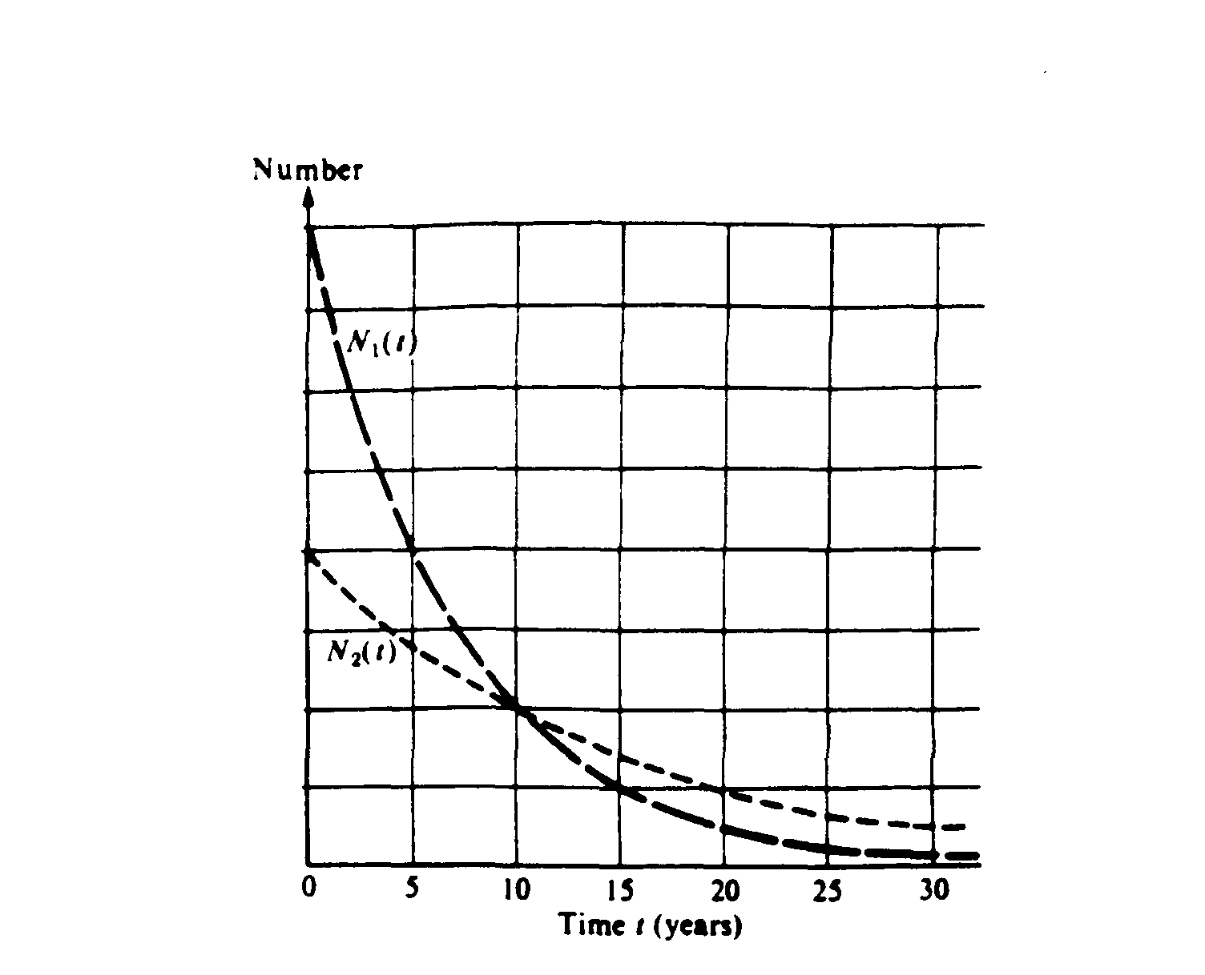  radioactive decay, half life, alpha
1983 | Rubric | 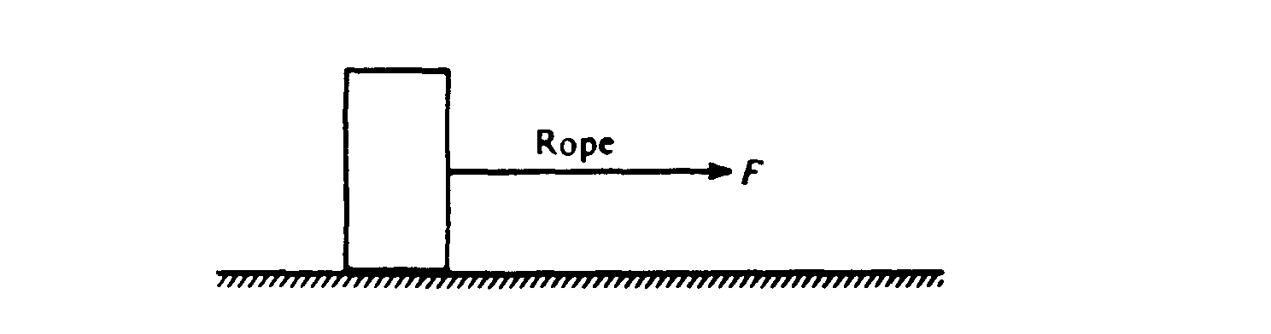  1983 – friction, F = ma, tipping | 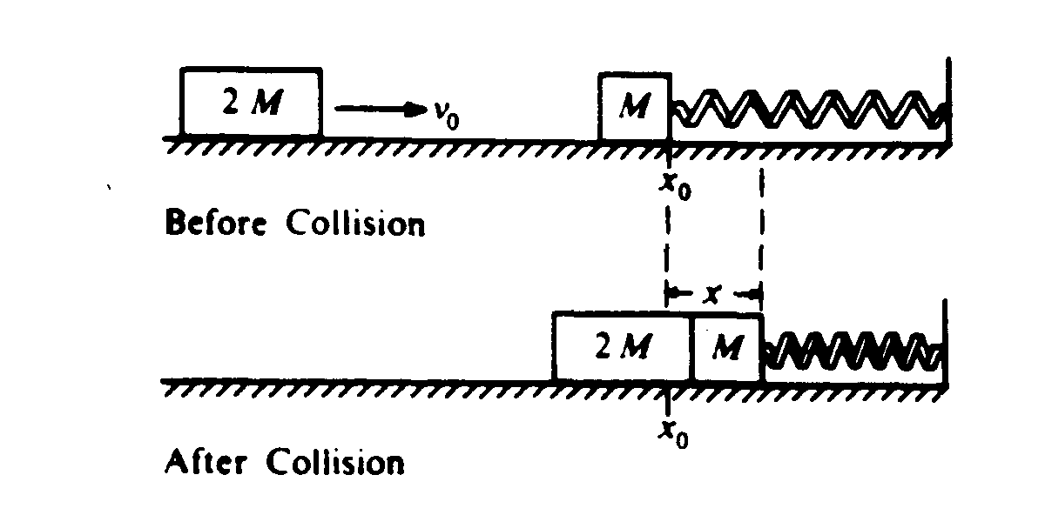  inelast coll, energy in spring, shm. | 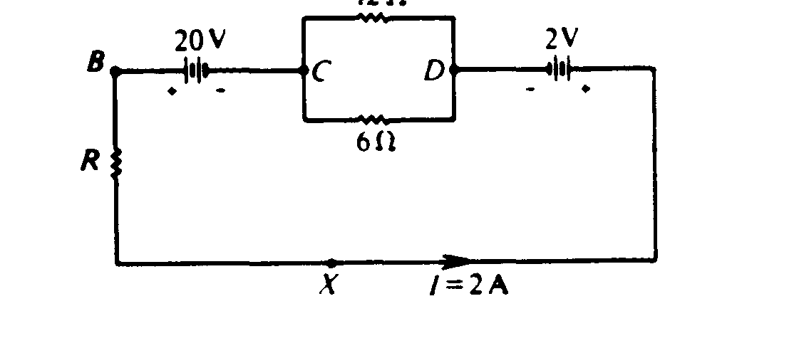  ohms law, circuit | 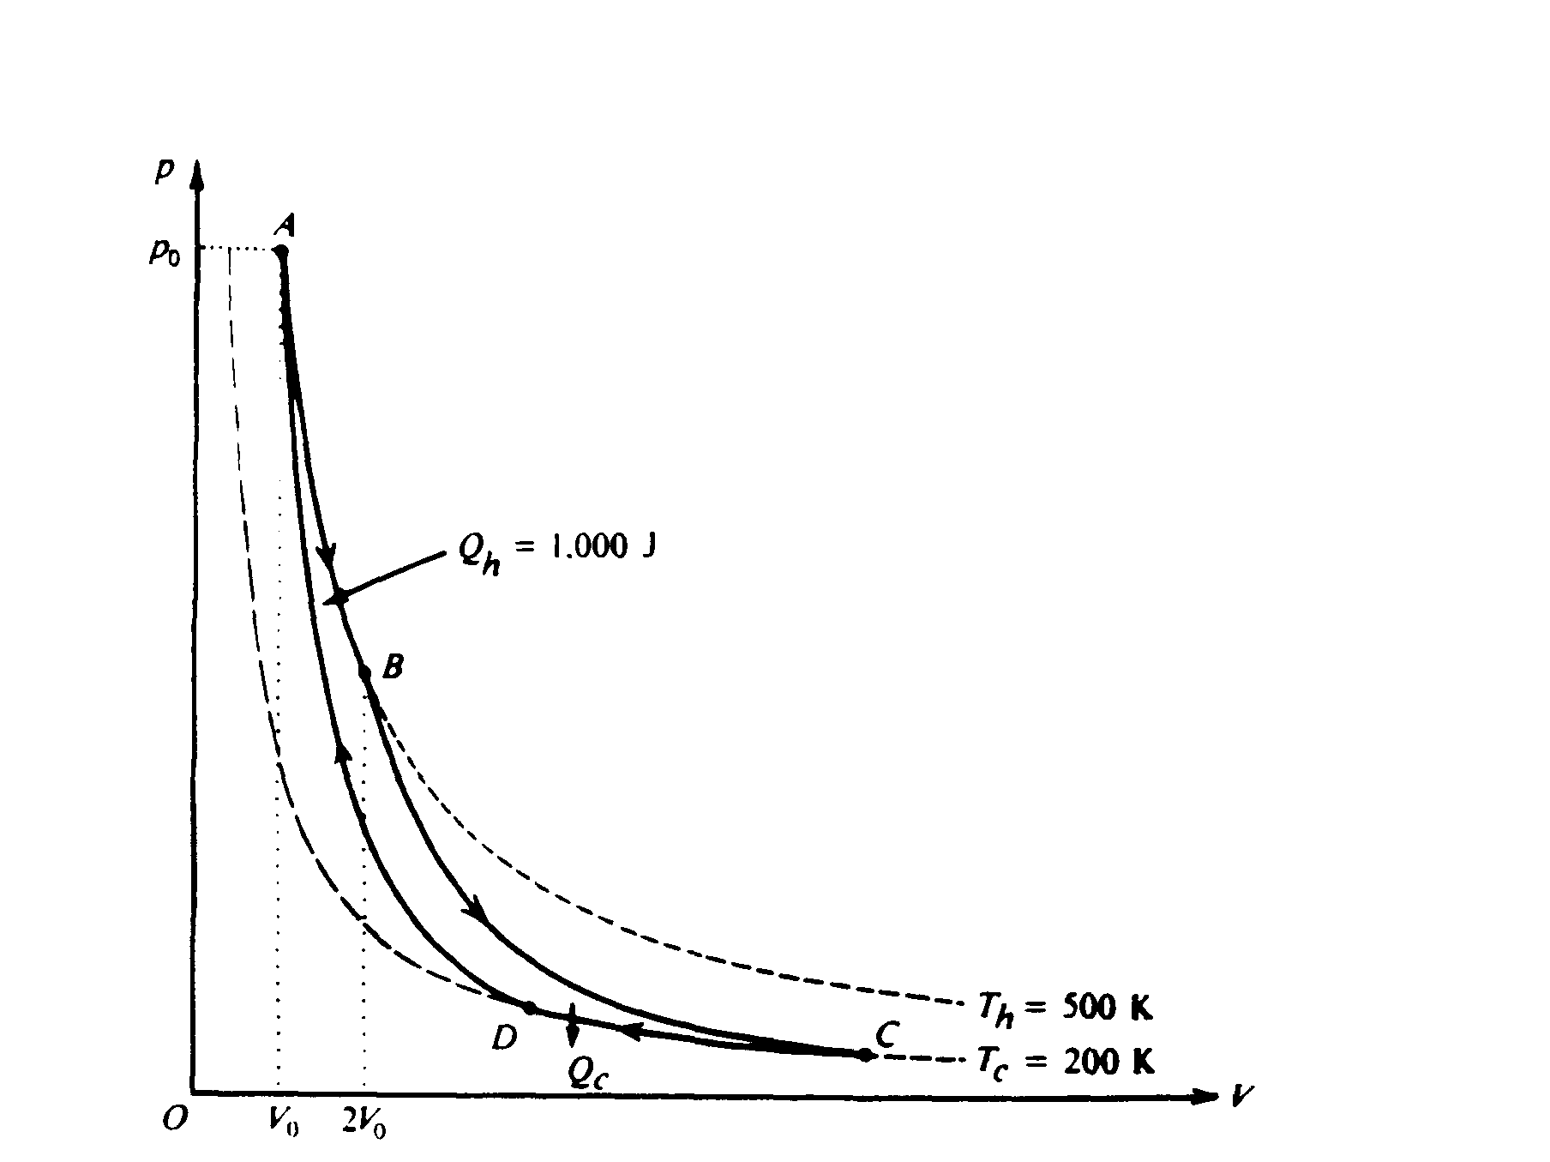  thermo processes work | 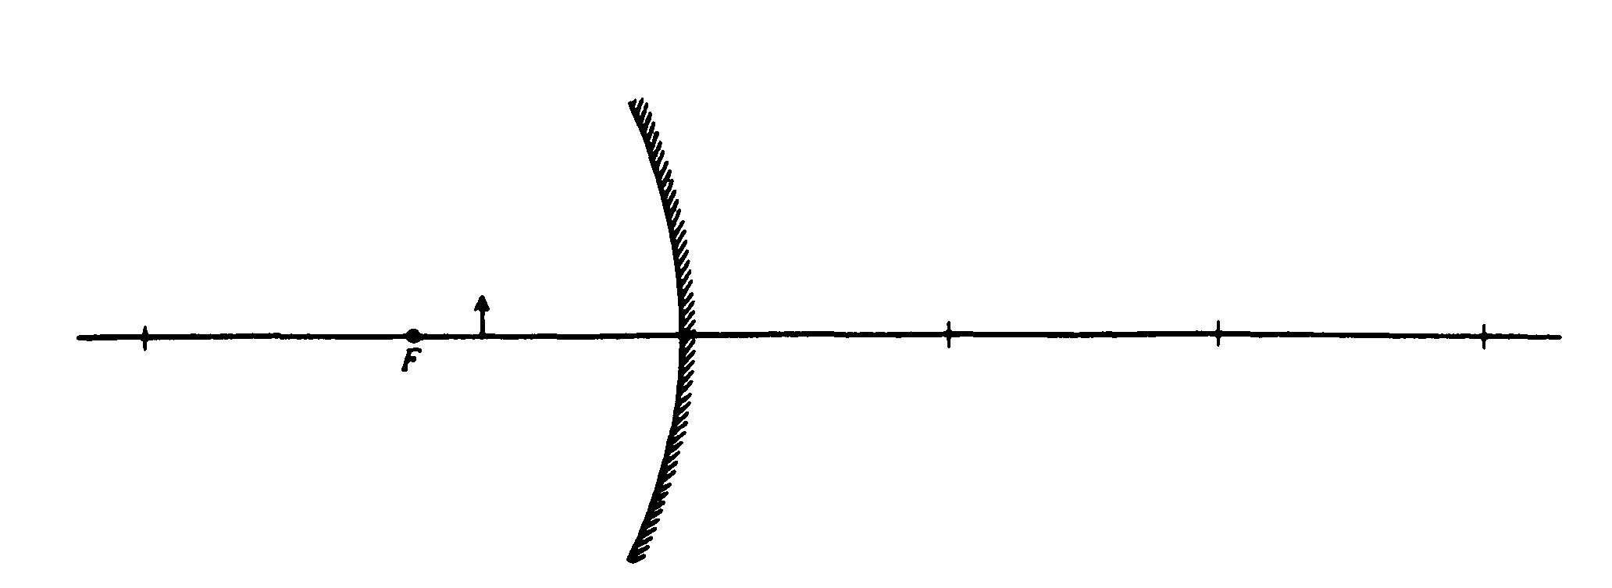  concave mirror | Photoelectric effect, calculations of h, work function . . .
1982 | Rubric | 1982 (left) sprinter, kinematics graph. | 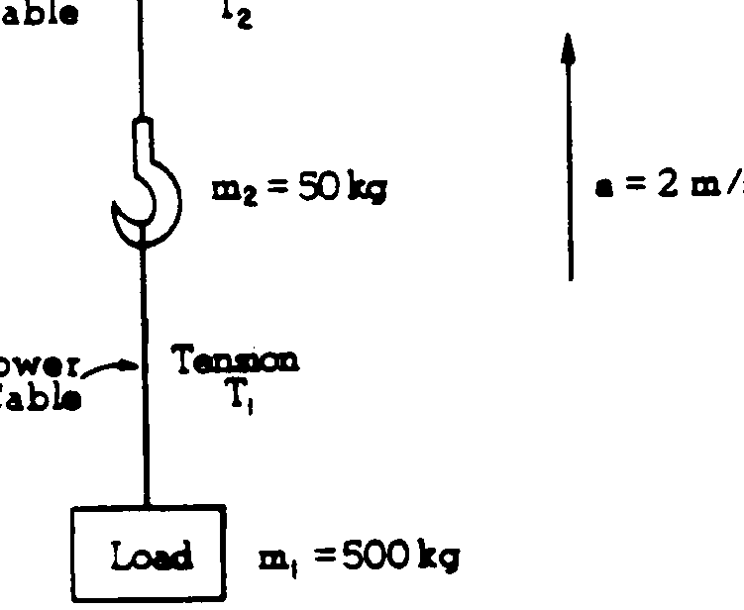 upward acceleration, tension in cables | 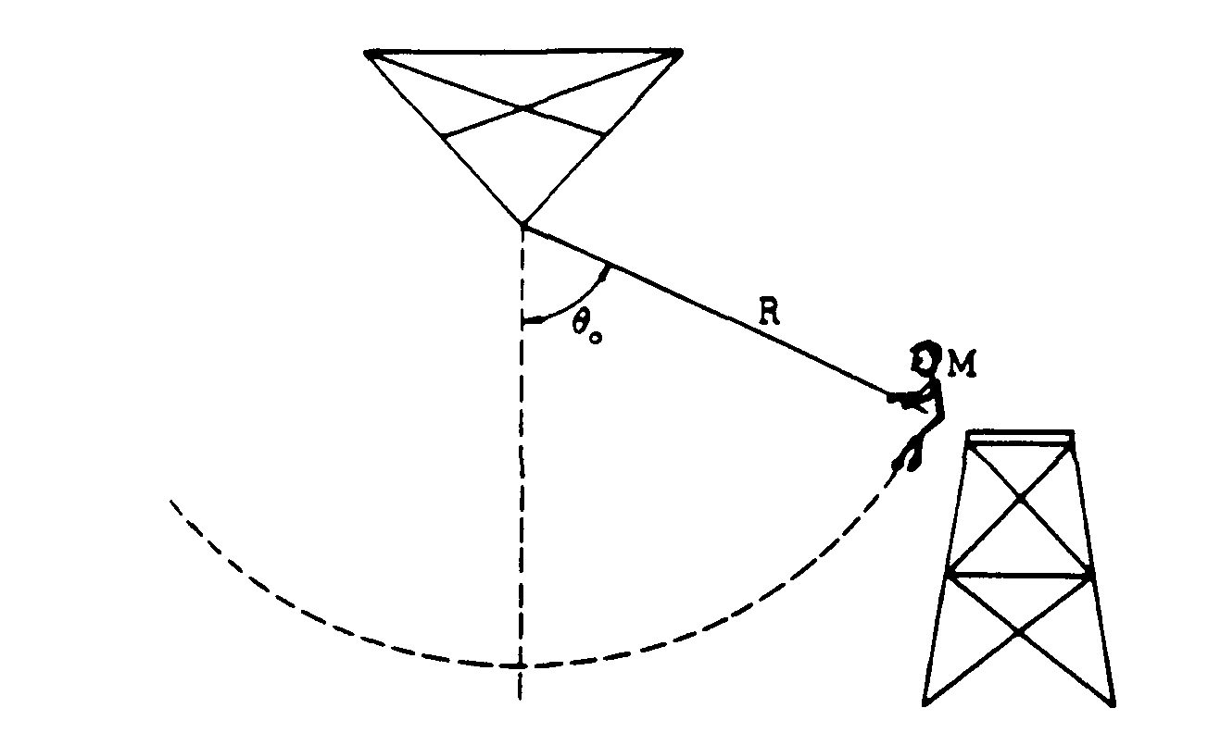  swing on rope, tension at lowest point, energy | 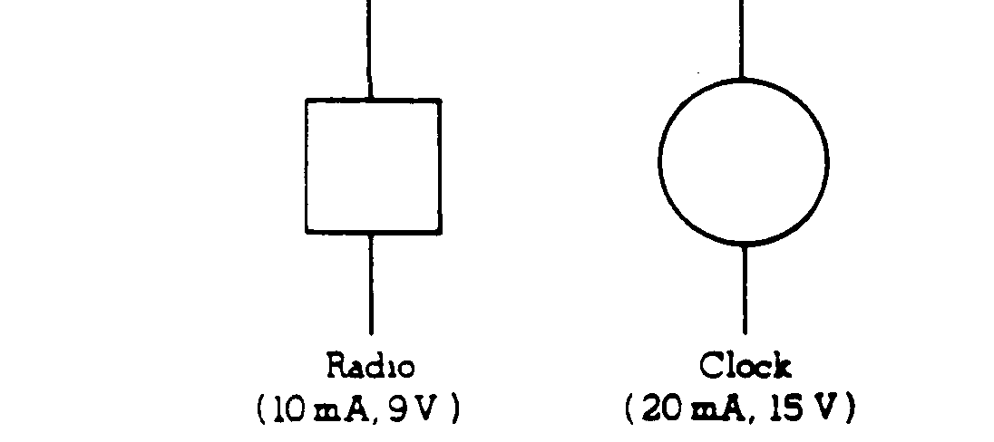  Hookup of clock and radio. | 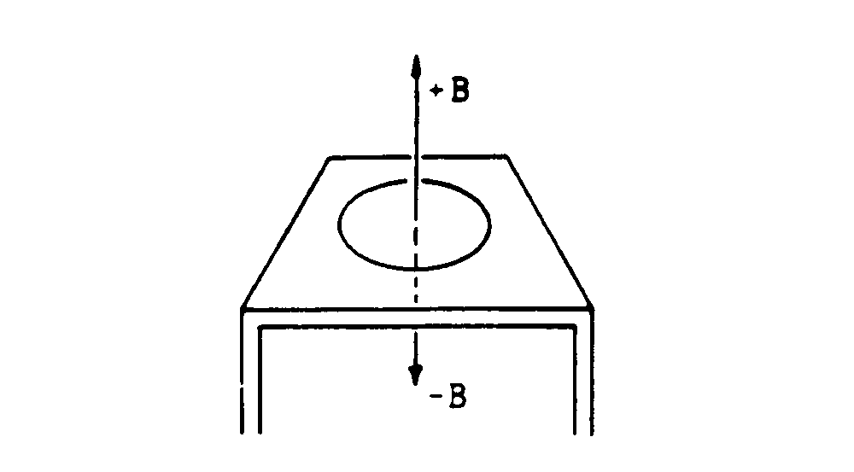  flux, induction | 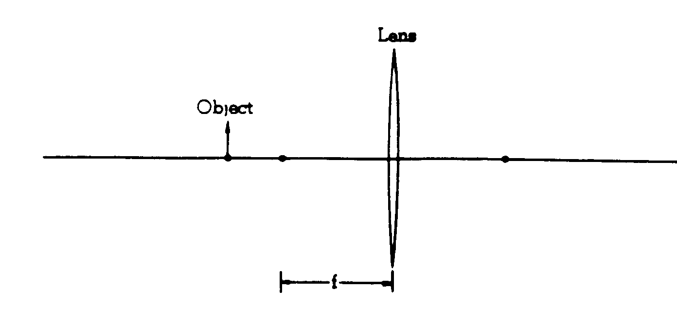  convex lens | four modern phys experiments – choose 1 and explain
1981 | Rubric | 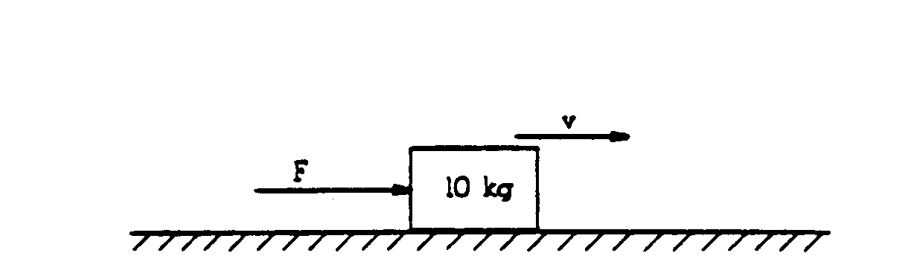  1981 – friction, work, energy |   springs, energy, momentum cons in explosion | 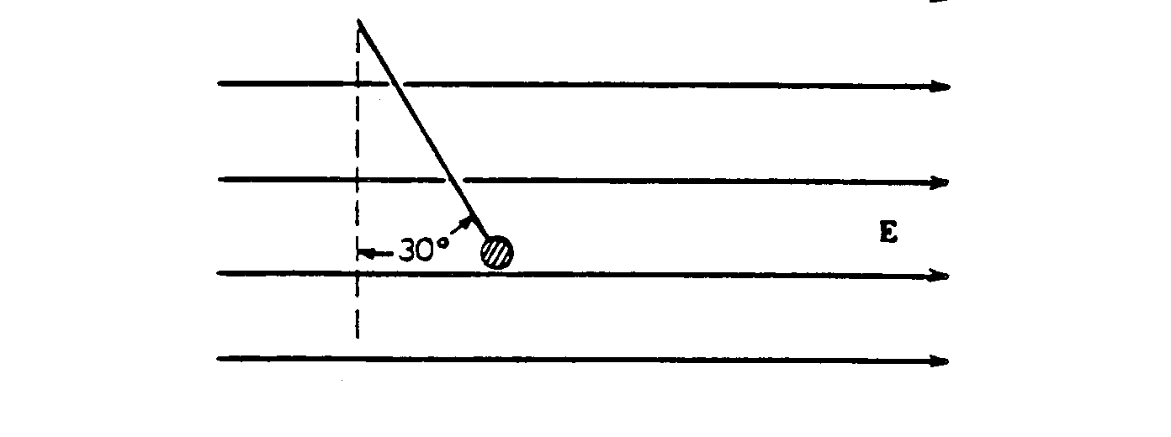  stat equil of charged particle in electric field | 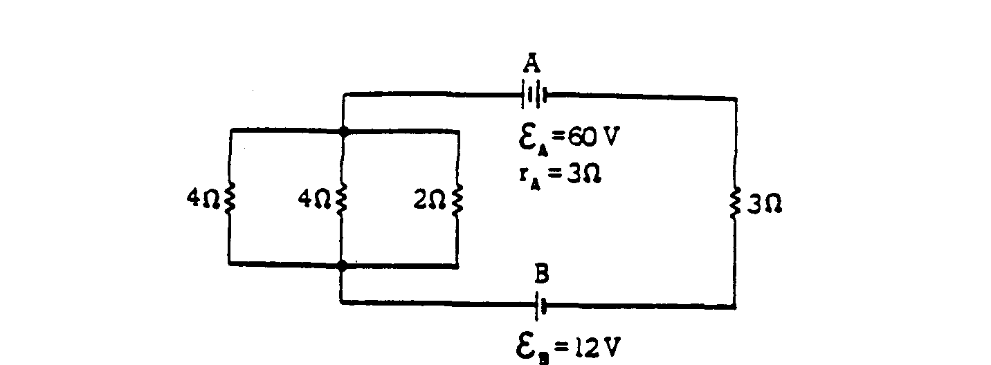  circuits – power, ohm’s law | 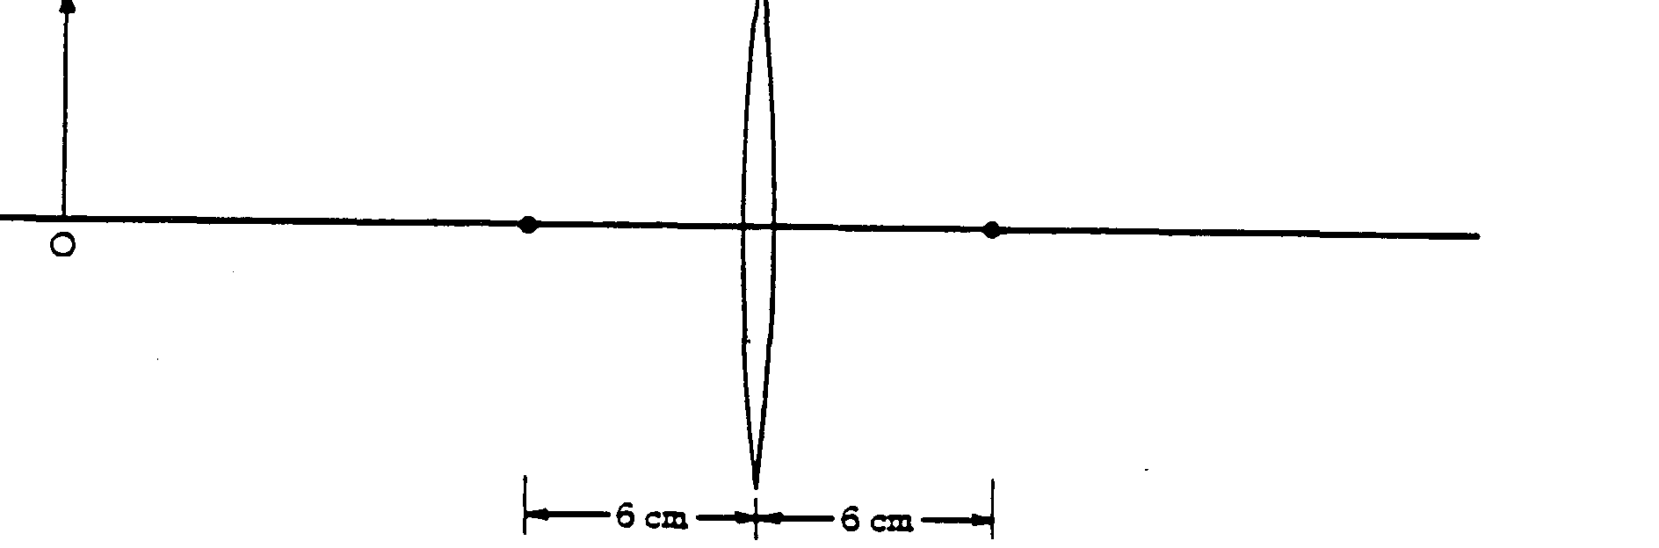  convex lenses, ray diagrams | Energy absorption, specific heat.
1980 | Rubric | 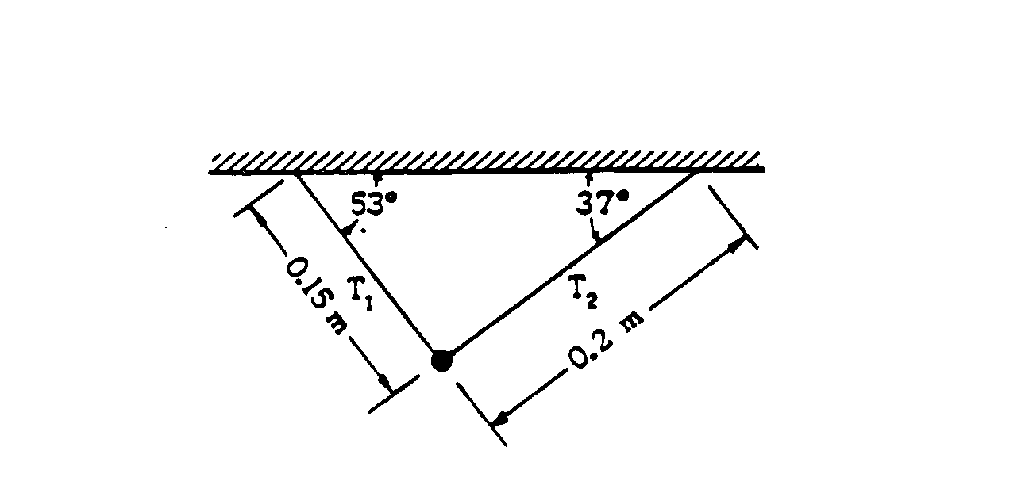  1980 - static equilibrium | 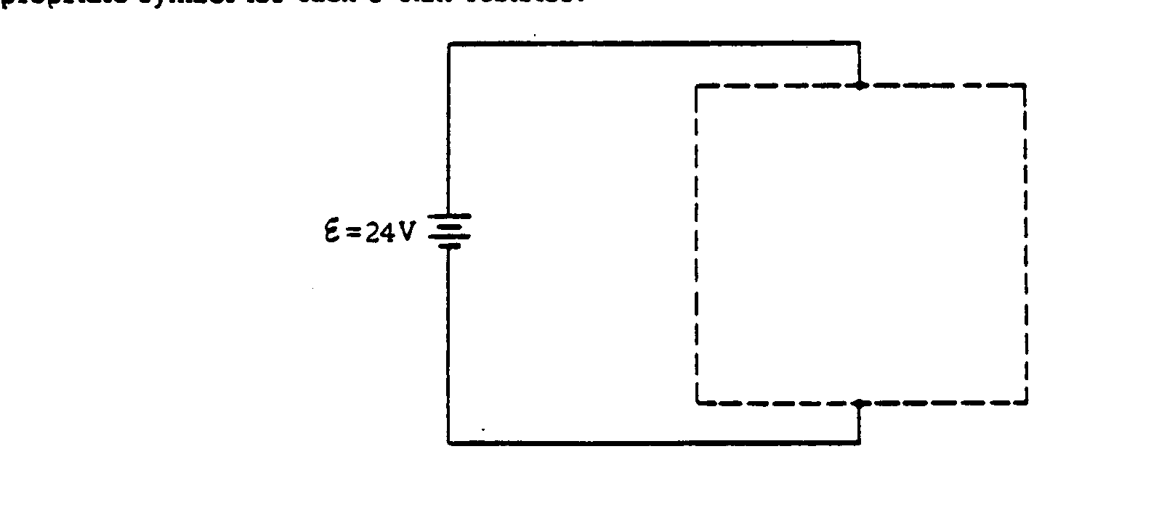  circuits and connections | 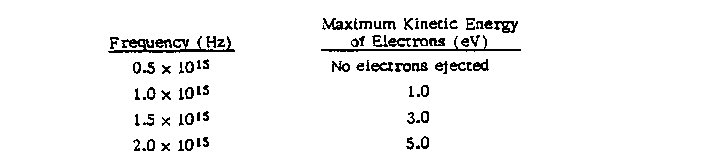  photoelectric eff. Data and graph | Using one graph, sketch its companion | Nuclear decay, cons of momentum, calc of energy | 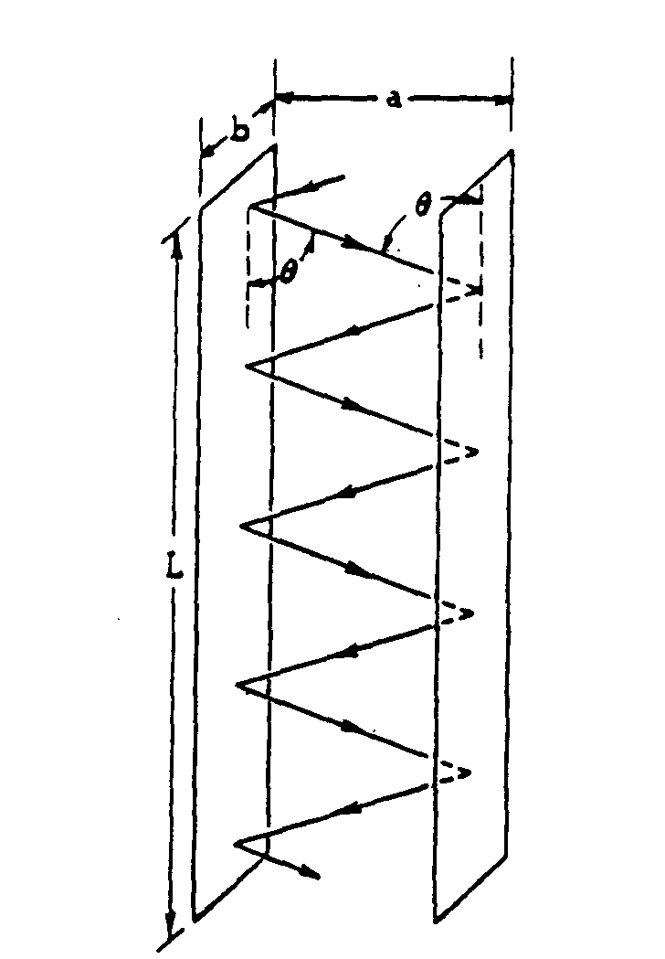  kin theory, press.
1979 | Rubric | 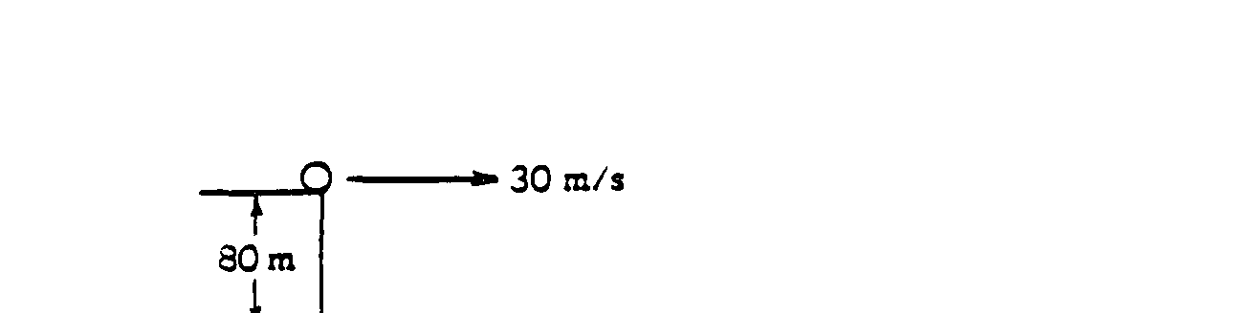  1979 – potential & Kinetic energy of projectile | 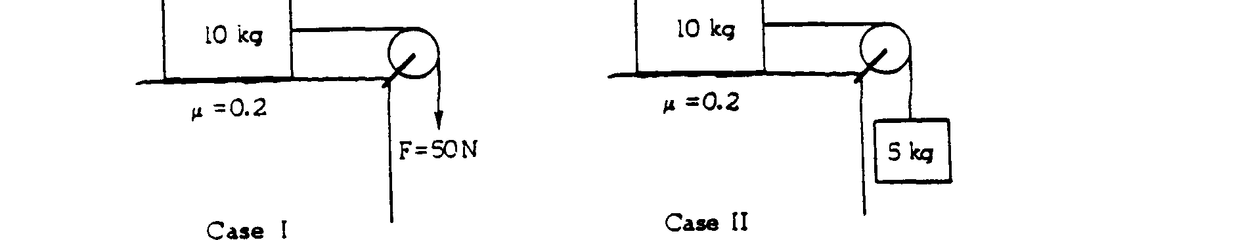  F = ma | muons, modern physics, relativity | 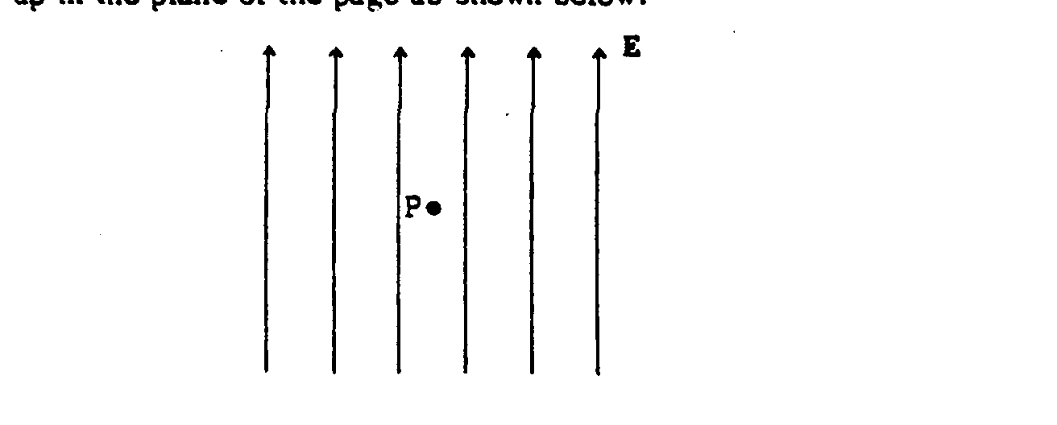  electric & magnetic forces on charged particles | 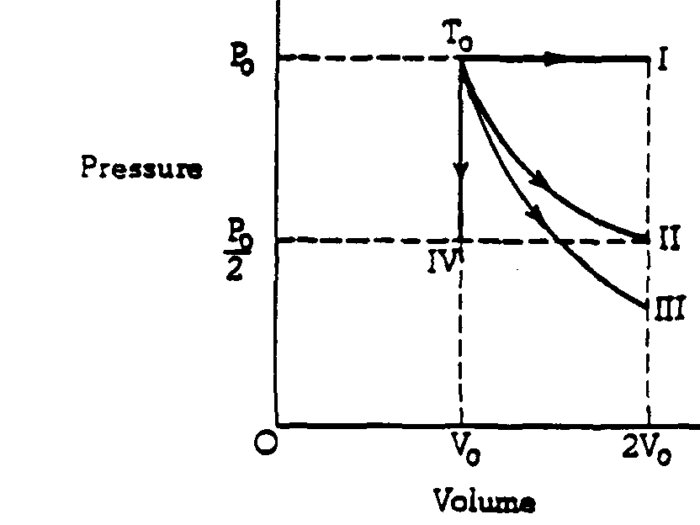  gas laws, p-v diagram, work | 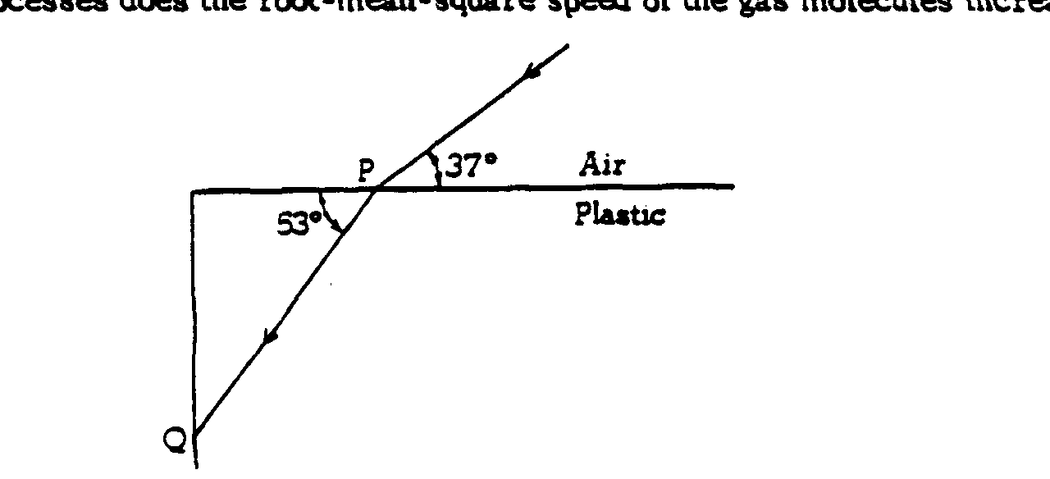  refraction | 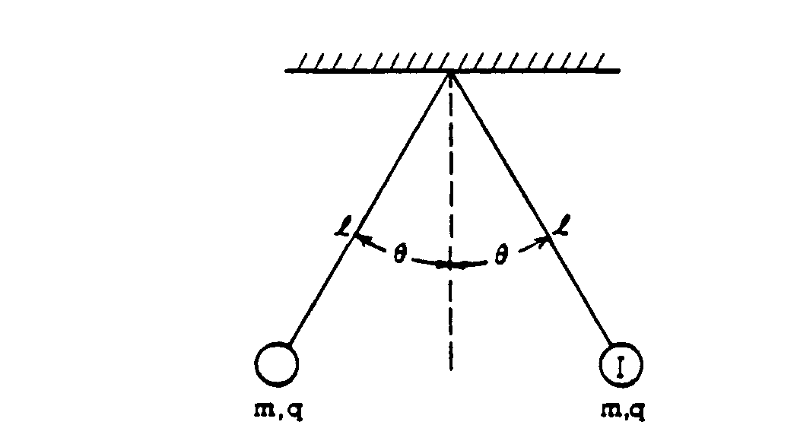  Charged spheres, elec forces.
1978 | Rubric | Vertical circular motion | Projectile; inelastic collision | 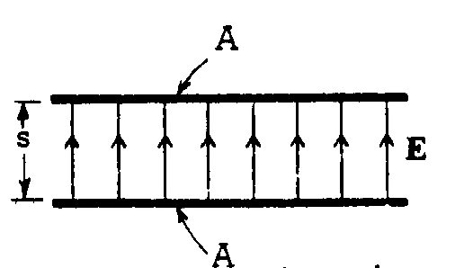  capacitor | Induced emf | 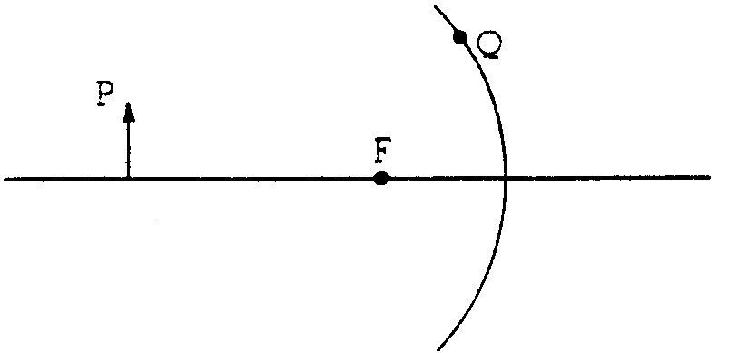  Concave mirror; ray diagram | Photon collision with mass | Bohr model; deBroglie wavelength
1977 | Rubric | 1977 work-energy, kinematics | 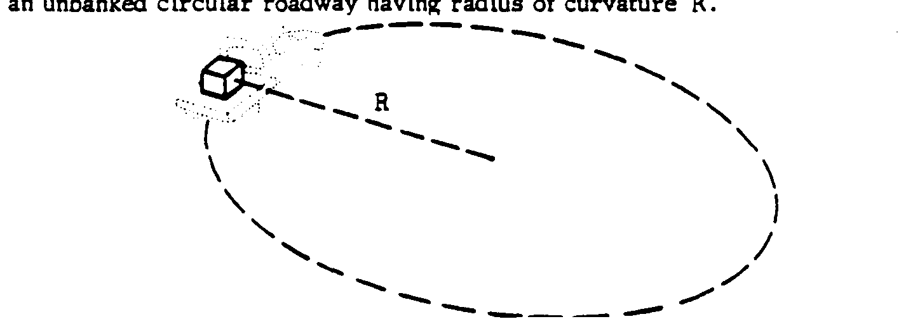  centripetal force, banked road. | 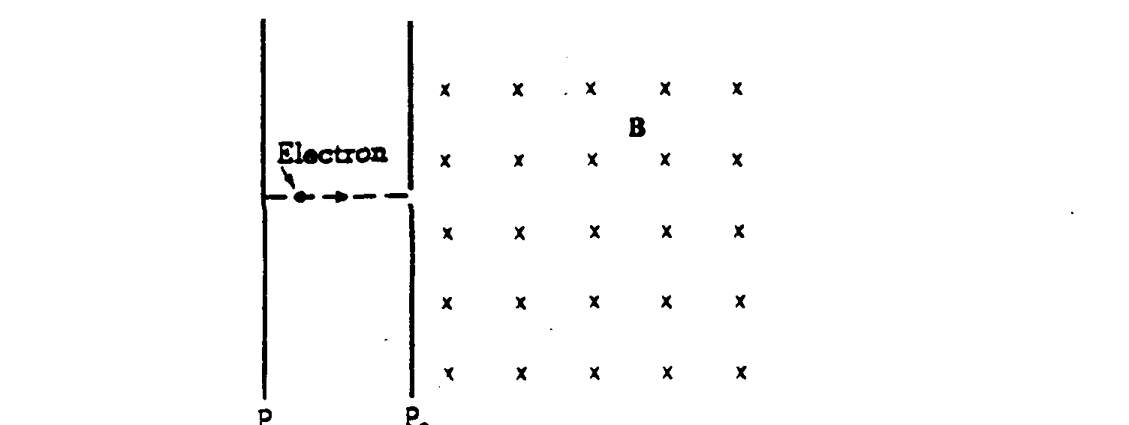  e-m forces, work, fields | 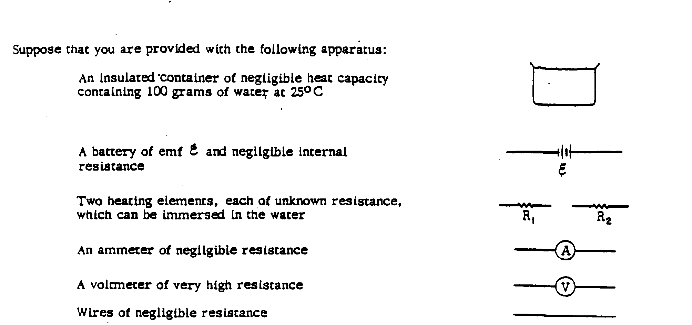  Ohm’s law, power, spec ht, thermo | 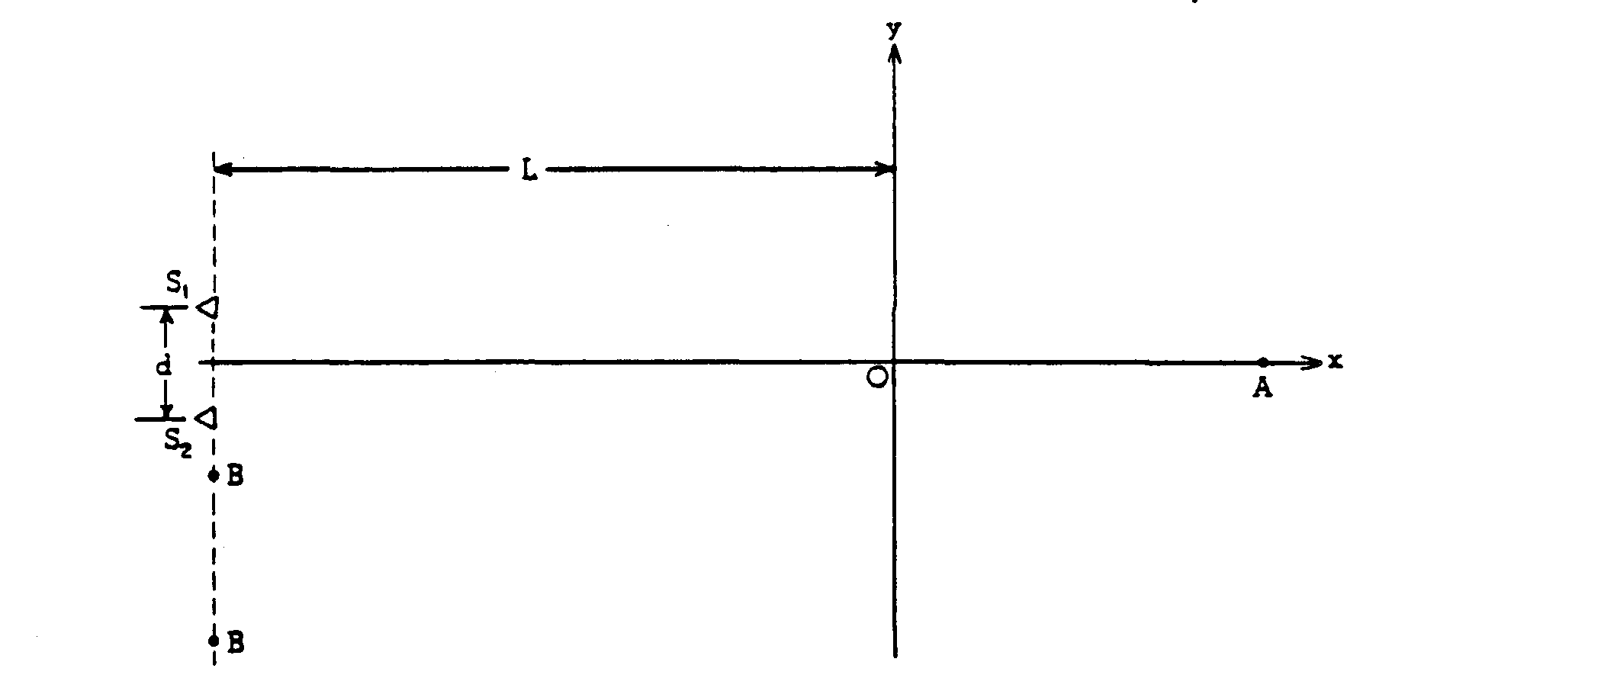  Interference of sound waves. 2 pt sources | Relativity and modern physics – sketching graphs
1976 | Rubric | 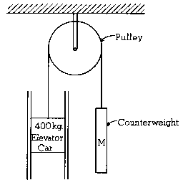  Elevator; Atwood’s machine | 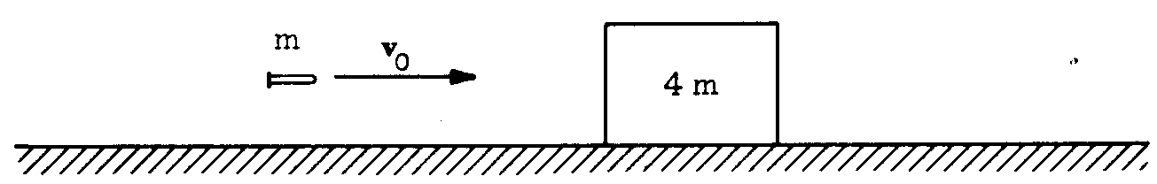  Cons of momentum; bullet block combo | 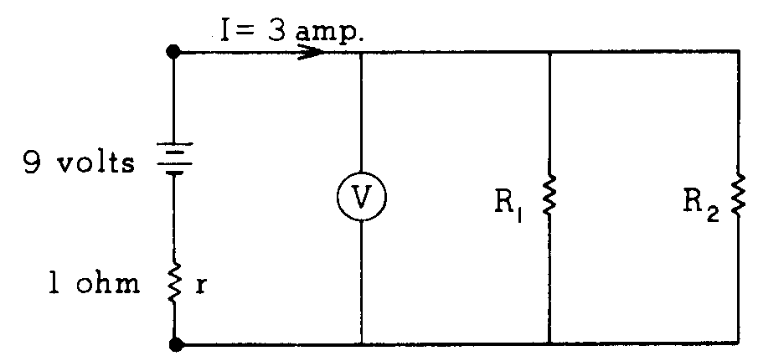  circuits | 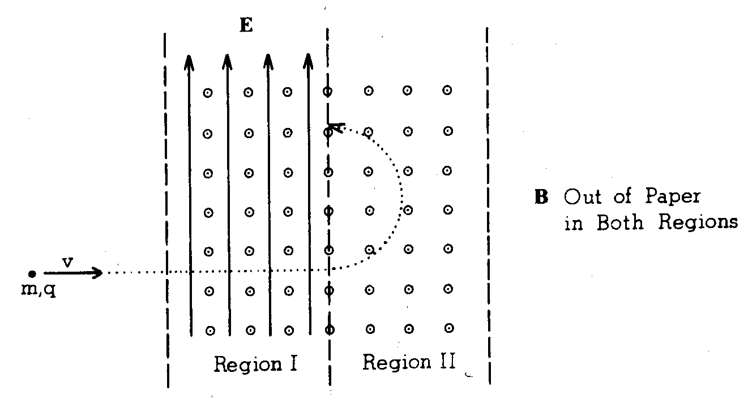  Mass spectrometer | Waterfall: Grav pot energy converted to thermal energy | Converging lens  Ray diagram | Photoelectric effect
1975 | Rubric | 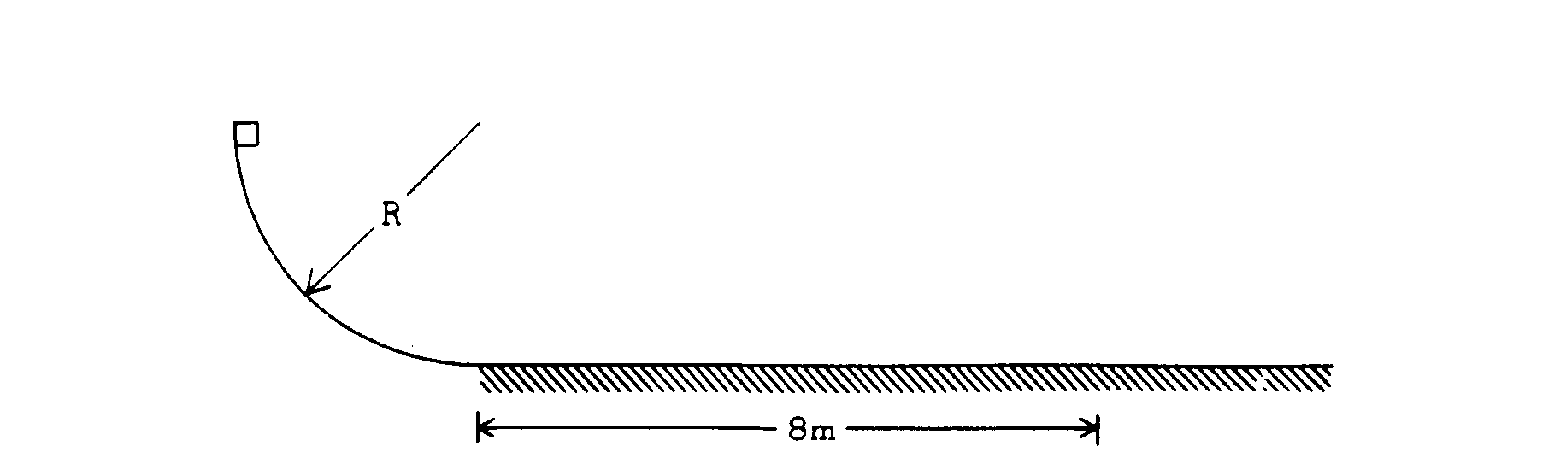  1975-friction, energy, kinematics | 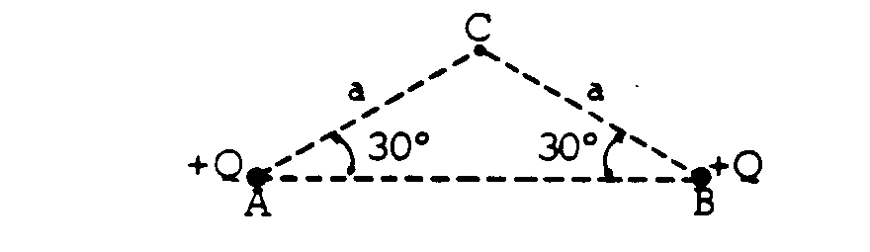  electric field, work | 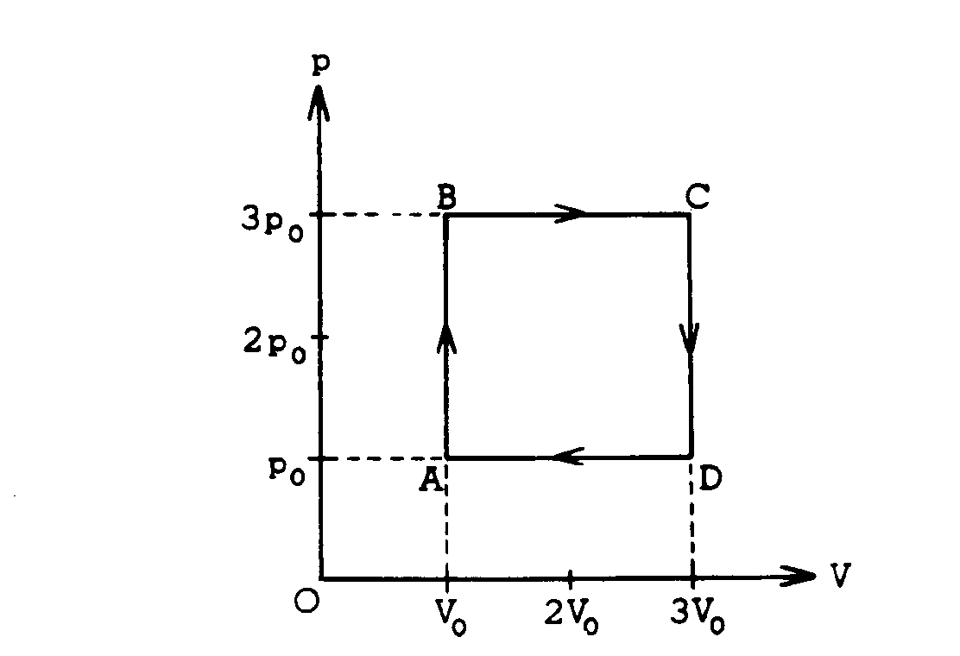  Thermo processes, gas laws | 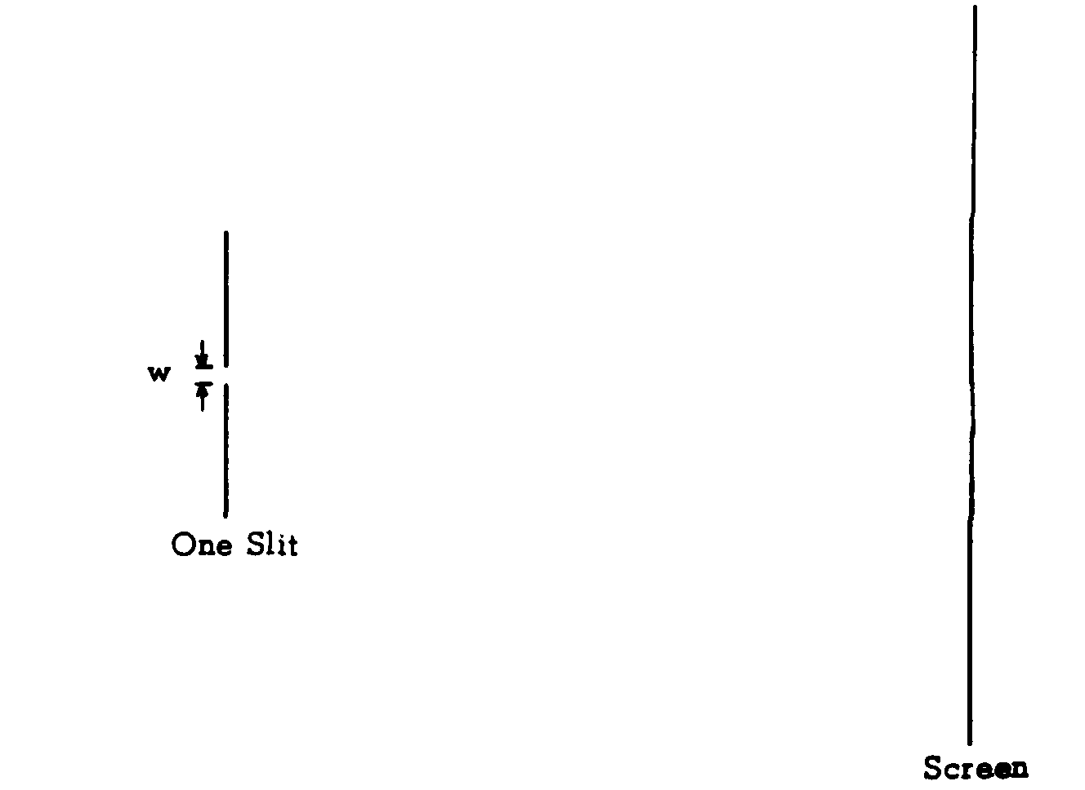  single and double slit interference | 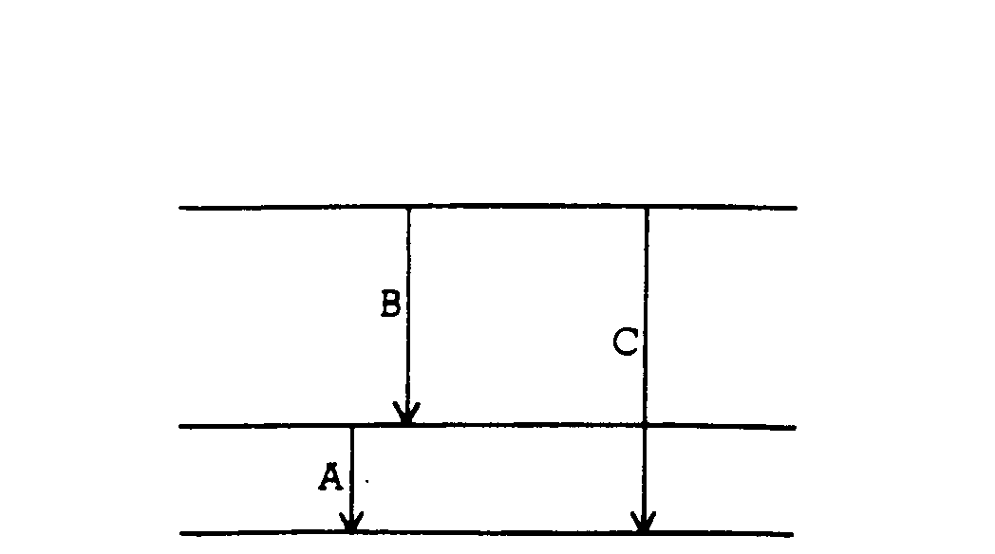  energy levels, transitions, photons | 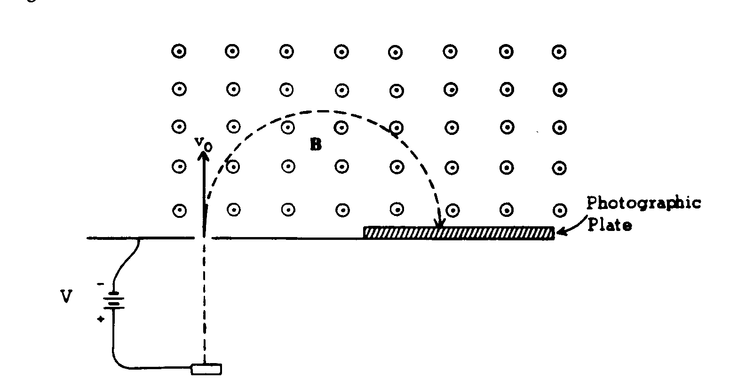  electrical work, centripetal motion, mass spectrometer. | 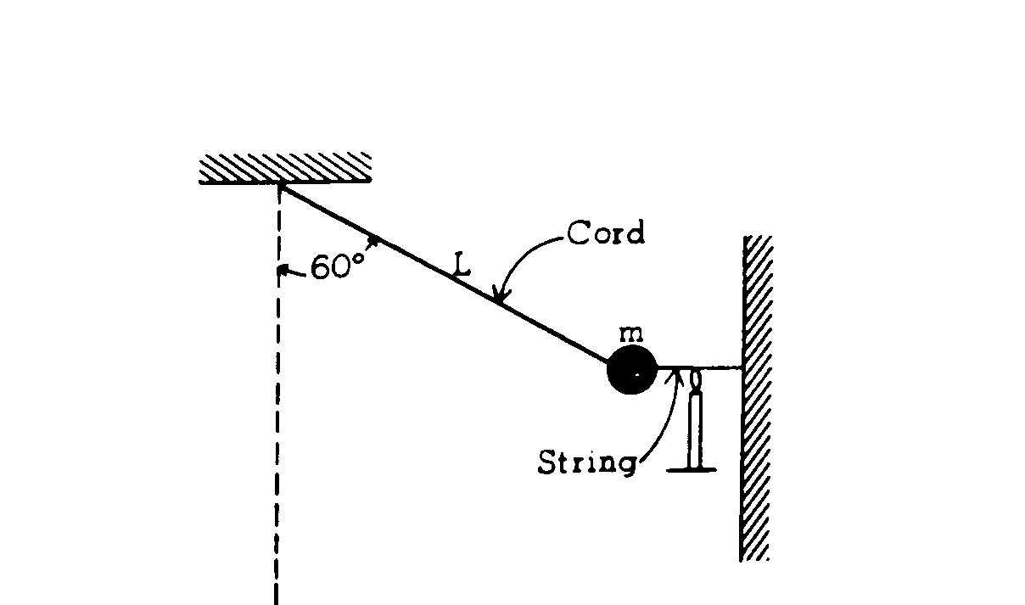  pendulum, shm, energy, centripetal.
1974 | Rubric | Pendulum; dynamics | Electron moving in a B field | Converging lens  Ray diagram | Experiment: determine # of photons/sec in a light beam | Electrostatics; lines of equipotential | Thermo; PV diagram | Mechanical power of ski lift
1973 | Rubric | Mechanics – friction | Mechanics – energy & vertical circles | Electron moving through E & B fields | Induced variable current | Calorimetry - GRAPH | Standing waves in pipes | Wave-particle duality of radiation and matter
1972 | Rubric | This year’s free-response section contained two-parts: Part A contained five “major” questions and seven “minor” questions.
1971 | Rubric | This year’s free-response section contained two-parts: Part A contained five “major” questions and seven “minor” question.
1970 | Rubric | This year’s free-response section contained two-parts: Part A contained five “major” questions and seven “minor” question.

