

AP® Physics B

1974 Free Response

The materials included in these files are intended for use by AP teachers for course
and exam preparation in the classroom; permission for any other use must be
sought from the Advanced Placement Program®. Teachers may reproduce them, in whole or in part, in limited quantities, for face-to-face teaching purposes but may
not mass distribute the materials, electronically or otherwise. These materials and
any copies made of them may not be resold, and the copyright notices must be
retained as they appear here. This permission does not apply to any third-party copyrights contained herein.

These materials were produced by Educational Testing Service® (ETS®), which develops and administers the examinations of the Advanced Placement
Program for the College Board. The College Board and Educational Testing Service (ETS) are dedicated to the principle of equal opportunity, and their
programs, services, and employment policies are guided by that principle.

The College Board is a national nonprofit membership association dedicated to preparing, inspiring, and connecting students to college and opportunity.
Founded in 1900, the association is composed of more than 4,200 schools, colleges, universities, and other educational organizations. Each year, the
College Board serves over three million students and their parents, 22,000 high schools, and 3,500 colleges, through major programs and services in
college admission, guidance, assessment, financial aid, enrollment, and teaching and learning. Among its best-known programs are the SAT®, the
PSAT/NMSQT®, and the Advanced Placement Program® (AP®). The College Board is committed to the principles of equity and
excellence, and that commitment is embodied in all of its programs, services, activities, and concerns.

APIEL is a trademark owned by the College Entrance Examination Board. PSAT/NMSQT is a registered trademark jointly owned by the College Entrance Examination Board and the National Merit Scholarship Corporation. Educational Testing Service and ETS are registered trademarks of Educational Testing Service.
College Entrance Examination Board 1974
Advanced Placement Examination

PHYSICS B
SECTION II

Time—90 minutes
7 Questions

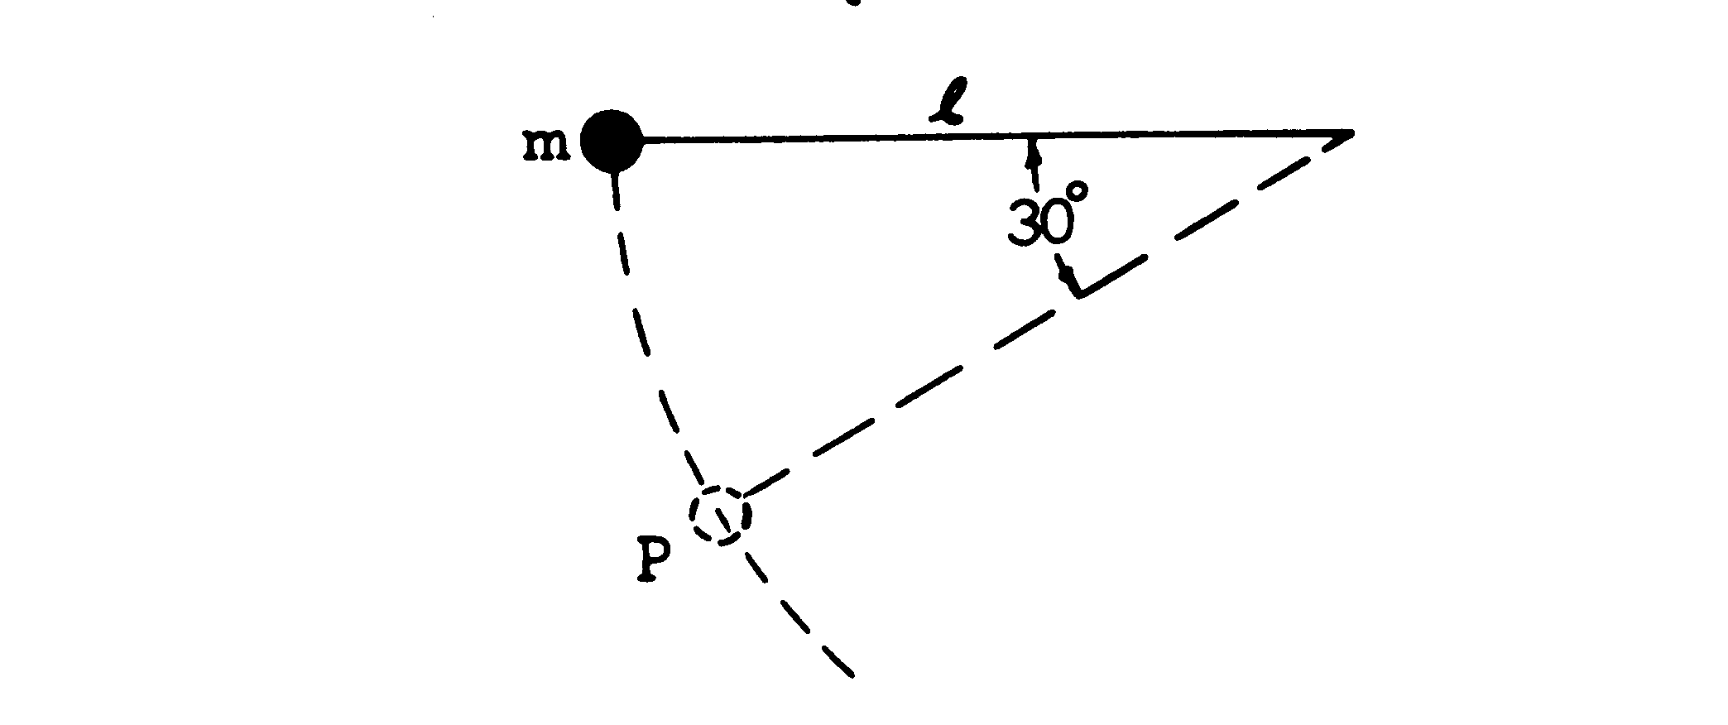
A pendulum consisting of a small heavy ball of mass m at the end of a string of length ℓ is released from a horizontal position. When the ball is at point P, the string forms an angle of 30” with the horizontal as shown above.

(a) In the space below, draw a force diagram showing all of the forces acting on the ball at P. Identify each force clearly.

(b) Determine the speed of the ball at P.
(c) Determine the tension in the string when the ball is at P.

2. Electrons of various nonrelativistic speeds are moving in a plane perpendicular to a uniform magnetic field B. Because of the magnetic force, the electrons move in circles of various radii. Show that the time required to travel around one complete circle is the same for all electrons, regardless of their speeds.

3. An object 1 centimeter high is placed 4 centimeters away from a converging lens having a focal length of
3 centimeters.
(a) Sketch a principal ray diagram for this situation.
(b) Find the location of the image by a numerical calculation.
(c) Determine the size of the image.

4. A parallel beam of monochromatic visible light enters your laboratory through a hole in the wall. You cannot investigate the source of light, though you have all the apparatus you wish for investigating the properties of the light beam. Describe how you could determine experimentally the number of photons per second entering the laboratory.
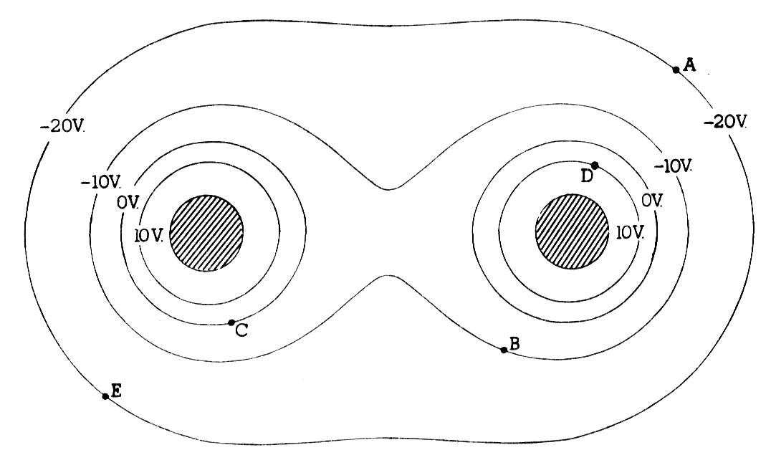
5. The diagram above shows some of the equipotentials in a plane perpendicular to two parallel charged metal cylinders. The potential of each line is labeled.

(a) The left cylinder is charged positively. What is the sign of the charge on the other cylinder?
(b) On the diagram above, sketch lines to describe the electric field produced by the charged cylinders.
(c) Determine the potential difference, V_{A} — V_{B}, between points A and B.

(d) How much work is done by the field if a charge of 0.50 coulomb is moved along a path from point A to point E and then to point D?

6. One-tenth of a mole of an ideal monatomic gas undergoes a process described by the straight-line path AB shown in the p-V diagram below.
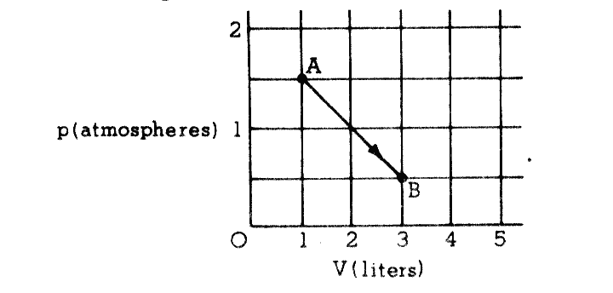
(a) Show that the temperature of the gas is the same at points A and 1-3.
(b) How much heat must be added to the gas during the process described by A $→$ B ?
(c) What is the highest temperature of the gas during the process described by A $→$ B?

7. 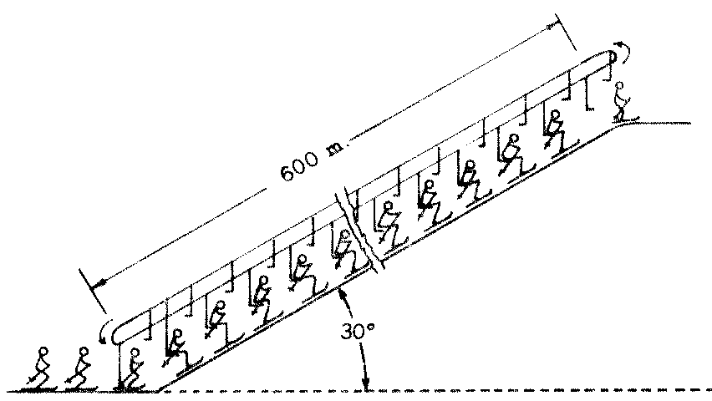
A ski lift carries skiers along a 600-meter slope inclined at 30°. Each chair has a mass of 50 kilograms, and each rider has a mass of 70 kilograms. The skiers get off at the top of the hill, so the chairs are empty for the return trip. Under maximum load conditions six riders per minute arrive at the top. If 60 per cent of the energy supplied by the motor goes into overcoming friction, what average power must the motor supply?

END OF EXAMINATION

