Copyright © 1975 Educational Testing Service. All rights reserved. Princeton, NJ 08541
For face-to-face teaching purposes, classroom teachers are permitted to reproduce only the questions from this green insert.

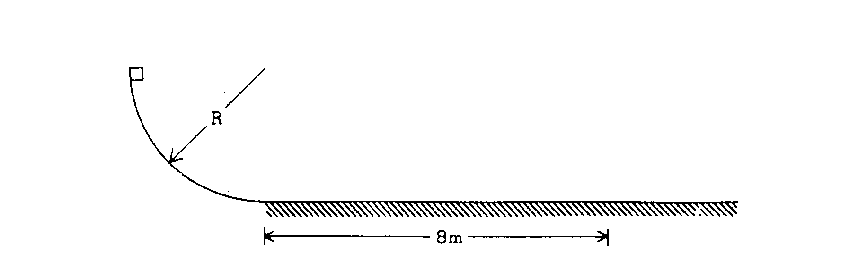

1975B1. A 2-kilogram block is released from rest at the top of a curved incline in the shape of a quarter of a circle of radius R. The block then slides onto a horizontal plane where it finally comes to rest 8 meters from the beginning of the plane. The curved incline is frictionless, but there is an 8-newton force of friction on the block while it slides horizontally. Assume g = 10 meters per second².
a. Determine the magnitude of the acceleration of the block while it slides along the horizontal plane.
b. What time elapses while the block is sliding horizontally?
c. Calculate the radius of the incline in meters.

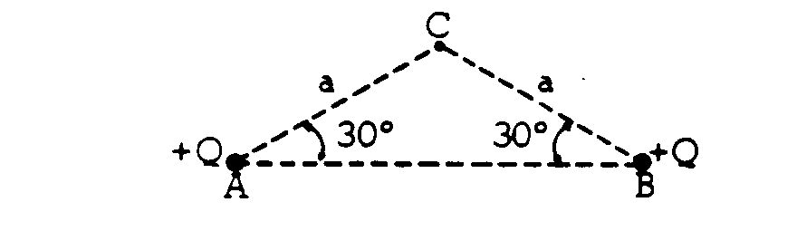
1975B2. Two identical electric charges +Q are located at two corners A and B of an isosceles triangle as shown above.
a. How much work does the electric field do on a small test charge +q as the charge moves from point C to infinity,
b. In terms of the given quantities, determine where a third charge +2Q should be placed so that the electric field at point C is zero. Indicate the location of this charge on the diagram above.

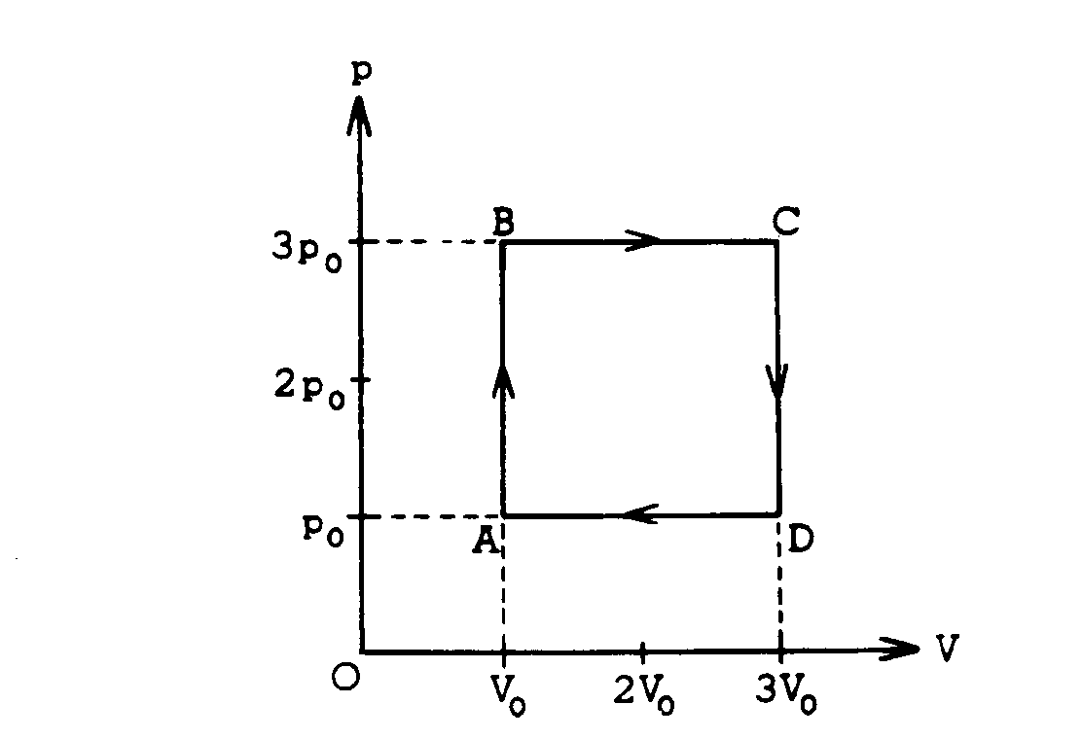
1975B3. One mole of a monatomic ideal gas enclosed in a cylinder with a movable piston undergoes the process ABCDA shown on the p-V diagram above.
a. In terms of p_{o} and V_{o} calculate the work done by the gas in the process.
b. In terms of p_{o} and V_{o} calculate the net heat absorbed by the gas in the process.
c. At what two lettered points in the process are the temperatures equal? Explain your reasoning.
d. Consider the segments AB and BC. In which segment is the amount of heat added greater? Explain your reasoning.
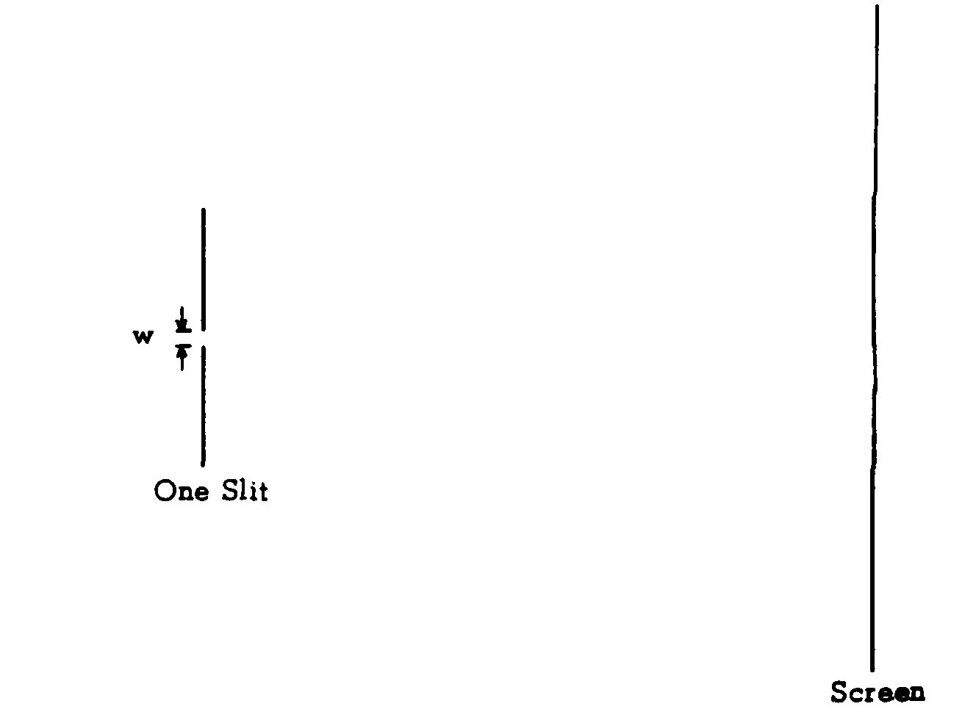
1975B4.
a. Light of a single wavelength is incident on a single slit of width w. (w is a few wavelengths.) Sketch a graph of the intensity as a function of position for the pattern formed on a distant screen.
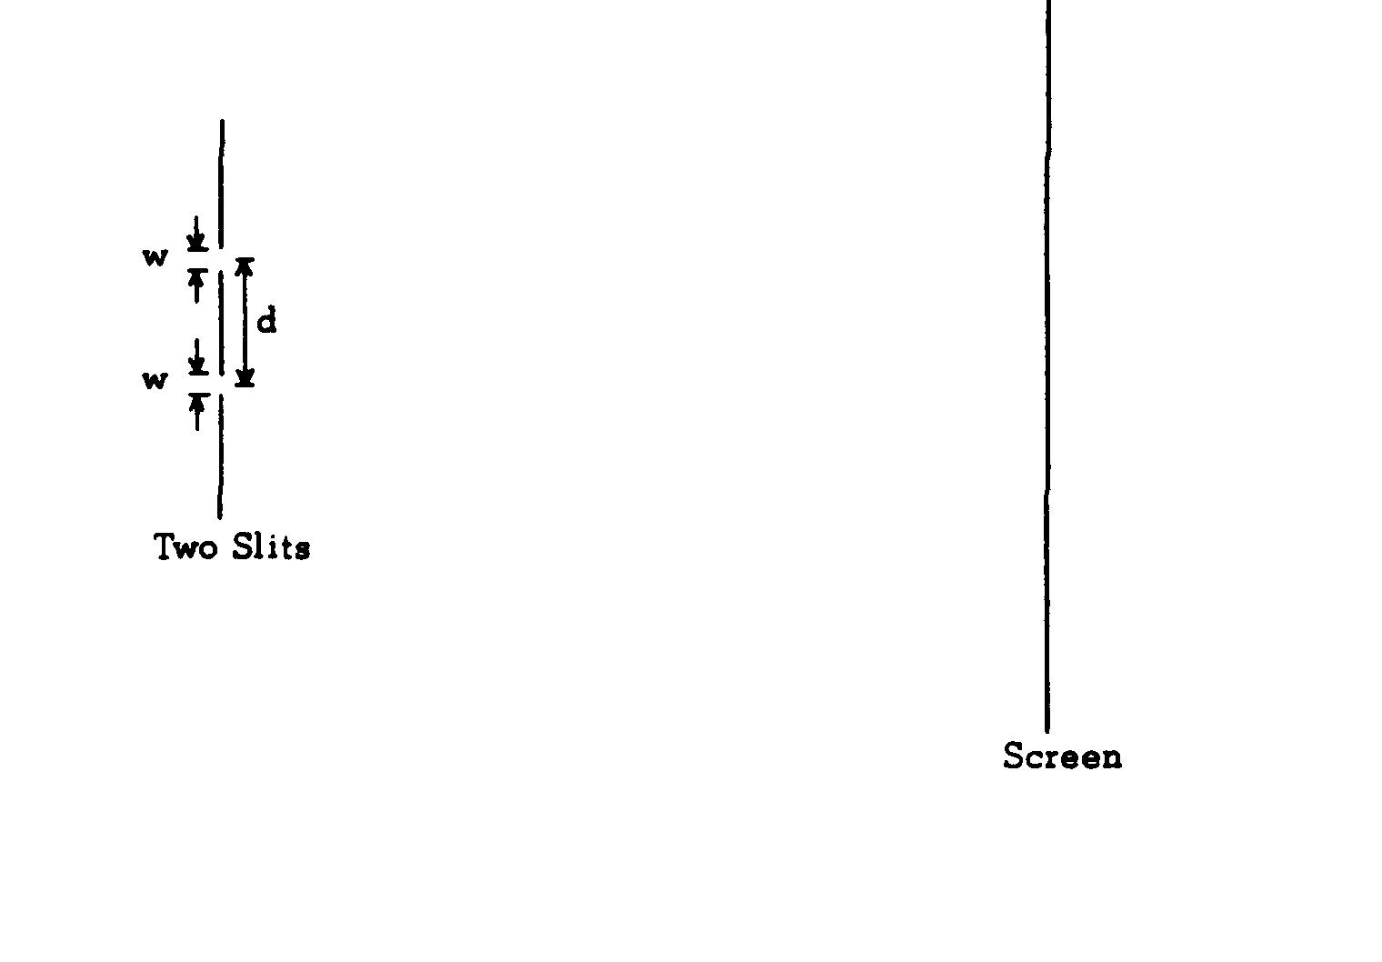
b. Repeat for the case in which there are two slits. The slits are of width w and are separated by a distance d (d >> w). Sketch a graph of the intensity as a function of position for the pattern formed on a distant screen.
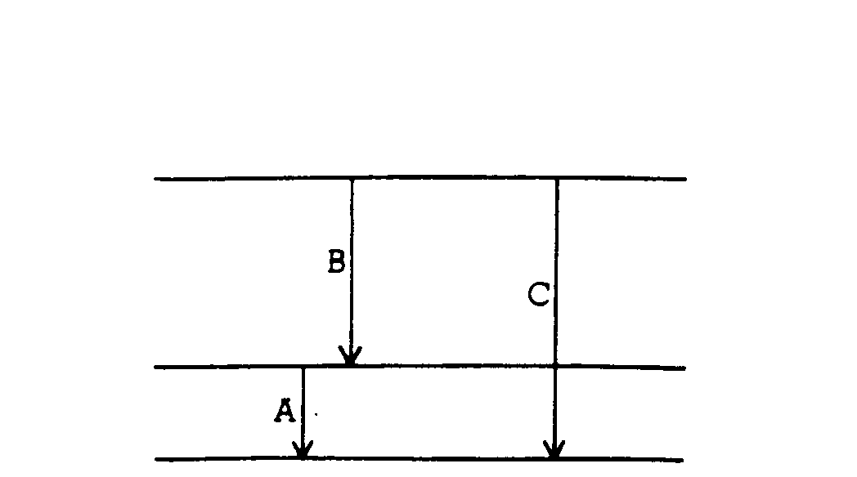
1975B5. The diagram above shows part of an energy-level diagram for a certain atom. The wavelength of the radiation associated with transition A is 600 nm (1 nm = 1 x 10 ⁻⁷ m) and that associated with transition B is 300 nm.
a. Determine the energy of a photon associated with transition A.
b. Determine the wavelength of the radiation associated with transition C.
c. Describe qualitatively what will happen to an intense beam of white light (400 to 600 nm) that is sent through this gaseous element

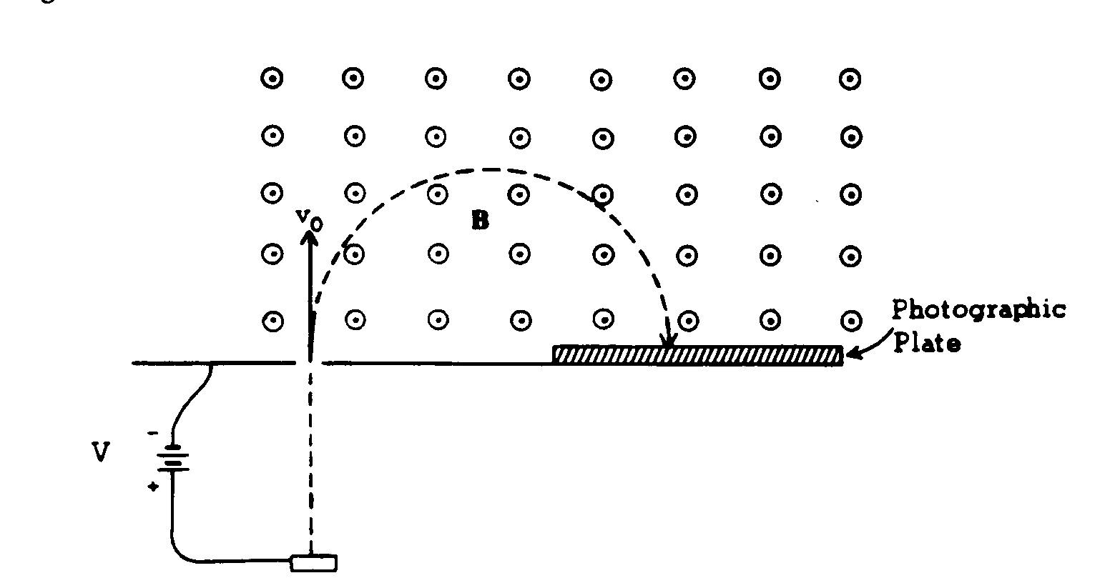
1975B6. In a mass spectrometer, singly charged ¹⁶O ions are first accelerated electrostatically through a voltage V to a speed v_{o}. They then enter a region of uniform magnetic field B directed out of the plane of the paper.
a. If singly charged ³²S ions are substituted for the ¹⁶O ions, what will be their speed for the same accelerating voltage?
b. When ³²S is substituted for ¹⁶O in part (a), determine by what factor the radius of curvature of the ions' path in the magnetic field changes.

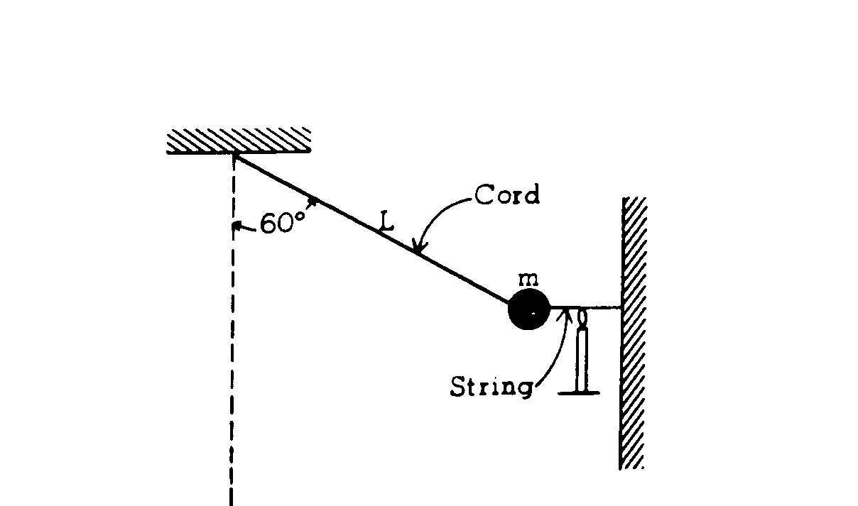
1975B7. A pendulum consists of a small object of mass m fastened to the end of an inextensible cord of length L. Initially, the pendulum is drawn aside through an angle of 60° with the vertical and held by a horizontal string as shown in the diagram above. This string is burned so that the pendulum is released to swing to and fro.
a. In the space below draw a force diagram identifying all of the forces acting on the object while it is held by the string.

b. Determine the tension in the cord before the string is burned.
c. Show that the cord, strong enough to support the object before the string is burned, is also strong enough to support the object as it passes through the bottom of its swing.
d. The motion of the pendulum after the string is burned is periodic. Is it also simple harmonic? Why, or why not?

