

AP® Physics B

1976 Free Response

The materials included in these files are intended for use by AP teachers for course
and exam preparation in the classroom; permission for any other use must be
sought from the Advanced Placement Program®. Teachers may reproduce them, in whole or in part, in limited quantities, for face-to-face teaching purposes but may
not mass distribute the materials, electronically or otherwise. These materials and
any copies made of them may not be resold, and the copyright notices must be
retained as they appear here. This permission does not apply to any third-party copyrights contained herein.

These materials were produced by Educational Testing Service® (ETS®), which develops and administers the examinations of the Advanced Placement
Program for the College Board. The College Board and Educational Testing Service (ETS) are dedicated to the principle of equal opportunity, and their
programs, services, and employment policies are guided by that principle.

The College Board is a national nonprofit membership association dedicated to preparing, inspiring, and connecting students to college and opportunity.
Founded in 1900, the association is composed of more than 4,200 schools, colleges, universities, and other educational organizations. Each year, the
College Board serves over three million students and their parents, 22,000 high schools, and 3,500 colleges, through major programs and services in
college admission, guidance, assessment, financial aid, enrollment, and teaching and learning. Among its best-known programs are the SAT®, the
PSAT/NMSQT®, and the Advanced Placement Program® (AP®). The College Board is committed to the principles of equity and
excellence, and that commitment is embodied in all of its programs, services, activities, and concerns.

APIEL is a trademark owned by the College Entrance Examination Board. PSAT/NMSQT is a registered trademark jointly owned by the College Entrance Examination Board and the National Merit Scholarship Corporation. Educational Testing Service and ETS are registered trademarks of Educational Testing Service.

Time—90 minutes
7 Questions
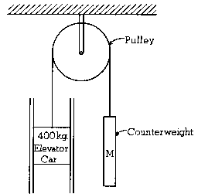
The two guide rails for the elevator shown above each exert a constant friction force of 100 newtons on the elevator car when the elevator car is moving upward with an acceleration of 2 meters per second squared. The pulley has negligible friction and mass. Assume g = 10 m/sec².

(a) On the diagram below, draw and label all forces acting on the elevator car. Identify the source of each force.
(b) Calculate the tension in the cable lifting the 400-kilogram elevator car during an upward acceleration of
2 m/sec². (Assume g 10 m/sec².)
(c) Calculate the mass M the counterweight must have to raise the elevator car with an acceleration of 2 m/sec².

2. 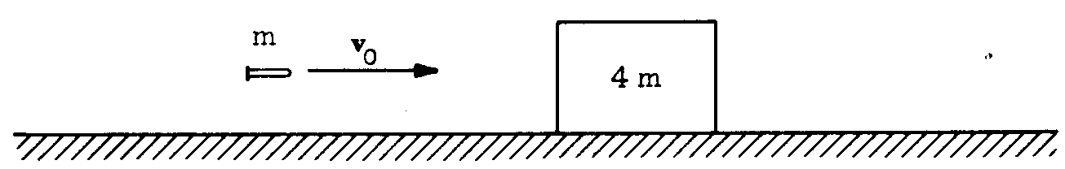
A bullet of mass m and velocity v₀ is fired toward a block of mass 4m. The block is initially at rest on a
frictionless horizontal surface. The bullet penetrates the block and emerges with a velocity of $\frac{v_{o}}{3}$

(a) Determine the final speed of the block.
(b) Determine the loss in kinetic energy of the bullet.
(c) Determine the gain in the kinetic energy of the block.

3. 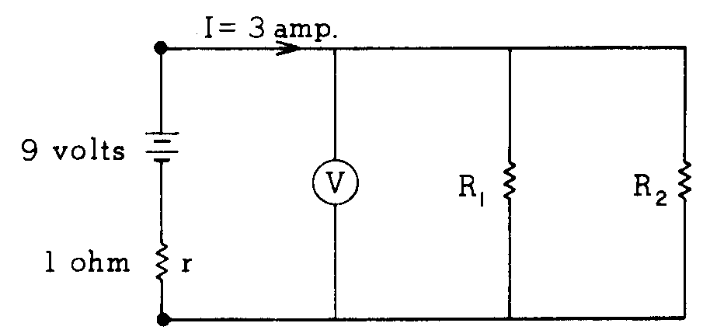
In the circuit shown above, the current delivered by the 9-volt battery of internal resistance 1 ohm is 3 amperes. The power dissipated in R₂ is 12 watts.

(a) Determine the reading of voltmeter V in the diagram.
(b) Determine the resistance of R₂.
(c) Determine the resistance of R₁.

4. 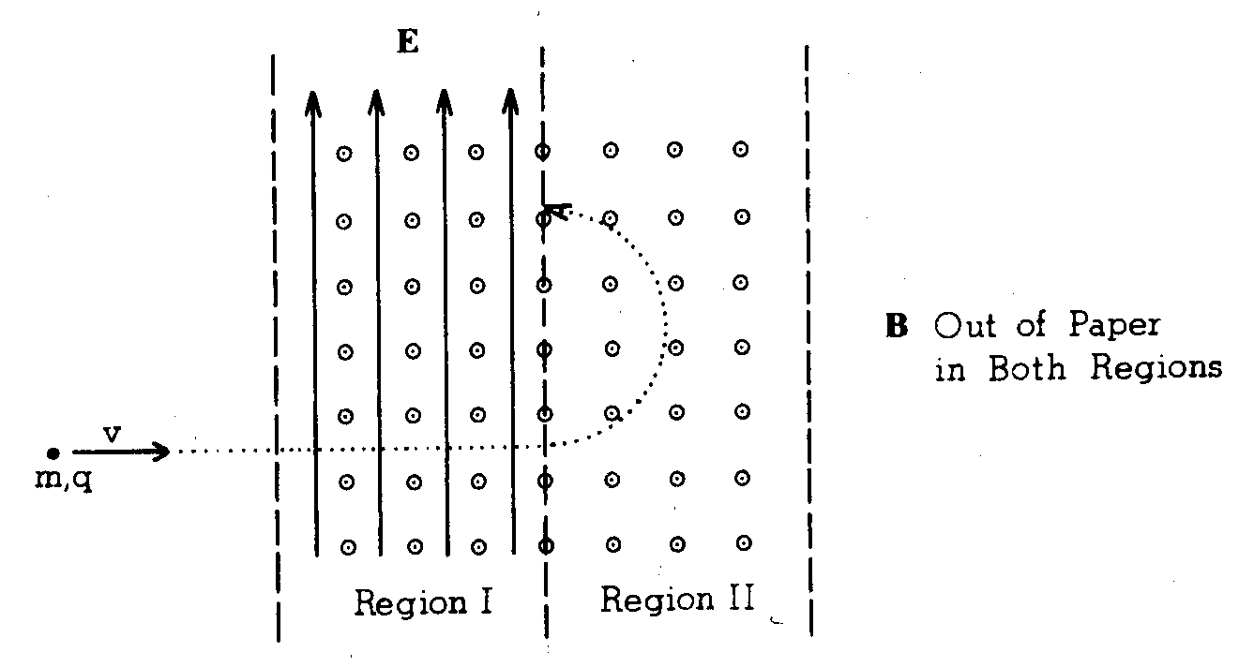
An ion of mass m and charge of known magnitude q is observed to move in a straight line through a region of space in which a uniform magnetic field B points out of the paper and a uniform electric field E points toward the top edge of the paper, as shown in region I above. The particle travels into region II in which the same magnetic field is present, but the electric field is zero. In region II the ion moves in a circular path as shown.

(a) Indicate on the diagram below the direction of the force on the ion at point P₂ in region II.
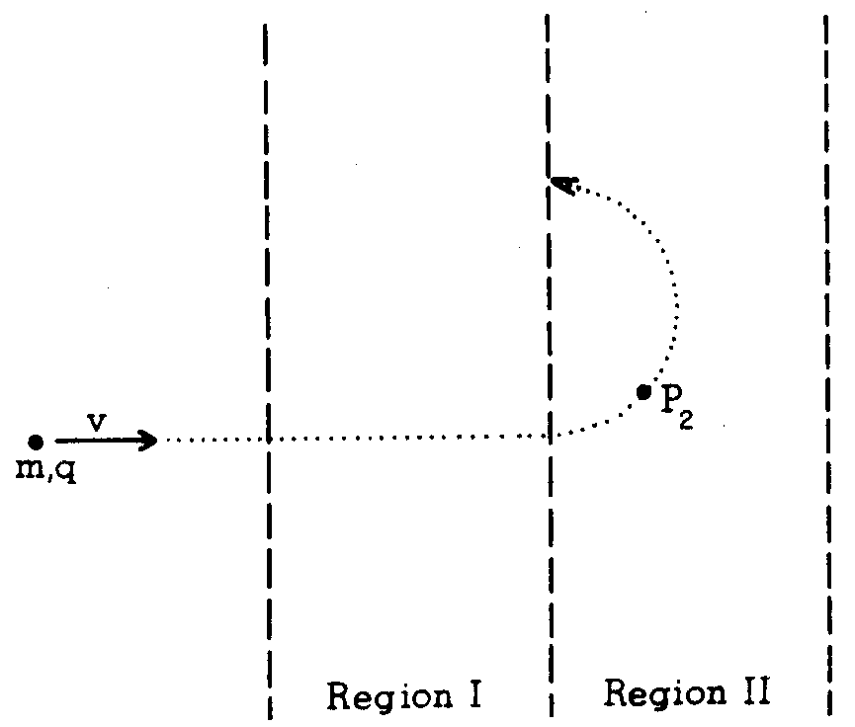

(b) Is the ion positively or negatively charged? Explain clearly the reasoning on which you base your conclusion.
(c) Indicate and label clearly on the diagram below the forces which act on the ion at point P₁ in region I.

(d) Find an expression for the ion’s speed v at point P₁ in terms of E and B.

5. (a) Explain why the temperature of the water at the base of a waterfall should be slightly higher than at the top of the fall.
(b) Calculate the minimum height of the waterfall that could cause a rise in water temperature of 1 Celsius degree. Explain clearly any assumptions you make. (Hint: Consider a given mass m of the water.)

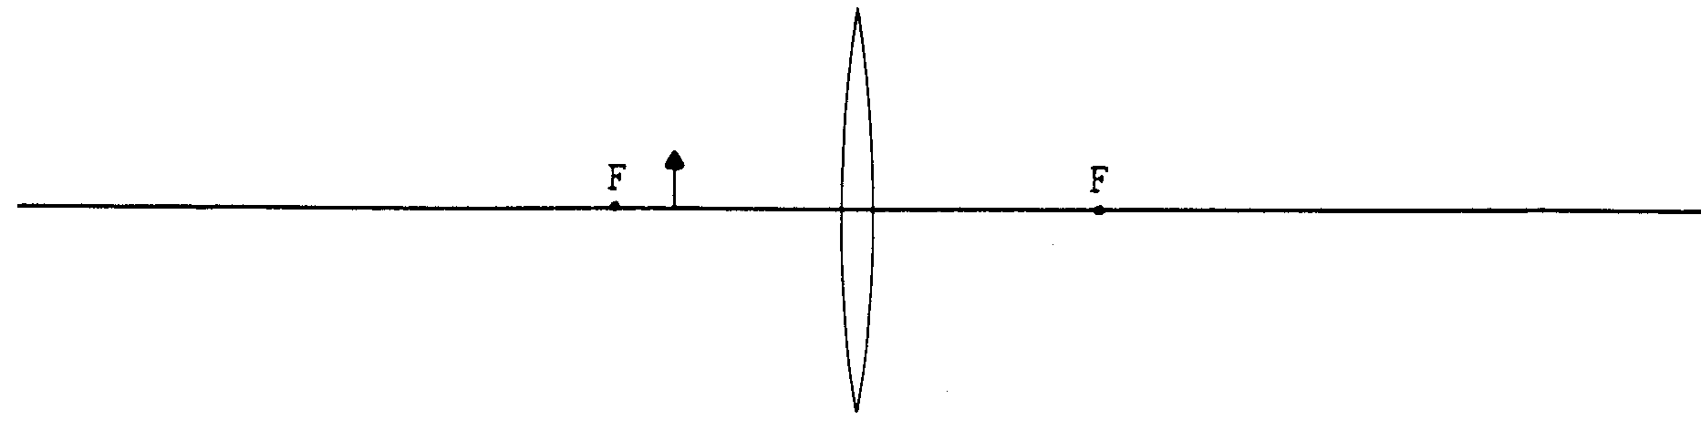
6. An object of height 1 centimeter is placed 6 centimeters to the left of a converging lens whose focal length is
8 centimeters, as shown on the diagram above.

(a) Calculate the position of the image. Is it to the left or right of the lens? Is it real or virtual?
(b) Calculate the size of the image. Is it upright or inverted?
(c) On the diagram, locate the image by ray tracing.
(d) What simple optical instrument uses this sort of object-image relationship?

7. Light of wavelength λ₁ incident on a clean metal surface ejects photoelectrons of maximum kinetic energy KE_{max}

(a) Discuss the effect on the photoelectrons as the wavelength of the incident radiation is made longer and longer.
(b) Discuss the effect on the photoelectrons if the intensity of the radiation is gradually increased, while the wavelength remains constant at
(c) State an experimental observation in a photoelectric experiment that is not satisfactorily explained by a wave model of light.

END OF EXAMINATION

