Copyright © 1977 Educational Testing Service. All rights reserved. Princeton, NJ 08541
For face-to-face teaching purposes, classroom teachers are permitted to reproduce only the questions from this green insert.

1977 B1. A block of mass 4 kilograms, which has an initial speed of 6 meters per second at time t = 0, slides on a horizontal surface.
a. Calculate the work W that must be done on the block to bring it to rest.
If a constant friction force of magnitude 8 newtons is exerted on the block by the surface, determine the following:
b. The speed v of the block as a function of the time t.
c. The distance x that the block slides as it comes to rest

1977 B2. A box of mass M, held in place by friction, rides on the flatbed of a truck which is traveling with constant speed v. The truck is on an unbanked circular roadway having radius of curvature R.
a. On the diagram provided above, indicate and clearly label all the force vectors acting on the box.
b. Find what condition must be satisfied by the coefficient of static friction μ between the box and the truck bed. Express your answer in terms of v, R, and g.

If the roadway is properly banked, the box will still remain in place on the truck for the same speed v even when the truck bed is frictionless.
c. On the diagram below indicate and clearly label the two forces acting on the box under these conditions

d. Which, if either, of the two forces acting on the box is greater in magnitude?
1977B3 An electron is accelerated from rest through a potential difference of magnitude V between infinite parallel plates P₁ and P₂. The electron then passes into a region of uniform magnetic field strength B which exists everywhere to the right of plate P₂. The magnetic field is directed into the page.
a. On the diagram above, clearly indicate the direction of the electric field between the plates.
b. In terms of V and the electron’s mass and charge, determine the electron's speed at plate P₂.
c. Describe in detail the motion of the electron through the magnetic field and explain why the electron moves this way.
d. If the magnetic field remains unchanged, what could be done co cause the electron to follow a straight-line path to the right of plate P₂?
1977B4. 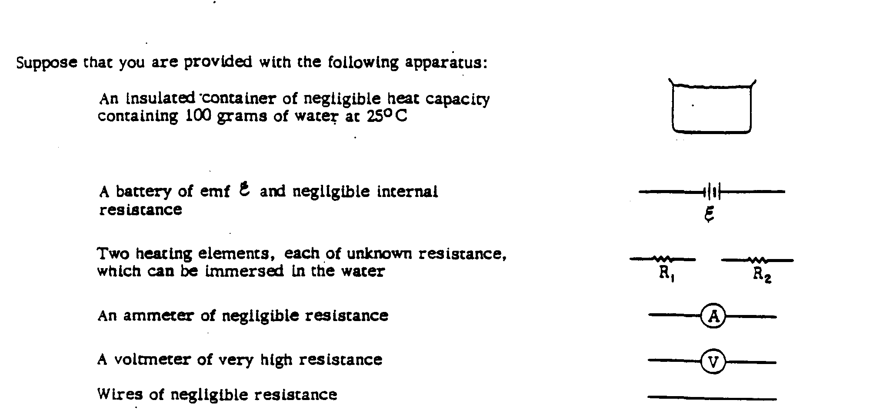
a. In the space below draw a diagram, using the symbols described above, to show how you should connect these components to heat the water as rapidly as possible. The meters should be connected so that from the two meter readings alone you could determine at what rate the water is being heated.

b. Suppose the emf ε of the battery is 50 volts and the current through the battery is 5 amperes. Assume the specific heat of the water is 4 joules per gram per Celsius degree, and the heat of vaporization is 2,200 joules per gram. Calculate the number of seconds required for all the water to boil away.
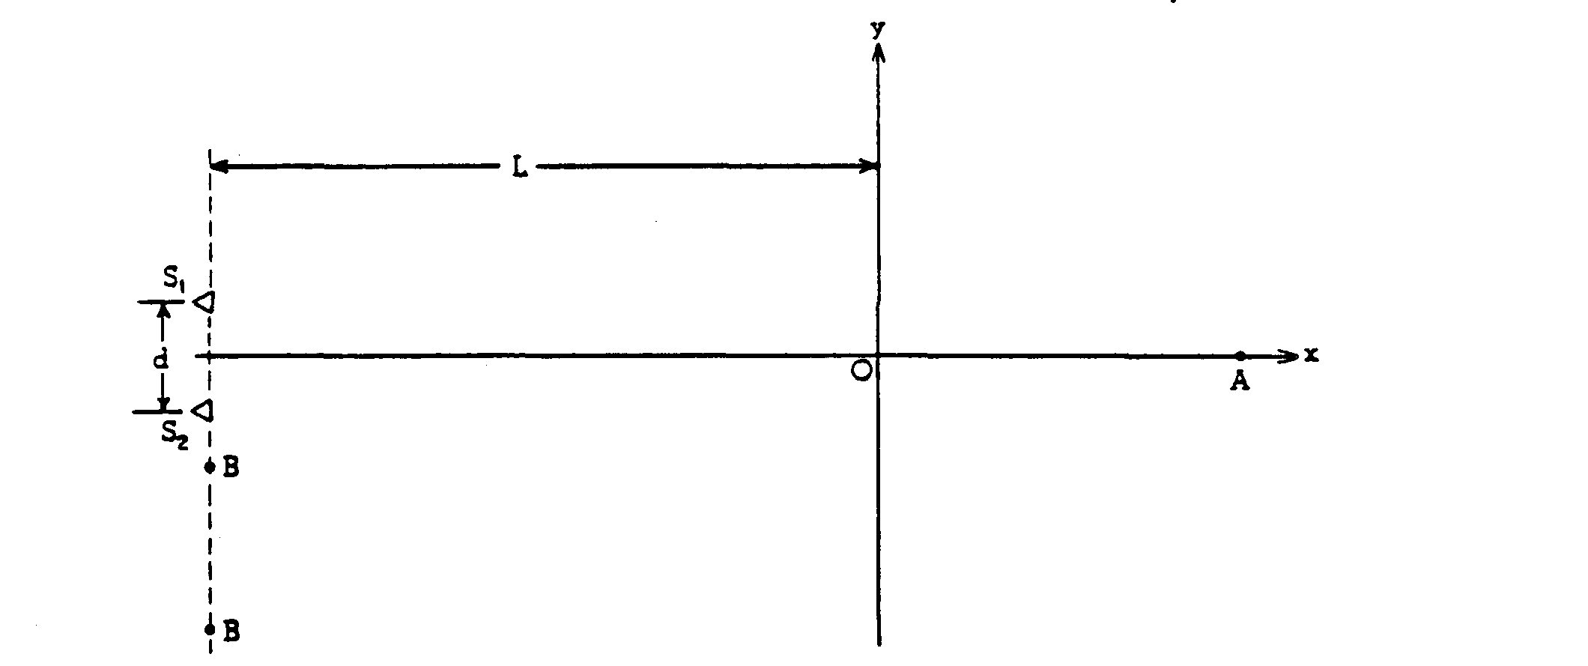
1977B5. Two loudspeakers, S₁ and S₂ a distance d apart as shown in the diagram above, vibrate in phase and emit sound waves of equal amplitude and wavelength λ. Assume d << L
a. Describe how sound intensity I varies as a function of position x along the line segment OA. Sketch the graph of this function on the axes below.
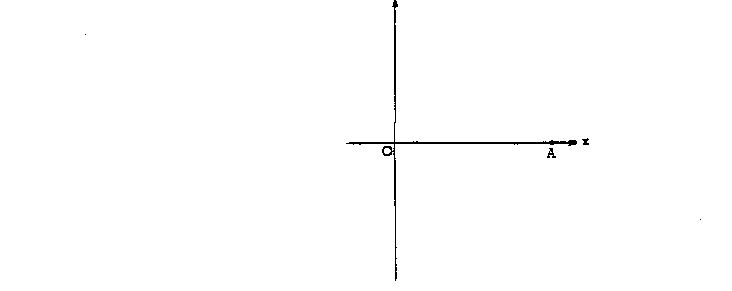

Assume lambda << d On the axes provided below sketch a graph of the sound intensity I as a function of position y along the y axis.
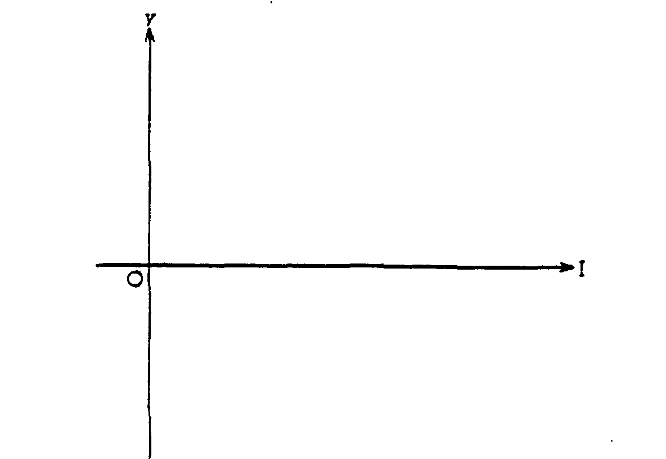
d. Assume that d = 2 meters and that the speed of sound is 360 meters per second. Find the lowest speaker frequency which will yield the minimum sound intensity along the line BB'.

1977B6. Sketch freehand graphs for 5 (only) of the following 7 graphs. Assume that the axes have linear scales and that the zero for each axis is at the origin. When appropriate, point out significant features of the graph which will reveal your understanding of the phenomenon involved. (Note: Cross out the two graphs you do not wish to be graded. Presenting more than 5 graphs will NOT improve your score. The first 5 graphs will be graded if you do not cross out two.)
