

AP® Physics B

1978 Free Response

The materials included in these files are intended for use by AP teachers for course
and exam preparation in the classroom; permission for any other use must be
sought from the Advanced Placement Program®. Teachers may reproduce them, in whole or in part, in limited quantities, for face-to-face teaching purposes but may
not mass distribute the materials, electronically or otherwise. These materials and
any copies made of them may not be resold, and the copyright notices must be
retained as they appear here. This permission does not apply to any third-party copyrights contained herein.

These materials were produced by Educational Testing Service® (ETS®), which develops and administers the examinations of the Advanced Placement
Program for the College Board. The College Board and Educational Testing Service (ETS) are dedicated to the principle of equal opportunity, and their
programs, services, and employment policies are guided by that principle.

The College Board is a national nonprofit membership association dedicated to preparing, inspiring, and connecting students to college and opportunity.
Founded in 1900, the association is composed of more than 4,200 schools, colleges, universities, and other educational organizations. Each year, the
College Board serves over three million students and their parents, 22,000 high schools, and 3,500 colleges, through major programs and services in
college admission, guidance, assessment, financial aid, enrollment, and teaching and learning. Among its best-known programs are the SAT®, the
PSAT/NMSQT®, and the Advanced Placement Program® (AP®). The College Board is committed to the principles of equity and
excellence, and that commitment is embodied in all of its programs, services, activities, and concerns.

APIEL is a trademark owned by the College Entrance Examination Board. PSAT/NMSQT is a registered trademark jointly owned by the College Entrance Examination Board and the National Merit Scholarship Corporation. Educational Testing Service and ETS are registered trademarks of Educational Testing Service.
The College Board
Advanced Placement Examination
PHYSICS B
SECTION II
Time—90 minutes
7 Questions
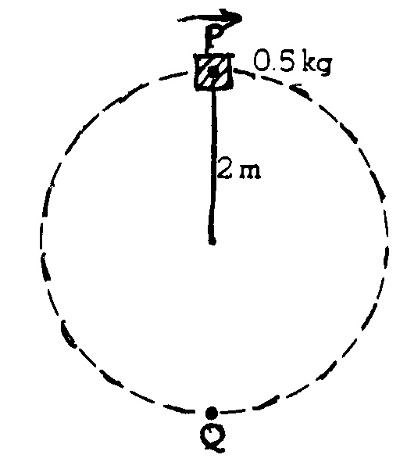
1. A 0.5-kilogram object rotates freely in a vertical circle at the end of a string of length 2 meters as shown above. As the object passes through point P at the top of the circular path, the tension in the string is 20 newtons. Assume g = 10 meters per second squared.

(a) On the following diagram of the object, draw and clearly label all significant forces on the object when it is at the point P.

(b) Calculate the speed of the object at point P.
(c) Calculate the increase in kinetic energy of the object as it moves from point P to point Q.
(d) Calculate the tension in the string as the object passes through point Q.

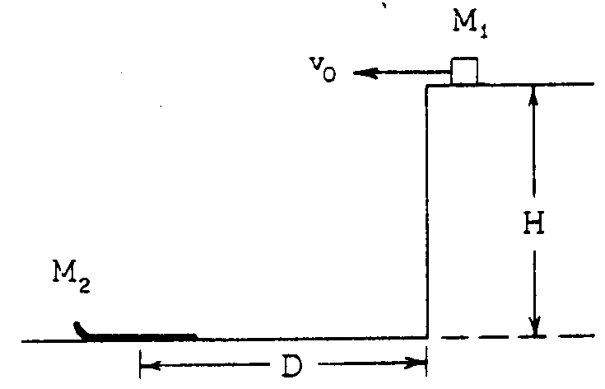
2. A block of mass M₁ travels horizontally with a constant speed v₀ on a plateau of height H until it comes to a cliff. A toboggan of mass M₂ is positioned on level ground below the cliff as shown above. The center of the toboggan is a distance D from the base of the cliff.

(a) Determine D in terms of v₀, H, and g so that the block lands in the center of the toboggan.
(b) The block sticks to the toboggan which is free to slide without friction. Determine the resulting velocity of the block and toboggan.

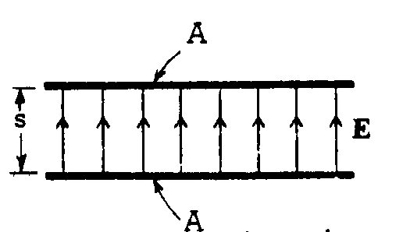
3. A uniform electric field E is established between two capacitor plates, each of area A, which are separated by a distance s as shown above.

(a) What is the electric potential difference V between the plates?
(b) Specify the sign of the charge on each plate.

The capacitor above is then connected electrically through a resistor to a second parallel-plate capacitor, initially uncharged, whose plates have the same area A but a separation of only s/2.

(c) Indicate on the diagram below the direction of the current in each wire, and explain why the current will
eventually cease.
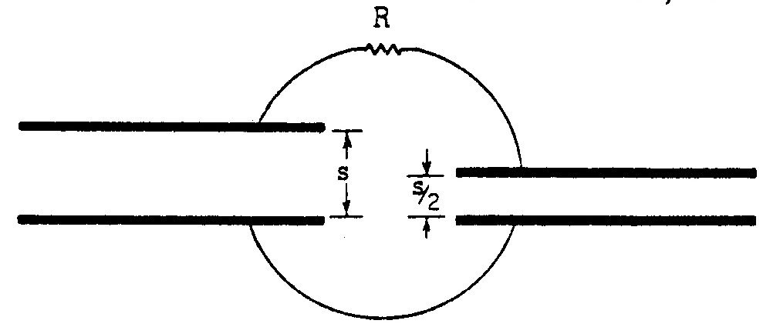
(d) After the current has ceased, which capacitor has the greater charge? Explain your reasoning.
(e) The total energy stored in the two capacitors after the current has ceased is less than the initial stored energy. Explain qualitatively what has become of this “lost” energy.
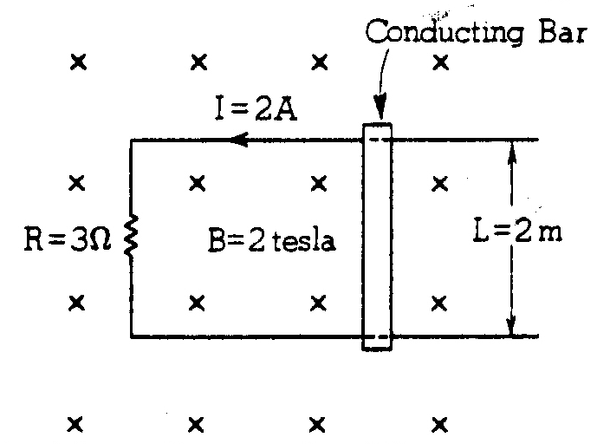
4. Two parallel conducting rails, separated by a distance L of 2 meters, are connected through a resistance R of
3 ohms as shown above. A uniform magnetic field with a magnitude B of 2 tesla points into the page. A conducting bar with mass m of 4 kilograms can slide without friction across the rails.

(a) Determine at what speed the bar must be moved, and in what direction, to induce a counterclockwise current I of 2 amperes as shown.
(b) Determine the magnitude and direction of the external force that must be applied to the bar to keep it moving at this velocity.
(c) Determine the rate at which heat is being produced in the resistor and determine the mechanical power being supplied to the bar.
(d) Suppose the external force is suddenly removed from the bar. Determine the energy in joules dissipated in the resistor before the bar comes to rest.
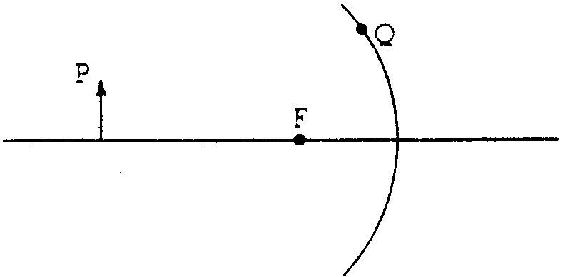
5. An object 6 centimeters high is placed 30 centimeters from a concave mirror of focal length 10 centimeters as shown above.

(a) On the diagram above, locate the image by tracing two rays that begin at point P and pass through the focal point F. Is the image real or virtual? Is it located to the left or to the right of the mirror?
(b) Calculate the position of the image.
(c) Calculate the size of the image.
(d) Indicate on the diagram above how the ray from point P to point Q is reflected, if aberrations are negligible.

6. An object of mass 0.5 kilogram (500 grams) is at rest on a frictionless surface. A burst of 10²⁰ photons strikes the object and all the photons are completely absorbed. Each photon has an energy of 100 electron volts =
1.6 x 10⁻¹⁷ joule. As a result of absorbing the photons, the object’s temperature rises 5 K.
(a) Calculate the momentum of a single photon.
(b) Calculate the speed of the object after it has absorbed the photons.
(c) If, instead, all the photons had been reflected, how would the answer to part (b) be changed?
(d) Calculate the specific heat of the material of which the object is made.

7. A particle of mass m moves back and forth between two solid walls separated by a distance L. Theory predicts that the only allowed values of the particle’s kinetic energy are given by the equation E_{n} = $\frac{n^{2}h^{2}}{{\text{8mL}}^{2}}$, where h is Planck’s constant and n = 1, 2, 3,...

(a) Determine the longest wavelength of light, λ_{max}, that this system can absorb when it is in its ground state,
n = 1.
(b) Show that the de Broglie wavelength of the particle for any value of n is given by $λ_{n}=\frac{\text{2L}}{n}$
(c) Describe one other physical system for which the same relation given in part (b) between a wavelength λ_{n} and a distance L holds.

END OF EXAMINATION

