Copyright © 1979 Educational Testing Service. All rights reserved. Princeton, NJ 08541
For face-to-face teaching purposes, classroom teachers are permitted to reproduce only the questions from this green insert.

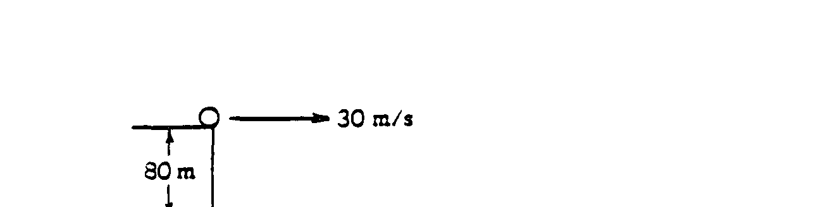
1979B1. From the top of a cliff 80 meters high, a ball of mass 0.4 kilogram is launched horizontally with a velocity of 30 meters per second at time t = 0 as shown above. The potential energy of the ball is zero at the bottom of the cliff. Use g = 10 meters per second squared.
a. Calculate the potential, kinetic, and total energies of the ball at time t = O.
b. On the axes below, sketch and Label graphs of the potential, kinetic, and total energies of the ball as functions of the distance fallen from the top of the cliff
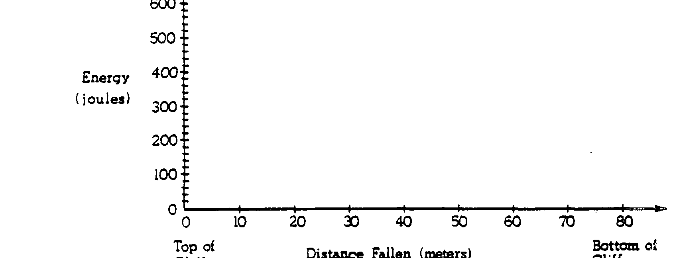
cliff
cliff

c. On the axes below sketch and label the kinetic and potential energies of the ball as functions of time until the ball hits
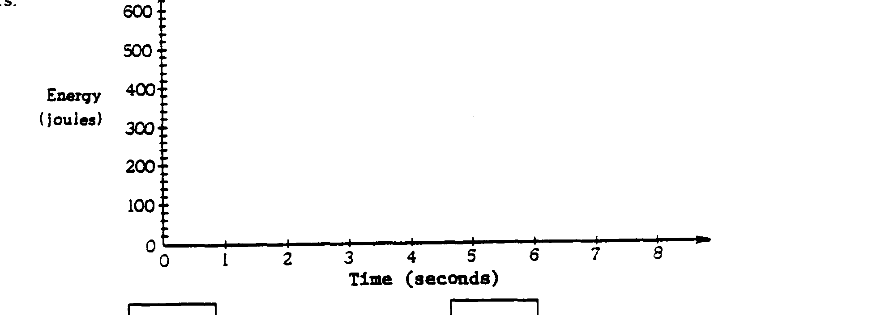

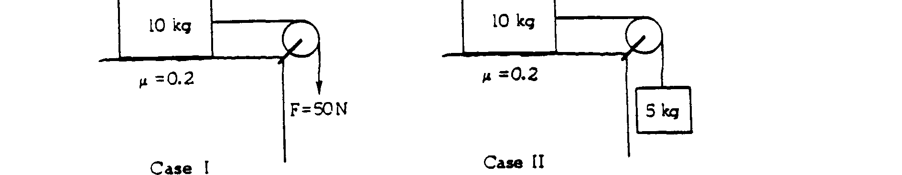
1979B2. A 10-kilogram block rests initially on a table as shown in cases I and II above. The coefficient of sliding friction between the block and the table is 0.2. The block is connected to a cord of negligible mass, which hangs over a massless frictionless pulley. In case I a force of 50 newtons is applied to the cord. In case II an object of mass 5 kilograms is hung on the bottom of the cord. Use g = 10 meters per second squared.
a. Calculate the acceleration of the 10-kilogram block in case I.
b. On the diagrams below, draw and label all the forces acting on each block in case II

c. Calculate the acceleration of the 10-kilogram block in case II.

1979B3. A group of muons is observed to pass a balloon at a height of 480 meters above the Earth's surface. The muons move at a speed of 0.8c straight down towards the Earth's surface.
a. Calculate the time for the muons to travel from the balloon to the Earth's surface as determined by an observer on the Earth.
b. Calculate the time for the muons to travel from the balloon to the Earth's surface as determined by an observer moving with the muons. Explain your reasoning.
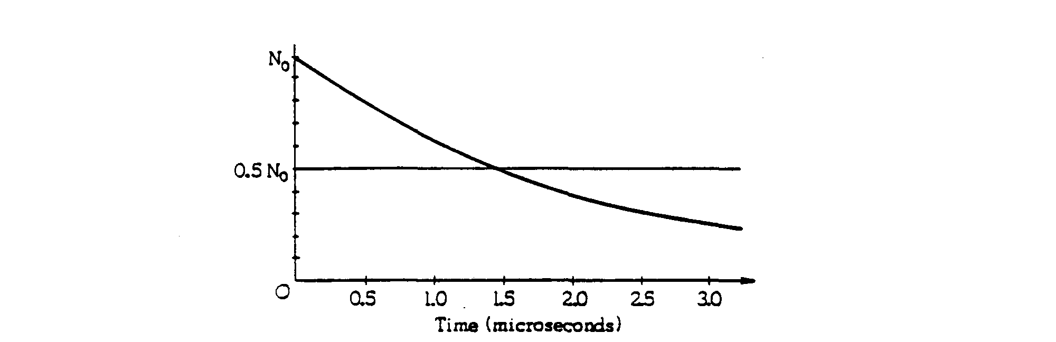

c. Stationary muons decay as shown in the figure above. Assume no muons pass the balloon at time t = 0 and determine the number that reach the Earth's surface. Give reasons for your answer.
1979B4. Determine the magnitude and direction of the force on a proton in each of the following situations. Describe qualitatively the path followed by the proton in each situation and sketch the path on each diagram. Neglect gravity.
a. The proton is released from rest at the point P in an electric field E having intensity 10⁴ newtons per coulomb and directed up in the plane of the page as shown below.
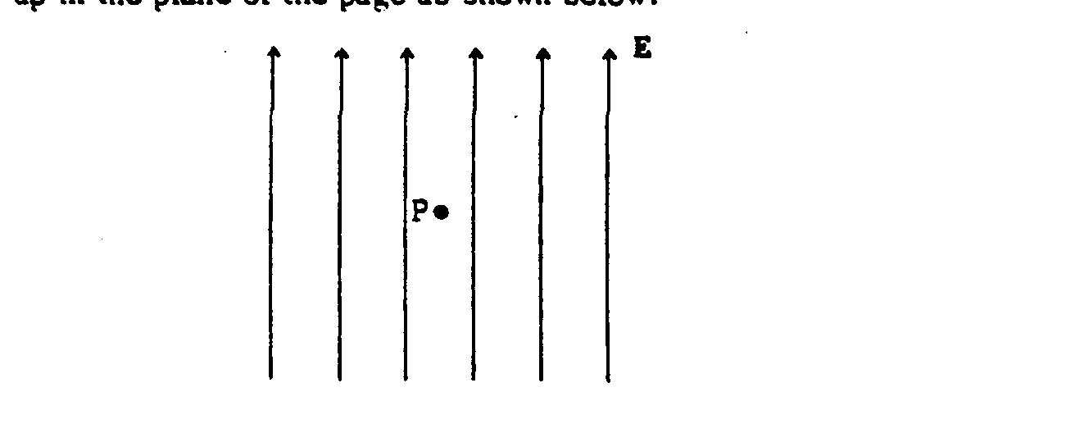

b. In the same electric field as in part (a), the proton at point P has velocity v = 10⁵ meters per second directed to the right as shown below.
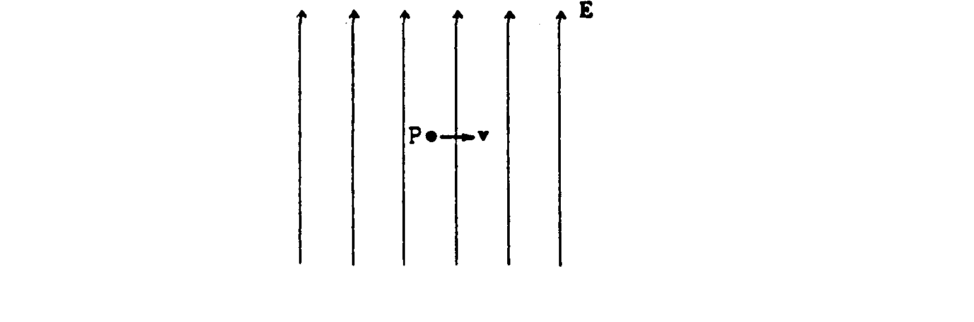
c. The proton is released from rest at point P in a magnetic field B having intensity 10^{-l} tesla and directed into the page as shown below.

d. In the same magnetic field as in part (c), the proton at point P has velocity v = 10⁵ meters per second
directed to the right as shown below.

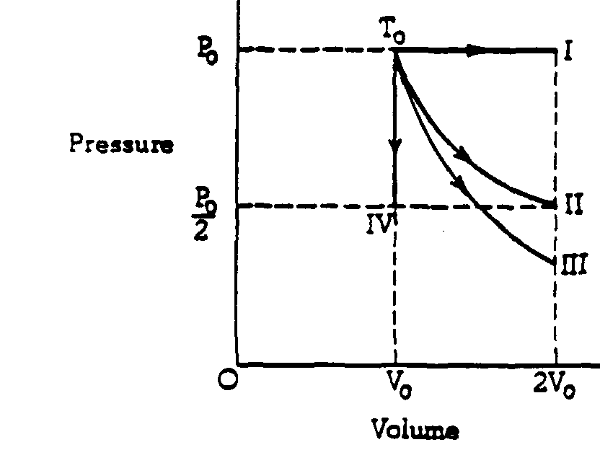

1979B5. Four samples of ideal gas are each initially at a pressure P_{o} and volume V_{o}, and a temperature T_{o} as shown on the diagram above. The samples are taken in separate experiment from this initial state to the final states I, II, III, and IV along the processes shown on the diagram.
a. One of the processes is isothermal. Identify which one and explain.
b. One of the processes is adiabatic. Identify this one and explain.
c. in which process or processes does the gas do work? Explain.
d. In which process or processes is heat removed from the gas? Explain.
e. In which process or processes does the root-mean-square speed of the gas molecules increase? Explain.

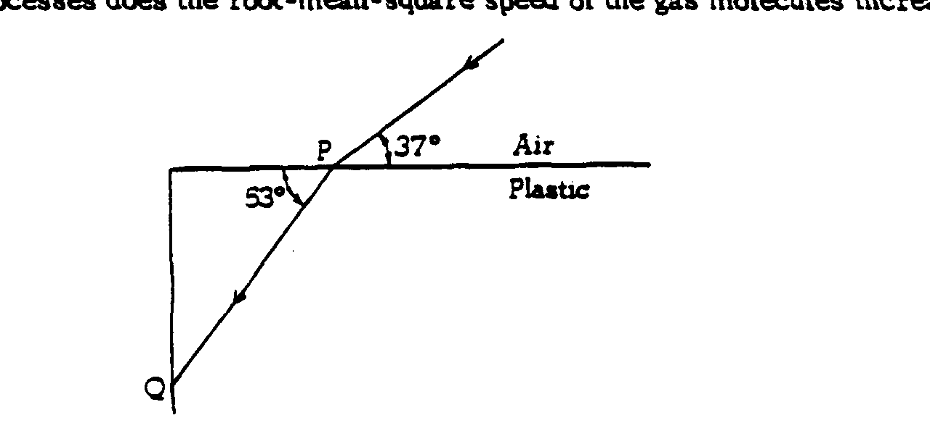
1979B6. A light ray enters a block of plastic and travels along the path shown above.
a. By considering the behavior of the ray at point P, determine the speed of light in the plastic.
b. Determine what will happen to the light ray when it reaches point Q, using the diagram above to illustrate your conclusion.
c. There is an air bubble In the plastic block that happens co be shaped like a plano-convex lens as shown below. Sketch what happens to parallel rays of light that strike this air bubble. Explain your reasoning.
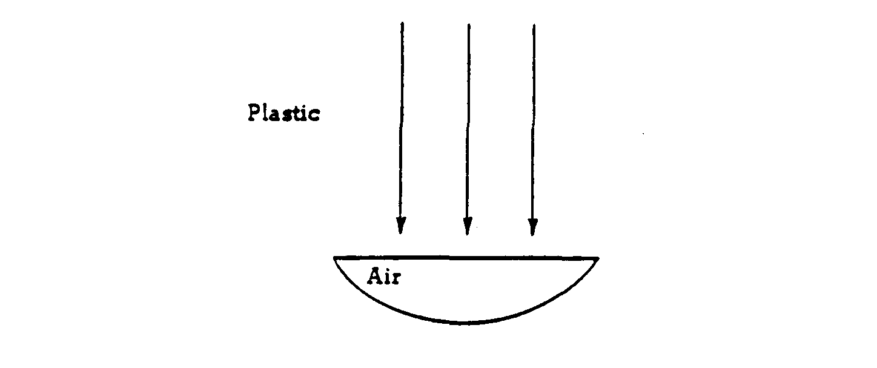

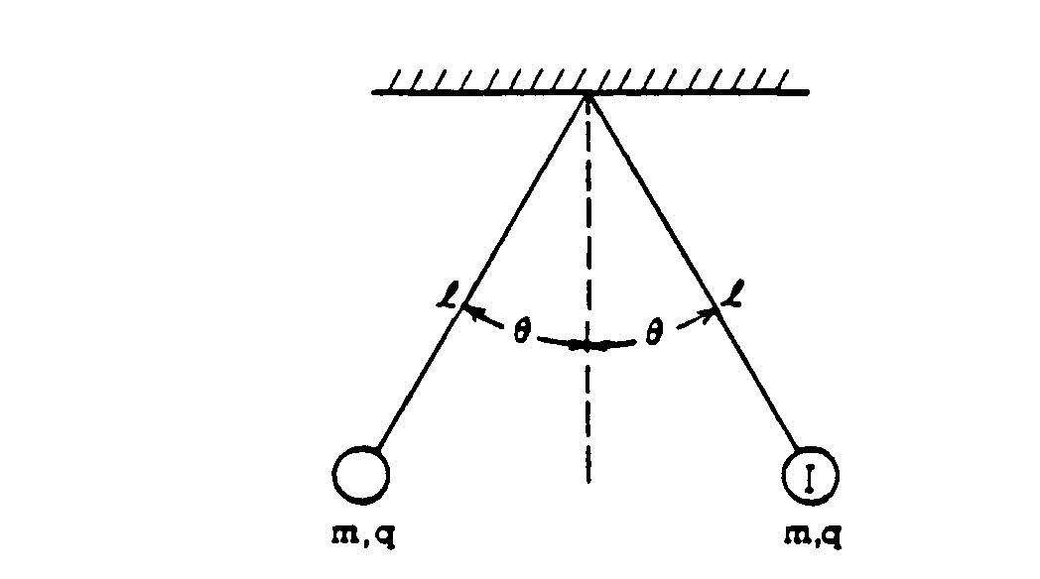
1979B7. Two small spheres, each of mass m and positive charge q, hang from light threads of lengths l. Each thread makes an angle θ with the vertical as shown above.
a. On the diagram below draw and label all forces on sphere I.
b. Develop an expression for the charge q in terms of m, l, θ, g, and the Coulomb's law constant.

