Copyright © 1987 Educational Testing Service. All rights reserved. Princeton, NJ 08541
For face-to-face teaching purposes, classroom teachers are permitted to reproduce only the questions from this green insert.

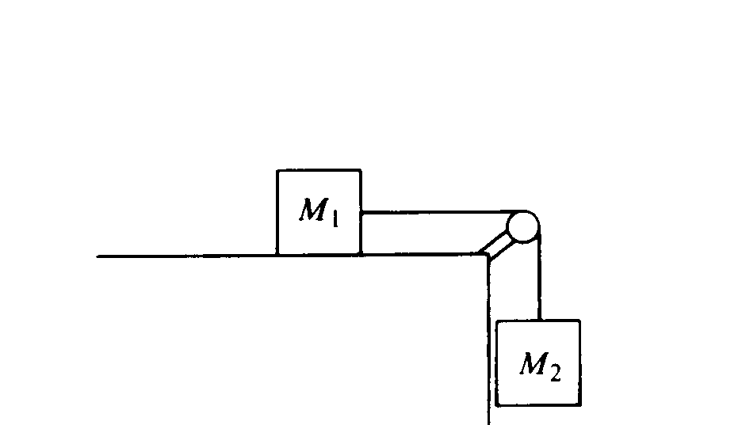
1987B1. In the system shown above, the block of mass M₁ is on a rough horizontal table. The string that attaches it to the block of mass M₂ passes over a frictionless pulley of negligible mass. The coefficient of kinetic friction μ_{k} between M₁ and the table is less than the coefficient of static friction μ_{s}
a. On the diagram below, draw and identify all the forces acting on the block of mass M₁.

b. In terms of M₁ and M₂ determine the minimum value of μ_{s} that will prevent the blocks from moving.

The blocks are set in motion by giving M₂ a momentary downward push. In terms of M₁, M₂, μ_{k}, and g, determine each of the following:
c. The magnitude of the acceleration of M₁
d. The tension in the string.
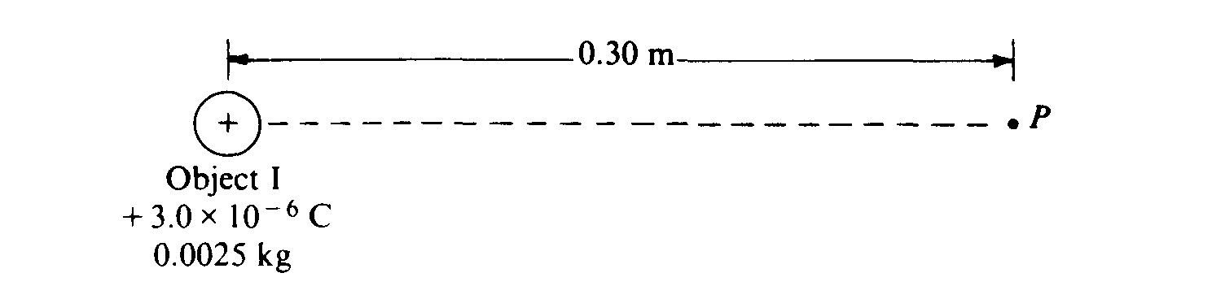
1987B2. Object I, shown above, has a charge of + 3 x 10⁻⁶ coulomb and a mass of 0.0025 kilogram.
a. What is the electric potential at point P, 0.30 meter from object I ?

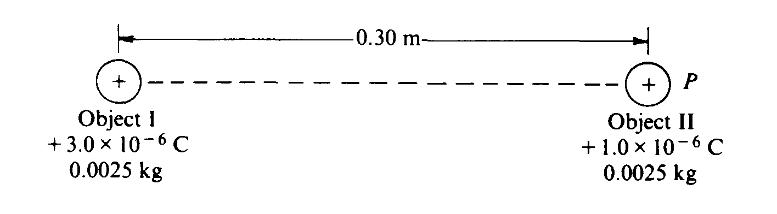
Object II, of the same mass as object I, but having a charge of + 1 x 10⁻⁶ coulomb, is brought from infinity to point P, as shown above.
b. How much work must be done to bring the object II from infinity to point P ?
c. What is the magnitude of the electric force between the two objects when they are 0.30 meter apart?
d. What are the magnitude and direction of the electric field at the point midway between the two objects?

The two objects are then released simultaneously and move apart due to the electric force between them. No other forces act on the objects.
e. What is the speed of object I when the objects are very far apart?

1987B3. A freezer contains 20 kilograms of food with a specific heat of 2 x 10³ J/kg°C. The temperature inside the freezer is initially -5º C. The freezer motor then operates for 10 minutes, reducing the temperature to - 8° C.
a. How much heat is removed from the food during this time? The freezer motor operates at 400 watts.
b. How much energy is delivered to the freezer motor during the 10-minute period?
c. During this time, how much total heat is ejected into the room in which the freezer is located?
d. Determine the temperature change in the room if the specific heat of air is 700 J/kg°C Assume there are 80 kilograms of air in the room, the volume of the air is constant, and there is no heat loss from the room.
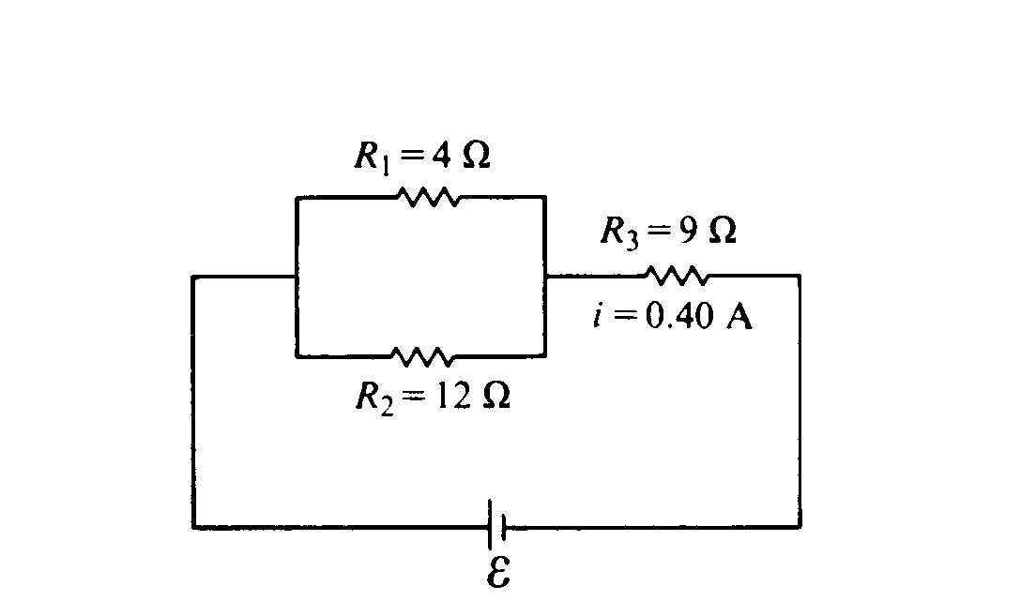
1987B4. Three resistors are arranged in a circuit as shown above. The battery has an unknown but constant emf E and a negligible internal resistance.
a. Determine the equivalent resistance of the three resistors. The current I in resistor R₃ is 0.40 ampere.
b. Determine the emf E (Voltage) of the battery.
c. Determine the potential difference across resistor R₁
d. Determine the power dissipated in resistor R₁
e. Determine the amount of charge that passes through resistor R₃ in one minute.

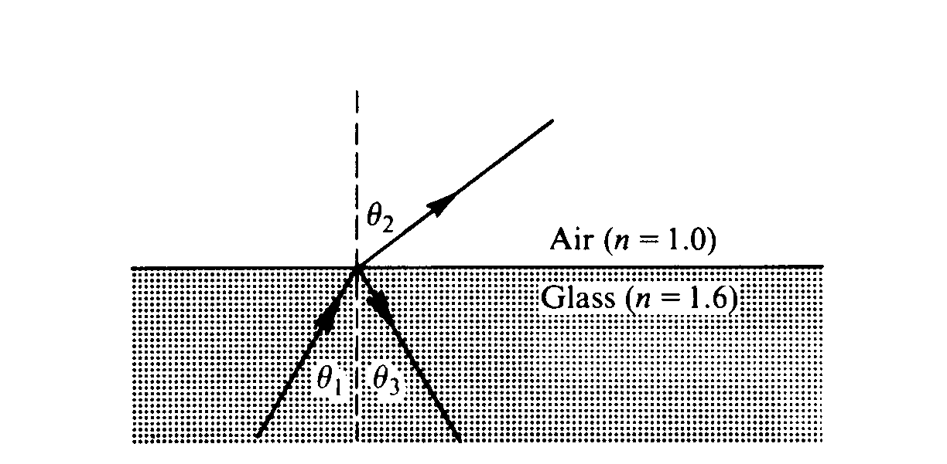
1987B5. Light of frequency 6.0 x 10¹⁴ hertz strikes a glass/air boundary at an angle of incidence θ₁. The ray is partially reflected and partially refracted at the boundary, as shown above. The index of refraction of this glass is 1.6 for light of this frequency.
a. Determine the value of θ₃ if θ₁ = 30°.
b. Determine the value of θ₂ if θ₁ = 30°.
c. Determine the speed of this light in the glass.
d. Determine the wavelength of this light in the glass.
e. What is the largest value of θ₁ that will result in a refracted ray?
1987B6. In a photoelectric experiment, light is incident on a metal surface. Electrons are ejected from the surface, producing a current in a circuit. A reverse potential is applied in the circuit and adjusted until the current drops to zero. That potential at which the current drops to zero is called the stopping potential. The data obtained for a range of frequencies are graphed below.
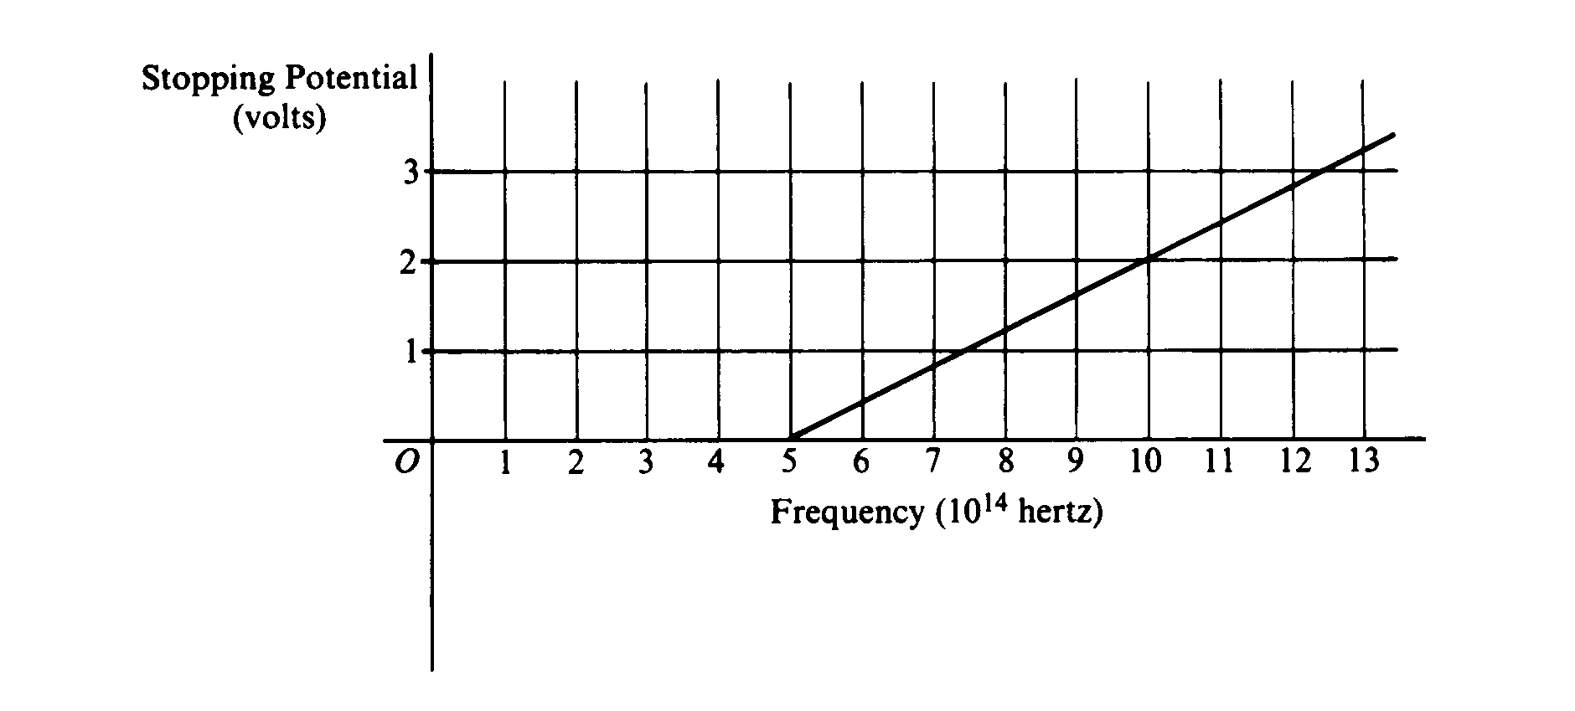
a. For a frequency of light that has a stopping potential of 3 volts, what is the maximum kinetic energy of the ejected photoelectrons?
b. From the graph and the value of the electron charge, determine an experimental value for Planck's constant.
c. From the graph, determine the work function for the metal.
d. On the axes above, draw the expected graph for a different metal surface with a threshold frequency of 6.0 x 10¹⁴ hertz.

