

AP® Physics B
1990 Free response Questions

The materials included in these files are intended for use by AP teachers for course and exam preparation in the classroom; permission for any other use must be sought from the Advanced Placement Program®. Teachers may reproduce them, in whole or in part, in limited quantities, for face-to-face teaching purposes but may not mass distribute the materials, electronically or otherwise. These materials and any copies made of them may not be resold, and the copyright notices must be retained as they appear here. This permission does not apply to any third-party copyrights contained herein.

These materials were produced by Educational Testing Service® (ETS®), which develops and administers the examinations of the Advanced Placement
Program for the College Board. The College Board and Educational Testing Service (ETS) are dedicated to the principle of equal opportunity, and their
programs, services, and employment policies are guided by that principle.

The College Board is a national nonprofit membership association dedicated to preparing, inspiring, and connecting students to college and opportunity.
Founded in 1900, the association is composed of more than 4,200 schools, colleges, universities, and other educational organizations. Each year, the
College Board serves over three million students and their parents, 22,000 high schools, and 3,500 colleges, through major programs and services in
college admission, guidance, assessment, financial aid, enrollment, and teaching and learning. Among its best-known programs are the SAT®, the
PSAT/NMSQT®, and the Advanced Placement Program® (AP®). The College Board is committed to the principles of equity and
excellence, and that commitment is embodied in all of its programs, services, activities, and concerns.

APIEL is a trademark owned by the College Entrance Examination Board. PSAT/NMSQT is a registered trademark jointly owned by the College Entrance Examination Board and the National Merit Scholarship Corporation. Educational Testing Service and ETS are registered trademarks of Educational Testing Service.
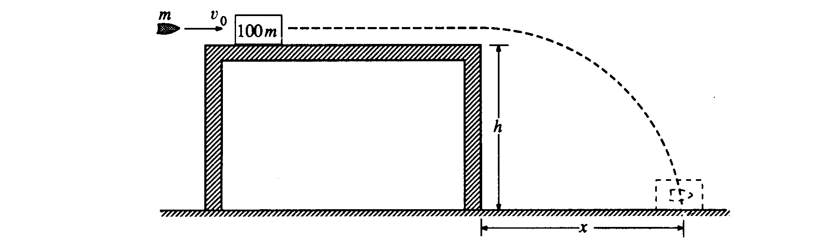
1990B1. A bullet of mass m is moving horizontally with speed v_{o} when it hits a block of mass 100m that is at rest on a horizontal frictionless table, as shown above. The surface of the table is a height h above the floor. After the impact the bullet and the block slide off the table and hit the floor a distance x from the edge of the table. Derive expressions for the following quantities in terms of m, h, v_{o}, and appropriate constants:
a. the speed of the block as it leaves the table
b. the change in kinetic energy of the bullet-block system during impact
c. the distance x

Suppose that the bullet passes through the block instead of remaining in it.
d. State whether the time required for the block to reach the floor from the edge of the table would now be greater, less, or the same. Justify your answer.
e. State whether the distance x for the block would now be greater, less, or the same. Justify your answer.

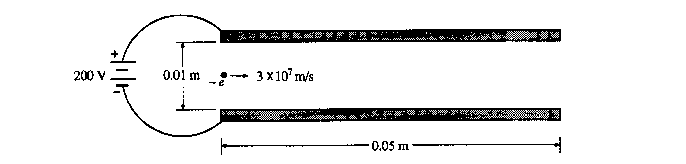
1990B2. A pair of square parallel conducting plates, having sides of length 0.05 meter, are 0.01 meter apart and are connected to a 200-volt power supply, as shown above. An electron is moving horizontally with a speed of 3 x 10⁷ meters per second when it enters the region between the plates. Neglect gravitation and the distortion of the electric field around the edges of the plates.
a. Determine the magnitude of the electric field in the region between the plates and indicate its direction on the figure above.
b. Determine the magnitude and direction of the acceleration of the electron in the region between the plates.
c. Determine the magnitude of the vertical displacement of the electron for the time interval during which it moves through the region between the plates.
d. On the diagram below, sketch the path of the electron as it moves through and after it emerges from the region between the plates. The dashed lines in the diagram have been added for reference only.
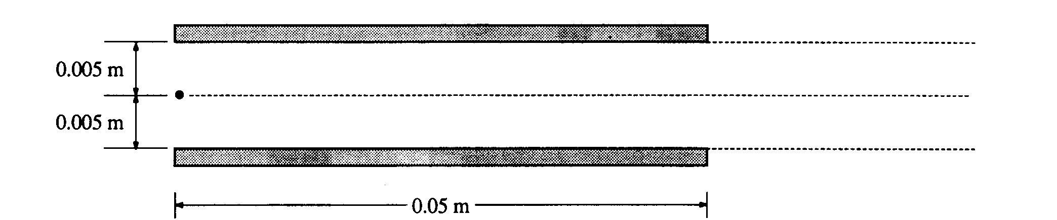
e. A magnetic field could be placed in the region between the plates which would cause the electron to continue to travel horizontally in a straight line through the region between the plates. Determine both the magnitude and the direction of this magnetic field.
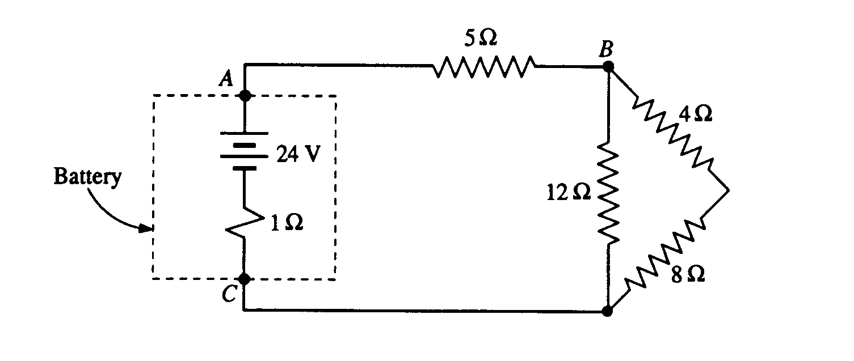
1990B3. A battery with an emf of 24 volts and an internal resistance of I ohm is connected to an external circuit as shown above. Determine each of the following:
a. the equivalent resistance of the combination of the 4-ohm, 8-ohm, and 12-ohm resistors
b. the current in the 5-ohm resistor
c. the terminal voltage, V_{AC} of the battery
d. the rate at which energy is dissipated in the 12-ohm resistor
e. the magnitude of the potential difference V_{BC}
f. the power delivered by the battery to the external circuit

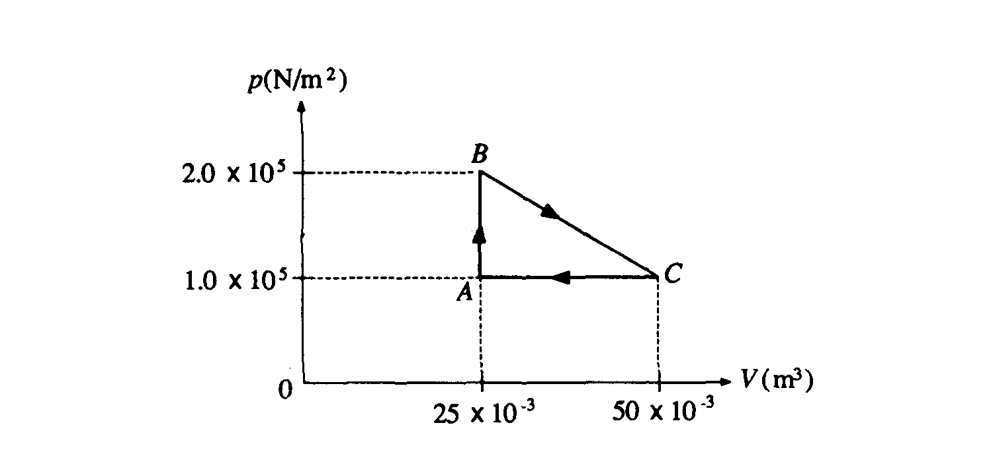
1990B4. One mole of an ideal monatomic gas, initially at point A at a pressure of 1.0 x 10⁵ newtons per meter squared and a volume of 25 x l0⁻³ meter cubed, is taken through a 3-process cycle, as shown in the pV diagram above. Each process is done slowly and reversibly. For a monatomic gas, the heat capacities for constant volume and constant pressure are, respectively, C_{v} = (3/2)R and C_{p} = (5/2)R, where R is the universal gas constant, 8.32 J/mole K. Determine each of the following:
a. the temperature of the gas at each of the vertices, A, B. and C, of the triangular cycle
b. the net work done by the gas for one cycle
c. the net heat absorbed by the gas for one full cycle
d. the heat given off by the gas for the third process from C to A
e. the efficiency of the cycle
1990B5. In a television picture tube, electrons are accelerated from rest through a potential difference of 12,000 volts and move toward the screen of the tube. When the electrons strike the screen, x-ray photons are emitted. Treat the electrons nonrelativistically and determine:
a. the speed of an electron just before it strikes the screen
b. the number of electrons arriving at the screen per second if the flow of electrons in the tube is 0.01 coulomb per second

An x-ray of maximum energy is produced when an electron striking the screen gives up all of its kinetic energy. For such x-rays, determine:
c. the frequency
d. the wavelength
e. the photon momentum

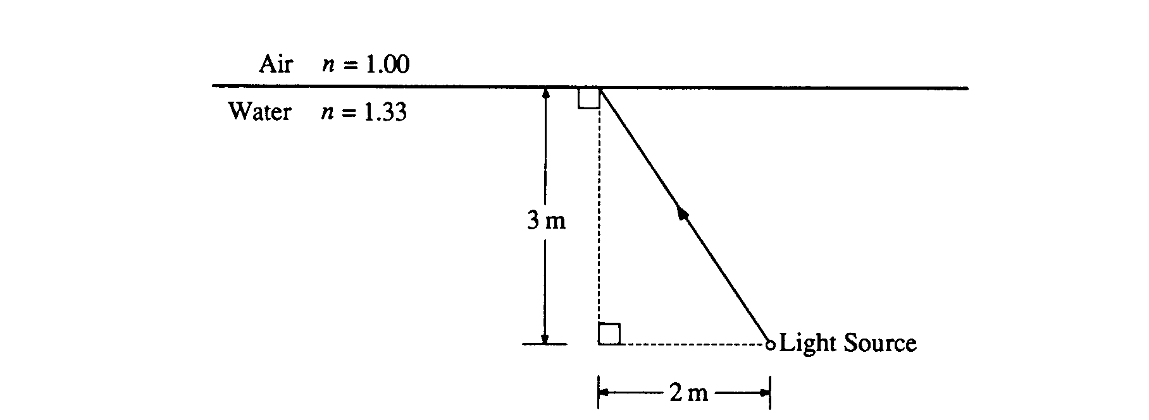
1990B6. A beam of light from a light source on the bottom of a swimming pool 3.0 meters deep strikes the surface of the water 2.0 meters to the left of the light source, as shown above. The index of refraction of the water in the pool is 1.33.
a. What angle does the reflected ray make with the normal to the surface?
b. What angle does the emerging ray make with the normal to the surface?
c. What is the minimum depth of water for which the light that strikes the surface of the water 2.0 meters to the left of the light source will be refracted into the air?

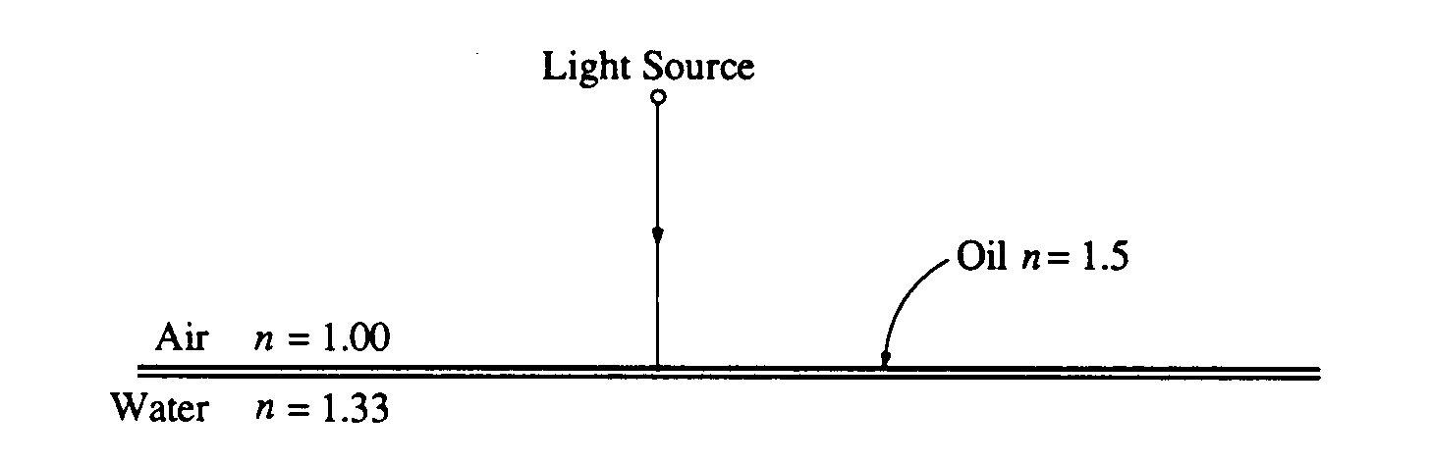
In one section of the pool, there is a thin film of oil on the surface of the water. The thickness of the film is 1.0 X l0⁻⁷ meter and the index of refraction of the oil is 1.5. The light source is now held in the air and illuminates the film at normal incidence, as shown above.
d. At which of the interfaces (air-oil and oil-water), if either, does the light undergo a 180° phase change upon reflection?
e. For what wavelengths in the visible spectrum will the intensity be a maximum in the reflected beam?

