

AP® Physics B
1999 Free response Questions

The materials included in these files are intended for use by AP teachers for course
and exam preparation in the classroom; permission for any other use must be
sought from the Advanced Placement Program®. Teachers may reproduce them, in whole or in part, in limited quantities, for face-to-face teaching purposes but may
not mass distribute the materials, electronically or otherwise. These materials and
any copies made of them may not be resold, and the copyright notices must be
retained as they appear here. This permission does not apply to any third-party copyrights contained herein.

These materials were produced by Educational Testing Service® (ETS®), which develops and administers the examinations of the Advanced Placement
Program for the College Board. The College Board and Educational Testing Service (ETS) are dedicated to the principle of equal opportunity, and their
programs, services, and employment policies are guided by that principle.

The College Board is a national nonprofit membership association dedicated to preparing, inspiring, and connecting students to college and opportunity.
Founded in 1900, the association is composed of more than 4,200 schools, colleges, universities, and other educational organizations. Each year, the
College Board serves over three million students and their parents, 22,000 high schools, and 3,500 colleges, through major programs and services in
college admission, guidance, assessment, financial aid, enrollment, and teaching and learning. Among its best-known programs are the SAT®, the
PSAT/NMSQT®, and the Advanced Placement Program® (AP®). The College Board is committed to the principles of equity and
excellence, and that commitment is embodied in all of its programs, services, activities, and concerns.

APIEL is a trademark owned by the College Entrance Examination Board. PSAT/NMSQT is a registered trademark jointly owned by the College Entrance Examination Board and the National Merit Scholarship Corporation. Educational Testing Service and ETS are registered trademarks of Educational Testing Service.
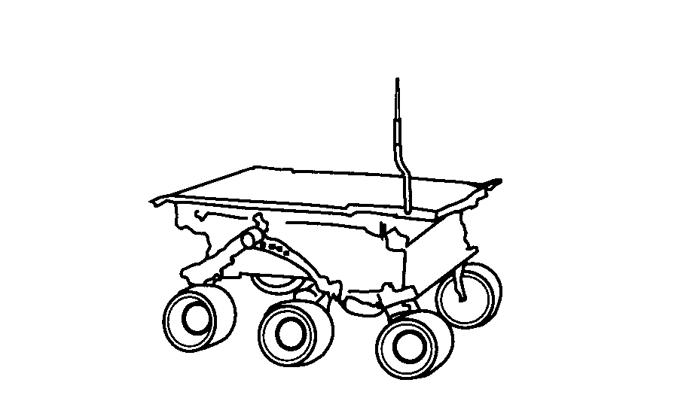
1999B1. The Sojourner rover vehicle shown in the sketch above was used to explore the surface of Mars as part of the Pathfinder mission in 1997. Use the data in the tables below to answer the questions that follow.
Mars Data Sojourner Data
Radius: 0.53 x Earth's radius Mass of Sojourner vehicle: 11.5 kg
Mass: 0.11 x Earth's mass Wheel diameter: 0.13 m
Stored energy available: 5.4 x 10⁵ J
Power required for driving
under average conditions: 10 W
Land speed: 6.7 x 10⁻³ m/s

a. Determine the acceleration due to gravity at the surface of Mars in terms of g, the acceleration due to gravity at the surface of Earth.
b. Calculate Sojourner's weight on the surface of Mars.
c. Assume that when leaving the Pathfinder spacecraft Sojourner rolls down a ramp inclined at 20° to the horizontal. The ramp must be lightweight but strong enough to support Sojourner. Calculate the minimum normal force that must be supplied by the ramp.
d. What is the net force on Sojourner as it travels across the Martian surface at constant velocity? Justify your answer.
e. Determine the maximum distance that Sojourner can travel on a horizontal Martian surface using its stored energy.
f. Suppose that 0.010% of the power for driving is expended against atmospheric drag as Sojourner travels on the Martian surface. Calculate the magnitude of the drag force.
1999B2. In a television set, electrons are first accelerated from rest through a potential difference in an electron gun. They then pass through deflecting plates before striking the screen.
a. Determine the potential difference through which the electrons must be accelerated in the electron gun in order to have a speed of 6.0 x 10⁷ m/s when they enter the deflecting plates.

The pair of horizontal plates shown below is used to deflect electrons up or down in the television set by placing a potential difference across them. The plates have length 0.04 m and separation 0.012 m, and the right edge of the plates is 0.50 m from the screen. A potential difference of 200 V is applied across the plates, and the electrons are deflected toward the top of the screen. Assume that the electrons enter horizontally midway between the plates with a speed of 6.0 x 10⁷ m/s and that fringing effects at the edges of the plates and gravity are negligible.
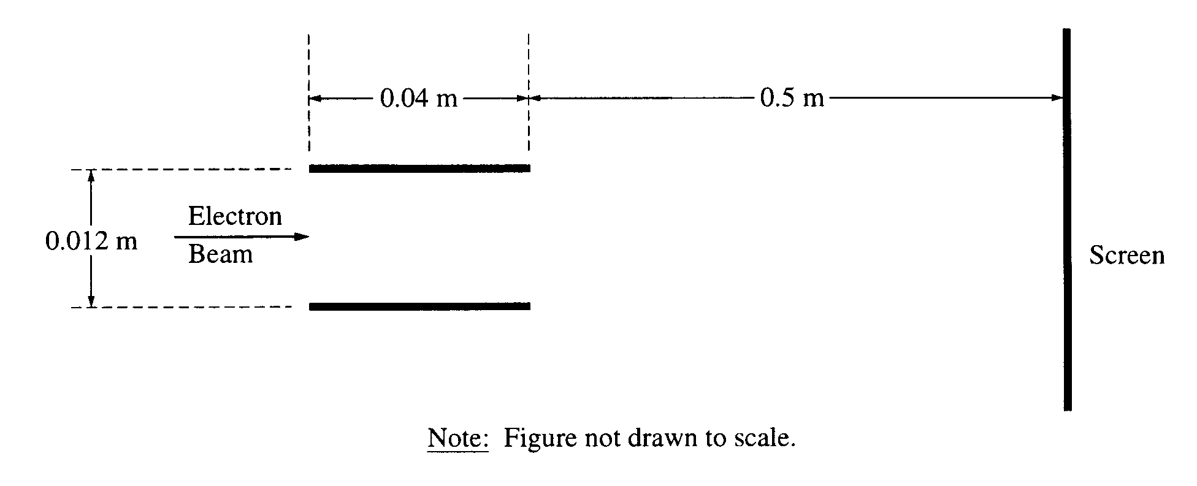

b. Which plate in the pair must be at the higher potential for the electrons to be deflected upward? Check the appropriate box below.
Upper plate Lower plate
Justify your answer.

c. Considering only an electron's motion as it moves through the space between the plates, compute the following.
i. The time required for the electron to move through the plates
ii. The vertical displacement of the electron while it is between the plates

d. Show why it is a reasonable assumption to neglect gravity in part c.
e. Still neglecting gravity, describe the path of the electrons from the time they leave the plates until they strike the screen. State a reason for your answer.
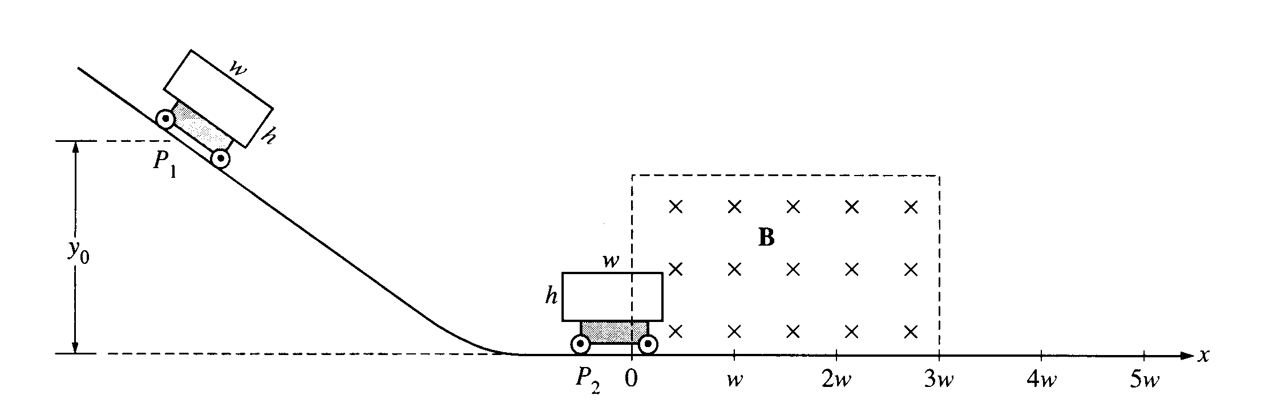
1999B3. A rectangular conducting loop of width w, height h, and resistance R is mounted vertically on a nonconducting cart as shown above. The cart is placed on the inclined portion of a track and released from rest at position P₁ at a height y₀ above the horizontal portion of the track. It rolls with negligible friction down the incline and through a uniform magnetic field B in the region above the horizontal portion of the track. The conducting loop is in the plane of the page, and the magnetic field is directed into the page. The loop passes completely through the field with a negligible change in speed. Express your answers in terms of the given quantities and fundamental constants.
a. Determine the speed of the cart when it reaches the horizontal portion of the track.
b. Determine the following for the time at which the cart is at position P₂, with one-third of the loop in the
magnetic field.
i. The magnitude of the emf induced in the conducting loop
ii. The magnitude of the current induced in the conducting loop
c. On the following diagram of the conducting loop, indicate the direction of the current when it is at Position P..
d. i. Using the axes below, sketch a graph of the magnitude of the magnetic flux φ through the loop as a function of the horizontal distance x traveled by the cart, letting x = 0 be the position at which the front edge of the loop just enters the field. Label appropriate values on the vertical axis.
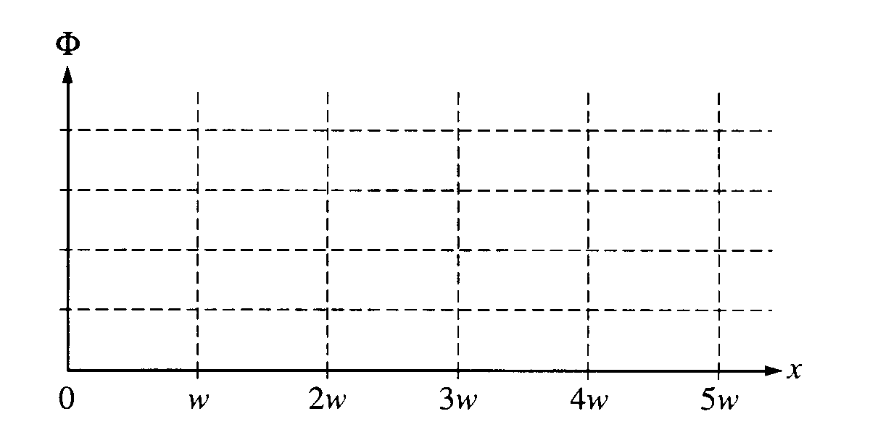
ii. Using the axes below, sketch a graph of the current induced in the loop as a function of the horizontal
distance x traveled by the cart, letting x = 0 be the position at which the front edge of the loop just enters the field. Let counterclockwise current be positive and label appropriate values on the vertical axis.
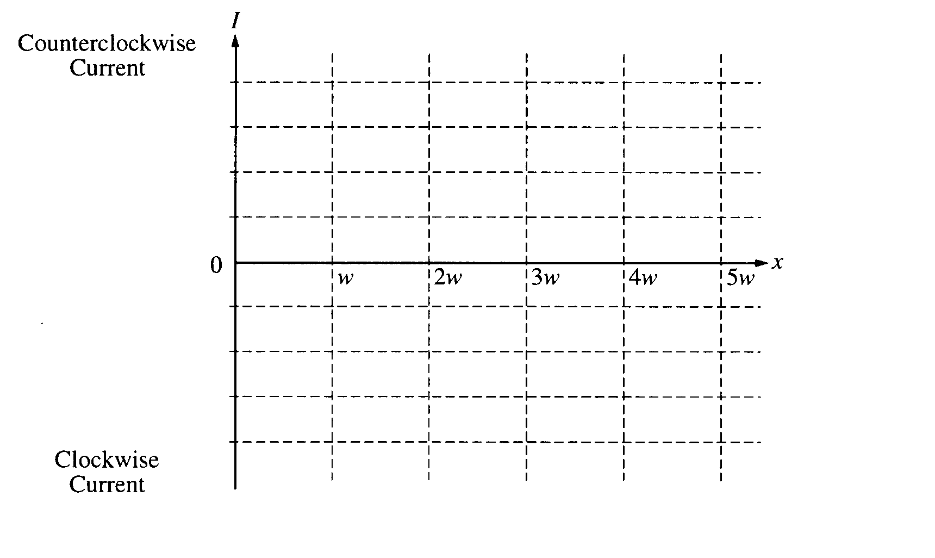

1999B4. You use a Geiger counter to measure the decay of a radioactive sample of bismuth 212 over a period of time and obtain the following results.
Time (min) 0 20 40 60 80 100 120 140 160 180 200
Counts/minute 702 582 423 320 298 209 164 154 124 81 79

a. Your results are plotted on the following graph. On the graph, draw an estimate of a best-fit curve that shows the radioactive counts as a function of time.
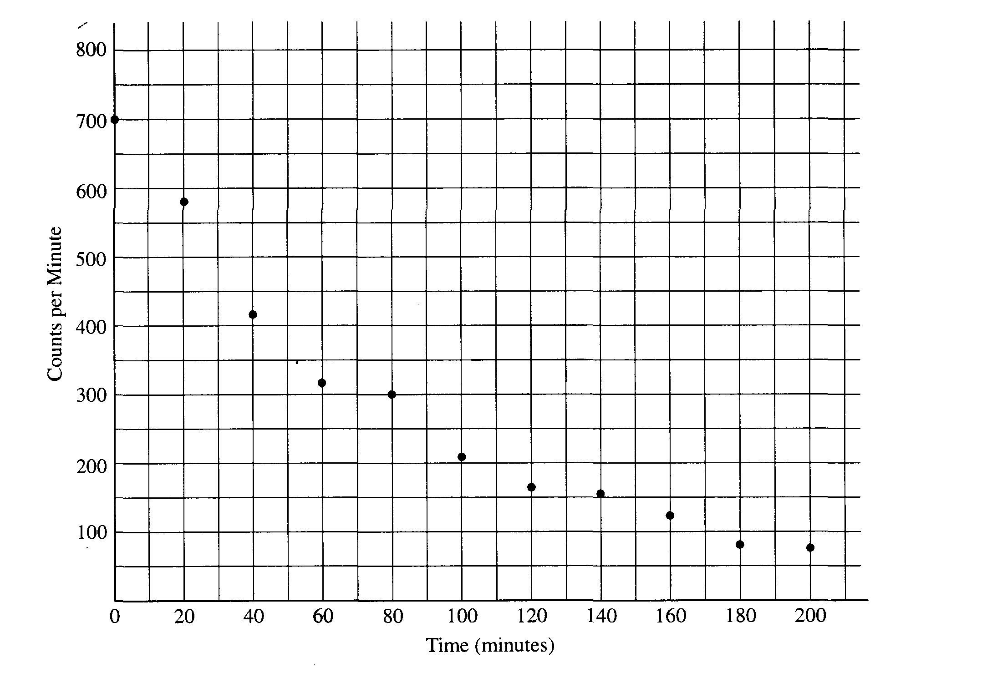
b. From the data or from your graph, determine the half-life of this isotope. Explain how you arrived at your answer.
c. The bismuth isotope decays into thallium by emitting an alpha particle according to the following equation:
${}_{\text{83}}^{\text{212}}{}\text{Bi}→\text{Tl}+α$

Determine the atomic number Z and the mass number A of the thallium nuclei produced and enter your answers in the spaces provided below.

Z= A=

d. The mass of the alpha particle is 6.64 x 10⁻²⁷ kg. Its measured kinetic energy is 6.09 MeV and its speed is much less than the speed of light.
i. Determine the momentum of the alpha particle.
ii. Determine the kinetic energy of the recoiling thallium nucleus.
e. Determine the total energy released during the decay of 1 mole of bismuth 212.
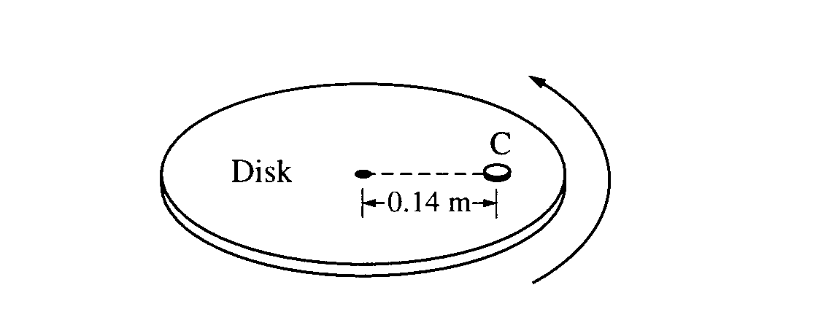
1999B5 (10 pts) A coin C of mass 0.0050 kg is placed on a horizontal disk at a distance of 0.14 m from the center, as shown above. The disk rotates at a constant rate in a counterclockwise direction as seen from above. The coin does not slip, and the time it takes for the coin to make a complete revolution is 1.5 s.
a. The figure below shows the disk and coin as viewed from above. Draw and label vectors on the figure below to show the instantaneous acceleration and linear velocity vectors for the coin when it is at the position shown.
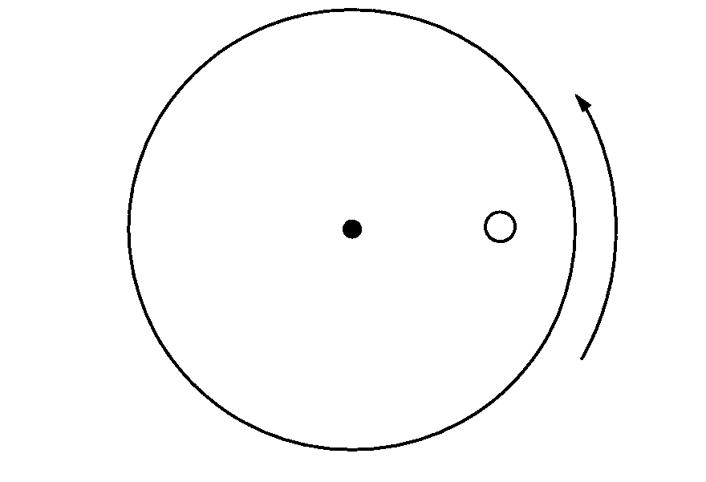
b. Determine the linear speed of the coin.
c. The rate of rotation of the disk is gradually increased. The coefficient of static friction between the coin and the disk is 0.50. Determine the linear speed of the coin when it just begins to slip.
d. If the experiment in part (c) were repeated with a second, identical coin glued to the top of the first coin, how would this affect the answer to part (c) ? Explain your reasoning.

1999B6 (10 points) You are given the following equipment for use in the optics experiments in parts (a) and (b).
A solid rectangular block made of transparent plastic
A laser that produces a narrow, bright, monochromatic ray of light
A protractor
A meterstick
A diffraction grating of known slit spacing
A white opaque screen

a. Briefly describe the procedure you would use to determine the index of refraction of the plastic. Include a labeled diagram to show the experimental setup. Write down the corresponding equation you would use in your calculation and make sure all the variables in this equation are labeled on your diagram.

b. Since the index of refraction depends on wavelength, you decide you also want to determine the wavelength of your light source. Draw and label a diagram showing the experimental setup. Show the equation(s) you would use in your calculation and identify all the variables in the equation(s). State and justify any assumptions you make.
1999B7 (10 points) A cylinder contains 2 moles of an ideal monatomic gas that is initially at state A with a volume of 1.0 x 10⁻² m³ and a pressure of 4.0 x 10⁵ Pa. The gas is brought isobarically to state B. where the volume is 2.0 x 10⁻² m³. The gas is then brought at constant volume to state C, where its temperature is the same as at state A. The gas is then brought isothermally back to state A.
a. Determine the pressure of the gas at state C.
b. On the axes below, state B is represented by the point B. Sketch a graph of the complete cycle. Label points A and C to represent states A and C, respectively.
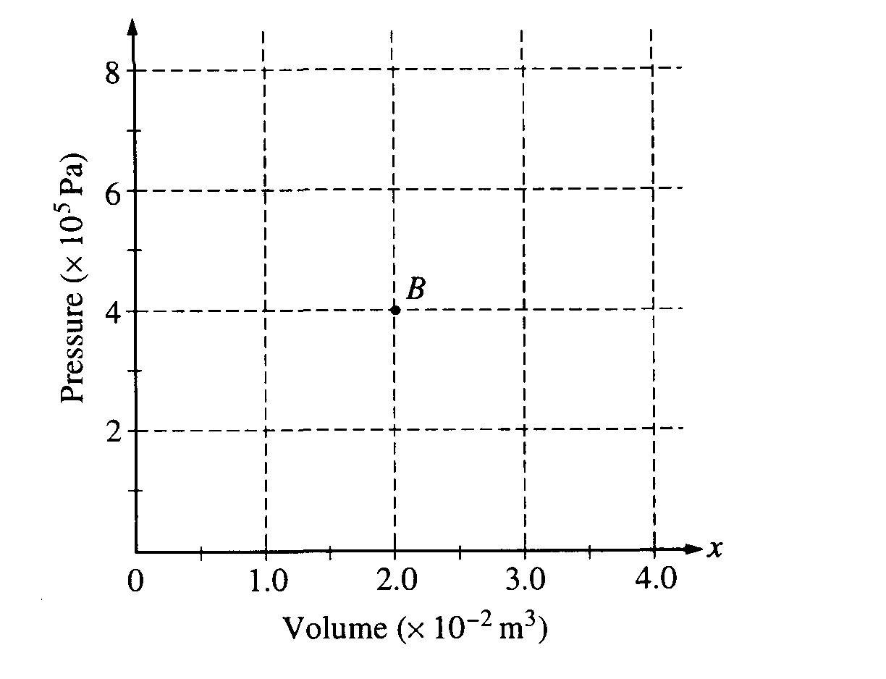
c. State whether the net work done by the gas during the complete cycle is positive, negative, or zero. Justify your answer.
d. State whether this device is a refrigerator or a heat engine. Justify your answer.

