

AP® Physics B

2002 Free response Questions

The materials included in these files are intended for use by AP teachers for course
and exam preparation in the classroom; permission for any other use must be
sought from the Advanced Placement Program®. Teachers may reproduce them, in whole or in part, in limited quantities, for face-to-face teaching purposes but may
not mass distribute the materials, electronically or otherwise. These materials and
any copies made of them may not be resold, and the copyright notices must be
retained as they appear here. This permission does not apply to any third-party copyrights contained herein.

These materials were produced by Educational Testing Service® (ETS®), which develops and administers the examinations of the Advanced Placement
Program for the College Board. The College Board and Educational Testing Service (ETS) are dedicated to the principle of equal opportunity, and their
programs, services, and employment policies are guided by that principle.

The College Board is a national nonprofit membership association dedicated to preparing, inspiring, and connecting students to college and opportunity.
Founded in 1900, the association is composed of more than 4,200 schools, colleges, universities, and other educational organizations. Each year, the
College Board serves over three million students and their parents, 22,000 high schools, and 3,500 colleges, through major programs and services in
college admission, guidance, assessment, financial aid, enrollment, and teaching and learning. Among its best-known programs are the SAT®, the
PSAT/NMSQT®, and the Advanced Placement Program® (AP®). The College Board is committed to the principles of equity and
excellence, and that commitment is embodied in all of its programs, services, activities, and concerns.

Copyright © 2002 by College Entrance Examination Board. All rights reserved. College Board, Advanced Placement Program, AP, SAT, and the acorn logo
are registered trademarks of the College Entrance Examination Board. APIEL is a trademark owned by the College Entrance Examination Board. PSAT/NMSQT is a registered trademark jointly owned by the College Entrance Examination Board and the National Merit Scholarship Corporation.
Educational Testing Service and ETS are registered trademarks of Educational Testing Service.
2002B1. A model rocket of mass 0.250 kg is launched vertically with an engine that is ignited at time t = 0, as shown above. The engine provides an impulse of 20.0 N•s by firing for 2.0 s. Upon reaching its maximum height, the rocket deploys a parachute, and then descends vertically to the ground.

(a) On the figures below, draw and label a free-body diagram for the rocket during each of the following intervals.
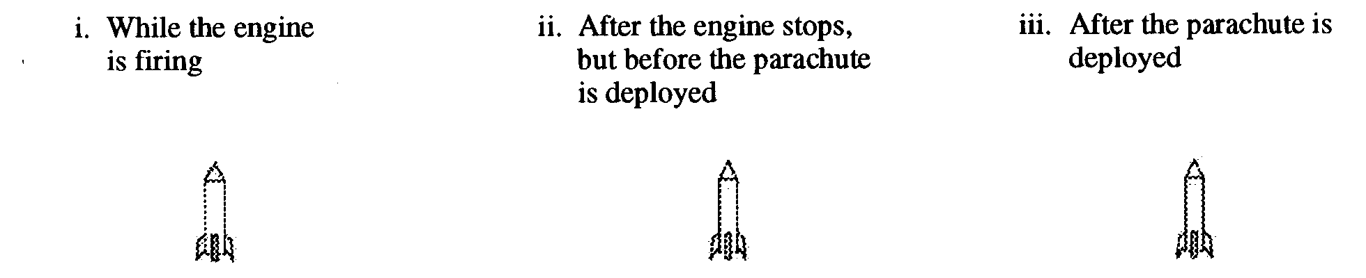
(b) Determine the magnitude of the average acceleration of the rocket during the 2 s firing of the engine.

(c) What maximum height will the rocket reach?

(d) At what time after t = 0 will the maximum height be reached?

2002B1 (15 points) A 3.0 kg object subject to a restoring force F is undergoing simple harmonic motion with a small amplitude. The potential energy U of the object as a function of distance x from its equilibrium position is shown above. This particular object has a total energy E: of 0.4 J.

(a) What is the object's potential energy when its displacement is +4 cm from its equilibrium position?

(b) What is the farthest the object moves along the x-axis in the positive direction? Explain your reasoning.

(c) Determine the object's kinetic energy when its displacement is -7 cm.

(d) What is the object's speed at x = 0 ?
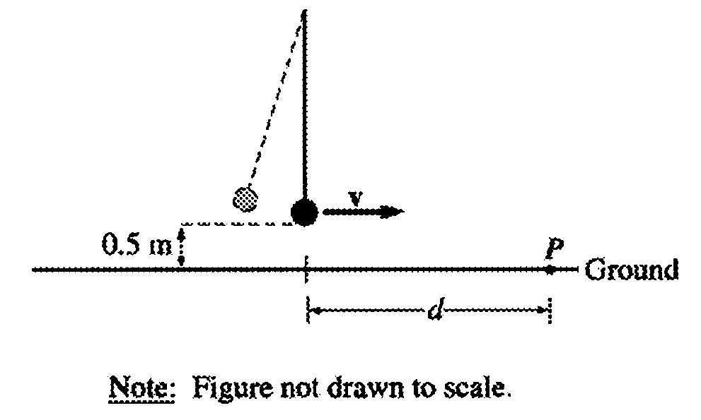
(e) Suppose the object undergoes this motion because it is the bob of a simple pendulum as shown above. If the object breaks loose from the string at the instant the pendulum reaches its lowest point and hits the ground at point P shown, what is the horizontal distance d that it travels?

2002B3 (15 points) Two lightbulbs, one rated 30 W at 120 V and another rated 40 W at 120 V, are arranged in two different circuits.
(a) The two bulbs are first connected in parallel to a 120 V source.

i. Determine the resistance of the bulb rated 30 W and the current in it when it is connected in this circuit.
ii. Determine the resistance of the bulb rated 40 W and the current in it when it is connected in this circuit.
(b) The bulbs are now connected in series with each other and a 120 V source.

i. Determine the resistance of the bulb rated 30 W and the current in it when it is connected in this circuit.
ii. Determine the resistance of the bulb rated 40 W and the current in it when it is connected in this circuit.
(c) In the spaces below, number the bulbs in each situation described, in order of their brightness.
(1= brightest, 4 = dimmest)
30 W bulb in the parallel circuit
40 W bulb in the parallel circuit
30 W bulb in the series circuit
40 W bulb in the series circuit
(d) Calculate the total power dissipated by the two bulbs in each of the following cases.
i. The parallel circuit
ii. The series circuit

2002B4. (15 points) A thin converging lens of focal length 10 cm is used as a simple magnifier to examine an object A that is held 6 cm from the lens.

(a) On the figure below, draw a ray diagram showing the position and size of the image formed.
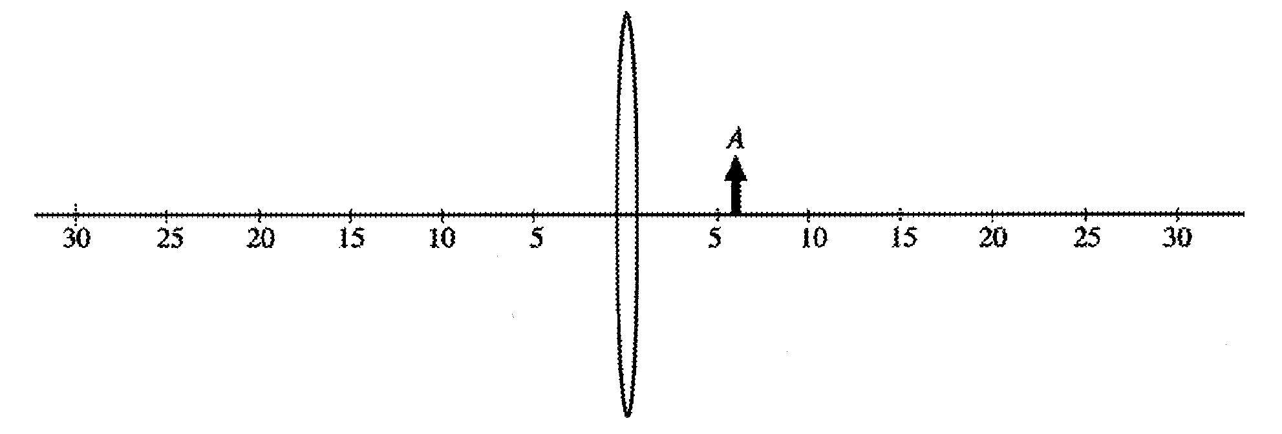
(b) State whether the image is real or virtual. Explain your reasoning.
(c) Calculate the distance of the image from the center of the lens.
(d) Calculate the ratio of the image size to the object size.
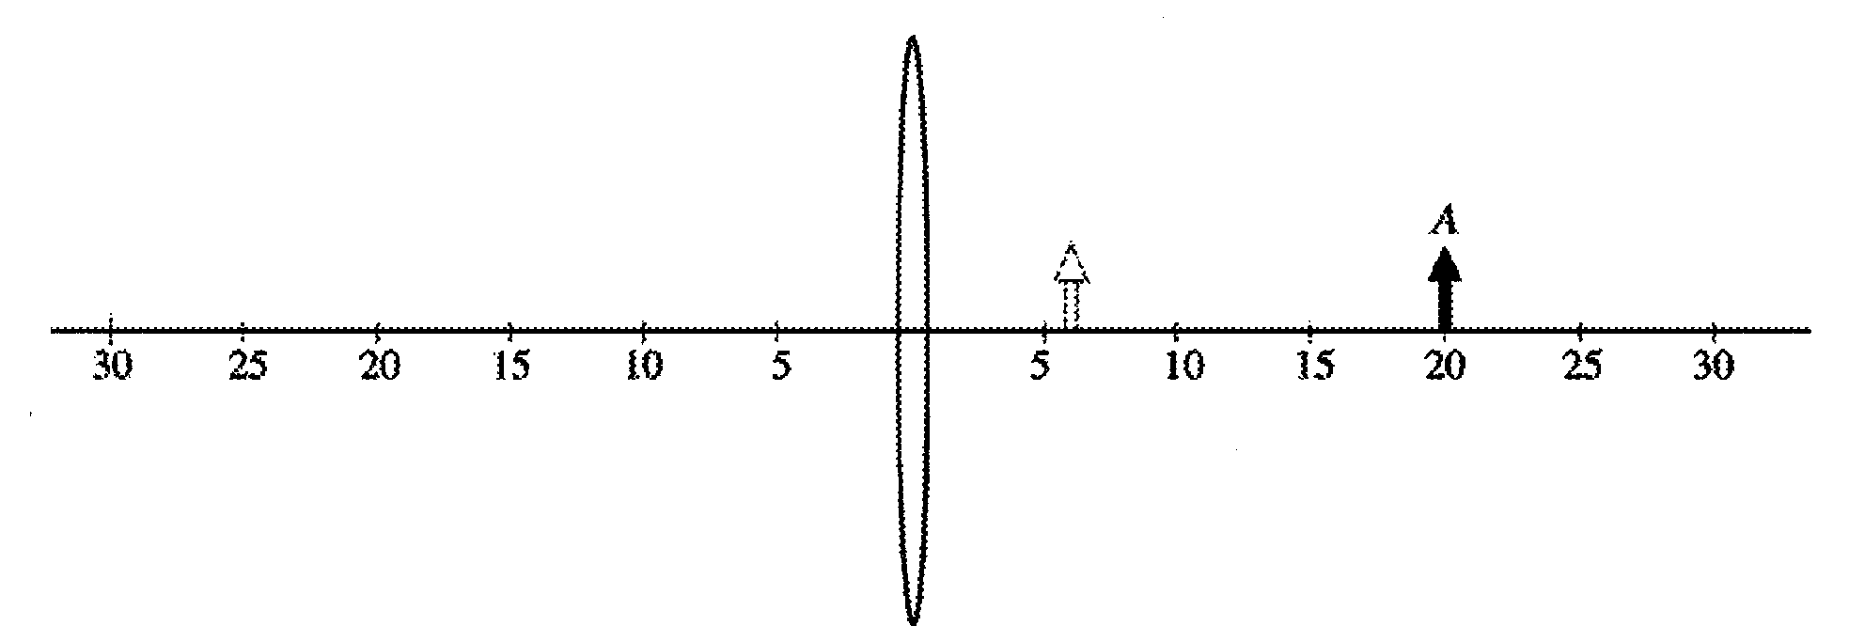
(e), The object A is now moved to the right from x = 6 cm to a position of x = 20 cm, as shown above. Describe the image position, size, and orientation when the object is at x = 20 cm.

2002B5. (10 points) A proton of mass m_{p} and charge e is in a box that contains an electric field E, and the box is located in Earth's magnetic field B. The proton moves with an initial velocity vertically upward from the surface of Earth. Assume gravity is negligible.

(a) On the diagram above, indicate the direction of the electric field inside the box so that there is no change in the trajectory of the proton while it moves upward in the box. Explain your reasoning.
(b) Determine the speed v of the proton while in the box if it continues to move vertically upward. Express your answer in terms of the fields and the given quantities.
The proton now exits the box through the opening at the top.
(c) On the figure on the previous page, sketch the path of the proton after it leaves the box.
(d) Determine the magnitude of the acceleration a of the proton just after it leaves the box, in terms of the given quantities and fundamental constants.

2002B6. (10 points) In the laboratory, you are given a cylindrical beaker containing a fluid and you are asked to determine the density ρ of the fluid. You are to use a spring of negligible mass and unknown spring constant k attached to a stand. An irregularly shaped object of known mass m and density D >> ρ) hangs from the spring. You may also choose from among the following items to complete the task.
• A metric ruler
• A stopwatch
• String
(a) Explain how you could experimentally determine the spring constant k.
(b) The spring-object system is now arranged so that the object (but none of the spring) is immersed in the unknown fluid, as shown above. Describe any changes that are observed in the spring-object system and explain why they occur.
(c) Explain how you could experimentally determine the density of the fluid.
(d) Show explicitly, using equations, how you will use your measurements to calculate the fluid density ρ. Start by identifying any symbols you use in your equations.

7. (10 points) A photon of wavelength 2.0 x 10⁻¹¹ m strikes a free electron of mass m_{e} that is initially at rest, as shown above left. After the collision, the photon is shifted in wavelength by an amount Δλ = 2hlm_{e}c, and reversed in direction, as shown above right.
(a) Determine the energy in joules of the incident photon.
(b) Determine the magnitude of the momentum of the incident photon.
(c) Indicate below whether the photon wavelength is increased or decreased by the interaction.
Increased Decreased
Explain your reasoning.
(d) Determine the magnitude of the momentum acquired by the electron.

