

AP® Physics B

2004 Free Response Questions

The materials included in these files are intended for noncommercial use by AP teachers for course and exam preparation; permission for any other use must be sought from the
Advanced Placement Program®. Teachers may reproduce them, in whole or in part, in limited quantities, for face-to-face teaching purposes but may not mass distribute
the materials, electronically or otherwise. This permission does not apply to any third-party copyrights contained herein. These materials and any copies made of them
may not be resold, and the copyright notices must be retained as they appear here.

The College Board is a nonprofit membership association whose mission is to connect students to college success and opportunity.
Founded in 1900, the association is composed of more than 4,500 schools, colleges, universities, and other educational organizations. Each year, the
College Board serves over three million students and their parents, 23,000 high schools, and 3,500 colleges, through major programs and services in
college admissions, guidance, assessment, financial aid, enrollment, and teaching and learning. Among its best-known programs are the SAT®, the
PSAT/NMSQT®, and the Advanced Placement Program® (AP®). The College Board is committed to the principles of equity and
excellence, and that commitment is embodied in all of its programs, services, activities, and concerns.

For further information, visit www.collegeboard.com

College Board, Advanced Placement Program, AP, SAT, and the acorn logo are registered trademarks of the College Entrance Examination Board.

2004B1. (15 points) A roller coaster ride at an amusement park lifts a car of mass 700 kg to point A at a height of 90 m above the lowest point on the track, as shown above. The car starts from rest at point A, rolls with negligible friction down the incline and follows the track around a loop of radius 20 m. Point B, the highest point on the loop, is at a height of 50 m above the lowest point on the track.
(a)

i. Indicate on the figure the point P at which the maximum speed of the car is attained.

ii. Calculate the value v_{max}. of this maximum speed.

(b) Calculate the speed v_{B} of the car at point B.

(c)
i. On the figure of the car below, draw and label vectors to represent the forces acting on the car when it is upside down at point B.



ii. Calculate the magnitude of all the forces identified in (c)i.
(d) Now suppose that friction is not negligible. How could the loop be modified to maintain the same speed at the top of the loop as found in (b)? Justify your answer.

2004B2. (15 points) While exploring a sunken ocean liner, the principal researcher found the absolute pressure on the robot observation submarine at the level of the ship to be about 413 atmospheres. The density of seawater is 1025 kg/m³ .
(a) Calculate the gauge pressure p_{g} on the sunken ocean liner.
(b) Calculate the depth D of the sunken ocean liner.
(c) Calculate the magnitude F of the force due to the water on a viewing port of the submarine at this depth if the viewing port has a surface area of 0.0100 m².
Suppose that the ocean liner came to rest at the surface of the ocean before it started to sink. Due to the resistance of the seawater, the sinking ocean liner then reached a terminal velocity of 10.0 m/s after falling for 30.0 s.
(d) Determine the magnitude a of the average acceleration of the ocean liner during this period of time.
(e) Assuming the acceleration was constant, calculate the distance d below the surface at which the ocean liner reached this terminal velocity.
(f) Calculate the time t it took the ocean liner to sink from the surface to the bottom of the ocean.
2004B3. (15 points) A square loop of wire of side 0.20 m has a total resistance of 0.60 Ω. The loop is positioned in a uniform magnetic field B of 0.030 T. The field is directed into the page, perpendicular to the plane of the loop, as shown above.
(a) Calculate the magnetic flux through the loop.
The field strength now increases uniformly to 0.20 T in 0.50 s.
(b) Calculate the emf ε induced in the loop during this period.
(c)
i. Calculate the magnitude I of the current in the loop during this period.
ii. What is the direction of the current in the loop?
______Clockwise ______Counterclockwise
Justify your answer.
(d) Describe a method by which you could induce a current in the loop if the magnetic field remained constant.
2004B4 (15 points)
Two small speakers S are positioned a distance of 0.75 m from each other, as shown in the diagram above. The two speakers are each emitting a constant 2500 Hz tone, and the sound waves from the speakers are in phase with each other. A student is standing at point P, which is a distance of 5.0 m from the midpoint between the speakers, and hears a maximum as expected. Assume that reflections from nearby objects are negligible. Use 343 m/s for the speed of sound.

(a) Calculate the wavelength of these sound waves.
(b) The student moves a distance Y to point Q and notices that the sound intensity has decreased to a minimum. Calculate the shortest distance the student could have moved to hear this minimum.
(c) Identify another location on the line that passes through P and Q where the student could stand in order to observe a minimum. Justify your answer.
(d)
i. How would your answer to (b) change if the two speakers were moved closer together? Justify your answer.
ii. How would your answer to (b) change if the frequency emitted by the two speakers was increased? Justify your answer.

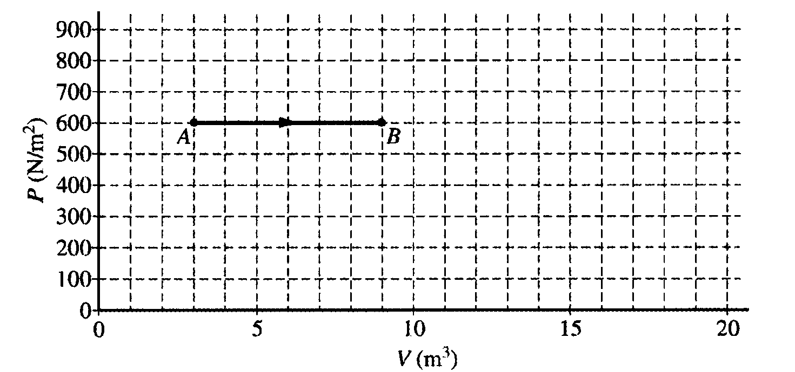
2004B5 (10 points) The diagram above of pressure P versus volume V shows the expansion of 2.0 moles of a monatomic ideal gas from state A to state B. As shown in the diagram, P_{A} = P_{B} = 600 N/m² , V_{A} = 3.0 m³, and V_{B} = 9.0 m³.
(a)
i. Calculate the work done by the gas as it expands.
ii. Calculate the change in internal energy of the gas as it expands.
iii. Calculate the heat added to or removed from the gas during this expansion.
(b) The pressure is then reduced to 200 N/m² without changing the volume as the gas is taken from state B
to state C. Label state C on the diagram and draw a line or curve to represent the process from state B to
state C.
(c) The gas is then compressed isothermally back to state A.
i. Draw a line or curve on the diagram to represent this process.
ii. Is heat added to or removed from the gas during this isothermal compression?
_______added to _______removed from
Justify your answer.

2004B6 (10 points) A student performs a photoelectric effect experiment in which light of various frequencies is incident on a photosensitive metal plate. This plate, a second metal plate, and a power supply are connected in a circuit, which also contains two meters, M₁, and M₂, as shown above. The student shines light of a specific wavelength λ onto the plate. The voltage on the power supply is then adjusted until there is no more current in the circuit, and this voltage is recorded as the stopping potential V_{s}. The student then repeats the experiment several more times with different wavelengths of light. The data, along with other values calculated from it, are recorded in the table below.
K_{max}(eV) | 0.65 | 0.45 | 0.30 | 0.15
λ(m) | 4.00 x 10⁻⁷ | 4.25 x 10⁻⁷ | 4.50 x 10⁻⁷ | 4.75 x 10⁻⁷
V_{S}(volts) | 0.65 | 0.45 | 0.30 | 0.15
f(Hz) | 7.50 x 10¹⁴ | 7.06 x 10¹⁴ | 6.67 x 10¹⁴ | 6.32 x 10¹⁴

(a) Indicate which meter is used as an ammeter and which meter is used as a voltmeter by checking the appropriate spaces below.

M₁ M₂
Ammeter _____ _____
Voltmeter _____ _____

(b) Use the data above to plot a graph of K_{max} versus f on the axes below, and sketch a best-fit line through the data.
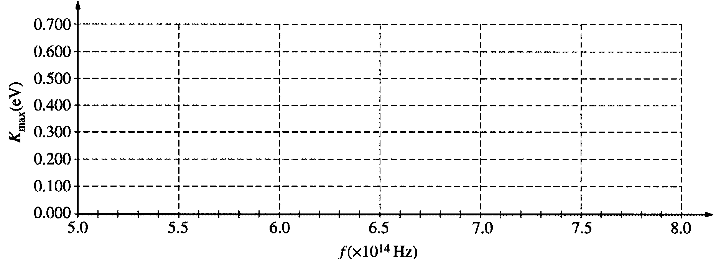
(c) Use the best-fit line you sketched in part (b) to calculate an experimental value for Planck's constant.

(d) If the student had used a different metal with a larger work function, how would the graph you sketched in part (b) be different? Explain your reasoning.

