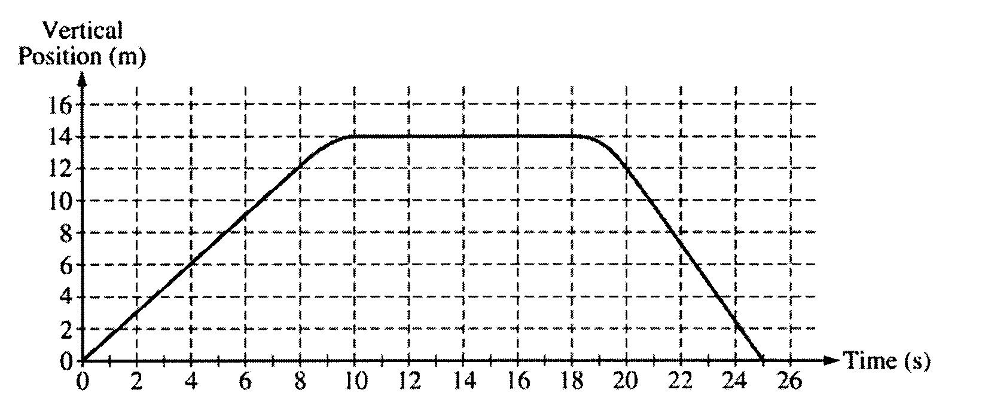

2005B1 (10 points) The vertical position of an elevator as a function of time is shown above.
a. On the grid below, graph the velocity of the elevator as a function of time.

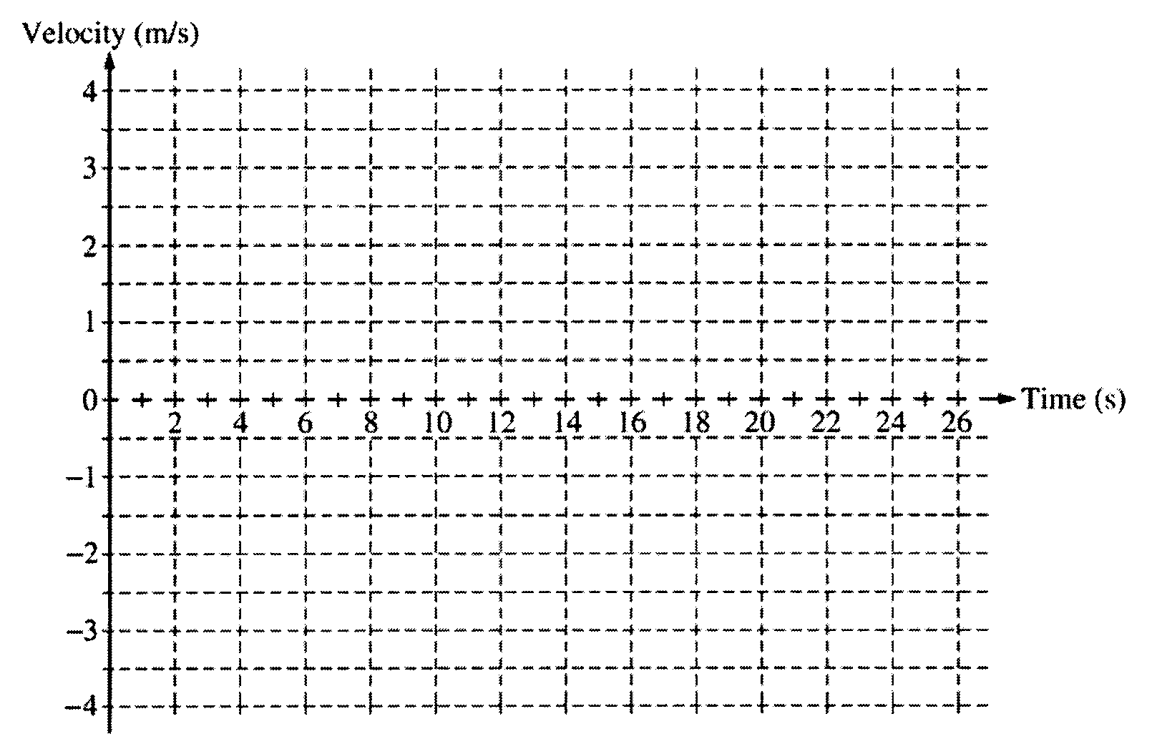

b. i. Calculate the average acceleration for the time period t = 8 s to t = 10 s.
ii. On the box below that represents the elevator, draw a vector to represent the direction of this
average acceleration.

c. Suppose that there is a passenger of mass 70 kg in the elevator. Calculate the apparent weight of the passenger at time t = 4 s.

2005B2 (10 points)A simple pendulum consists of a bob of mass 1.8 kg attached to a string of length 2.3 m. The pendulum is held at an angle of 30° from the vertical by a light horizontal string attached to a wall, as shown above.
a. On the figure below, draw a free-body diagram showing and labeling the forces on the bob in the position shown above.

b. Calculate the tension in the horizontal string.
c. The horizontal string is now cut close to the bob, and the pendulum swings down. Calculate the speed of the bob at its lowest position.

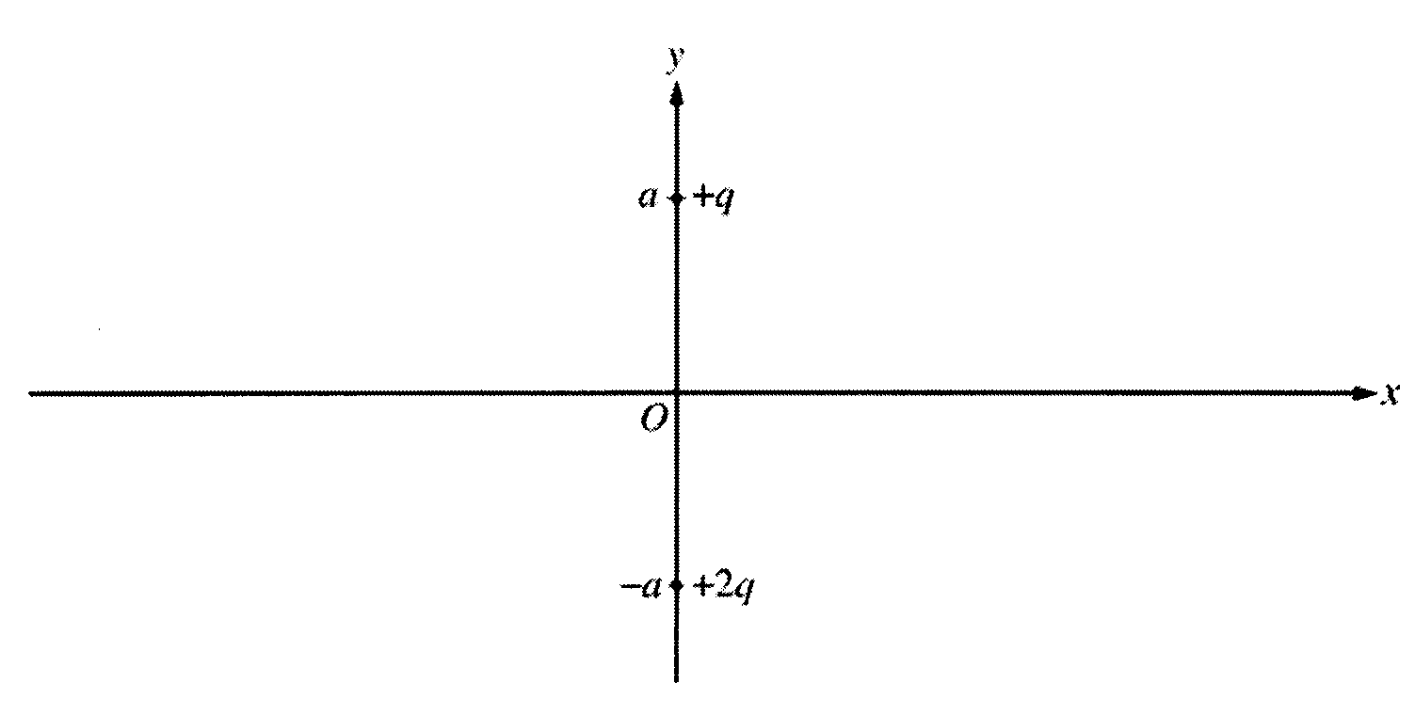
2005B3 (15 points)Two point charges are fixed on the y-axis at the locations shown in the figure above. A charge of +q is located at y = +a and a charge of +2q is located at y = -a. Express your answers to parts (a) and (b) in terms of q, a, and fundamental constants.
a. Determine the magnitude and direction of the electric field at the origin.
b. Determine the electric potential at the origin.

A third charge of -q is first placed at an arbitrary point A (x = -x_{o}) on the x-axis as shown in the figure
below.
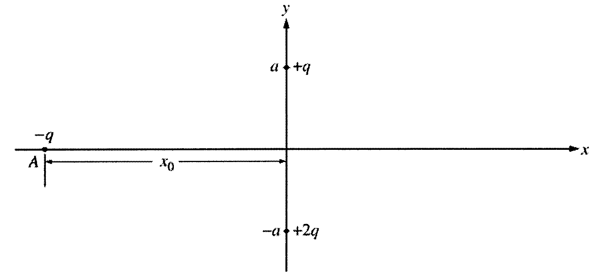
c. Write expressions in terms of q, a, x₀, and fundamental constants for the magnitudes of the forces on the -q charge at point A caused by each of the following.
i. The +q charge
ii. The +2q charge
d. The -q charge can also be placed at other points on the x-axis. At each of the labeled points (A, B, and C) in the following diagram, draw a vector to represent the direction of the net force on the -q charge due to the other two charges when it is at those points.
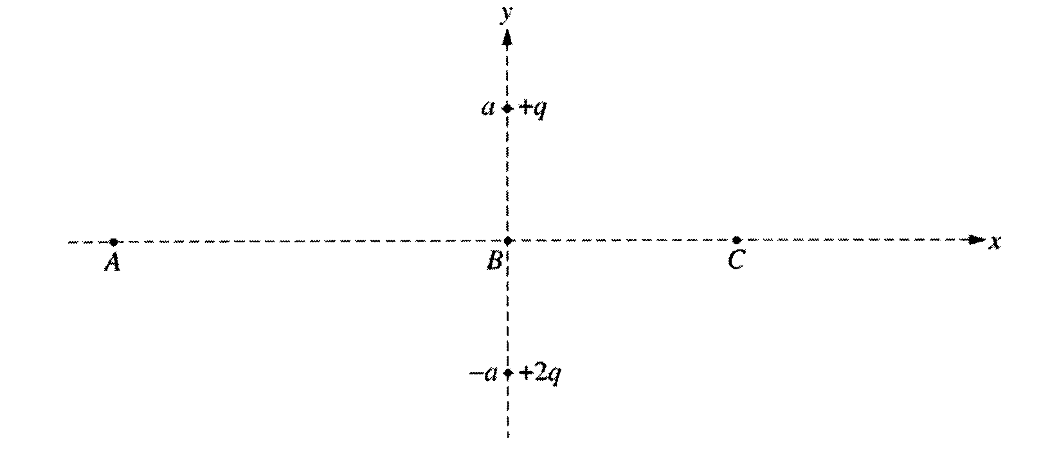

2005B4 (15 points) Your teacher gives you a slide with two closely spaced slits on it. She also gives you a laser with a wavelength λ = 632 nm. The laboratory task that you are assigned asks you to determine the spacing between the slits. These slits are so close together that you cannot measure their spacing with a typical measuring device.
a. From the list below, select the additional equipment you will need to do your experiment by checking the line next to each item.

_____Meterstick _____Ruler _____Tape measure _____Light-intensity meter

_____Large screen _____Paper _____Slide holder _____Stopwatch

b. Draw a labeled diagram of the experimental setup that you would use. On the diagram, use symbols to identify carefully what measurements you will need to make.
c. On the axes below, sketch a graph of intensity versus position that would be produced by your setup, assuming that the slits are very narrow compared to their separation.
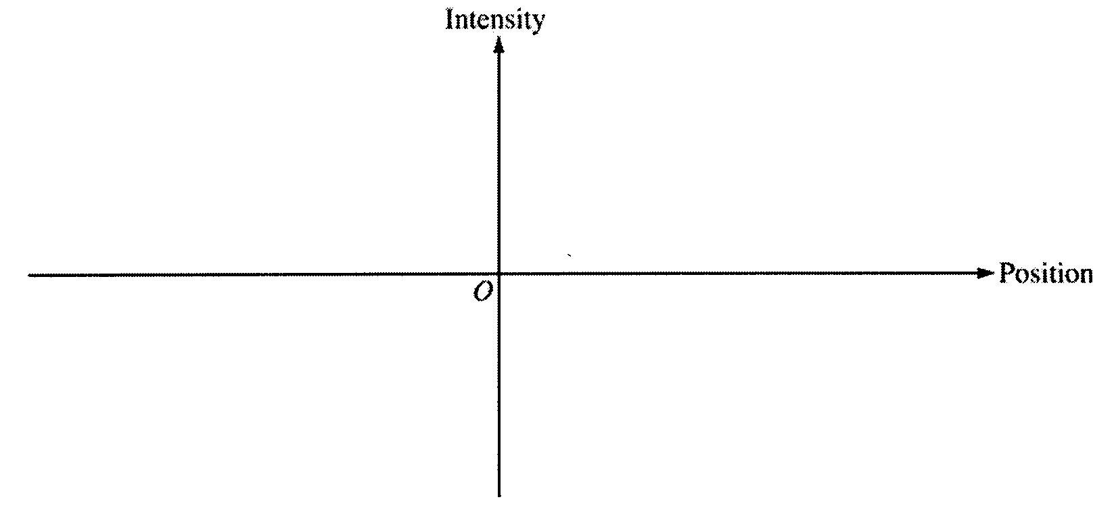
d. Outline the procedure that you would use to make the needed measurements, including how you would use each piece of the additional equipment you checked in a.
e. Using equations, show explicitly how you would use your measurements to calculate the slit spacing.

2005B5 (10 points)A large rectangular raft (density 650 kg/m³) is floating on a lake. The surface area of the top of the raft is 8.2 m2 and its volume is 1.80 m³. The density of the lake water is 1000 kg/m³.
a. Calculate the height h of the portion of the raft that is above the surrounding water.
b. Calculate the magnitude of the buoyant force on the raft and state its direction.
c. If the average mass of a person is 75 kg, calculate the maximum number of people that can be on the raft without the top of the raft sinking below the surface of the water. (Assume that the people are evenly distributed on the raft.)
2005B6 (10 points) An experiment is performed to determine the number n of moles of an ideal gas in the cylinder shown above. The cylinder is fitted with a movable, frictionless piston of area A. The piston is in equilibrium and is supported by the pressure of the gas. The gas is heated while its pressure P remains constant. Measurements are made of the temperature T of the gas and the height H of the bottom of the piston above the base of the cylinder and are recorded in the table below. Assume that the thermal expansion of the apparatus can be ignored.

a. Write a relationship between the quantities T and H, in terms of the given quantities and fundamental constants, that will allow you to determine n.

b. Plot the data on the axes below so that you will be able to determine n from the relationship in part (a). Label the axes with appropriate numbers to show the scale.
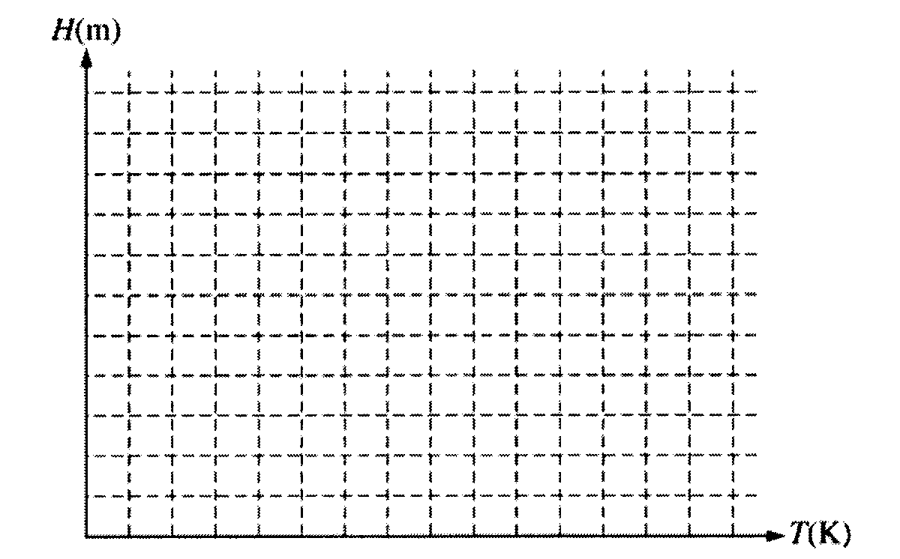
c. Using your graph and the values A = 0.027 m² and P = 1.0 atmosphere, determine the experimental value of n.

2005B7 (10 points)The diagram above shows the lowest four discrete energy levels of an atom. An electron in the n = 4 state
makes a transition to the n = 2 state, emitting a photon of wavelength 121.9 nm.
a. Calculate the energy level of the n = 4 state.
b. Calculate the momentum of the photon.

The photon is then incident on a silver surface in a photoelectric experiment, and the surface emits an electron with maximum possible kinetic energy. The work function of silver is 4.7 eV.
c. Calculate the kinetic energy, in eV, of the emitted electron.

