(2005Bb1—10 points) A student of mass m stands on a platform scale in an elevator in a tall building. The positive direction for all vector quantities is upward.
a. Draw a free-body diagram showing and labeling all the forces acting on the student, who is represented by the dot below.

b. Derive an expression for the reading on the scale in terms of the acceleration a of the elevator, the mass m of the student, and fundamental constants. An inspector provides the student with the following graph showing the acceleration a of the elevator as a function of time t.

c. i. During what time interval(s) is the force exerted by the platform scale on the student a maximum
value?
ii. Calculate the magnitude of that maximum force for a 45 kg student.
d. During what time interval(s) is the speed of the elevator constant?

(2005Bb2—10 points) A simple pendulum consists of a bob of mass 0.085 kg attached to a string of length 1.5 m. The pendulum is raised to point Q, which is 0.08 m above its lowest position, and released so that it oscillates with small amplitude θ between the points P and Q as shown below.
a. On the figures below, draw free-body diagrams showing and labeling the forces acting on the bob in each of the situations described.
i. When it is at point P ii. When it is in motion at its lowest position

b. Calculate the speed v of the bob at its lowest position.
c. Calculate the tension in the string when the bob is passing through its lowest position.
d. Describe one modification that could be made to double the period of oscillation.

(2005Bb3—15 points) The figure above shows two point charges, each of charge -2Q, fixed on the y-axis at y = +a and at y = -a. A third point charge of charge -Q is placed on the x-axis at x = 2a. Express all algebraic answers in terms of Q, a, and fundamental constants.

a. Derive an expression for the magnitude of the net force on the charge -Q due to the other two charges, and state its direction.
b. Derive an expression for the magnitude of the net electric field at the origin due to all three charges, and state its direction.
c. Derive an expression for the electrical potential at the origin due to all three charges.
d. On the axes below, sketch a graph of the force F on the -Q charge caused by the other two charges as it is moved along the x-axis from a large positive position to a large negative position. Let the force be positive when it acts to the right and negative when it acts to the left.

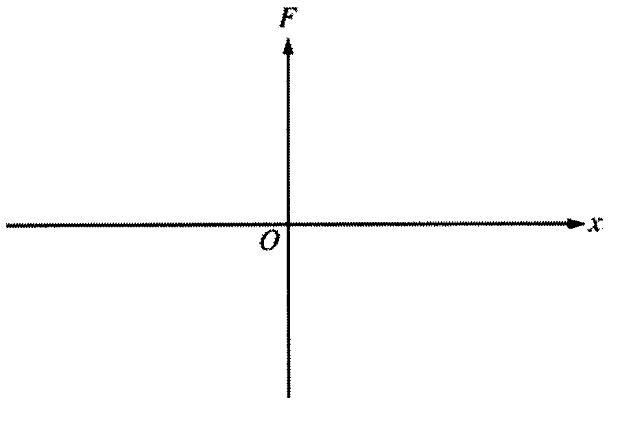

(2005Bb4—15 points) Your teacher gives you two speakers that are in phase and are emitting the same frequency of sound, which is between 5000 and 10,000 Hz. She asks you to determine this frequency more precisely. She does not have a frequency or wavelength meter in the lab, so she asks you to design an interference experiment to determine the frequency. The speed of sound is 340 m/s at the temperature of the lab room.

a. From the list below, select the additional equipment you will need to do your experiment by checking the line next to each item.

_____Speaker stand _____Meterstick _____Ruler _____Tape measure

_____Stopwatch _____Sound-level meter

b. Draw a labeled diagram of the experimental setup that you would use. On the diagram, use symbols to identify what measurements you will need to make.
c. Briefly outline the procedure that you would use to make the needed measurements, including how you would use each piece of equipment you checked in a.
d. Using equations, show explicitly how you would use your measurements to calculate the frequency of the sound produced by the speakers.
e. If the frequency is decreased, describe how this would affect your measurements.

(2005Bb5—10 points) A large tank, 25 m in height and open at the top, is completely filled with saltwater (density 1025 kg/m3). A small drain plug with a cross-sectional area of 4.0 x 10-5 m2 is located 5.0 m from the bottom of the tank. The plug breaks loose from the tank, and water flows from the drain.

a. Calculate the force exerted by the water on the plug before the plug breaks free.
b. Calculate the speed of the water as it leaves the hole in the side of the tank.
c. Calculate the volume flow rate of the water from the hole.

(2005Bb6—10 points) You are given a cylinder of cross-sectional area A containing n moles of an ideal gas. A piston fitting closely in the cylinder is lightweight and frictionless, and objects of different mass m can be placed on top of it, as shown in the figure above. In order to determine n, you perform an experiment that consists of adding 1 kg masses one at a time on top of the piston, compressing the gas, and allowing the gas to return to room temperature T before measuring the new volume V. The data collected are given in the table below.

m (kg) | V (m³) | 1/V (m⁻³) | P (Pa)
0 | 6.0x10⁻⁵ | 1.7x10⁴
1 | 4.5x10⁻⁵ | 2.2x10⁴
2 | 3.6x10⁻⁵ | 2.8x10⁴
3 | 3.0x10⁻⁵ | 3.3x10⁴
4 | 2.6x10⁻⁵ | 3.8x10⁴

a. Write a relationship between total pressure P and volume V in terms of the given quantities and fundamental constants that will allow you to determine n.

You also determine that A = 3.0 x 10⁻⁴ m² and T = 300 K.
b. Calculate the value of P for each value of m and record your values in the data table above.
c. Plot the data on the graph below, labeling the axes with appropriate numbers to indicate the scale.
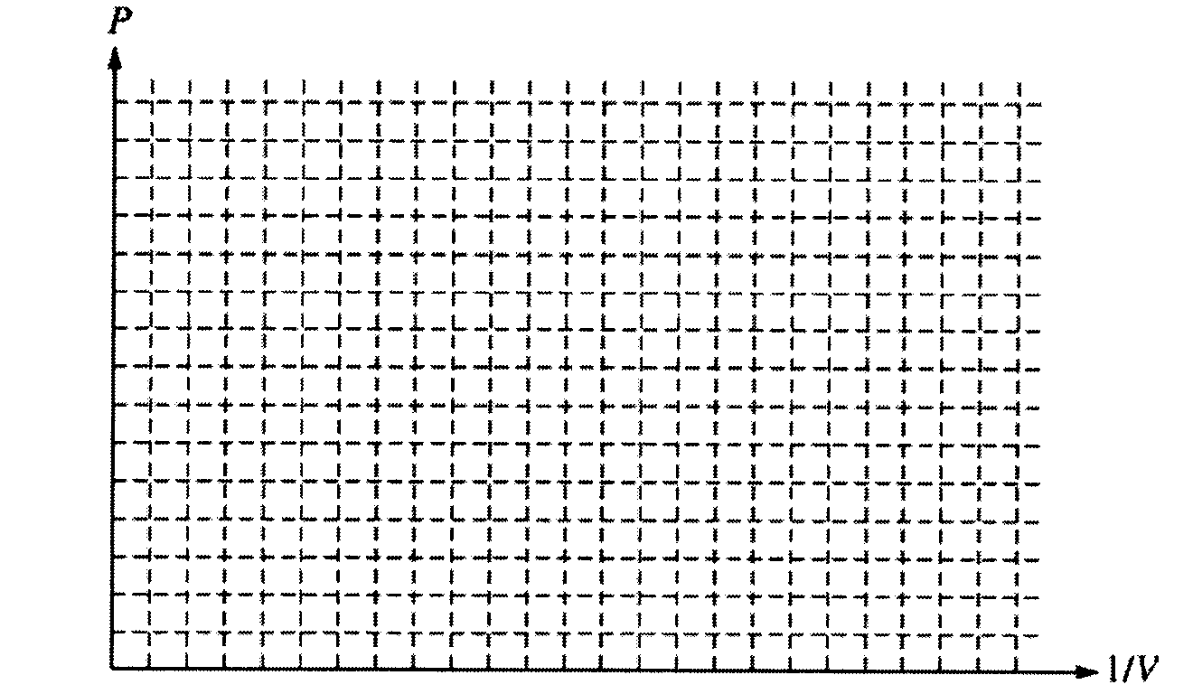
d. Using your graph in part (c), calculate the experimental value of n.

(2005Bb7—10 points) A monochromatic source emits a 2.5 mW beam of light of wavelength 450 nm.
a. Calculate the energy of a photon in the beam.
b. Calculate the number of photons emitted by the source in 5 minutes.

The beam is incident on the surface of a metal in a photoelectric-effect experiment. The stopping potential for
the emitted electron is measured to be 0.86 V.
c. Calculate the maximum speed of the emitted electrons.
d. Calculate the de Broglie wavelength of the most energetic electrons.

