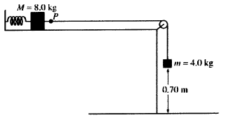

2006 B1 (15 points)
An ideal spring of unstretched length 0.20 m is placed horizontally on a frictionless table as shown above. One end of the spring is fixed and the other end is attached to a block of mass M = 8.0 kg. The 8.0 kg block is also attached to a massless string that passes over a small frictionless pulley. A block of mass m = 4.0 kg hangs from the other end of the string. When this spring-and-blocks system is in equilibrium, the length of the spring is 0.25 m and the 4.0 kg block is 0.70 m above the floor.

(a) On the figures below, draw free-body diagrams showing and labeling the forces on each block when the system is in equilibrium.
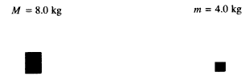

(b) Calculate the tension in the string.

(c) Calculate the force constant of the spring.

The string is now cut at point P.

(d) Calculate the time taken by the 4.0 kg block to hit the floor.

(e) Calculate the frequency of oscillation of the 8.0 kg block.

(f) Calculate the maximum speed attained by the 8.0 kg block.

2006B2 (15 points)

A world-class runner can complete a 100 m dash in about 10 s. Past studies have shown that runners in such a race accelerate uniformly for a time t_{u} and then run at constant speed for the remainder of the race. A world-class runner is visiting your physics class. You are to develop a procedure that will allow you to determine the uniform acceleration a_{u} and an approximate value of t_{u} for the runner in a 100 m dash. By necessity your experiment will be done on a straight track and include your whole class of eleven students.

(a) By checking the line next to each appropriate item in the list below, select the equipment, other than the runner and the track, that your class will need to do the experiment.

_____ Stopwatches _____Tape measures _____Rulers _____Masking tape
_____Metersticks _____Starter’s pistol _____String _____Chalk

(b) Outline the procedure that you would use to determine a_{u} and t_{u} , including a labeled diagram of the experimental setup. Use symbols to identify carefully what measurements you would make and include in your procedure how you would use each piece of the equipment you checked in part (a).

(c) Outline the process of data analysis, including how you will identify the portion of the race that has uniform acceleration, and how you would calculate the uniform acceleration.

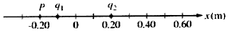

2006 B3 (15 points)

Two point charges, q₁ and q₂, are placed 0.30 m apart on the x-axis, as shown in the figure above. Charge q₁ has a value of -3.0 x 10⁻⁹ C. The net electric field at point P is zero.

(a) What is the sign of charge q₂?
_____Positive _____Negative

Justify your answer.

(b) Calculate the magnitude of charge q₂.

(c) Calculate the magnitude of the electric force on q₂ and indicate its direction.

(d) Determine the x-coordinate of the point on the line between the two charges at which the electric potential is zero.

(e) How much work must be done by an external force to bring an electron from infinity to the point at which the electric potential is zero? Explain your reasoning.

2006 B4 (15 points)

A student performs an experiment to determine the index of refraction n of a rectangular glass slab in air. She is asked to use a laser beam to measure angles of incidence θ_{i} in air and corresponding angles of refraction θ_{r} in glass. The measurements of the angles for five trials are given in the table below.

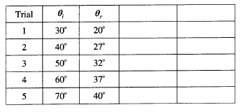

(a) Complete the last two columns in the table by calculating the quantities that need to be graphed to provide a linear relationship from which the index of refraction can be determined. Label the top of each column.

(b) On the grid below, plot the quantities calculated in (a) and draw an appropriate graph from which the index of refraction can be determined. Label the axes.
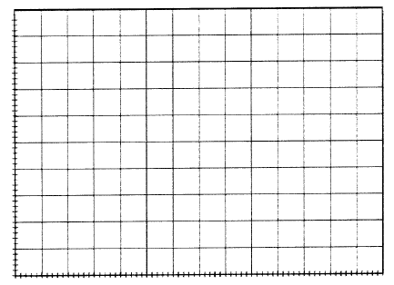

(c) Using the graph, calculate the index of refraction of the glass slab.

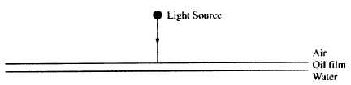

The student is also asked to determine the thickness of a film of oil (n = 1.43) on the surface of water (n = 1.33). Light from a variable wavelength source is incident vertically onto the oil film as shown above. The student measures a maximum in the intensity of the reflected light when the incident light has a wavelength of 600 nm.

(d) At which of the two interfaces does the light undergo a 180° phase change on reflection?

_____ The air-oil interface only _____The oil-water interface only
_____Both interfaces _____Neither interface

(e) Calculate the minimum possible thickness of the oil film.

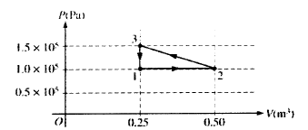

2006B5 (10 points)

A cylinder with a movable frictionless piston contains an ideal gas that is initially in state 1 at 1 x10⁵ Pa,
373 K, and 0.25 m³ . The gas is taken through a reversible thermodynamic cycle as shown in the PV diagram above.

(a) Calculate the temperature of the gas when it is in the following states.

i. State2
ii. State 3

(b) Calculate the net work done on the gas during the cycle.

(c) Was heat added to or removed from the gas during the cycle?

_____Added _____Removed _____Neither added nor removed

Justify your answer.

2006 B6 (10 points)

A photon with a wavelength of 1.5 x 10⁻⁸ m is emitted from an ultraviolet source into a vacuum.

(a) Calculate the energy of the photon.

(b) Calculate the de Broglie wavelength of an electron with kinetic energy equal to the energy of the photon.

(c) Describe an experiment that illustrates the wave properties of this electron.

