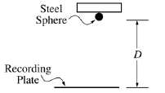
1. (15 points)
A student wishing to determine experimentally the acceleration g due to gravity has an apparatus that holds a small steel sphere above a recording plate, as shown above. When the sphere is released, a timer automatically begins recording the time of fall. The timer automatically stops when the sphere strikes the recording plate.
The student measures the time of fall for different values of the distance D shown above and records the data in the table below. These data points are also plotted on the graph.

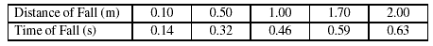
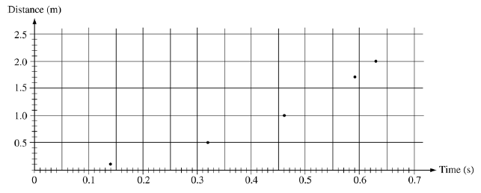
(a) On the grid above, sketch the smooth curve that best represents the student’s data.
The student can use these data for distance D and time t to produce a second graph from which the acceleration g due to gravity can be determined.
(b) If only the variables D and t are used, what quantities should the student graph in order to produce a linear relationship between the two quantities?
(c) On the grid below, plot the data points for the quantities you have identified in part (b), and sketch the best straight-line fit to the points. Label your axes and show the scale that you have chosen for the graph.
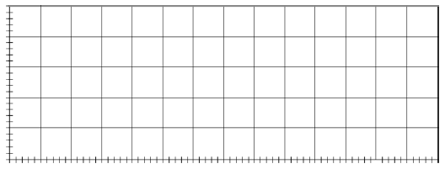
(d) Using the slope of your graph in part (c), calculate the acceleration g due to gravity in this experiment.
(e) State one way in which the student could improve the accuracy of the results if the experiment were to be performed again. Explain why this would improve the accuracy.

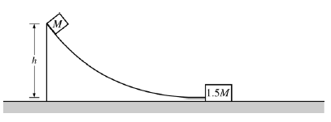
2. (15 points)
A small block of mass M is released from rest at the top of the curved frictionless ramp shown above. The block
slides down the ramp and is moving with a speed 0 3.5u when it collides with a larger block of mass 1.5M at rest
at the bottom of the incline. The larger block moves to the right at a speed 2 0 u immediately after the collision.
Express your answers to the following questions in terms of the given quantities and fundamental constants.
(a) Determine the height h of the ramp from which the small block was released.
(b) Determine the speed of the small block after the collision.
(c) The larger block slides a distance D before coming to rest. Determine the value of the coefficient of kinetic
friction m between the larger block and the surface on which it slides.
(d) Indicate whether the collision between the two blocks is elastic or inelastic. Justify your answer.

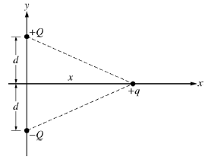
3. (15 points)
Three electric charges are arranged on an x-y coordinate system, as shown above. Express all algebraic answers
to the following parts in terms of Q, q, x, d, and fundamental constants.
(a) On the diagram, draw vectors representing the forces F1 and F2 exerted on the +q charge by the +Q
and –Q charges, respectively.
(b) Determine the magnitude and direction of the total electric force on the +q charge.
(c) Determine the electric field (magnitude and direction) at the position of the +q charge due to the other
two charges.
(d) Calculate the electric potential at the position of the +q charge due to the other two charges.
(e) Charge +q is now moved along the positive x-axis to a very large distance from the other two charges. The
magnitude of the force on the +q charge at this large distance now varies as 1/x³. Explain why this happens.

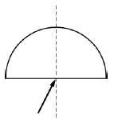
4. (15 points)
A ray of red light in air (λ=650 nm) is incident on a semicircular block of clear plastic (n = 1.51 for this light),
as shown above. The ray strikes the block at its center of curvature at an angle of incidence of 27°.
(a) Part of the incident ray is reflected and part is refracted at the first interface.
i. Determine the angle of reflection at the first interface. Draw and label the reflected ray on the
diagram above.
ii. Determine the angle of refraction at the first interface. Draw and label the refracted ray on the
diagram above.
iii. Determine the speed of the light in the plastic block.
iv. Determine the wavelength of the light in the plastic block.
(b) The source of red light is replaced with one that produces blue light ( λ=450 nm ), for which the plastic
has a greater index of refraction than for the red light. Qualitatively describe what happens to the
reflected and refracted rays.
(c) The semicircular block is removed and the blue light is directed perpendicularly through a double slit and
onto a screen. The distance between the slits is 0.15 mm. The slits are 1.4 m from the screen.
i. On the diagram of the screen below, sketch the pattern of light that you should expect to see.
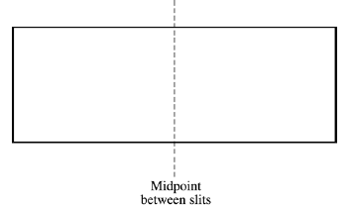

ii. Calculate the distance between two adjacent bright fringes.

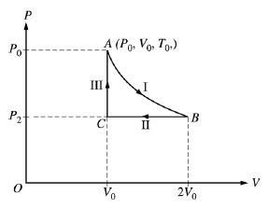

5. (10 points)
A sample of ideal gas is taken through steps I, II, and III in a closed cycle, as shown on the pressure P versus
volume V diagram above, so that the gas returns to its original state. The steps in the cycle are as follows.
I. An isothermal expansion occurs from point A to point B, and the volume of the gas doubles.
II. An isobaric compression occurs from point B to point C, and the gas returns to its original volume.
III. A constant volume addition of heat occurs from point C to point A and the gas returns to its original
pressure.
(a) Determine numerical values for the following ratios, justifying your answers in the spaces next to each ratio.
i.
ii.
iii.
iv.

(b) During step I, the change in internal energy is zero. Explain why.
(c) During step III, the work done on the gas is zero. Explain why.

6. (10 points)
An electron of mass m is initially moving with a constant speed v , where v <<c . Express all algebraic
answers in terms of the given quantities and fundamental constants.
(a) Determine the kinetic energy of the electron.
(b) Determine the de Broglie wavelength of the electron.
The electron encounters a particle with the same mass and opposite charge (a positron) moving with the same
speed in the opposite direction. The two particles undergo a head-on collision, which results in the disappearance
of both particles and the production of two photons of the same energy.
(c) Determine the energy of each photon.
(d) Determine the wavelength of each photon.
(e) Explain why there must be two photons produced instead of just one.

