

AP® Physics B
2007 Free-Response Questions
Form B

The College Board: Connecting Students to College Success

The College Board is a not-for-profit membership association whose mission is to connect students to college success and opportunity. Founded in 1900, the association is composed of more than 5,000 schools, colleges, universities, and other educational organizations. Each year, the College Board serves seven million students and their parents, 23,000 high schools, and 3,500 colleges through major programs and services in college admissions, guidance, assessment, financial aid, enrollment, and teaching and learning. Among its best-known programs are the SAT®, the PSAT/NMSQT®, and the Advanced Placement Program® (AP®). The College Board is committed to the principles of excellence and equity, and that commitment is embodied in all of its programs, services, activities, and concerns.
© 2007 The College Board. All rights reserved. College Board, Advanced Placement Program, AP, AP Central, SAT, and the acorn logo are registered trademarks of the College Board. PSAT/NMSQT is a registered trademark of the College Board and National Merit Scholarship Corporation.
Permission to use copyrighted College Board materials may be requested online at:
www.collegeboard.com/inquiry/cbpermit.html.

PHYSICS B
SECTION II
Time-90 minutes
7 Questions
Directions: Answer all seven questions, which are weighted according to the points indicated. The suggested times are about 17 minutes for answering each of Questions 1 and 3 and about 11 minutes for answering each of Questions 2 and 4-7. The parts within a question may not have equal weight. Show all your work in the goldenrod booklet in the spaces provided after each part, NOT in this lavender insert.

B2007b1. (15 points) A child pulls a 15 kg sled containing a 5.0 kg dog along a straight path on a horizontal surface. He exerts a force of 55 N on the sled at an angle of 20° above the horizontal, as shown in the figure above. The coefficient of friction between the sled and the surface is 0.22.
(a) On the dot below that represents the sled-dog system, draw and label a free-body diagram for the system as it is pulled along the surface.

(b) Calculate the normal force of the surface on the system.
(c) Calculate the acceleration of the system.
(d) Calculate the work done by the child's pulling force as the system moves a distance of 7.0 m.
(e) At some later time, the dog rolls off the side of the sled. The child continues to pull with the same force. On the axes below, sketch a graph of speed v versus time t for the sled. Include both the sled's travel with and without the dog on the sled. Clearly indicate with the symbol t_{r} the time at which the dog rolls off.

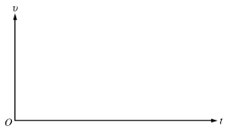

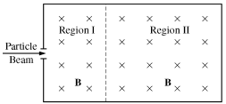
B2007b2. (10 points) A beam of particles of charge q = +3.2 x 10⁻¹⁹ C and mass m = 6.68 x 10-26 kg enters Region I with a range of velocities all in the direction shown in the diagram above. There is a magnetic field in Region I directed into the page with magnitude B = 0.12 T. Charged metal plates are placed in appropriate locations to create a uniform electric field of magnitude E = 4800 N/C in Region I. As a result, some of the charged particles pass straight through Region I undeflected. Gravitational effects are negligible.

(a) i. On the diagram above, sketch electric field lines in Region I.
ii. Calculate the speed of the particles that pass straight through Region I.

The particles that pass straight through enter Region II in which there is no electric field and the magnetic field has the same magnitude and direction as in Region I. The path of the particles in Region II is a circular arc of radius R.
(b) Calculate the radius R.

(c) Within the beam there are particles moving slower than the speed you calculated in (a)ii. In what direction is the net initial force on these particles as they enter Region I?
_____To the left _____Toward the top of the page _____Out of the plane of the page
_____To the right _____Toward the bottom of the page _____Into the plane of the page
Justify your answer.

(d)A particle of the same mass and the same speed as in (a)ii but with charge q = –3.2 x 10⁻¹⁹ C enters Region I. On the following diagram, sketch the complete resulting path of the particle.

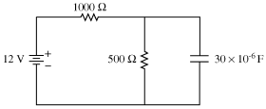
B2007b3. (15 points) In the circuit above, a 12.0 V battery is connected to two resistors, one of resistance 1000 Ω and the other of resistance 500 Ω . A capacitor with a capacitance of 30 x 10⁻⁶ F is connected in parallel with the 500 Ω resistor. The circuit has been connected for a long time, and all currents have reached their steady states.
(a) Calculate the current in the 500 Ω resistor.

(b)
(i) Draw an ammeter in the circuit above in a location such that it could measure the current in the 500 Ω resistor. Use the symbol to indicate the ammeter.
(ii) Draw a voltmeter in the circuit above in a location such that it could measure the voltage across the 1000 S2, resistor. Use the symbol to indicate the voltmeter.
(c) Calculate the charge stored on the capacitor.
(d) Calculate the power dissipated in the 1000 Ω resistor.
(e) The capacitor is now discharged, and the 500 Ω resistor is removed and replaced by a resistor of greater resistance. The circuit is reconnected, and currents are again allowed to come to their steady-state values. Is the charge now stored on the capacitor larger, smaller, or the same as it was in part (c)?
______Larger ______Smaller ______The same as
Justify your answer.

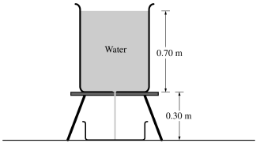
B2007b4. (10 points) A cylindrical tank containing water of density 1000 kg/m³ is filled to a height of 0.70 m and placed on a stand as shown in the cross section above. A hole of radius 0.0010 m in the bottom of the tank is opened. Water then flows through the hole and through an opening in the stand and is collected in a tray 0.30 m below the hole. At the same time, water is added to the tank at an appropriate rate so that the water level in the tank remains constant.
(a) Calculate the speed at which the water flows out from the hole.
(b) Calculate the volume rate at which water flows out from the hole.
(c) Calculate the volume of water collected in the tray in t = 2.0 minutes.
(d) Calculate the time it takes for a given droplet of water to fall 0.25 m from the hole.
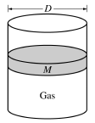
B2007b5 (10 points) The cylinder above contains an ideal gas and has a movable, frictionless piston of diameter D and mass M. The cylinder is in a laboratory with atmospheric pressure P_{atm} . Express all algebraic answers in terms of the given quantities and fundamental constants.

(a) Initially, the piston is free to move but remains in equilibrium. Determine each of the following.
(i) The force that the confined gas exerts on the piston
(ii) The absolute pressure of the confined gas
(b) If a net amount of heat is transferred to the confined gas when the piston is fixed, what happens to the pressure of the gas?
_______Pressure goes up. _______Pressure goes down. _______Pressure stays the same.
Explain your reasoning.
(c) In a certain process the absolute pressure of the confined gas remains constant as the piston moves up a distance x_{o} . Calculate the work done by the confined gas during the process.

B2007b6 (10 points) A student is asked to determine the index of refraction of a glass slab. She conducts several trials for measurement of angle of incidence θa in the air versus angle of refraction θg in the glass at the surface of the slab. She records her data in the following table. The index of refraction in air is 1.0.
Trial # | θ_{g} (degrees) | θ_{a} (degrees) | Sin θ_{g} | Sin θ_{a}
1 | 5.0 | 8.0 | 0.09 | 0.14
2 | 15 | 21 | 0.26 | 0.36
3 | 25 | 39 | 0.42 | 0.63
4 | 35 | 56 | 0.57 | 0.83
(a) Plot the data points on the axes below and draw a best-fit line through the points.
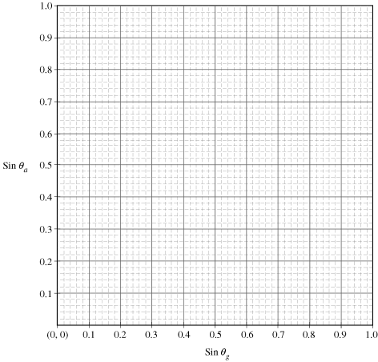
(b) Calculate the index of refraction of the glass slab from your best-fit line.
(c) Describe how you could use the graph to determine the critical angle for the glass-air interface. Do not use the answer to the part (b) for this purpose.
(d) On the graph in (a), sketch and label a line for a material of higher index of refraction.

B2007b7. (10 points) In the vicinity of a heavy nucleus, a high-energy photon can be converted into two particles: an electron and a positron. A positron has the same mass as the electron and equal but opposite charge. This process is called pair production.
(a) Calculate the rest energy of an electron, in eV.
(b) Determine the minimum energy, in eV, that a photon must have to give rise to pair production.
(c) Calculate the wavelength corresponding to the photon energy found in part (b).
(d) Calculate the momentum of the photon.

