2008 AP® PHYSICS B FREE-RESPONSE QUESTIONS (Form B)

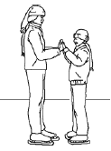

1. (10 points)
A 70 kg woman and her 35 kg son are standing at rest on an ice rink, as shown above. They push against each other for a time of 0.60 s, causing them to glide apart. The speed of the woman immediately after they separate is 0.55 m/s. Assume that during the push, friction is negligible compared with the forces the people exert on each other.
(a) Calculate the initial speed of the son after the push.
(b) Calculate the magnitude of the average force exerted on the son by the mother during the push.
(c) How do the magnitude and direction of the average force exerted on the mother by the son during the push compare with those of the average force exerted on the son by the mother? Justify your answer.
(d) After the initial push, the friction that the ice exerts cannot be considered negligible, and the mother comes to rest after moving a distance of 7.0 m across the ice. If their coefficients of friction are the same, how far does the son move after the push?

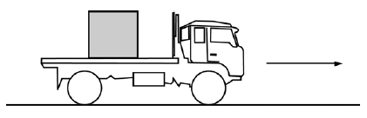
2. (15 points)
A 4700 kg truck carrying a 900 kg crate is traveling at 25 m/s to the right along a straight, level highway, as shown above. The truck driver then applies the brakes, and as it slows down, the truck travels 55 m in the next 3.0 s. The crate does not slide on the back of the truck.
(a) Calculate the magnitude of the acceleration of the truck, assuming it is constant.
(b) On the diagram below, draw and label all the forces acting on the crate during braking.


(c)
i. Calculate the minimum coefficient of friction between the crate and truck that prevents the crate from sliding.
ii. Indicate whether this friction is static or kinetic.
____ Static ____Kinetic

Now assume the bed of the truck is frictionless, but there is a spring of spring constant 9200 N m attaching the crate to the truck, as shown below. The truck is initially at rest.

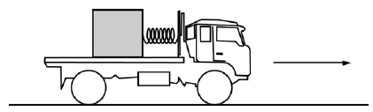

(d) If the truck and crate have the same acceleration, calculate the extension of the spring as the truck accelerates from rest to 25 m s in 10 s.
(e) At some later time, the truck is moving at a constant speed of 25 m/s and the crate is in equilibrium.
Indicate whether the extension of the spring is greater than, less than, or the same as in part (d) when the truck was accelerating.
___ Greater ___ Less ___ The same
Explain your reasoning.

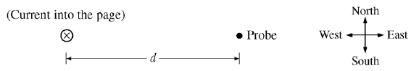
3. (15 points)
A student is measuring the magnetic field generated by a long, straight wire carrying a constant current. A magnetic field probe is held at various distances d from the wire, as shown above, and the magnetic field is measured. The graph below shows the five data points the student measured and a best-fit curve for the data.
Unfortunately, the student forgot about Earth’s magnetic field, which has a value of 5.0x10⁻⁵ T at this location and is directed north.
(a) On the graph, plot new points for the field due only to the wire.
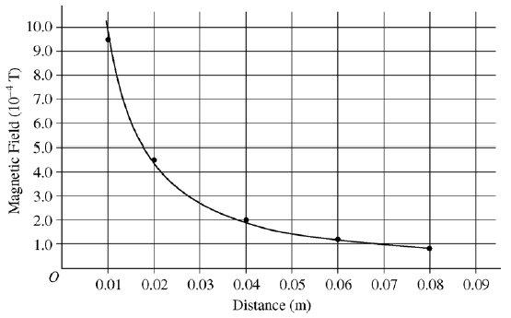
(b) Calculate the value of the current in the wire.

Another student, who does not have a magnetic field probe, uses a compass and the known value of Earth’s magnetic field to determine the magnetic field generated by the wire. With the current turned off, the student places the compass 0.040 m from the wire, and the compass points directly toward the wire as shown below. The student then turns on a 35 A current directed into the page.
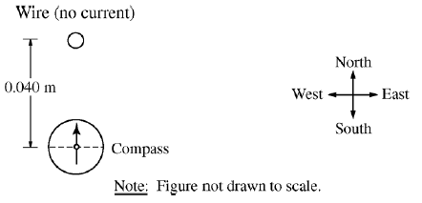
(c) On the compass, sketch the general direction the needle points after the current is established.
(d) Calculate how many degrees the compass needle rotates from its initial position pointing directly north.

The wire is part of a circuit containing a power source with an emf of 120 V and negligible internal resistance.
(e) Calculate the total resistance of the circuit.
(f) Calculate the rate at which energy is dissipated in the circuit.
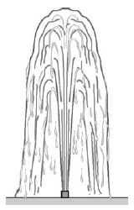

4. (10 points)
A fountain with an opening of radius 0.015 m shoots a stream of water vertically from ground level at 6.0 m/s. The density of water is 1000 kg/m³.
(a) Calculate the volume rate of flow of water.
(b) The fountain is fed by a pipe that at one point has a radius of 0.025 m and is 2.5 m below the fountain’s opening. Calculate the absolute pressure in the pipe at this point.
(c) The fountain owner wants to launch the water 4.0 m into the air with the same volume flow rate. A nozzle can be attached to change the size of the opening. Calculate the radius needed on this new nozzle.

5. (10 points)
A thin converging lens L of focal length 10.0 cm is used as a simple magnifier to examine an object O that is placed 6.0 cm from the lens.
(a) On the figure below, draw a ray diagram showing at least two incident rays and the position and size of the image formed.
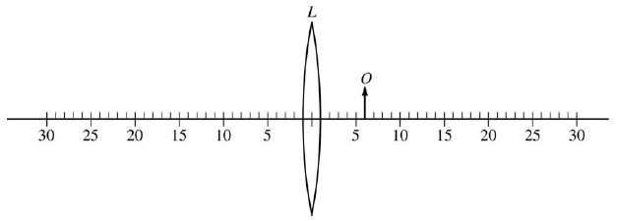
(b)
i. Indicate whether the image is real or virtual.
____ Real ____ Virtual
ii. Justify your answer.

(c) Calculate the distance of the image from the center of the lens. (Do NOT simply measure your ray diagram.)

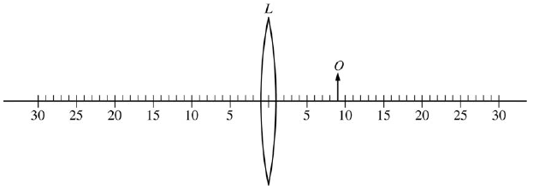
(d) The object is now moved 3.0 cm to the right, as shown above. How does the height of the new image compare with that of the previous image?
____ It is larger. ____ It is smaller. ____ It is the same size.
Justify your answer.

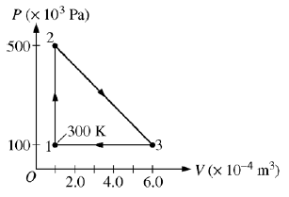
6. (10 points)
A 0.0040 mol sample of a monatomic gas is taken through the cycle shown above. The temperature T₁ of state 1is 300 K.
(a) Calculate T₂ and T₃ .
(b) Calculate the amount of work done on the gas in one cycle.
(c) Is the net work done on the gas in one complete cycle positive, negative, or zero?
____ Positive ____ Negative ____ Zero
(d) Calculate the heat added to the gas during process

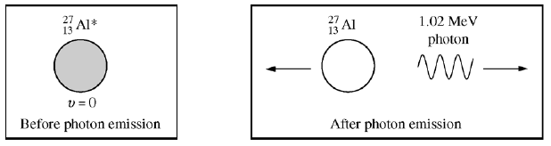
7. (10 points)
Following a nuclear reaction, a nucleus of aluminum is at rest in an excited state represented by as shown above left. The excited nucleus returns to the ground state by emitting a gamma ray photon of energy 1.02 MeV, as shown above right. The aluminum nucleus in the ground state has a mass of 4.48x10⁻²⁶ kg.
Assume non relativistic equations apply to the motion of the nucleus.
(a) Calculate the wavelength of the emitted photon in meters.
(b) Calculate the momentum of the emitted photon in kg m.s.
(c) Calculate the speed of the recoiling nucleus in m/s.
(d) Calculate the kinetic energy of the recoiling nucleus in joules.

