Adopt an Element Name:______________________________________
Baby Book due___________
Element:____________________________________

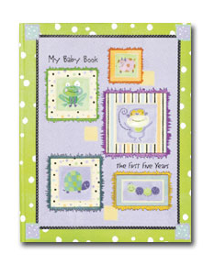
You have adopted an element from the periodic table. As a proud parent of your element, you will create a baby book to remember every stage of your element’s life. This project will count 75 points towards your Marking Period 1 grade.

Here are the requirements : (check off each one as you complete it)

_____Cover page—5 points
Name of your element and your name
Decorative cover

_____Page 1—10 points
Complete provided birth certificate including pictures
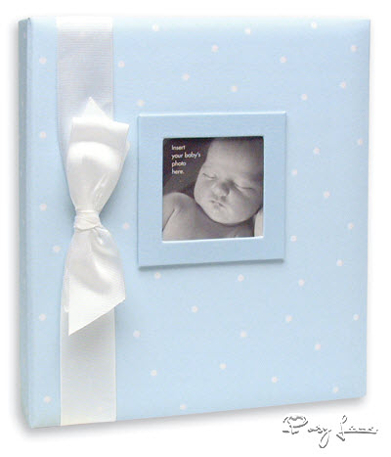
_____Page 2—10 points
Name of element (give your element a first name)
Nickname of element (symbol)
Birth date (date element was discovered)
Birth weight (atomic mass)
Birth height (atomic number)
Race (type of element—metal, nonmetal, metalloid, noble gas)
Attending physician (person credited with discovery)
Gender (state of matter at room temperature)
Place of birth (country of discovery)
Personality (emotions: boiling point and melting point)

_____Page 3—10 points
Pronunciation rebus for your element’s name

_____Page 4—10 points
Picture of element (Bohr model including protons, neutrons, electrons)
Family name (family or group of periodic table)
Brothers and sisters (names of other elements in the same family
Pictures of brothers and sisters—Bohr models including protons, neutrons, electrons

_____Page 5—10 points
Your element’s future partners (other elements it can react with & the compounds they make)
Your element’s future career (what it will be used for when it grows up)
A picture of your element’s career (one picture of its uses)

_____Page 6—10 points
A poem dedicated to your element (at least 6-8 lines)

_____Presentation and originality—10 points
Total = 75 points

Congratulations

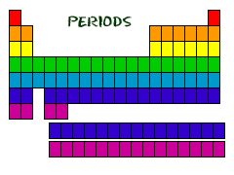

Place
Your
Element’s
Photo
Here!

Place
Your
Photo
Here!

Place
Your
Photo
Here!
Place
Your
Element’s
Photo
Here!

This is to certify that

Is the proud adoptive parent of _________

Element #__________

In this month of September in the year _____,
for the school year ending in June _____.

Acknowledged by R. Pittenger, Instructor

