LAB: Electrolysis of Water

Sometimes the materials that make up a substance are not obvious. Early scientists thought that water was an element. In other words, they thought that there was only one kind of material in water. They had not discovered a way of breaking it down further. Water, however, can be broken down further.

The decomposition of a compound into simpler substances by means of an electric current is called electrolysis. During the electrolysis of water, electricity is passed through water, which allows water to then separate into its elemental components of oxygen and hydrogen.

Since pure water does not conduct electricity well enough to allow electrolysis to occur at a reasonable rate, a catalyst is needed to speed up the reaction. In this experiment, 1.0 M sulfuric acid will be used to increase the rate of the reaction.

Make sure the observation section is completed after each procedure. I will be walking around to see that it is. The more observations you make, the easier it will be to answer the lab questions.
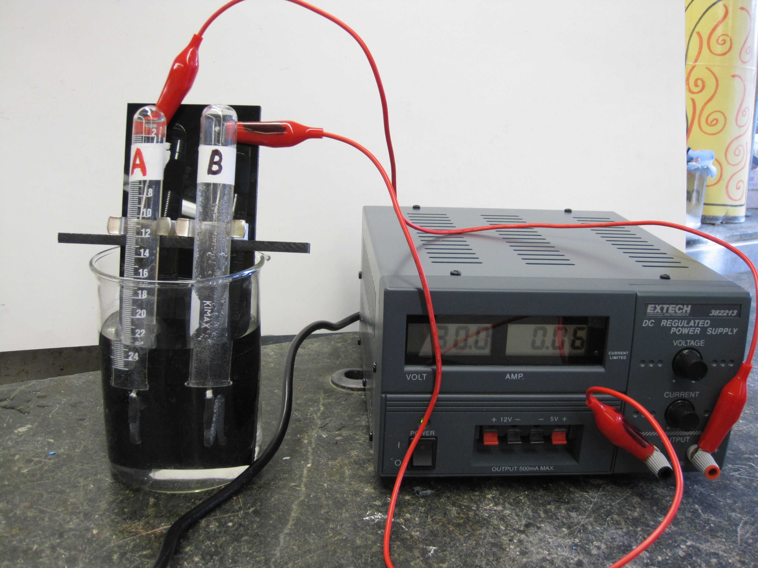
Name_________________________________ Date: ______________Period_________
LAB: Electrolysis of Water
Procedures: | Observations:
1. Fill a 600 mL beaker with 400 mL of water. | Write down 3 observations of water.
2. Carefully remove the two test tubes from the apparatus. Label one test tube A and the other B. Completely fill them with water and then insert rubber stoppers so that the stoppers are barely inside the test tube. | Once procedures 1-6 have been completed, draw a diagram of your set up below:
3. Once the rubber stoppers are in place, the two test tubes will be inverted (rubber stoppers down) and submerged in the beaker of water. Carefully, snap the test tubes into the clamps making sure the rubber stoppers are above the wire.
4. Once the test tubes are secured in place, use a scoopula to remove the rubber stoppers and leave them at the bottom of the beaker. Slide the test tubes up or down so that the wires are under the opening of the test tube and NOT inside the test tubes.
5. Rotate the red and black knobs on the apparatus so that the screws are exposed. DO NOT remove the knobs completely.
The power should be off on the power source box.
6. Connect the red alligator clip to the red screw on the apparatus and the other red end to the red screw on the power supply. Connect the black alligator clip to the black screw on the apparatus and the other end to the black screw on the power supply.
Please call teacher over to check your set up before continuing. I will sign off on this paper.
7. Once the set up is approved, the power will be turned on by the teacher.
Name_________________________________ Date: ______________Period_________
LAB: Electrolysis of Water
Procedures: | Observations:
8. After 5 minutes, 1 to 2 mL of sulfuric acid will be added to the water. | What do you see?
9. After 15 minutes, the power will be turned off and then the source box will be unplugged. | What do you see?
10. Carefully remove the test tubes from the clamp making sure not to remove the test tubes from the water. Remove the apparatus from the beaker and place aside. Using tongs, place the rubber stoppers back into the test tubes. It is very important that the test tubes are completely sealed closed with the rubber stoppers!
11. The sealed test tubes can now be removed and placed into a test tube rack. | What do you see?
12. Obtain a wooden splint, and light it. Keep tube B in the test tube rack with its mouth up. At the same time, remove the stopper from test tube B and immediately place the lit wooden splint near the open end of the test tube. | What do you notice?
13. Keep test tube A in the test tube rack with its mouth up, but keep it stoppered. Obtain another wooden splint and light it, this time blow out the splint so that it is now glowing. Remove test tube A’s stopper and quickly place the glowing wooden splint in test tube A. | What do you notice?
14. Clean-up, dump liquids down the drain. Bring everything up to the teacher’s desk.

QUESTIONS: (answer in complete sentences)
- What is the formula for water, hydrogen gas, and oxygen gas?

- What does electrolysis mean?

- What happened when the sulfuric acid solution was added to the beaker? What is the scientific term for this?

- How do the relative amounts of gas formed in the test tubes compare (which one had more, less)?

- Based on what was observed with the glowing wooden splint, what gas was in test tube A? Give reasons for your answer.

- Based on what was observed with the lit wooden splint, what gas was in test tube B? Give reasons for your answer.

- Which gas formed at the negative connection? Positive connection? Explain why.

- From this lab, it can be concluded that water decomposes into hydrogen gas and oxygen gas. Write an equation to show this decomposition reaction.

