Name:___________________________________________ Date:_____________
Chemistry-2 Period___________________ Lumsden/Pittenger/Jurgrau

Chapter 1 Activity 3: Physical and Chemical Changes

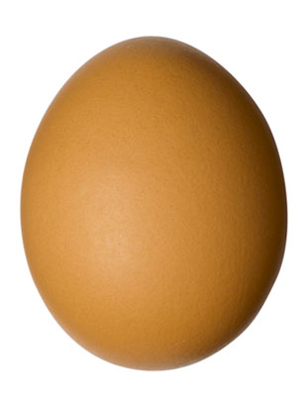
1. Label each process as a physical or chemical change:
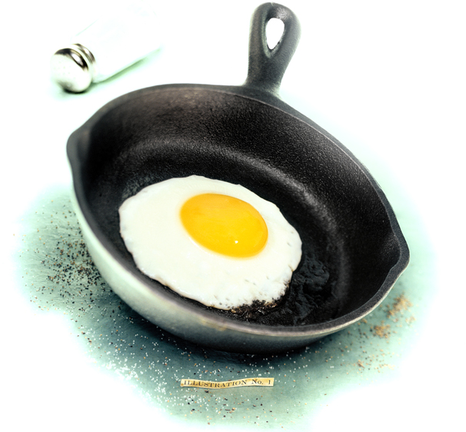
a. perfume evaporating on your skin
b. butter melting
c. wood rotting
d. charcoal heating a grill
e. autumn leaves changing color
f. a hot glass cracking when placed in cold water
g. melting copper metal
h. burning sugar
i. mixing sugar in water
j. digesting food

2. Which of the following would NOT be a physical change?
a. freezing water to make ice cubes
b. melting gold to make jewelry
c. burning gasoline in a lawnmower
d. boiling water for soup
e. tearing a piece of aluminum foil

3. Which of the following is NOT a physical change?
a. grating cheese
b. melting cheese
c. fermenting of cheese
d. mixing two cheeses in a bowl
4. Which are physical and which are chemical changes?
a. boil
b. burn (combustion)
c. condense
d. corrode
e. crumple
f. ferment
g. melt
h. rust
i. crush
j. freeze
k. oxidize
l. tarnish
m. explode
n. grind
o. rot
p. vaporize
q. photosynthesis
r. sublimation
5. Label each process as a physical or chemical change:
a. Moth balls gradually vaporize in a closet
b. hydrofluoric acid attacks glass (used to etch glassware)
c. A chef making a sauce with brandy is able to burn off the alcohol from the brandy, leaving just the brandy flavoring
d. Chlorine gas liquefies at -35 °C under normal pressure
e. hydrogen burns in chlorine gas
6. Label each process as a physical or chemical change:
a. fogging a mirror with your breath
b. breaking a bone
c. mending a broken bone
d. burning paper
e. slicing potatoes for fries
f. mixing sugar with coffee
g. frying chicken
h. a nail rusting
i. paper ripping
j. wood burning
k. mixing water and food coloring
l. food molding (rotting)
m. writing on paper
n. dyeing fabric
1. Label each process as a physical or chemical change:
a. perfume evaporating on your skin - physical
b. butter melting - physical
c. wood rotting - chemical
d. charcoal heating a grill - see below
e. autumn leaves changing color - chemical
f. a hot glass cracking when placed in cold water - physical
g. melting copper metal - physical [see (b) above]
h. burning sugar - chemical
i. mixing sugar in water - physical
j. digesting food - chemical
Part (d) of this question can be understood two ways: is it asking about the charcoal producing the heat or about the metal grill getting hot? The metal grill getting hot is a physical change, the charcoal reacting with oxygen (which produces the heat) is a chemical change.
2. Which of the following would NOT be a physical change?
a. freezing water to make ice cubes
b. melting gold to make jewelry
c. burning gasoline in a lawnmower - this one is NOT a physical change
d. boiling water for soup
e. tearing a piece of aluminum foil
3. Which of the following is NOT a physical change?
a. grating cheese
b. melting cheese
c. fermenting of cheese - this one is NOT a physical change
d. mixing two cheeses in a bowl
4. Which are physical and which are chemical changes?
a. boil - physical
b. burn (combustion) - chemical
c. condense - physical
d. corrode - chemical
e. crumple - physical
f. ferment - chemical
g. melt - physical
h. rust - chemical
i. crush - physical
j. freeze - physical
k. oxidize - chemical
l. tarnish - chemical
m. explode - see comment below
n. grind - physical
o. rot - chemical
p. vaporize - physical
q. photosynthesis - chemical
r. sublimation - physical
Part (m) of this question can be understood two ways: does 'exposion' means the actual opening up of the container (a bomb, for example) or does it refer to the chemical inside the bomb reacting? The exposion which throws pieces of the bomb about is a physical change, the chemical reacting inside the bomb (which produces the heat & pressure causing the bomb to shatter into pieces) is a chemical change.
5. Label each process as a physical or chemical change:
a. Moth balls gradually vaporize in a closet - physical
b. hydrofluoric acid attacks glass (used to etch glassware) - chemical
c. A chef making a sauce with brandy is able to burn off the alcohol from the brandy, leaving just the brandy flavoring - chemical
d. Chlorine gas liquefies at -35 °C under normal pressure - physical
e. hydrogen burns in chlorine gas - chemical
6. Label each process as a physical or chemical change:
a. fogging a mirror with your breath - physical
b. breaking a bone - physical
c. mending a broken bone - chemical
d. burning paper - chemical
e. slicing potatoes for fries - physical
f. mixing sugar with coffee - physical
g. frying chicken - chemical
h. a nail rusting - chemical
i. paper ripping - physical
j. wood burning - chemical
k. mixing water and food coloring - physical
l. food molding (rotting) - chemical
m. writing on paper - physical
n. dyeing fabric - see comment below
Part (n) of this question can be understood two ways: the dye can simply be absorbed by the fabric (this is a physical change) or it can react chemically with the fabric (this is a chemical change). Depending on the fabric and the dye involved, one or both processes may occur.

