Name:________________________________________________ Date:_______________
Chemistry 2 Period________________________ Lumsden/Pittenger/Jurgrau
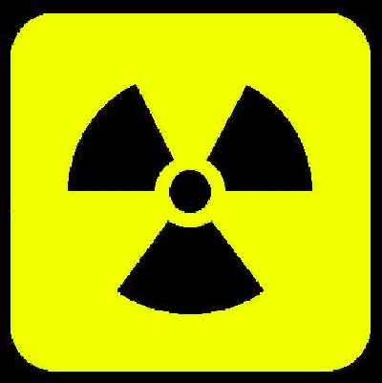
Activity 9: Nuclear Chemistry
Your task will be to use the internet to answer the following questions.
1- you must use at least 5 different websites for this activity.
2- write down the website address (URL) for each question
1. Define nuclear chemistry.

website address:____________________________________________________________________
2. Define radiation.

website address:____________________________________________________________________
3. List 3 man-made radiation sources:
1_______________________________________
2_______________________________________
3_______________________________________
website address:____________________________________________________________________
4. List 3 natural radiation sources:
1_______________________________________
2_______________________________________
3_______________________________________
website address:____________________________________________________________________
5. A radioisotope can lose energy by emitting 3 different types of radiation. Name the three types:
a.__________________________________
b.__________________________________
c.__________________________________
website address:____________________________________________________________________
6. What is an alpha particle?

Draw the symbol used for an alpha particle: ________________________
Draw what an alpha particle looks like:

What happens to the mass of an atom after it emits an alpha particle?

website address:____________________________________________________________________
7. What is a Beta particle?

Draw the symbol used for a beta particle: ________________________
Draw what a beta particle look like:

What happens to the mass of an atom after it emits a beta particle?

website address:____________________________________________________________________
8. What is a Gamma ray?

Draw the symbol used for a gamma ray: ________________________
Draw what a gamma ray look like:

What happens to the mass of an atom after it emits a gamma ray?

website address:____________________________________________________________________
9. What is half-life?

- What is the half-life of carbon-14? ____________________________
- If you are given 10 grams of Carbon-14, how many years will it take for it to decay to 5 grams?
___________________________________
website address:____________________________________________________________________
10. What is fusion?

a. Can it be controlled on Earth? _____________________________
b. Where can fusion be found occurring?_________________________________

website address:____________________________________________________________________

11. What is fission?

a. Can it be controlled on Earth? _____________________________
b. Where can fission be found occurring?_________________________________

website address:____________________________________________________________________
12. Complete the chart:
Type of Radiation | Symbol | What it can penetrate | Where in life we can find them
1.
2.
3.

website address:_________________________________________________________________________

